**From:** Neil Laurie

**To:** Erin Aston; Robert Setter

**Cc:** David Reed; Dave Stewart

**Subject:** Letter regarding CWP Committee

**Date:** Monday, 14 August 2017 5:21:18 PM

**Attachments:** SKM_C36817081417170.pdf

Good afternoon,

Please find attached a letter in response to Mr Setter’s email of 10 August 2017 attaching a

letter dated 9 August 2017 relating to recommendation 67 of the Coal Workers' Pneumoconiosis

Select Committee report titled Black Lung

White Lies.

Regards

**Neil Laurie**

**The Clerk of the Parliament**

______________________________________

**QUEENSLAND PARLIAMENTARY SERVICE**

Parliament House

Cnr George and Alice Streets

Brisbane Qld 4000

Ph: 07 3553 6450 Fax: 07 3553 6454

mailto

Consider the environment before you print this email.

NOTICE - This e-mail and any attachments are confidential and only for the use of the addressee.

If you have received this e-mail in error, you are strictly prohibited from using, forwarding, printing, copying or dealing in anyway

whatsoever with it, and are requested to reply immediately by e-mail to the sender or by telephone to the Parliamentary Service on

+61 7 3553 6000.

Any views expressed in this e-mail are the author's, except where the e-mail makes it clear otherwise. The unauthorised publication

of an e-mail and any attachments generated for the official functions of the Parliamentary Service, the Legislative Assembly, its

Committees or Members may constitute a contempt of the Queensland Parliament. If the information contained in this e-mail and

any attachments becomes the subject of any request under Right to information legislation, the author or the Parliamentary Service

should be notified.

It is the addressee's responsibility to scan this message for viruses. The Parliamentary Service does not warrant that the information

is free from any virus,defect or error.

S73 - irrelevant

Released under RTI - PSC

**RELEASE DOCUMENTS RTIPSC34.pdf - Page Number: 1 of 6**

**THE CLERK OF THE PARLIAMENT**

Parliament House

Ph; +61 7 3553 6451

**Queensland Parliamentary Service**

**Sne^^Qw**

**email: ClerksOfnce@parliament.qld.gov.au**

**www.parliament.qld.gov.au**

**Your Ref;**

**Our Ref:**

August

14

2017

Mr Robert Setter

Commission Chief Executive

Public Service Commission

PC Box 15190

CITY EAST OLD 4002

Dear Mr Setter

I refer to your email of 10 August 2017 attaching a letter dated 9 August 2017 relating to

recommendation 67 of the Coal Workers' Pneumoconiosis Select Committee report titled

*Black Lung*

*White Lies.*

You are correct in noting that parliamentary privilege creates an obstacle to the Commission discharging

this recommendation.

Section 8 of the the

*Pariiament of Queensland Act 2001*

(

POQAct) now restates the traditional privilege

established in Article 9 of the Bill of Rights 1688:

*8*

*Assembly proceedings cannot be impeached or questioned*

*(1)*

*The freedom of speech and debates or proceedings in the Assembly cannot be impeached or*

*questioned in any court or place out of the Assembly.*

*(2)*

*To remove doubt, it is declared that subsection (1) is intended to have the same effect as*

*article 9 of the Bill of Rights (1688) had in relation to the Assembly immediately before the*

*commencement of the subsection.*

Section 9 of the POQ Act now elucidates the protection by providing a non-exhaustive definition of

"proceedings in the Assembly". It clearly includes evidence given before a committee whether orally, by

submission or in tabling a document (see s.9(2)(a)-(d)).

In terms of powers, the Legislative Assembly has the power to punish for contempt breaches of its

privileges and any interference in its proceedings (see s.37 POQAct).

***Possible scenarios***

In respect of public officers, there are at least four scenarios that I can envisage arising from a

committee's inquiry:

Correspondence to be addressed to: The Clerk of the Parliament, Parliament House, Cnr Alice and George Sts, Brisbane QLD 4000 Australia

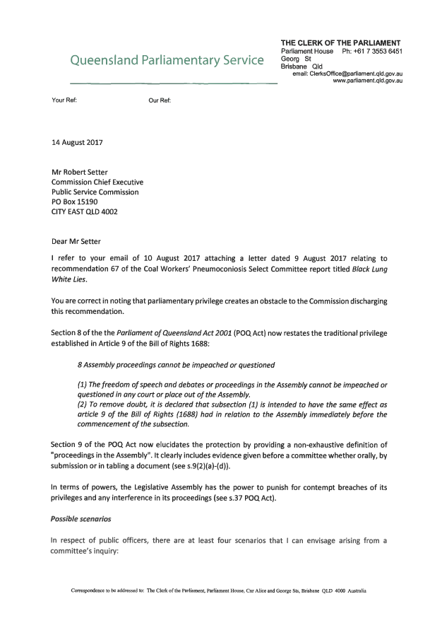

**RELEASE DOCUMENTS RTIPSC34.pdf - Page Number: 2 of 6**

Released under RTI - PSC

1

. A committee's inquiry reveals conduct by pubiic officers in relation to a matter that is the

subject of or incidental to a committee inquiry that could constitute an offence and/or a breach

of a relevant code of conduct. The conduct would usually have occurred before the committee's

inquiry, but not necessarily.

In any event, in this scenario the conduct does not directly relate to 'proceedings in the

Assembly', in that the use of proceedings in the Assembly is not required for the prosecution of

the offence or the disciplinary action.

The Parliamentary Crime and Misconduct Committee's (PCMC)

*Inquiry into the CMC's release*

*and destruction of Fitzgerald Inquiry documents*

is an example. In that inquiry the PCMC was

clearly concerned that Commission officers had, amongst other things, breached legislative

provisions, been negilgent in respect of their duties and not disclosed critical matters to the

leadership of the Commission in a timely and fulsome manner. In the relevant report {PCMC

Report No.90), the PCMC made the following recommendation;

*The Committee recommends that an appropriate, independent investigation of issues*

*relating to the dissemination and destruction of the Fitzgeraid Inquiry material be*

*established with a view to identifying possible disciplinary action or breaches of the*

*Crime and Misconduct Act 2001.*

*In accordance with normal protocols, the CMC and the Committee wiii liaise about the*

*most appropriate mechanism for the investigation.*

*it is important that any inquiry be commenced ab initio (from the beginning) and that*

*evidence gathered by the Committee not be used in such inquiry, in contravention of*

*sections 8 and 9 of the Parliament of Queensland Act 2001.*

*Without limiting the inquiry, the inquiry should consider the following matters:*

•

*Whether any breaches of section 62 of the Crime and Misconduct Act 2001 has*

*occurred (unlawful dissemination of material), by whom and if any defences exist for*

*those breaches*

*• Whether any breaches of the Public Records Act 2002 has occurred (such as*

*destruction of permanent records), by whom and if any defences exist for those breaches*

*• Whether any other breaches of the Crime and Misconduct Act 2001 has occurred,*

*including specific consideration of section 210 (fabrication of record, destruction or*

*alteration of record with the intent to obstruct or delay a Commission function) or*

*section 218 (providing a false or misleading document to the Commission);*

*• Whether any CMC officer has committed official misconduct or another disciplinary*

*breach by:*

***0***

*Failing to follow a lawful directive;*

*o Maladministration;*

*o Negligently or deliberately failing to report matters in accordance with*

*approved frameworks, charters or policies or in accordance with the general*

*provisions of the Code of Conduct.*

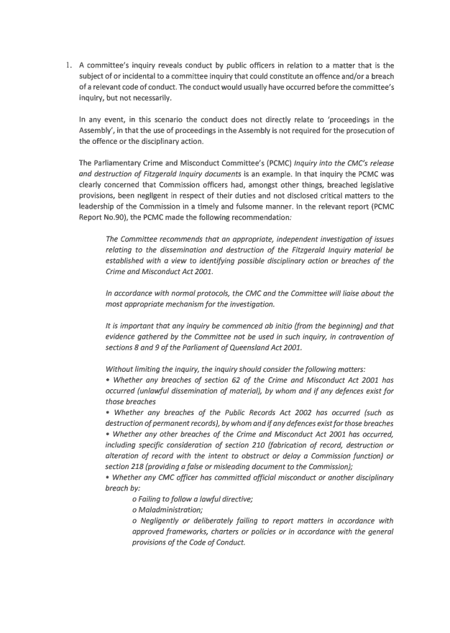

**RELEASE DOCUMENTS RTIPSC34.pdf - Page Number: 3 of 6**

Released under RTI - PSC

2

. A committee's inquiry reveais conduct by public officers in reiation to the committee's inquiry.

The conduct directly relates to a 'proceedings in the Assembly' and is a matter that could also

constitute a criminai offence under Chapter 8 of the

*Criminal Code 1899*

(

Offences against the

executive and legislative power). Those offences include;

o

Unlawful interference with the duties or authority of the Governor, Ministers or

Executive Council (s.54)

o

Demands with menaces upon the agencies of government (s.54A)

o

By force or fraud, intentionally interfering or attempting to interfere with the free

exercise of authority by the Legislative Assembly, its committees or Member (s.55)

Disturbing the Assembly (ss.56A-56C)

o

During an examination before the Legislative Assembly or a committee, knowingly

o

giving a false answer (s.57)

In this scenario the public officer could be charged with the offence under Chapter 8 of the

*Criminai Code 1899*

and any evidence that forms part of a 'proceeding in parliament' could be

used in the prosecution of the offence because of the statutory exception to s.8 POQ Act found

in s. 53 of the

*Criminal Code.*

The public officer would also be liable to be proceeded against for a contempt of Parliament, if

the conduct could amount, or is intended or likely to amount, to an improper interference

with—

(

a) the free exercise by the Assembly or a committee of its authority or functions; or

(

b) the free performance by a member of the member's duties as a member. (See s. 37

POQAct)

If the public officer's conduct is both a contempt of the Assembly and an offence against

Chapter 8 of the Criminai Code, they may be proceeded against for the contempt or for the

offence, but not both (see s.47 POQAct).

The conduct would also likely amount to a breach of a relevant code of conduct. However, the

use of 'proceedings in the Assembly' would be problematic, as s.8 POQ Act would mean that

evidence failing within the definition could not be impeached or questioned in in any court or

place out of the Assembly, in this context, 'or place out of the Assembly' would be a relevant

disciplinary body.

3

. A committee's inquiry reveals conduct by pubiic officers in relation to the committee's inquiry.

The conduct directly relates to a 'proceeding in parliament' but is a matter where there is an

express statutory ability to use those proceedings in disciplinary proceedings. The only known

example is found in S.323A of the

*Crime and Corruption Act 2001,*

which enables the use of a

report on investigation conducted by the Parliamentary Crime and Corruption Committee or

the Parliamentary Crime and Corruption Commissioner in disciplinary proceedings. (Section

323

A was inserted in

2014.)

in this scenario the public officer would also be liable to be proceeded against for a contempt

of Pariiament, if the conduct could amount, or is intended or likely to amount, to an improper

interference with—

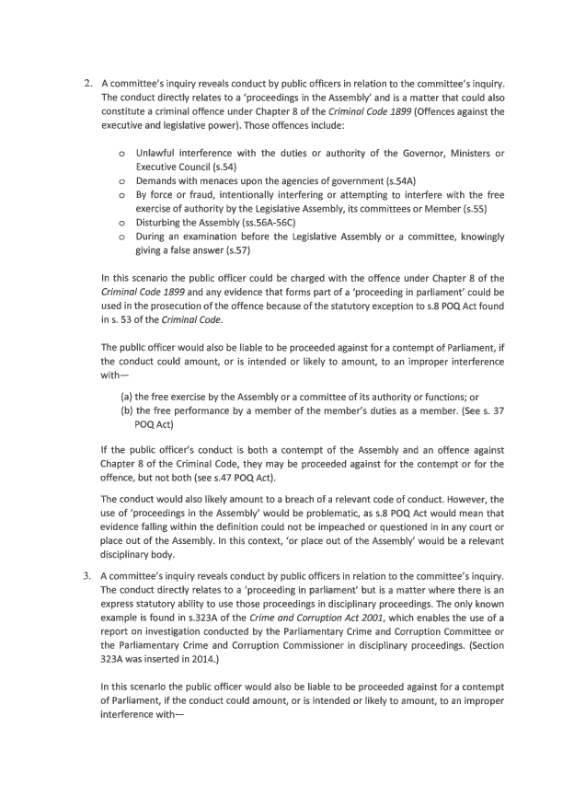

**RELEASE DOCUMENTS RTIPSC34.pdf - Page Number: 4 of 6**

Released under RTI - PSC

(

a) the free exercise by the Assembly or a committee of its authority or functions; or

(

b) the free performance by a member of the member's duties as a member. (See s. 37

POQAct).

Interestingly, the 'double jeopardy' provision in s.47 POQ Act would not apply and the public

officer's conduct could be dealt with as both a contempt of the Assembly and disciplinary action.

4

. A committee's inquiry reveals conduct by public officers in relation to the committee's inquiry.

The conduct directly relates to a 'proceeding in parliament' but is not a matter that could

constitute a criminal offence under Chapter 8 of the

*Criminal Code 1899.*

In this scenario the public officer would also be liable to be proceeded against for a contempt

of Parliament, if the conduct could amount, or is intended or likely to amount, to an improper

interference with—

(

a) the free exercise by the Assembly or a committee of its authority or functions; or

(

b) the free performance by a member of the member's duties as a member. (See s. 37

POQAct).

Again, the conduct would also likely amount to a breach ofa relevant code of conduct. However,

the use of 'parliamentary proceedings' would be problematic, as s.8 POQAct would mean that

evidence falling within the definition could not be impeached or questioned in any court or

place out of the Assembly. In this context, 'or place out of the Assembly' would be a relevant

disciplinary body.

I note that there is some dicta in

*OC v. Nationwide News Pty Ltd and Anar*

[1996] 2

Qd R 444 [

http://archive.sclQld.orE.au/qjudgment/1994/QCA94-352.Ddf ], that suggests that if an act

constituting an offence at law is also a contempt of parliament the Jurisdiction of the courts was

not necessarily excluded (see Pincus JA referring

*to Bunting and Ors.*

(1885) 7

O.R. 524 at 536,

558

and

*La Commission Royale d'Enquete v. Boulanger*

[1962]

B.R. 251 at 261-4 and Davies JA

refering to

*Bradlaugh v. Gossett*

(1884) 12

Q.B.D. 271 at 283-4). It could be argued, by the same

reasoning, that if an act that would be a disciplinary offence is also a contempt of parliament

the jurisdiction of the relevant tribunal is not necessarily excluded. However, the cases referred

to by Pincus JA and Davies JA are where the act that constitutes the offence could be proven

without reference to a 'proceeding in parliament' proper.

***CWP matter***

Based on our conversation last week and your letter, it appears that the matter under consideration

falls within the description in Scenario 2 above. That is, the conduct in question directly relates to

'proceedings in the Assembly' and may also constitute a criminal offence under Chapter 8 of the

*Criminal*

*Code 1899.*

I would recommend that you respond to the Committee as follows:

*The conduct by public servants the subject of recommendation 67, as the Public Service*

*Commission understands, directly relates to their conduct in 'proceedings in the Assembly' as*

*defined by s.9 of the Parliament of Queensland Act 2001 (POQ Act) (see s.9(2)(a)-(d)).*

*It may well also be that the conduct. If proven, could constitute either:*

*• a contempt of parliament under s.37 POQ Act;*

•

*a criminal offence under Chapter 8 of the Criminal Code 1899 (see for example, s.57); or*

*• a disciplinary offence under the Public Service Code of Conduct.*

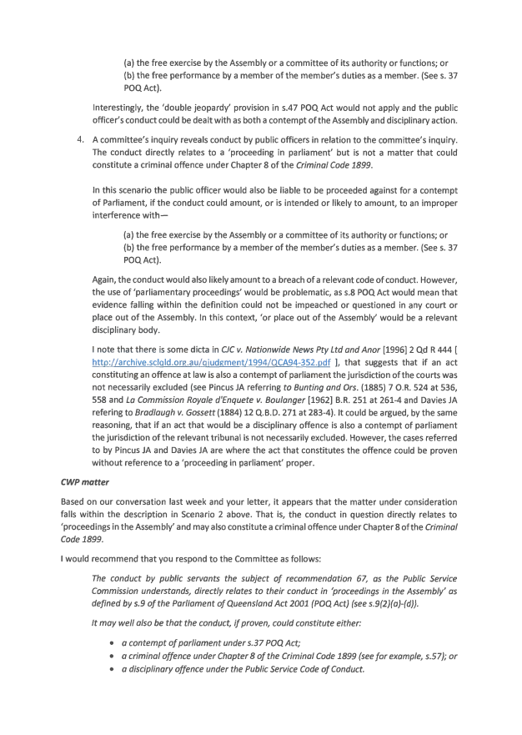

**RELEASE DOCUMENTS RTIPSC34.pdf - Page Number: 5 of 6**

Released under RTI - PSC

*In the prosecution ofa crime under Chapters of the Criminal Code 1899 the use of parliamentary*

*proceedings is expressly permitted by s.55 of the Code. However, there is no such exemption for*

*disciplinary proceedings in these circumstance. Therefore, s.8 POQ Act operates to prevent the*

*use of 'proceedings in the Assembly' by a disciplinary body.*

*The Public Service Commission believes that the Coal Workers' Pneumoconiosis Select*

*Committee is best placed to identify and assess whether there are sufficient grounds to*

*recommend that particular matters be referred to the Assembly's Ethics Committee as a possible*

*contempt. It is noted that Standing Order 273 empowers the Ethics Committee to refer possible*

*criminal offences to other agencies if it believes it is more appropriate.*

Yours sincerely

***ie\\***

Laurie

he Clerk of the Parliament

CO.

Mr Dave Stewart, Director-General, Department of the Premier and Cabinet

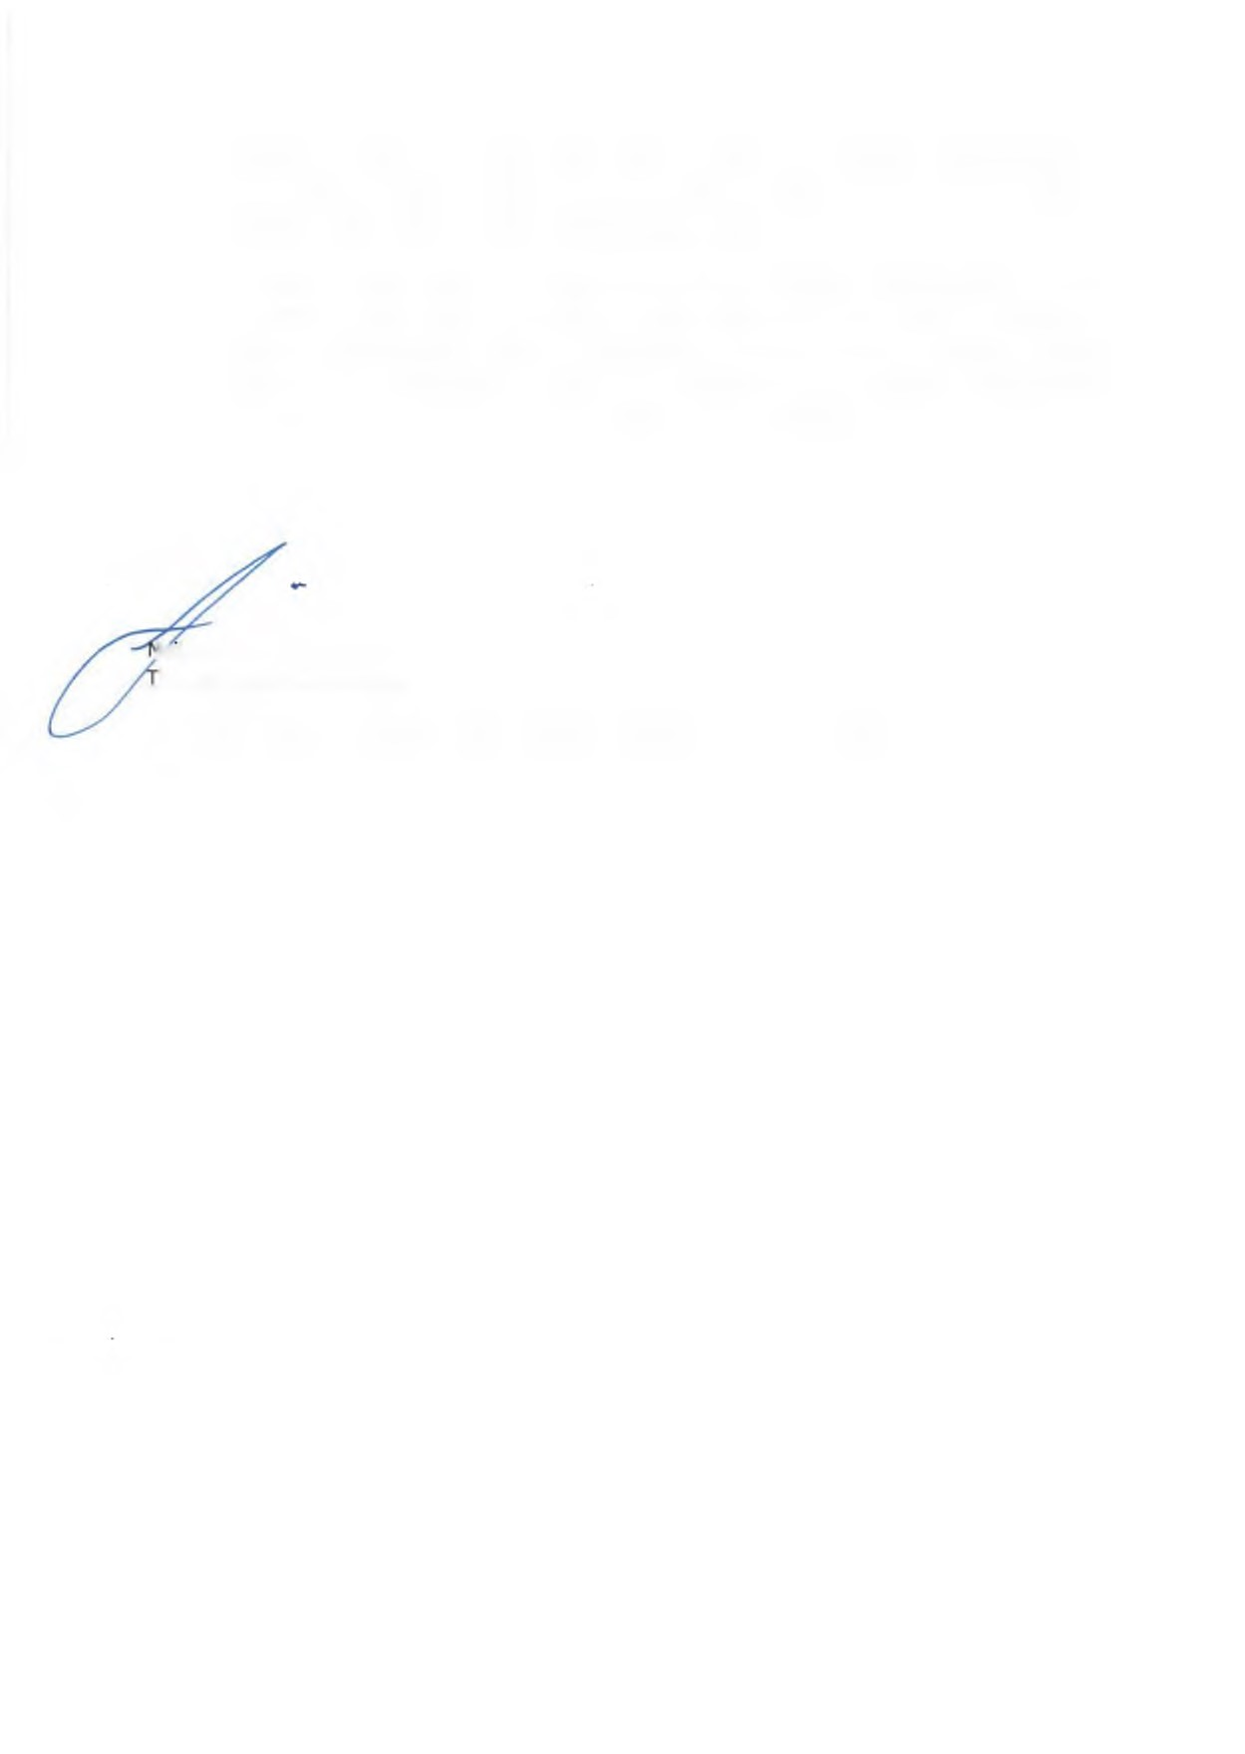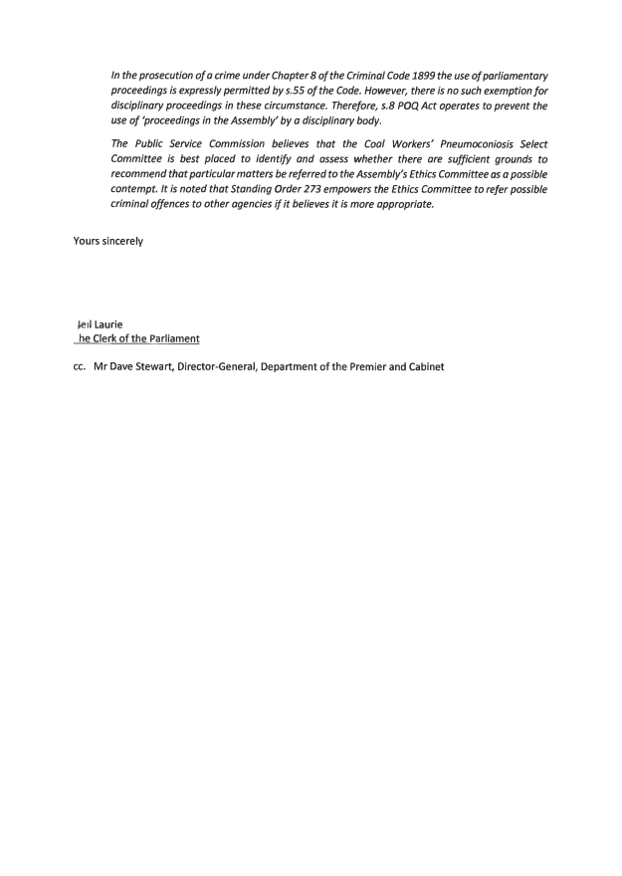

**RELEASE DOCUMENTS RTIPSC34.pdf - Page Number: 6 of 6**

Released under RTI - PSC