Committee of the | ParFiament House George Street
Legislative Assembly | Brisbane QId 4000 Pl.: 07 355 36610 cla@parliament.qld.gov.au www.parliament.qld.gov.au/cla

Ref: A727963
2 September 2021
Mr Stuart Vaccaneo
By Email: stuvac@bigpond.com
Dear Mr Vaccaneo
Recommendation 67 of the Coal Workers' Pneumoconiosis Select Committee Report No. 2, 55th Parliament
I refer to your correspondence dated 21 and 22 June 2021, concerning recommendation 67 of the Coal Workers' Pneumoconiosis Select Committee (select committee) of the 55th Parliament.
On behalf of the Committee of the Legislative Assembly (CLA), I can advise that the committee has considered the matters you have raised and has been advised that the select committee did not proceed to make a referral to the Ethics Committee prior to the select committee's expiry on 29 September 2017.
Accordingly, the CLA is of the view that the select committee considered this correspondence and the matter was finalised during the 55th Parliament upon the expiry of the committee.
Yours sincerely
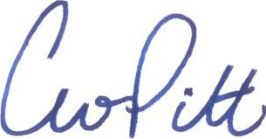
Hon Curtis Pitt MP
Chair

