Mackay District Office
P.O. Box 1801, MACKAY QLD 4740
Queensland Government Phone: (07) 4999 8512, Fax: (07) 4999 8519
Mine Name | Mine ID | Operator | Activity Type | Region | Activity Date
Grosvenor Coal Mine | M102976 | Anglo Coal (Grosvenor Management) Pty Ltd | Enspectton | Central | 05/07/2016
Vision: Our Industries Free of Safety and Health Incidents

Mine Record Entry
This report forms part of the Mine Record under s68 of the Coal Mining Safety and
Health Act 1999, It must be placed in the Mine Record and displayed on Safety Notice Boards.
Note that inspection or audit activities conducted by the Mines Inspectorate are based upon sample techniques. It remains the primary responsibility of Mine Personnel to identify hazards, and risks associated with Operations and ensure those risks are at an acceptable level.
Today, Tuesday 5 July 2016, arriving at 8am, Inspectors Richard Gouldstone and Paul Brown attended Grosvenor Mine to conduct an announced inspection.

1.0 Roof Fall HPI Report 101 LW- 2422m chainage
Inspector Gouldstone had received a telephone call during the previous night from Mr Wayne Bull (UMM) at 1:01am after he had returned from underground having examined a strata failure. Mr Bull explained that there had been a fall of roof at 101 LW, Maingate end of the face at approximately 9:30pm the previous evening. The fall stretched from 8 powered support to the maingate across 1 and 2 powered supports and 4m outbye of the faceline. The details of the fall appear later in this MRE. Inspector Gouldstone was informed that no person was injured and that ventilation was not disturbed.
2.0 Introduction
The inspectors were met by — Mr Wayne Bull (UMM)
Mr David Thomasson (TSM)
Mr Julien Joubert (SHE Manager)
The Inspectors indicated that their intention was to —
• Inspect LW 101 , examine the roof fall and the effectiveness of dust mitigation measures
Inspect MG 102 B and C developments to examine the recovery of the roof fall in
C heading and view the cavities currently being encountered in B heading
A copy of the following documents was requested
In relation to LW 101
ERZ Controllers Statutory Reports for LW 101 for the previous 48 hours
Support Plans for MG 101 C heading in its development stage and subsequent secondary support for longwall retreat in the area of the roof fall
Longwall Hazard Plan
Photograph and plan of the fall area and local geological or man-made anomalies
7 day LW shear trend — LVA record is to follow by email
PHMP Strata Control and Risk Assessments for longwall and developments
Form IA for the 101 LW roof failure
Hazard & Incident Report Form for LW 101 roof fall
HMP for Respirable Dust and TARPS
HMP for use of Polymeric Chemicals
Record of location and amounts of strata reinforcement or cavity fill materials used on
LW 101- a location plan was provided but volumes used are to follow by email
Records of health monitoring conducted on personnel deployed to use or potentially affected by polymeric chemicals —T to follow by email
Inspection SOP for the Mine — The associated Risk Assessment was to follow by email
Mr Bull also provided the following documents as part of the on-going follow up to the roof fall in MG 102 C heading which occurred on 5/6/16.
Jenmar Australia report into quality of materials in use at the time of the fall
Jenmar Australia report into tests on JX bolts in use at the time of the fall
Jenmar Australia report into tests on plates and bolts in use at the time of the fall
Examination of the above three documents showed that there were no issues with quality, installation or date of materials used.
o In relation to general issues —
Mine Inspection SOP, the risk assessment is to follow by email.
The inspectors undertook to examine the documents and provide feedback where relevant.
3.0 Mine update by Mr Bull

3.1 101 LWRoof Fall
LW 101 has retreated approximately 240m about 60m short of ^{C}square'. Roof control problems have been encountered} particularly at the tail gate end of the face. Creep control has been problematic with the last support on the face not always positioned mainly in the gate but straddling the T-junction and tending to break the roof.
The intention is to work the face remotely from the console in the maingate slung from the monorail. This has yet to be used. The face has operated mainly on auto, on uni-directional cutting, with two operatives plus a trainee shearer operator. Full commissioning is still to be completed with main problems associated with ineffective operation of base lift rams.
In regard to the fall at 101 MG Mr Bull explained that he had inspected the face on the previous day. A cavity at 3-4 support was beginning to lip on and bagging of the mesh just outbye the face-end was observed but not considered significant. Rock props had been set on the travel side of the BSL but overall conditions looked to be improving.
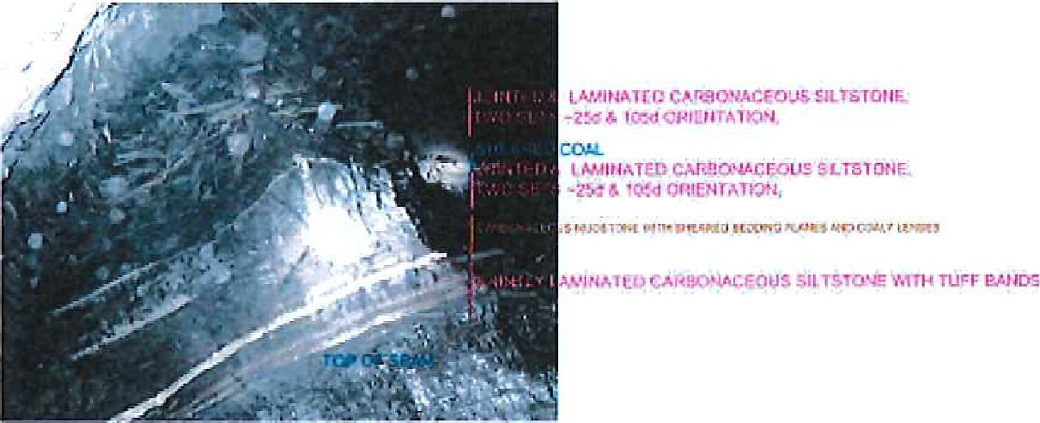
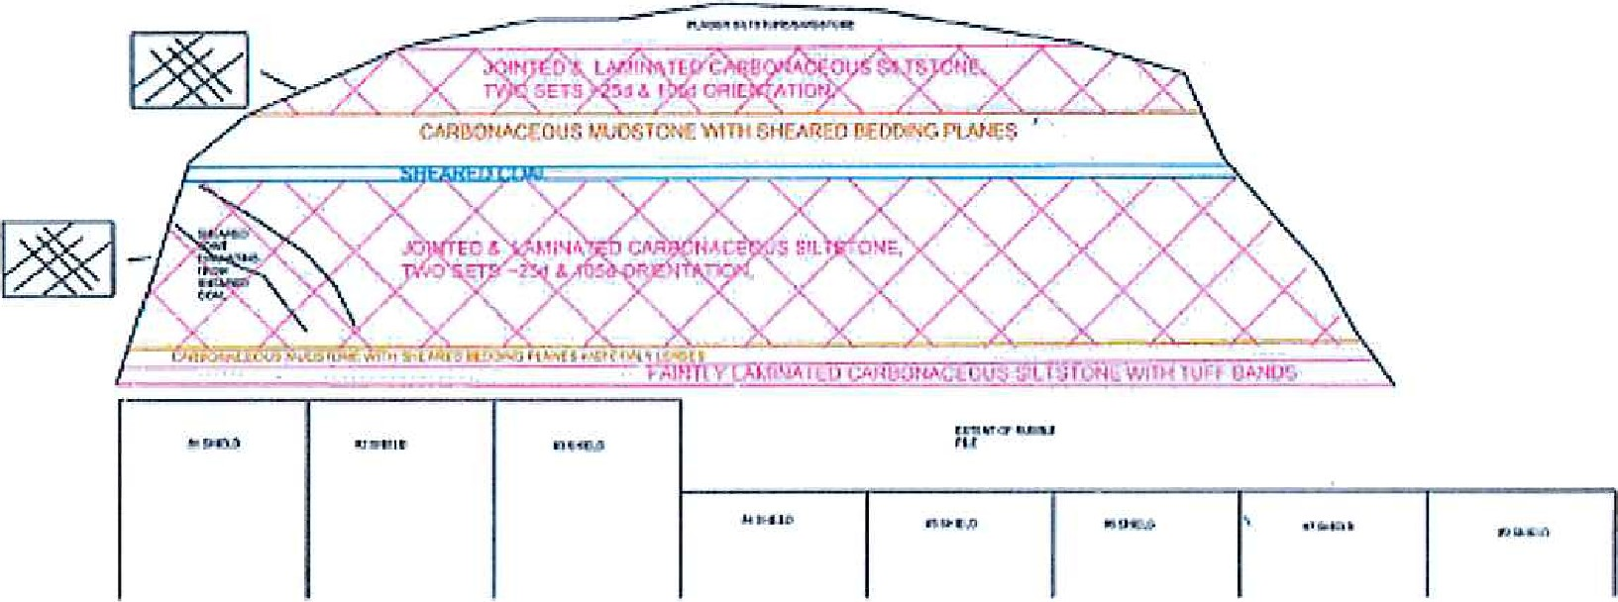
Later, on the sixth shear for the day, as the shearer entered and pulled up the face from the MG a fall occurred —a photograph of a view into the cavity and a cross section of the strata are shown above.
The conditions at the maingate were effectively communicated shift to shift and the fall was unexpected. Later, on inspection, the nature of the roof was highly laminated with a highly polished layer close to the top of the cavity. The cavity was largely empty of debris as it had slid out into the hole in front of 1-2 support.
Dayshift crews were involved during the inspection consolidating the approach to the fall by pinning extra heavy duty mesh along the BSL to the fall and propping the travel side of the BSL. They were also conducting a risk assessment to establish a recovery plan for the immediate fall area. The details are still to be established but they will include cavity filling on face and in the gate, reinforcement of the coal face and in advance in the gate and, spiling from the gate in advance of the face.
The current status of the conveyor road support outbye of the immediate fall will need to be assessed with suitable reinforcement provided the timing of which is critical. Mr Bull is to provide a copy of the full recovery plan once it has been established.
The nature of this roof fall, with the experience of that encountered in 102 MG C heading roof fall, which was also unexpected, will need to be considered and its implications for the long term strata control prospects for the Mine.
Other factors Mr Bull indicated as relevant issues were
- Developed horizon in the MG means that the floor cutting horizon is lifted thinning the coal roof on the normal run of face. There is a need to grade up into the maingate end of the face.
The face is in 'Domain A' where there is a seam split of the top ply.
- The mining depth is 350m.
In development, roof support provided between intersections was 8x 1.8m JX bolts plus two 8.2m megabolts each 4m.
Secondary support was added between intersections and the following diagram shows positions of all megabolts, and temporary rock props at the MG face end.
e There was a small amount of floor lift and roof cracking along the BSL.
The full support provided will be analysed as part of the Mine investigation.
A discussion later the following day with Mr Bull suggests that an option will be to introduce a centrally placed 8.2m megabolt before the belt extension in the development stage to better even out the support provided.
Location of Megabolts and Rock Props
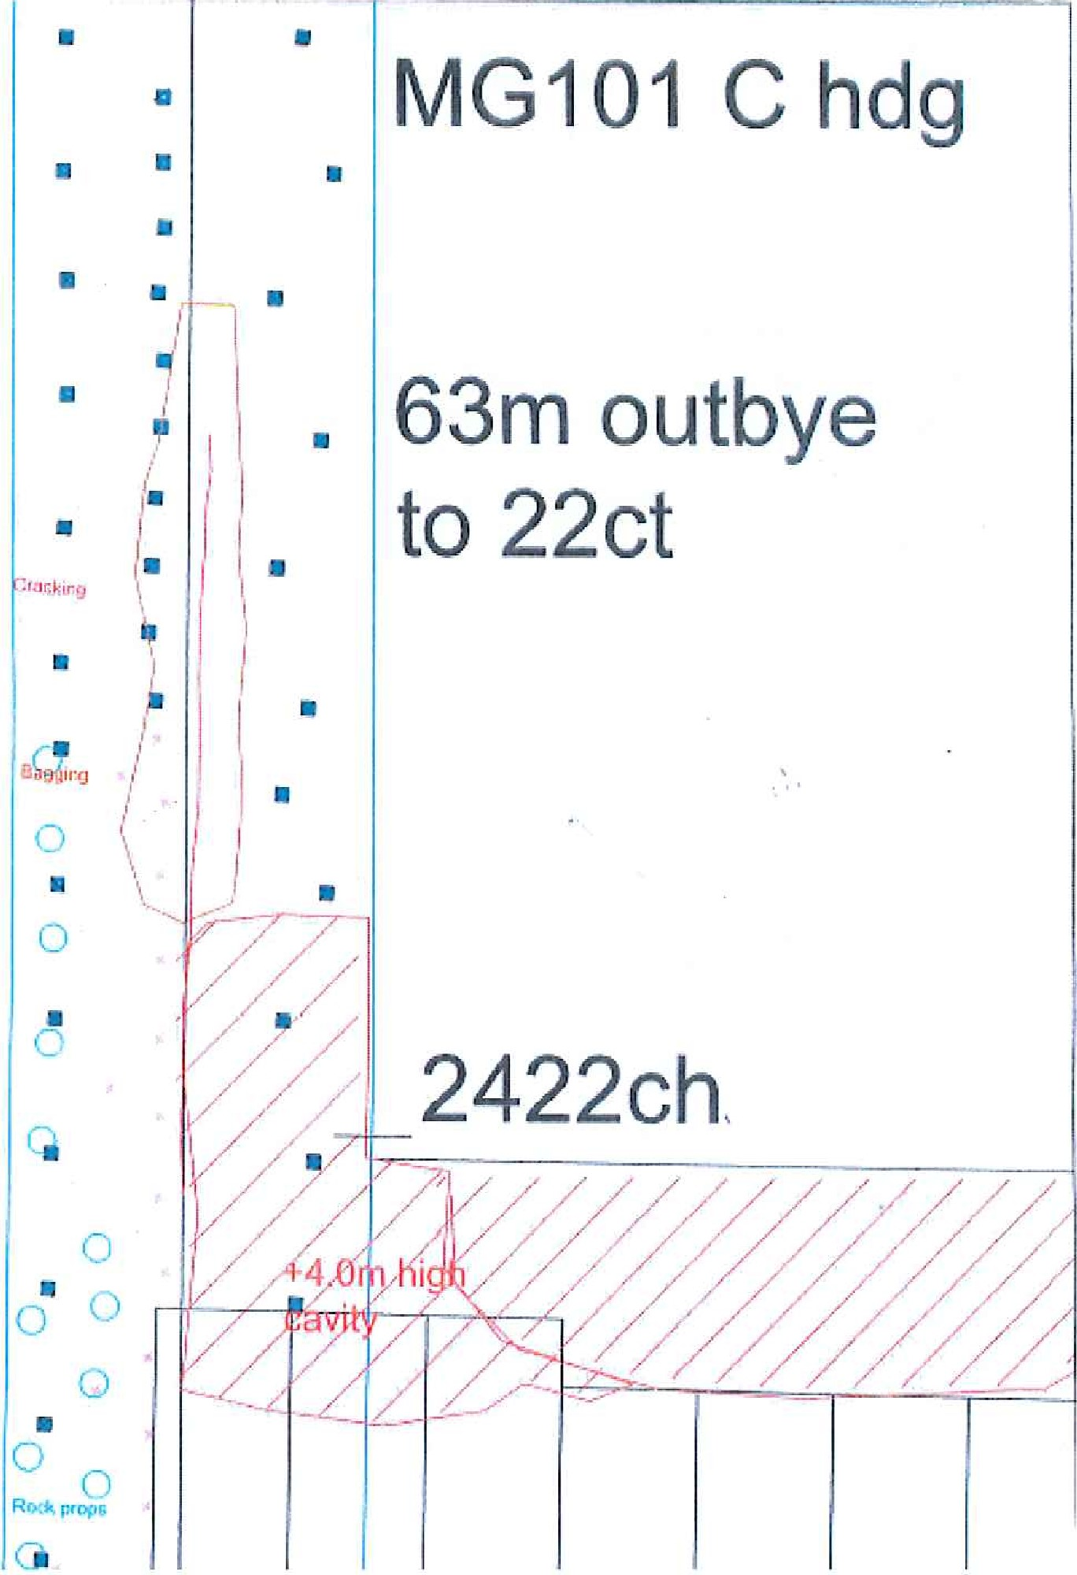
3.2 LW 101 Dust Mitigation Measures
Discussions on the surface and on meeting with Mr Wayne Pate (Longwall Superintendent) on the longwall included -
Pick modifications - the need to cut stone floor (200mm) had created several instances where the tungsten tips had been lost or damaged (20 to 30 [week replaced). Design has been modified after discussions with OEM. A supply of new picks is awaited.
Shearer on board sprays not seen in operation no cutting due to fall — the 'Bretby' spray looked to have been effective from the clean appearance of the Bretby.
Chock spray on shearer — this is mounted facing the goaf and hoses down the front face of each support. — later on inspection there was evidence that this blasted down dust as most supports, even after 12 hours post roof fall, were still clean.
Leg (halo) sprays — these are mounted to wash-down powered support legs but have not proved too successful as the time taken to lower-advance-set meant the spray was only triggered for a short time.
Beam sprays — observed but not in operation
Spray curtain adjacent to MG face end — this is planned to be installed as it has proven effective elsewhere.
The shearer drum cowls originally fitted have been removed and work has still to be effectively applied to linking the spray operations to shearer position and speed of operations to gain maximum dust mitigation outcomes.
Only 3 operators are on the longwall during production.
Spill plates mounted sprays for product on AFC — positioned to spray on the top of a loaded AFC to help quell dust on discharge to the BSI-.
BSL modified covers — these are in the out-bye cross cut (22) the plan being to install them imminently but the roof fall has prevented that. Had they been in place it is almost certain that the debris from the fall would have destroyed them.
The monitoring regime has been discussed with fellow inspectors Shaun Dobson and Fritz Djukic on 13/06/16 and details are contained in the MRE.
3.3 Development
MG 102 is now advanced to 19 to 20 CT with C heading just at 20CT intersection and B heading at 65m chainage.
'Deadweight' support design post C heading roof fall was continuing to be installed in both headings and will be the case for the foreseeable future until there is tangible evidence that an alternative design would be safe to install.
There have been no further roof control problems in C heading and the fall has been fully recovered using shotcrete, timber cogs and a RSJ false roof with timber lagging. Tell tales either side of the fall show no post failure movement. The cavity is being ventilated with venturis and will be cavity filled.
B heading has encountered poor roof in the last 30m of drivage. In the last 24 hours the ERZ Controller made the call to tram the ED 24 CM out to re-secure the face with a QDS Bolter. The initial poor roof had been caught and the cutting horizon lowered to catch a coal roof but this again failed. The crew today were in the process of re-securing the lip and the decision has been made to again lower the cutting horizon after a recovery support plan had been devised.
4.0 Underground Inspection
Inspectors Brown and Gouldstone were accompanied underground by Mr Bull
Mr Thomasson
Mr Joubert
Mr Tim Reeves (Production Manager)
Mr Wayne Pate
Mr Neal Bryan (Shift Undermanager)
4.1 General Comments
The mine where travelled was clean and tidy with sufficient suppression to dampen all travel roads sufficiently to not cause intake dust pollution.
All traffic and pedestrian interaction was without risk and in accordance with protocols.
Inspector Brown viewed ERZ Controllers Reports which were of a significantly high standard.
Inspector Gouldstone spoke with the CRO and was shown the tailgate gas monitoring trends before during and after the roof fall on the longwall and there was nothing of significance. An earlier transient spike in the methane trend was confirmed as a temporary shutdown on the surface methane drainage plant.
4.2 LW 101
We were met by ERZ Controller Mr Bill Ramsey (window shift ERZC) who explained the activity on-going in the district. We first viewed the fall area which was as described earlier in this MRE
Three CMW were engaged in pinning heavy duty mesh over the BSL to better contain the bagged mesh and were in close proximity to a telltale which was showing no further roof movement post fall,
The fall was not presenting any significant obstruction to ventilation and questioning of the official revealed that there was a pick-up of methane from 0.2 to 0.5% along from MG to TG on the face. Three venturis were set up and two ventilation curtains face side to assist in dispersing methane flushing from the goaf on the last 60m of faceline. Goaf holes have been spaced at 50m and some difficulty has been experienced with n07 hole being slow to become productive.
As we passed through the longwall Mr Pate explained the various dust mitigation issues already listed in section 3.3 of this MRE. Dust gathered on supports was not excessive and there was clear evidence of caking of dust and washing down leaving clean surfaces where suppression water had been applied. This was 18 hours after the face had been stood post fall. The dust that was present increased in amounts towards the tailgate.
Water guns were present on alternate powered supports.
Mr Pate explained that the volume of water used was causing belt slip problems and that dewatering chute work was planned to assist with the matter.
The line, grade, pan angles and roof conditions, with the exception of the MG face-end, were all good.
There was visible water vapour at the TG end of the face as the goaf stream met the normal ventilation stream and a noticeable intermittent oily odour, This was attributed to leaked soluble oil from the support system. It was stressed that such issues required continued close surveillance and that officials should be liaising shift by shift because the true characteristics of the goaf stream have yet to emerge.
4.3 MG 102 Development
We were met by ERZ Controller, Mr Chris Eyre, who explained clearly all activities in progress in both B and C headings. He was aware of ventilation quantities and was able to test, using a probe for layering in the various cavities on the district.
We fitted our isolation locks to the ED25 CM and moved into B heading. The roof problems explained in section 3.3 were viewed. The face had been well supported with only 5x 4m spiling dowels remaining to be installed which were angled up and in the direction of drivage to provide a canopy to assist in establishing a coal roof.
Mr Thomasson pointed out a number of minor disturbances and the friable nature of the coal which trended right to left across the heading. It was also apparent that the dip of the coal had increased in the direction of drivage. The direction was such that the same structure would likely present itself in C heading which when viewed showed the same increased seam dip.
Mr Bull later, at noon on 6 July 2016, reported to Inspector Gouldstone that the B heading had restarted cutting and quickly progressed holding a coal roof for 5m and that the feature referred to had been encountered as expected in C heading. This meant that the position of 20CT would be reviewed.
On moving to C heading support was being installed for 20CT intersection but generally roof conditions were good. The site of the fall was viewed and it was clear there had been no movement after the initial failure.
Inspector Brown inspected the shuttle-car cable management standard which was satisfactory.
There were no issues with the auxiliary fan installation or belt boot end and the district was well stonedusted.
5.0 Close-out Meeting
The Inspectors were joined at the close-out meeting by
Mr Bull
Mr Thomasson
Mr Joubert
Mr Reeves
Mr Stuart Sulter (Compliance Superintendent)
The content of this MRE was discussed at length. The Inspectors undertook to read and provide feedback on the documentation provided but specifically In relation to LW 101 MG fall
Look at the support provided and comment upon potential options to deal with the immediate problem of fall recovery and remedial work for the existing LW 101 MG. Also what the future strategy should be in support installed in development and secondary support phases.
In relation to dust mitigation
Examine the planned mitigation work and how the initial experience has meant changes. The Mine is still subject to direction given by Inspectors Dobson and Djukic on 13/06/16.
In relation to information supplied subsequent to the roof fall in C heading
Read and provide feedback on the 'CAM report provided.
Rich 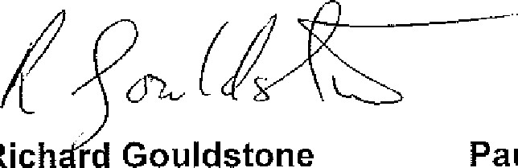rd Gouldstone Paul Brown
Inspector of Mines Inspector of Mines (Mining)
Central Region Central Region

