Mackay Office
P.O. Box 1801, Mackay QLD 4740
Queensland Government Phone: 07 4999 8512, Fax: 07 4999 8519
Mine Name | Mine ID | Operator | Activity Type Activity Date
Grosvenor Coal Mine | M102976 | Anglo Coal  (Grosvenor  Management) Pty Ltd | Subject Audit or Specific 09/05/2018 System Audit

Vision: Our Industries Free of Safety and Health Incidents

Mine Record Entry
This repotf forms part of the Mine Record under s68 of the Coal Mining Safety and
Health Act 1999. It must be placed in the Mine Record and displayed on Safety Notice Boards.
Note that inspection or audit activities conducted by the Mines Inspectorate are based upon sample techniques. It remains the primary responsibility of Mine Personnel to identify hazards, and risks associated with Operations and ensure those risks are at an acceptable level.
Inspectors Richard Gouldstone and Les Marlborough arrived at the Mine at 1 1:30am to deliver the Structured Audit (SAG) Report on Gas Management conducted between 17 and 19 April 2018.
Present at the Meeting in addition to the Inspectors was Mr Marc Kirsten (SSE)
Ms Kate Bachmann (Safety & Health Manager)
Mr Trent Griffiths (SSE)
Mr Rob Nowell (Production Manager)
Mr Michael Webber (VO)
Mr Garry Morrissey (Ventilation and Gas Drainage Superintendent) )
Mr Wayne Pate (Compliance Superintendent)
Mr Scott Seears (Gas Compliance Coordinator)
A copy of the Report, Mandatory Corrective Actions (MCAs, two in number) and
Recommended Corrective Actions (RCAs, six in number) had been forwarded to Mr Kirsten by email.
The inspectors made the following points -
The Mine had prepared extremely well and were able to furnish the Department with almost all the necessary documentation well in advance of the audit which meant there was very little wasted time.
All persons involved were helpful, well informed and assisted as required.
11105/2018 Mine Record Entry Page 1 of 2
The MCAs and RCAs were read through and a discussions took place where clarification was sought. Inspector Gouldstone passed the hard copies to Mr Kirsten for him to sign and establish with his team the details of the response, and a timetable for implementation of the Actions required.
There were no points in dispute and the Mine expected to furnish the Department (Inspector
Gouldstone) with a response within a week.
It is expected that the report, findings and response will be included in the Mine Record.
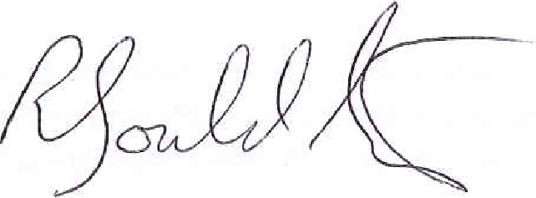

Richard Gouldstone Les Marlborough
Lead Auditor Inspector of Mines
Inspector of Mines
11/05/2018 Mine Record Entry Page 2 of 2

