Mackay Office
P.O. Box 1801, Mackay QLD 4740
Queensland Government Phone: 07 4999 8512, Fax: 07 4999 8519
Mine Name | Mine ID | Operator | Activity Type Activity Date
Grosvenor Coal Mine | M102976 | Anglo Coal  (Grosvenor  Management) Pty Ltd | Subject Audit or Specific 17/04/2018 System Audit

Vision: Our Industries Free of Safety and Health Incidents

Mine Record Entry
This repon forms part of the Mine Record under s68 of the Coal Mining Safety and
Health Act 1999. It must be placed in the Mine Record and displayed on Safety Notice Boards.
Note that inspection or audit activities conducted by the Mines Inspectorate are based upon sample techniques. It remains the primary responsibility ofMine Personnel to identify hazards, and risks associated with Operations and ensure those risks are at an acceptable level.
Inspectors of Mines, Richard Gouldstone, Les Marlborough and Paul Brown conducted a Gas Management audit at Grosvenor Mine from 17 April to 19 April 2018.
Day 1.
Inspectors briefed staff at an opening meeting on the Audit schedule and scope, present at the meeting were:
Compliance Manager Wouter Niehaus
Gas Compliance Coordinator Scott Seears
EEM Ian Bailey vo Mick Webber
The audit was expected to span over 3 days with both desktop and underground components for evidence gathering. Day one primarily focussed on the Control Room and reports for Gas Management. Inspectors also continued with desktop audit of documents.
Day 2.
Inspector Brown conducted the Outbye and Development component of the Audit accompanied by the relevant area ERZ Controllers.
Inspector Gouldstone continued with the document audit.
Day 3.
Inspector Gouldstone conducted the Longwall component of the Audit accompanied by the area ERZ Controller.
23/04/2018 Mine Record Entry Page 1 of 2
Inspector Brown continued with the gathering of documents and talking to staff about the implementation and effectiveness of the systems.
A brief close out meeting was conducted by Inspectors with the following staff present:
SSE Mark Kirsten
UMM Cec Ivers
Compliance Manager Wouter Niehaus
V.O Mick Webber
Inspectors provided interim findings so far, one mandatory action was identified and a further 3 recommendations were discussed. The audit report was still in the process of being constructed and the extent of the findings were yet to be finalised. Inspectors gave commitment to attend site when the report is completed. It was anticipated the report to be ready in approximately one week pending other priorities.
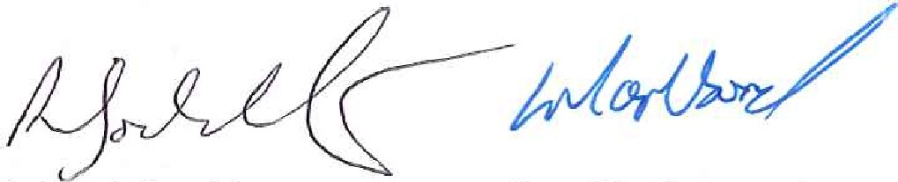

Richard Gouldstone Les Marlborough
Lead Auditor Inspector of Mines
Inspector of Mines
23/04/2018 Mine Record Entry
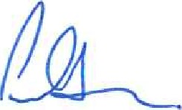
Paul Brown
Inspector of Mines
Page 2 of 2

