No pre drainage of the GML seam has been conducted for LW104. The GML is expected to release gas due to the reservoir size combined with proximity to the working seam between Ch4000 and Ch2000 (MG104 20-36c/t)
LW 104 Second Workings SOP

LW 104 Development HPI’s
All reported as “An event causing the withdrawal of a person from the mine or part of the mine”

- 29th of October. CH4 Generated – 132m
An incident occurred in MG104 Development Panel on the 29th of October at approximately 2:50am. The Continuous Miner was producing in C Hdg 22-23ct and was 60m from the last open C/T.
Miner at the face completed the cut cycle and started bolting with the Shuttle car at the boot end when a release of gas / floor heaved behind the C/M. (reading greater than 2.5 % recorded on the Miner Drivers PGD). The C/M tripped power correctly.
Floor heave could be observed after the event in the area from the 45 -50m mark up to the back end of the C/M.

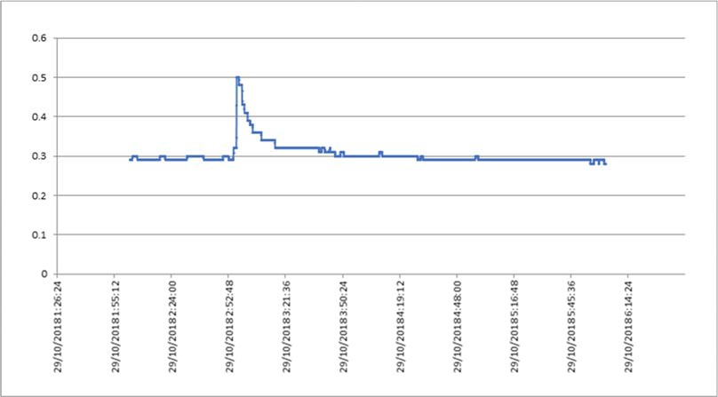

- 3rd of November.
An incident occurred in MG104 Development Panel on the 3rd of November at approximately 12:15am. The Continuous Miner was producing in B Hdg 22-23ct and was approximately 60m from the last open C/T.
The CM operator noticed a smell and noted that the CH4 sensor on the heads accelerated very quickly and tripped power to the CM. At this time the men retreated back to fresh air. The CM operator checked his Personal Gas Detector for peaks and noted a peak of 3.25% CH4 and 8 ppm H2S.
The ERZ controller conducted his inspection and found that the GB behind the CM was 0.3%, he found max layering of 0.5% CH4 at the CM. On Chris’s way back to the intersection he found fresh cracking on the floor from approx. the 25-50m mark.
At 12:30am the outbye general body gas sensor at the dogleg read a peak of 0.6% CH4.
Prior to recommencing production the CM was checked for gas (no purging required) and a venturi blowing towards the affected area was set up.
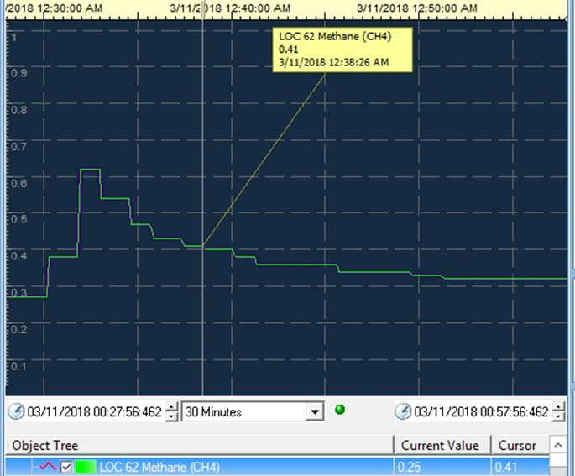

- 9th of November.
An incident occurred in MG104 Development Panel on the 9th of November at approximately 12:55am. The Continuous Miner was producing in B Hdg 22-23ct and was approximately 140m from the last open C/T.
The crew on the continuous miner were conducting bolting activities when an increase in CH4 was noted. At this time the men retreated back to fresh air. The Gas Detector at the continuous miner recorded a peak reading of 3.6% CH4.
The outbye general body gas sensor at the dogleg read a peak of 0.36% CH4.
Prior to recommencing production the CM was checked for gas (no purging required) and the area was mapped for floor heave / cracking and geological structures,

Actions
The controls implemented for this hazard was to minimise the coal floor and conduct targeted gas drainage in the lower part of the GM seam below the Tonstein Band.
Both controls were checked and found to have been implemented.
Following the previous event additional controls were implemented to minimise the impact of any further events.

- All coal in the floor has been mined out to leave only stone in the floor,
- An additional auxiliary fan and vent line was installed to increase the ventilation at the face.
- Additional hand held gas detectors placed at the face to capture gas data.

The area was quarantined and an investigation into the matter was commenced with the following actions completed:
Information gathered from the hand-held monitors on the miner,
Geotechnical inspection of the area completed,
Continuous miner de-gassed,
Preliminary findings indicate the following:
CH4 Background – 0.2% CH4
CH4 Peak at Panel Dogleg – 0.36% CH4

- 23rd of November.
An incident occurred in MG104 Development Panel on the 23rd of November at approximately 3:35pm. The Continuous Miner was producing in 24ct and was approximately 5m into the break off from C Hdg.
A floor heave event occurred releasing CH4 gas into working face in MG104. The Gas release event caused the Continuous Miner to trip power on the GB gas sensor.
Hand held Gas Detector at the continuous miner recorded peak readings of 3.1% CH4 while the second unit presented an off scale reading.
The outbye general body gas sensor at the dogleg read a peak of 0.43% CH4. Ventilation at working face with both aux fans running was 29m3sec

Actions
The area was quarantined and an investigation into the matter was commenced with the following actions completed:
Information gathered from the hand-held monitors on the miner,
Inspection of the area completed,
Continuous miner de-gassed,
Additional UIS Flanking holes are in the process of being drilled to investigate the drilling as a possible control for the gas release events.
- 1st of December
An incident occurred in MG104 Development Panel on the 1st of December at approximately 2:28pm. The Continuous Miner was producing in B Hdg 23-24ct and was approximately 66m from the last open ct.
A floor heave event occurred releasing CH4 gas into working face in MG104. The Gas release event caused the Continuous Miner to trip power on the GB gas sensor.
Hand held Gas Detector at the continuous miner recorded peak readings of 1.1% CH4 while the second unit presented an offscale reading.
The outbye general body gas sensor at the dogleg read a peak of 0.34% CH4. Ventilation at working face with both aux fans running was 29m3sec.

Actions
The area was quarantined and an investigation into the matter was commenced with the following actions completed:
Information gathered from the hand-held monitors on the miner,
Inspection conducted by geotechnical engineer and area mapped,
Continuous miner de-gassed,
Additional UIS Flanking hole in B Hdg has been completed.
The proximity of the drainage hole to B Hdg drilled from 22ct will only be at the designed location from 24ct inbye as per the attached plan.
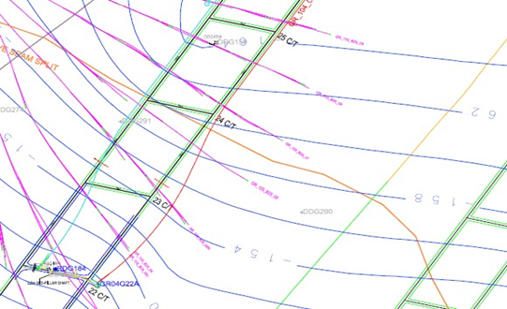

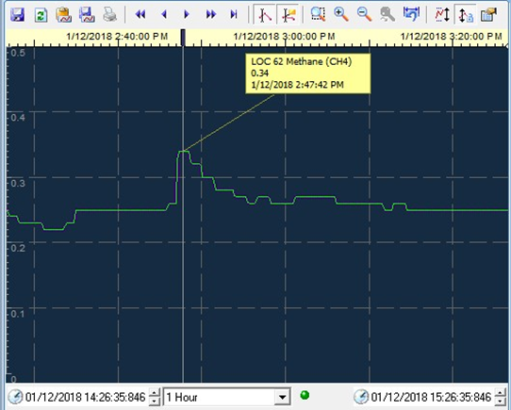

- 30th of January
An incident occurred in MG104 Development Panel on the 30th of January at 5:33pm.
The Continuous Miner was producing in C Hdg 26-27ct with the face at 99m from the last open ct.
A floor heave event occurred releasing CH4 gas into working face in MG104. The Gas release event caused the Continuous Miner to trip power on the GB gas sensor and the development crew withdrew from the area.
Hand held Gas Detector at the continuous miner recorded peak readings of 5% CH4.
The outbye general body gas sensor at the dogleg read a peak of 0.45% CH4.
The internal Methane monitors in the Auxiliary fans recorded peak readings of 2.36% and 2.97% CH4 respectively.
Ventilation at working face with both aux fans running was 30m3sec

Actions
The area has been quarantined with mining operations suspended until the investigation has been completed.
- 17th of February
An incident occurred in MG104 Development Panel on the 17th of February at 12:45pm.
The Continuous Miner was producing in C Hdg 27-28ct with the face at 188m from the last open ct.
A floor heave event occurred releasing CH4 gas into working face in MG104. The Gas release event caused the Continuous Miner to trip power on the GB gas sensor and the development crew withdrew from the area.
Hand held Gas Detector at the continuous miner recorded peak readings of 3.1 and 1.9% CH4.
The outbye general body gas sensor at the dogleg read a peak of 0.43% CH4.
The internal Methane monitors in the Auxiliary fans recorded peak readings of 3.3% and 2.2% CH4 respectively.
Ventilation at working face with both aux fans running was 28m3sec

Actions
The area has been quarantined with mining operations suspended until the investigation has been completed.

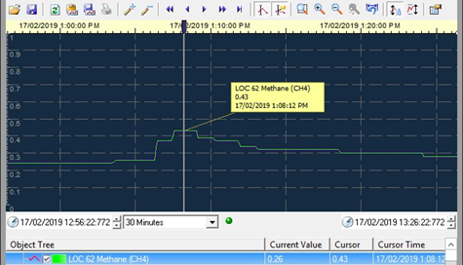

The MG 103 floor heave events were discussed in detail.
I highlighted the incident report dated 1/05/17, this incident report identified "Off Scale" alarms on the 4 gas Altair instrument. The report also identified 1.35% methane present within the fan ducting. The incident report does not contain the level of detail required to fully understand all circumstances and actions taken. The fact the Altair is recorded as off scale should escalate the investigation process and determine if CMW's where exposed to danger being, methane greater than 2.5% in general body.

The incident dated 2/05/17 does not identify the level of gas that tripped the auxiliary fan which was stated by UMM Ivers to be 2.01% methane, again more detail and further investigation required.

There are numerous reports of floor heave through Statutory reports from 3/05/17 and back to 6/03/17 (which was as far back as I checked while on site).

There was a report on the 6/03/17 (report number 12984) of an auxiliary fan trip due to surge of methane.
Another report on 9/04/17 (report number 14091) of an auxiliary fan trip due to surge of methane after floor heave event.

My concerns from these events is there is a lack of follow up investigation into the circumstances. The current phenomenon of floor heave in the gateroads is not fully understood meaning understanding and tracking the mechanism that is initiating the heave and, where is the reservoir of methane that is being released during the floor heave events? The hazard is not currently identified on the Geological Hazard Plans and is not referenced within the Permit to Mine.
A Directive was issued to the SSE in relation to the risk presented by the floor heave events.

1 Floor Heave and uncontrolled Methane release 26/05/2017 To reduce risk by:
1 . Conducting investigations into the floor heave events causing uncontrolled releases of methane contained within MREs dated 3/05/17, 4/05/17. (to be completed by 19/05/17) and:

2. Identify SHMS controls to be developed or reviewed specifically for identifying, managing and controlling the risk of uncontrolled methane releases induced by floor heave. Provide the Inspector with a report of actions taken immediately and proposed actions to address the issue. (to be completed by 26/05/17)

The surface Statutory Notice Board in the Muster area was not up to date, there was an MRE absent, the V.O's monthly report was more than 3 months old and the Safety Bulletins were not the most recent Bulletins issued. Mr Ivers gave an undertaking this would be addressed.
Gas leaking from bolt holes on MG 102 install face has been planned to pressure grout on the faceline, noted in the oncoming Nightshift planning notes.
I requested a copy of the two incident reports raised for the floor heave / gas trip events, I-JMM Ivers committed to making these reports available and would check on availability of the Gas Drainage Engineer.

Prior to leaving site I met with Gas Drainage Engineer, Mr Salani Mudongo. We discussed the 2 most recent floor heave events that occurred in MG 103 on the A/Shift of 1/5/07 and A/Shift 2/5/17. Mr Mudongo explained the lithology of the seams and Interburden in the vicinity of the 103 floor heave events, the cause of the floor heave and the gas reservoir is to be determined

