PLEASE DO NOT REFORMAT THIS FORM
MINES INSPECTORATE  VERSION 11  November 2017 | NOTICE OF CONFIRMATION  TO THE MINES INSPECTORATE OF A COAL MINE  HIGH POTENTIAL INCIDENT, SERIOUS ACCIDENT OR DISEASE
MINE: Grosvenor |  | DATE:21/03/2019
This notice* is made by or on behalf of the SSE primarily** pursuant to section 198(4) or (5) of the CMSHA to confirm the initial oral report to an inspector and an ISHR. It is also used to report prescribed diseases pursuant to section 198(6) of the CMSHA.
NOTE: * Notice required within 48 hours or 24 hours in the case of a fatality: ** Also serves to report “Non-Reportable Incidents”

SECTION 1: INITIAL ORAL REPORT
Made By: Wouter Niehaus | Company Position: UMM |  | Phone: 0427954509
Made To: Les Marlborough | Time: 10:10am | Date:21/03/2019
Made To: Jason Hill | Time: 10:15am | Date:21/03/2019
Made To: | Time: | Date Click here to enter a date.

SECTION 2: SERIOUS ACCIDENT
Is this a SERIOUS ACCIDENT: |  |  |  |  |  |  |  |  |  |  | NO
NOTE 1: |  |  | Act s16: A SERIOUS ACCIDENT is one that causes (a) death or (b) a person to be admitted to hospital as an in-patient for treatment of the injury.  Also by definition it is a HPI
NOTE 2: |  |  | While not included in the definition of SERIOUS ACCIDENT, Act s198(2)(iii) requires immediate notification of an accident “that causes a person to suffer an injury, causing or likely to cause, a permanent injury to a person’s safety or health”. (This is also a HPI as defined by Act s.17)
NOTE 3: |  |  | Schedule 9 of the Regulation defines SERIOUS BODILY INJURY as an “injury endangering, or likely to endanger, life or causing, or likely to cause, a permanent injury to health” of a person.
SECTION 3: PRESCRIBED HPI TYPE BEING REPORTED
SCHEDULE 1C  Act 198(2b) |  |  |  | Choose an item.
SCHEDULE 2  Part 1 Act 200(1) |  |  |  | Choose an item. |  |  |  |  |  |  |  |  |  |  |  |  |  |  |  |  |  |  | Must not interfere with site without inspectorate permission
SCHEDULE 2  Part 2 Act 201(1c) |  |  |  | Choose an item. |  |  |  |  |  |  |  |  |  |  |  |  |  |  |  |  |  |  | Investigation Report to an inspector within 1 month.
NOTE 1: |  |  |  | Some HPI types in Schedule 1C also qualify as types in Schedule 2, Part 1 and/or Part 2. See details on reverse of this form
SECTION 4: NON PRESCRIBED HPI OR NON REPORTABLE INCIDENT NRI
NON PRESCRIBED HPI ☒ |  |  |  |  |  |  |  |  |  |  |  |  |  | Where a “match” cannot be made to the Schedule 1C but the event is a HPI as defined by CMSHA section 17
NON REPORTABLE INCIDENT (NRI ) ☐ |  |  |  |  |  |  |  |  |  |  |  |  |  | Where the incident is significant and has a safety “message” to share with industry
NOTE | Act s17 HPI “an event, or a series of events, that causes or has the potential to cause a significant adverse effect on the safety or health of a person”
SECTION 5: REPORTABLE DISEASE SCHEDULE 1
Chronic obstructive pulmonary disease |  |  |  |  | ☐ | coal workers’ pneumoconiosis |  |  |  | ☐ |  |  | legionellosis |  |  |  | ☐ | silicosis |  |  |  |  |  |  | ☐ |  | Other
NOTE 1 |  | To be reportable, the disease must have been contracted by a current or former coal mine worker who was exposed to dust/agent and has had the diagnosis confirmed by a nominated medical adviser or another doctor
NOTE 2: Tick relevant box above (no further disease information is required on this form)
SECTION 6: DETAILS OF THE EVENT
NOTE Information provided in this section includes the “Primary Information” required by s.198(3) of the Act
CONCISE DESCRIPTION OF THE NATURE OF THE EVENT (put all other information in the “Other information/details” field below)
At approximately 5:04am the shearer had cut out the TG area and was parked at shield #129. While advancing the TG shields stone rilled in from above shield #149 and closed off the face ventilation. The resulting restriction in the face ventilation and the scouring of the goaf resulted in the goaf gasses flushing into the roadway.
As per the attached graphs the CH4 readings in the TG recorded 2.62% CH4 on the inbye sensor and 2.85% on the outbye sensor in the LW TG.
DATE: 21/03/2019 |  |  |  |  |  |  |  | TIME 5:17am |  |  |  |  |  |  |  | LOCATION: LW103 return sensors
EQUIPMENT INVOLVED: LW103 |  |  |  |  |  |  |  |  |  |  |  |  |  |  | DAMAGE: nil
ENVIRONMENTAL CONDITIONS: (x) |  |  |  |  |  |  |  |  | Light: ☐ |  |  | Dark:☐ |  |  |  | Sunny: ☐ |  |  | Wet: ☐ |  |  |  |  |  |  | Dry: ☐ |  |  | Windy: ☐
PERSONS INVOLVED: (x) |  |  |  |  |  |  | Number: 0 |  |  | Employee ☐ |  |  |  |  |  | Contractor ☐ |  |  |  |  |  |  |  | Labour Hire ☐ |  |  |  |  | Visitor ☐
NAME(S) OF DECEASED: |  |  |  |  |  |  |  |  |  |  |  |  |  |  |  | TYPE DEATH |  |  |  | NATURAL☐ |  |  |  |  |  |  |  | ACCIDENT ☐
NAME(S) OF PERSONS INJURED |  |  |  |  |  |  |  |  |  |  |  | INJURIES |  |  |  |  |  |  |  |  | _{EMPLOYER} (contractor where applicable)
NAMES OF ANYONE WHO SAW THE INCIDENT OR WERE  PRESENT AT THE TIME AND IF NO WITNESSES, NAME  OF PERSON FINDING THE INCIDENT |  |  |  |  |  |  |  |  |  |  |  | NAME |  |  |  |  |  |  |  |  | _{EMPLOYER} (contractor where applicable)
 |  |  |  |  |  |  |  |  |  |  |  | Chris Stebbeings (ERZC) |  |  |  |  |  |  |  |  | Anglo Grosvenor

OTHER INFORMATION/DETAIL:
Citect Graphs showing Production and Gas Information leading up to event. Clear indication of the ventilation restriction in the LW return resulting in the increased CH4 levels

Peak at Inbye Sensor 2.62% CH4 at 5:17am
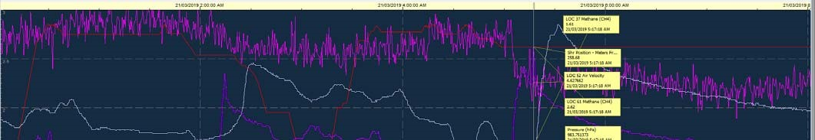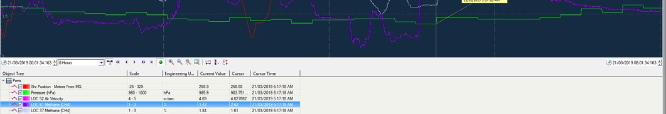

Peak at Outbye Dogleg Sensor 2.85% CH4 at 5:32am
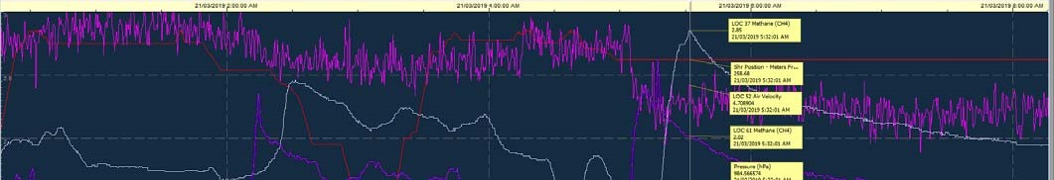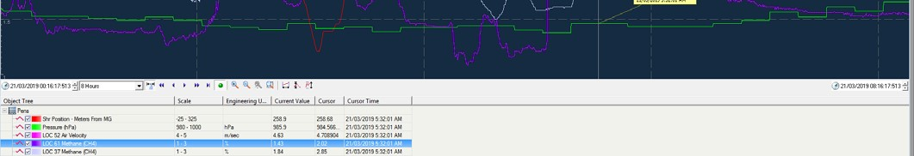

LW103 is currently Retreating past LW102 Install face and as a result encountering a Super Stress Notch
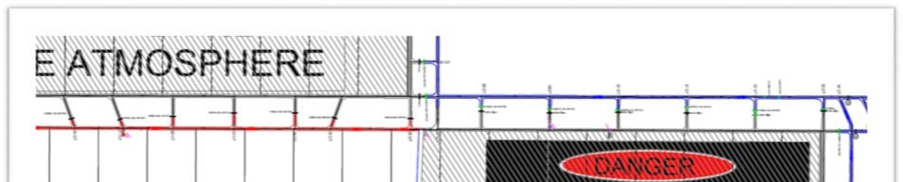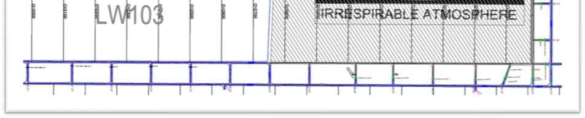

Additional Information:
As per attached CITECT Graphs.

