GROSVENOR INQUIRY SUBMISSION ISSUE 5 (4)

Whether the risk of Spontaneous Combustion posed by the density of the goaf drainage wells was addressed sufficiently if at all?

Andrew Self was asked during Testimony about the need for a risk assessment for Spontaneous Combustion associated with Gas Drainage
TRA.500.021.0046
Q. Would you embark upon production on a longwall, if you were operating a mine, without doing a risk assessment for spontaneous combustion associated with gas drainage - that is, post-drainage?
A. No.
FINDING 1
Grosvenor Management did not address the issue of spontaneous Combustion at all in the Grosvenor Risk Assessment for LW 104 Goaf Drainage.
Grosvenor had deliberately decided that they would not be required to do until the 25th of May 2020.
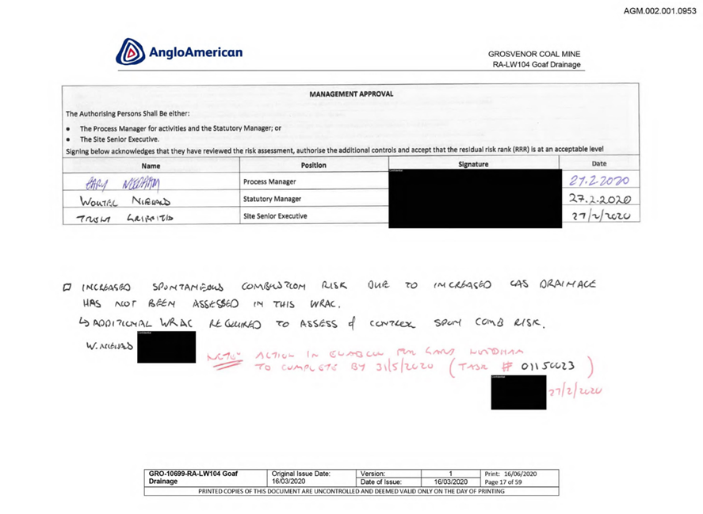

Increased spontaneous combustion risk due to increased gas drainage has not been assessed in this WRAC. (W. Niehaus)
Additional WRAC Required to assess of Control Spon Com Risk (Date redacted)
Note Action in Enablon (xyz xyz xyz?) to Completed by 31/5/2020 (Task # 01150023) (Name Redacted)
Date 27th February 2020

FINDING 2
Grosvenor Management found it an acceptable level of risk to commence LW 104 Longwall Mining without a Risk Assessment for Spontaneous Combustion required till the 25th of May 2020.

FINDING 3
There were also discussions with the DNRME in advance of submitting the Second Workings SOP,
14th Feb 2020
Email above (including attachment) forwarded from UMM to DNRME Inspector of Mines – “We will have a second TG roadway for the first couple of pillars in LW104 and looking for a suitable way to manage this. We have multiple options and just want to run our preferred option past you to see if we have missed anything. (Especially with the new legislation changes)”.

The strategy to manage C heading as part of the Tailgate 104 return was supported by ventsim modelling, detailed in the Second Workings SOP and submitted through to the DNRME. There were also discussions with the DNRME in advance of submitting the Second Workings SOP, particularly given the change in regulation, with no concerns raised.

FINDING 4
Mines Inspectorate find the Second Workings SOP and supporting documentation including the management of the Second TG Roadway and LW 104 Risk Assessment for Gas Drainage achieves an Acceptable level or Risk to the Safety and Health of Mineworkers.
The Reply from the Inspectors just confirming the Receipt of the Second Workings Notices under S320. (The email to the Inspectors quoted the wrong Regulation 230)
UMM emailed DNRME Inspector of Mines notice to Commence Second Workings LW104 under s230, with the following attachments:
Notice to Commence Second Working Letter
LW104 Second Workings Risk Assessment.
LW104 Second Workings Standard Operating Procedure.
Reply from DNRME Inspector of Mines - “Confirming I have received your notice for second workings LW104 pursuant to s320 of the Regulations”.

FINDING 5
Second Workings Notices to the Mines Inspectors are not in Line with Windridge Moura 2 Wardens Inquiry Recommendations.
It is recommended that all mines be required to develop and implement a spontaneous combustion management plan along the lines outlined to provide effective long term control of that risk and which satisfies any requirements of the Chief Inspector of Coal Mines as a condition for continued operation of the mine.

It is recommended, therefore, that it be made a requirement of Part 60 (Second Working Extraction) submissions that spontaneous combustion be specifically included as a factor to be considered and evaluated

FINDING 6
Prior to deliberate decision of Mines Department the requirement to have the APPROVAL of Mines Inspector was changed to giving notice in the CMSHR 2001.
Moura 2 Inquiry
Part 60 of the General Rules for Underground Coal Mines (Second Working Extraction) requires the mine manager to submit to the inspector, for approval, full details of the proposed scheme of work for the extraction of pillars or of secondary workings of bottom coal.

FINDING 7
Increased and Unacceptable Risk to Safety and Health of Underground Coal Mine Workers.

RECOMMENDATION
Overhaul of Section 320 of CMSHR 2001.
Approval Process to be included rather than just Giving Notice

WINDRIDGE MOURA NO 2 INQUIRY EXCERPTS
PANEL DESIGN
Part 60 of the General Rules for Underground Coal Mines (Second Working Extraction) requires the mine manager to submit to the inspector, for approval, full details of the proposed scheme of work for the extraction of pillars or of secondary workings of bottom coal.
The legislation stipulates the submission to include information on a list of factors all of which clearly relate to the safety of the proposed scheme of work. None of these factors, however, refer specifically to or can be construed as being directly related to spontaneous combustion as an issue for consideration in the proposed scheme of work.
The requirements, as set out, were complied with at Moura No 2 in respect of 512 Panel. In addition, the manager, albeit prompted by others, arranged for a risk assessment of the proposed extraction design. The assessment made scant reference to spontaneous combustion and then only with a low level probability that it could arise from the extraction of bottom coal. Moreover, the consequence of an occurrence was rated at the lowest safety level, mentioning short panel life and use of continuous gas monitoring as existing safeguards. Flooding the panel with water was mentioned as a further safeguard if required.

As we now know, the factors considered and taken account of in the design of 512 Panel and its extraction were lamentably inadequate. It is recommended, therefore, that it be made a requirement of Part 60 (Second Working Extraction) submissions that spontaneous combustion be specifically included as a factor to be considered and evaluated.

