GROSVENOR SUBMISSIONS 5 (2)

WHETHER A RELIANCE ON POST DRAINAGE RATHER THAN PREDRAINAGE CONTRIBUTED TO THE DIFFICULTIES IN MANAGING HIGH OXYGEN LEVELS WITHIN THE GOAF
(Difficulties managing methane emissions on the face will be a separate submission)

FINDINGS (8 in all)

- A Methane TARP driven reliance on higher post drainage borehole density leading to movement oxygen and explosion fringe around goaf.

- The oxygen levels at the inbye seals, MG103 41c/t B-C heading seal had around 14% oxygen up to around the 17th of May before then being maintained at around 11% oxygen thereafter.

- Ethylene is detected at MG103/TG104 C hdg 40-41ct and detected and re-run a number of times, by two separate Operators.
Oxygen at nearly 20 % until the 23rd of April (4x recommended), and drops to 7%.
The Sample Results were not saved into the Grosvenor LW104 gas files.

Muller Report 2.3.3

- An increase in carbon monoxide and Graham’s ratio is noted at this location from March to early April.

- An increase in adjusted Young’s ratio is noted at this location during early June prior to the second event.

- On the 31st of March, the carbon monoxide (CO) integration was flawed. This resulted in a substantial under reporting of CO. With proper integration the result increased from approx. 55ppm to 90ppm.

- Between the 17th March and 9th of April, the CO result slowly increased and then decreased, with a peak of approx. 136ppm on the 3rd April.

On both the 3rd and 4th April small ethylene peaks (<1ppm) were visible but not originally integrated. The CO result was approx. 136ppm and 130ppm, respectively.

On the 7th of April, there was a sample run for this location with an ethylene peak. The Graham’s ratio was 0.18 and the CO was 99ppm. Unlike the samples on the 3rd and 4th of April the operator noticed and integrated the ethylene peak.

A separate operator then ran the sample two more times. None of these sample runs appears to have been saved into the LW104 SPW file.
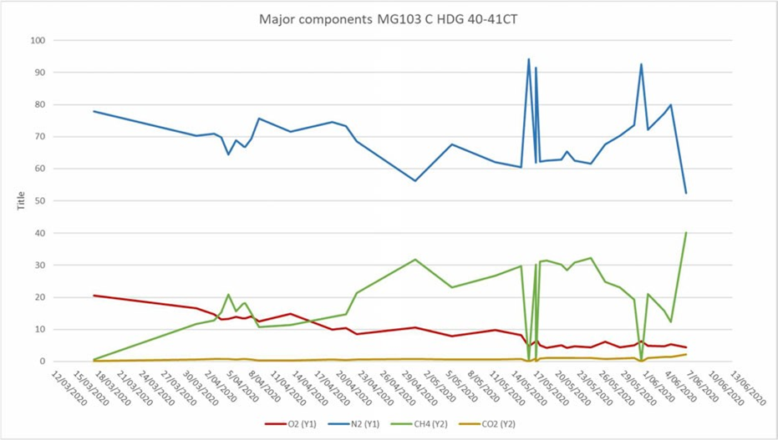

- Ethylene detected MG104 38ct / MG104 38ct seal. Oxygen at nearly 20 % until the 23rd of April (4x recommended), and drops to 7% till 1st June when ventilation changes were made by the VO when it goes up to approximately 12%

Between the 19th of April and the 23rd of April, this location consistently had low-level ethylene peaks present (<1ppm). The operators never integrated it; however, they were very small peaks.
The Graham’s ratio fluctuated slightly between approx. 0.23 and 0.34 with CO between approx. 77-193ppm. The CO/CO2 ratio was above textbook values for normal during this period, peaking at approx. 0.026 and ending at approx. 0.020.

These are indications that the oxidation occurring at this location was not normal.

Between the 22nd and 23rd of April, there were eight samples taken from this location indicating increased monitoring during this period despite the ethylene not being identified.

Figure 17 shows an increase in carbon monoxide in late March/ early April at this location which begins to increase again during late May/ early June.

Figure 18 shows an increase in CO2/CH4 ratio over the duration of the investigation at this location. It should be noted that this location is at the back of the goaf on the main gate side.

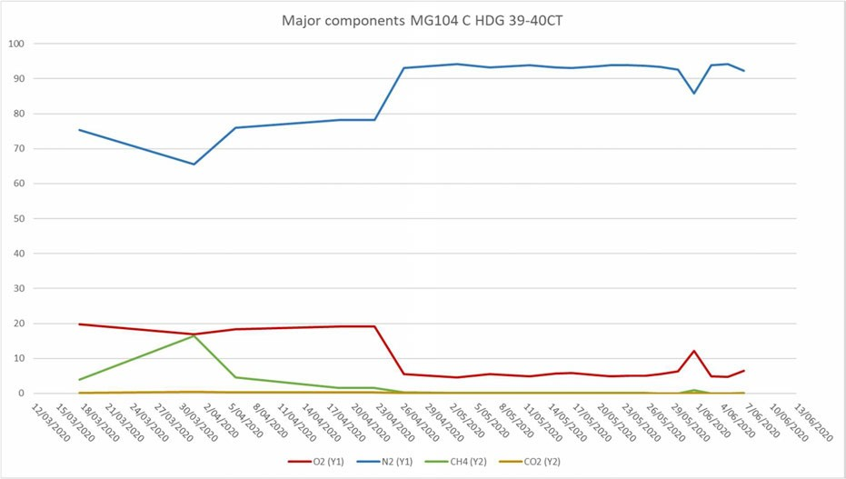

Figure 19 shows an increase in nitrogen from the 26th of April which indicates nitrogen likely from inertisation reporting to this location.
- The Oxygen Levels (20%) are basically fresh air till the around the 23rd of April up to 4 times as high as the 5% maximum recommended by Andrew Self and beyond that level he would not operate them.

Q. We'll come to the TARPs in a moment, but what do you say about a description of a goaf
with a maximum of 8 per cent oxygen as being normal?
A. I wouldn't do it.

THE CHAIRPERSON: Q. Sorry, what did you say?
A. I wouldn't do it.

Q. Wouldn't do what?
A. Run a goaf at up to 8 per cent.

Anything over 5 per cent, I think it's fair to say that most coals will spontaneously combust.
My figure is 5 per cent.
I would like to say 2 per cent, but I don't think we can adequately manage gas at planned production rates and achieve less than 2 per cent oxygen in the goaf.

- Sean Muller identifies that the Oxygen level dropping from the 23rd to 26th of April appear to coincide with an increase in Nitrogen from Inertisation.

- Despite the active Inertisation the Oxygen Level remains at 10% and above until the 6th of May 2020, the date of the face ignition.

This is still at least twice the maximum 5% Mr Self recommends and he would refuse to operate over.

- This use of the goaf drainage boreholes is in combination with the inherent pressure differential problems with the Grosvenor LW 104 as Mr Self identifies during Testimony.

Q. What is this diagram designed to show us?
A. These are not the only goaf wells, as I think most people would know. There are older goaf wells around here, other goaf wells along here, but that's not the point of this discussion.
So the gas fringe, which we've spoken about, which will not be that shape, but the general characteristic is of air entering the goaf at this end, sweeping around here and coming back out the tailgate. So it's just a graphical representation of what the goaf fringe may look like.

Q. We've spoken about spontaneous combustion.
A. Could you go back to that one, please?

Q. I beg your pardon, I'm sorry.
A. I pressed the button twice. What I'm trying to show here is that we've got this back over return thing happening here, which is taking a small quantity of airflow across that triangle piece of goaf there. This is the compromise between spontaneous combustion and gas management.

We want to sweep this gas fringe away from this zone here because there are potential ignition sources.

Andrew Self Gas, Ventilation and Spontaneous Combustion Systems Review Report (1)

Page 38

There is a conflict between the management of high gas make and spontaneous combustion. The requirements of a gas management system in a longwall mine include the following.

- High ventilation airflow quantities
- High ventilation pressures, required to drive the airflow quantity and to bleed gas from the goaf
- High goaf drainage flow rates, likely to encourage air to enter the goaf.
- Operation of the goaf gas fringe as far away from the longwall face into the goaf as possible

Management of spontaneous combustion requirements include the following

- Low ventilation pressures to minimise air Ingress into the goaf and across the pillars
- Maintenance of an inert goaf with minimal oxygen concentration
- Maintenance of the goaf fringe close to the longwall face

Clearly, all of these requirements cannot be met simultaneously.

High capacity goaf drainage systems are required where high gas make exist. The gas drawn from the goaf will be mainly inert, methane and nitrogen. Management of spontaneous combustion requires inert gas to remain in the goaf, including introduced inert gas (inertisation).

Management of these two major hazards represent a compromise, good practice in mining regarding one of the hazards generally represents bad practice concerning the other.

Maintenance of a near inert goaf in the interests of spontaneous combustion risk reduction is practically impossible, particularly where the goaf drainage system extracts high flows of mainly inert gases.

These facts cast doubts on the often held belief that pro-active inertisation and high capacity goaf drainage systems can be used in combination to mitigate the risk of manifestation of either hazard or both.

The task of managing both of these major mining hazards at Grosvenor is onerous. This would require a robust and reliable risk management process which is capable of responding rapidly to changes in the mining environment.

TRA.500.021.0035

