Evidence that a spontaneous combustion heating in the smaller Pillars in TG 104 40 to 41 cut-through and a methane explosion in this location was the first overpressure event on May 6th 2020.

SIMTARS deployed at Grosvenor in June 2019 for an advanced spontaneous combustion event in LW 103.
I note that this occurred after the Longwall had passed the start of the extracted LW 102 block.
And the forcing fan bleeder shaft is in the same relative position LW104.

Ten days after the first shear on LW 104, evidence points to an advanced heating (spontaneous combustion event) at the rear of the longwall Tailgate with the confirmed presence of Ethylene from the 19th of March 2020 on.

Let us accept the well-known fact that the confirmed presence of Ethylene confirms that the heating has reached over 100 Celsius before or about the 19th of March.

Evidence that points to it being a Pillar fire in the smaller Pillars in TG 104 40 to 41 cut-through.

- SIMTARS deployed in June 2019 for an advanced spontaneous combustion event.
TRA.500.019.0004
- Most recently have you been deployed to Moranbah North mine in the last few months, or weeks?
- Yes. I was also, before that, deployed to Grosvenor in June.
Q. June of last year?
A. Yes.
2.The ventilation shaft changed from exhaust to intake before LW first shear.
3. Confirmed presence of Ethylene as early as 19th March ten days after the first shear.
Ethylene proved to have been detected multiple times by Grosvenor Mine from 7th April onwards.
MULLER REPORT MG103/TG104 C hdg 40-41ct
During the processing of the data the following observations where made:
• An increase in carbon monoxide and Graham’s ratio is noted at this location from March to early April.
• An increase in adjusted Young’s ratio is noted at this location during early June prior to the second event.
• On the 31st of March, the carbon monoxide (CO) integration was flawed. This resulted in a substantial under reporting of CO. With proper integration the result increased from approx. 55ppm to 90ppm.
• Between the 17th March and 9th of April, the CO result slowly increased and then decreased, with a peak of approx. 136ppm on the 3rd April.
• On both the 3rd and 4th April small ethylene peaks (<1ppm) were visible but not originally integrated. The CO result was approx. 136ppm and 130ppm, respectively.
• On the 7th of April, there was a sample run for this location with an ethylene peak. The Graham’s ratio was 0.18 and the CO was 99ppm. Unlike the samples on the 3rd and 4th of April the operator noticed and integrated the ethylene peak. A separate operator then ran the sample two more times.
. None of these sample runs appears to have been saved into the LW104 SPW file.
By the evidence of Muller SIMTARS the Mine also appears to have initiated action under the TARPS.
Q. This is back to slide 5. You were talking before about whether or not these hits for ethylene were picked up by the operator. We've only got the ones for 31 March and April with asterisks beside them. Does that indicate whoever was operating the GC or reviewing the data did spot these small amounts of ethylene?
A. Yes, that's right. If it doesn't have an asterisk beside it, it indicates that the operator identified that themselves.
Q. Similarly if we go to the results for the goaf seal at 39-40 cut-through, which is at the back left of the goaf, and the one on the maingate side at 38 cut-through, in particular the latter, we can see that whilst there were some that were missed, there were several that were picked up?
A. Yes, that's right, and you can note with those samples as well, they have relatively high CO even compared to the other samples that I'd shown in the goaf stream on the earlier table, so 147, 193 ppm CO. I'd imagine that was associated with some sort of TARP and they've identified the ethylene to go along with those samples as well. And there's also CO/CO2 ratios that exceed the 0.02, and some of those Graham's ratios are above 0.3, so you can see the higher or the more of those indicators that are present, they all seem to go together.
Q. So does that suggest to you that those detections, say, for 22 April for ethylene were genuine detections?
A. Yes.
4. Location of Ethylene detection in TG 104 (MG103) C heading 40 to 41 C/T.
An increase in carbon monoxide and Graham’s ratio is noted at this location from March to early April.
An increase in adjusted Young’s ratio is noted at this location during early June prior to the second event.
On the 31st of March, the carbon monoxide (CO) integration was flawed. This resulted in a substantial under reporting of CO. MULLER REPORT page 17

5. Grosvenor LW 104 Ventilation Arrangement not used anywhere in world. Grosvenor LW 104 Ventilation Arrangement inherent design flaws.
6. Intake ventilation shaft with forcing fan arrangement at around 700Pa positive pressure.
7. Arguably the highest differential pressure ever put in place at a Queensland Coal Mine in history.
8. Pressure differential many multiples of recommended maximum suggested in Mining literature.
9. Pressure Differential changes of 50% in week prior to May 6th,
10. The smallest pillars in the TG and MG did not have their Factor of Safety calculated and would at an estimate well below the 2 identified for the Face bleeder road pillars.
11. Products of Combustion including Ethylene detected at TG 3 to 4 cut through but never on the 400m TG monitoring point.
12. Loss of grossly substandard segregation VCD’s in the Tailgate that induced goaf gas flows down C heading in the Tailgate.
1st May. LFI Investigation Report for gas exceedances on 6th and 7th April 2020 finalized and signed.
One of the key findings was that the VCDs within the cut-throughs were considered damaged (not able to inspect them as they are in goaf area). These VCDs were allowing the ventilation to pass through the goaf and allow gasses to bleed out into C Hdg Roadway.

- Continued presence of between 10% and 14% for 2 months of Oxygen at the back Tailgate of the block even with continuous Nitrogen injections.

- Oxygen Concentrations vary by up to 2% due to daily barometric fluctuation.

- Extreme barometric fluctuations in April and May including a “KING” barometer on May 5 to May 6.

- The Tailgate and Maingate Chain Pillar “roadways” hanging up to a much greater extent than previous LW blocks creating in effect clear goaf ventilation paths for high Oxygen levels. Witnesses “as far as you could see” ADAM MAGGS ERZC

- Effects of Ventilation System Changes on First May on goaf well gas readings.

- Apparent Ventilation System changes in early to mid-April for the MG Compartment – Pre-driven Recovery Road 13.
(Muller Report)

- Post first event the readings at the TG 3 to 4 C/T are higher than the 400m monitoring point.

- Apparent direction of wind blast from first overpressure event at the LW 104 face.

- Suck back not apparent on the Longwall Face; and a ventilation dead spot on the Longwall face for the 13 to 15 seconds until the LW 104 Methane Ignition and Explosion/ Deflagration on the face.

- TG 104 (MG103) C heading 40 to 41 C/T
An increase in adjusted Young’s ratio is noted at this location during early June prior to the second event.
Andrew Self

Going back, early stages of my career, if we identified ethylene, we knew we had a major problem and we moved quickly.

It was absolutely acknowledged that if ethylene was detected at all, then we had a serious problem.

However, ethylene does not come off at low temperatures. You don't get ethylene, generally speaking, at much less than 100 degrees Centigrade. I said earlier on that at 100 degrees Centigrade, I think it's all over, we've lost this battle, so we're really into damage control.

If a gas monitoring point, whether it be a bag sample or a person or whatever, picks up ethylene at 1 ppm, then the ethylene at the source is more than 1, because almost every sample that's taken has been diluted to some extent.

Q. What if, for example, you were detecting very small amounts of ethylene at 3-4 cut-through - so I'm talking about less than 1 ppm?
A. Yes.

Q. That's about 4 kilometres from the face.
A. Yes.

Q. In, what, 70 metres per second of air. What would it tell you if you got, let's say, 1 ppm at 3-4 cut-through about what's going on in the goaf itself?
A. Something very serious, because the dilution rate would have to be at least 70 to 1.

SELF GROSVENOR LW 104 VENTILATION ARRANGEMENT

Q. Again, we don't need to go to it unless you want to - we can if you need to. In that section to which that conclusion relates, you had discussed the issue with shaft 9?
A. Yes.
Q. And the ventilation set-up for that?
TRA.500.021.0079
A. Yes.
Q. And also the C heading roadway?
A. Yes.
Q. In essence, what you've shown the Board with Mr Hunter's questioning today are some issues that you have associated with that ventilation set-up?
A. Ways I would do it differently, yes.

SELF VENT CHANGE COMMENT

This is why I say that a ventilation change when there's a spontaneous combustion event happening is a very serious thing, almost to the point where if you asked me to make a ventilation change, I'll plan it, I'll analyse it, and then I won't do it, because the risk of making that change can be significantly higher than the risk of not making that change.

2nd WORKINGS PROCEDURES
A cross block roadway at the outbye end of the section has two chute roads driven perpendicular to the retreating face to provide access points for the recovery of the face upon reaching the take-off chainage mark.

LW 103 CHANGE, LW INTAKE SHAFT TO BLEEDER SHAFT
The change over to a return bleeder system (at the suggestion of Inspector Brennan) occurred in early July 2019.

There continued to be methane HPI’s* for the remainder of LW 103 block.
(* The HPI’s are attached)

The mechanisms were attributed to.
1. Floor Blowers.
2. Roof falls in the Tailgate of the face restricting ventilation and pulling methane out of the goaf.
3. Position of shearer in the tailgate end of face

PREVIOUS DEPLOYMENT SIMTARS to GROSVENOR LW 103

SIMTARS deployed at Grosvenor in June 2019 for an advanced spontaneous combustion event in LW 103.
I note that this occurred.

- After the Longwall had passed the start of the extracted LW 102 block.
- The forcing fan bleeder shaft intake, is in the same relative position LW104 face and Intake Shaft #9.

I am informed that Ethylene was detected in TG boreholes in this event.

I am also informed that during the first 400 metres of retreat in LW 103, Carbon Monoxide in the 100’s of parts per million were detected in line with LW 104.

GROSVENOR SPONTANEOUS COMBUSTION TARPS NEVER TRIGGERED
LFI 8th JUNE
6.5 Spontaneous Combustion
Leading into the event on the 6th May 2020, no Spontaneous Combustion TARP was active and no additional actions beyond normal operating procedure were required.
The below data was reviewed for the week prior and days post event as part of the re-entry risk assessment:
Goaf Stream CO
Tailgate Roadway CO make
Tube bundle CO levels from goaf seals around LW perimeter
CO levels from goaf well
No TARP triggers or of-concern trending was identified from Carbon Monoxide levels analysed. See Figures 9-12 below for CO trends prior to and post ignition.
The investigation team considers at this time that spontaneous combustion was not an issue prior to the event and is unlikely to be a contributing factor to the ignition.

The Methane HPI dated 31st May 2019 shows the position of the face at that date.

- THE OUTBYE SENSOR PEAKED AT 5.49%
- THE INBYE SENSOR PEAKED AT 4.46%

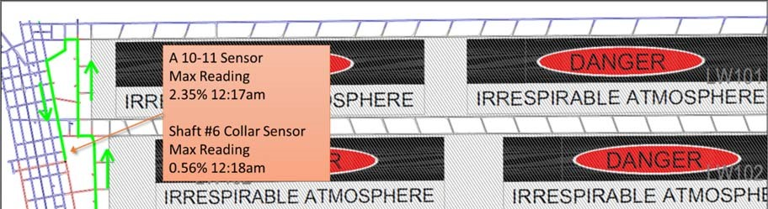
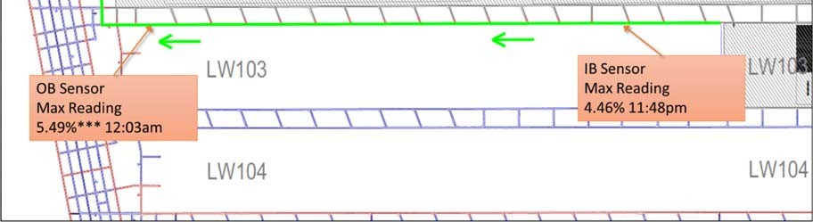

10b A ventilation failure causing a dangerous accumulation of methane or other gas that endangers the safety and health of a person.

OTHER INFORMATION/DETAIL:

• IMT formed and action plan generated to re-establish airway
• WRAC completed before using shearer to cut away fall material to open up airway, to dilute TG gas levels
• Once air-way re-established, changed out real time sensors and consolidating the TG block corner with PUR
• Ventilation was restored at 7:20pm 2/06/19 and all sensors were replaced and return to normal functions.

HPI 12th June 2019.
Reported panel ventilation reduced 8m3/s from prior day shift readings. The goaf had flushed in to rear of 149 roof support and across to the adjacent rib.
The barometer prior to the event was trending down and reached 991hPa at 2:45pm, the minimum for the 12-hour period. Production recommenced as the barometer was beginning to rise.

Face conditions were not affected by cavities or strata deformation at the time of the event.

HPI 24th April 2019
OTHER INFORMATION/DETAIL:
Despite further shearer speed reduction to 10m/min in both directions that were made after the 2 x exceedances on the 21/4/19, there has been 2 x further exceedances both when the shearer was cutting MG to TG through the cavity area around 119 to 127 roof support.
After the exceedance on the 23/04/19, production was stopped until detailed analysis was undertaken to assess the event including 12 hour and 4 hour trending of barometric pressure, shearer speed, shearer position, TG drive methane monitor, shearer methane monitor, MG drive methane monitor, inbye TG methane monitor, outbye (B3‐B4 TG103) methane monitor, roof support movements, roof support leg pressure and goaf drainage system.
In particular, understanding what is the “limit” the inbye methane monitor can be to reduce the risk of a further gas exceedance in the TG roadway induced when the shearer moves through the cavity area.
Face conditions were good other than the area from around 115 to 120 and 134 to 140 roof support where the cavity was being managed. No additional floor heave observable in the tailgate roadway and no evidence of any “methane blowers” out of the floor along the face or TG roadway area.
Incident Management Team (IMT) activated as per the General Body TARP with key stakeholders to review current controls and propose additional controls prior to recommencing production. Production was stopped until the inbye methane monitor decreased to 1.70% to allow shearer to safely cut out the TG and close the face up around the cavity.
Production profile then amended to Uni Di to help manage gas emissions when cutting MG to TG through the cavity area. Prior to this event 9 shears had been successfully completed through the cavity area with no abnormal strata deterioration from the Uni Di cut process.

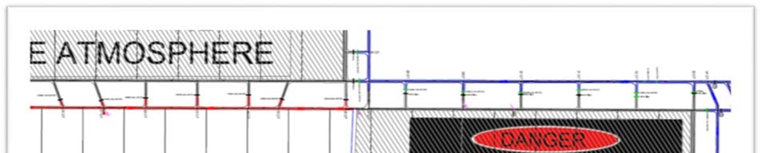
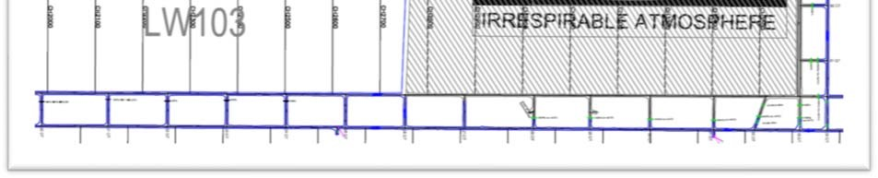

MULLER REPORT EXTRACTS

It is evident from the gas well data that up to three separate heating events were present in the goaf of Longwall 104 between the 9th of March and the 6th of May. .

• An increase in oxidation is detected in late March peaking on the 27th of March as evident from data from GRO4L001, GRO4V002A and GRO4V003.
• An increase in oxidation is detected in mid-April, peaking on the 17th to the 19th of April as evident from the data from wells GRO4V006.5 and GRO4V007. Wells GRO4V005, GRO4V005.5, GRO4V006.5 and GRO4V007 were shut-in or reduced flow around this time, either temporarily or permanently.
• An increase in oxidation is detected in early May as evident from the data on wells GRO4V007, GRO4V008, GRO4V008.5 and GRO4V009 particularly in CO and methane free CO trends.

This same heating potentially existed at a similar intensity before the ignition on May 6th as indicated by the relative seam gas adjusted CO/CO2 ratio from the tailgate GC bag samples taken between the 4th of May and the 14th of May. The absolute values for these ratios are likely to be underestimated due to dilution by seam gas and excess nitrogen in the tailgate. The relative values indicate a step change prior to the event which persist after the event.
The CO make indicates that the size of this heating was relatively small on the basis that the absolute CO make value was around 30l/min during May and no obvious sustained increase in carbon monoxide generation was observed until early June.

CO/CO2 ratio and Graham’s ratio has been trended from 3-4 CT Tailgate GC bag samples as a way of comparing relative intensity to the goafstream samples during the periods where goafstream samples were not taken, and also prior to the event. These trends indicate a step change in heating intensity from May 5th which is sustained throughout May. See Figure 77 and Figure 79.

An analysis of the reprocessed goaf stream data indicates that a heating of serious intensity was present post ignition during May. This is evident from the reasonably consistent and Graham’s ratio values between 0.6 and 1.

This same heating potentially existed at a similar intensity before the ignition on May 6th as indicated by the relative seam gas adjusted CO/CO2 ratio from the tailgate GC bag samples taken between the 4th of May and the 14th of May. The absolute values for these ratios are likely to be underestimated due to dilution by seam gas and excess nitrogen in the tailgate.
The relative values indicate a step change prior to the event which persist after the event.

The CO make indicates that the size of this heating was relatively small on the basis that the absolute CO make value was around 30l/min during May and no obvious sustained increase in carbon monoxide generation was observed until early June.

CO/CO2 ratio and Graham’s ratio has been trended from 3-4 CT Tailgate GC bag samples as a way of comparing relative intensity to the goafstream samples during the periods where goafstream samples were not taken, and also prior to the event. These trends indicate a step change in heating intensity from May 5th which is sustained throughout May. See Figure 77 and Figure 79.

.21 Conclusions from gas well data
• Increased oxidation activity is noted around late March as observed from gas wells GRO4V002A, GRO4L002, GRO4V003, GRO4V004 and GRO4V004.5.
• Increased oxidation activity is noted around mid-April as observed in data from GRO4V003, GRO4V004.5, GRO4V005.5, GRO4V006.5 and GRO4V007.
• Increased oxidation activity is noted around early May as evident from wells GRO4V006.5, GRO4V007, GRO4V008, GRO4V008.5 and GRO4V009.
• Low-level oxygen is not reliable on the sensors used for the real time skids.

01/05/2020 Vent change for the LW104 Pre-Driven Recovery Road. Changes included:
MG 103 1 c/t Dogleg changed from 38.6 to 40.5m3/s
104 X Drive Chute Road 2 changed from 28.5 to 35.6m3/s
Model shows 6m3/s drop to LW Return
2ND CHANGE TO GOAF FLOWS ON SAME DAY DUE TO

01/05/2020 17:00 Gas Drainage Authority (GDA) signed on 1 st May 2020 by Ventilation Officer and Gas Drainage Coordinator, permitting GR04VOOIO to be opened, suction applied and monitor for signs of flow.

THE CHANGE IN VENTILATION HAS AN IMMEDIATE AFFECT ON VENTILATION ON GOAF

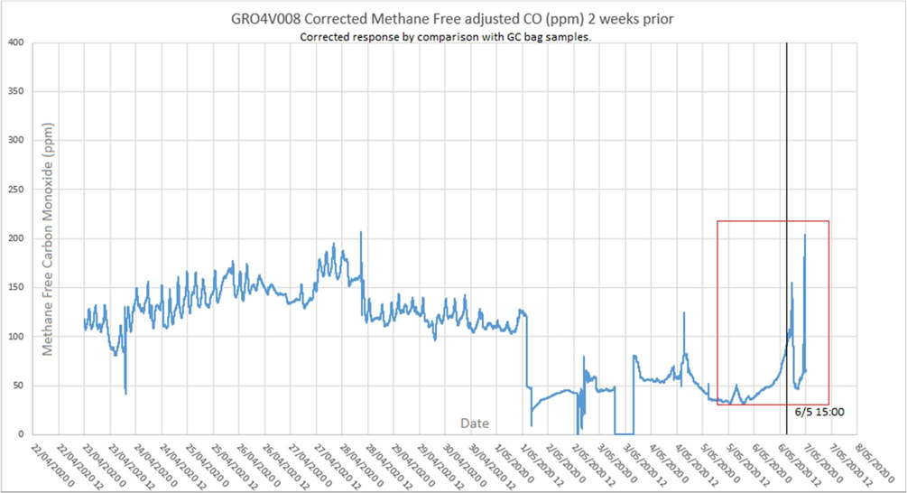

30/04/2020 09:47 Production A Crew Electrician lost Personal Proximity Device (PPD) on longwall (approximately roof support #102).

OVER THE NEXT 24 HOURS THIS CHANGE IS EVIDENT FOR METHANE MIGRATION TO THE FACE FROM THE GOAF

02/05/2020 14:30 Gas 'MT formed following continual stoppages and delays from periods of elevated methane in the tailgate. 24 minutes slow down and 303 minutes of stoppages last 24 hours. 6 new actions raised.
FIVE AND A HALF HOURS LOST.
6 NEW ACTIONS ON TOP OF THE PREVIOUS NINE AND WHAT WAS IN ACTION PLAN?

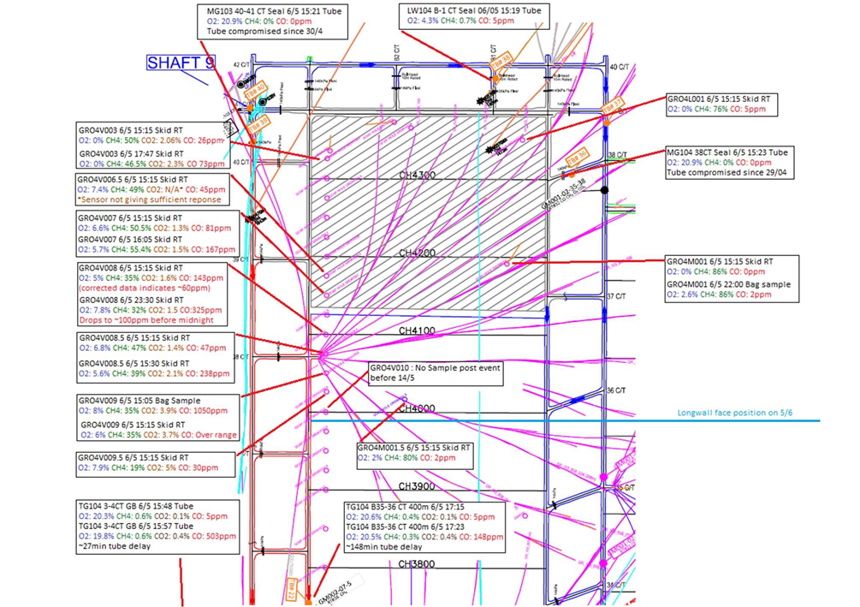

SAMPLE POINT | PRE-EXPLOSION | POST EXPLOSION | DIFFERENCE
MG 103 40-41 CT | TUBE COMPROMISED 30th APRIL. NO READINGS
GRO4V003 | 26 | 73 | 46
GRO4V006.5 | 45 | No reading | Unknown
GRO4V007 | 81 | 167 | 86
GRO4V008 | 60 | 325 | 245
GRO4V008.5 | 47 | 238 | 191
GRO4V009 | 1050 | Off Scale | Unknown
GRO4V009.5 | 30 | No reading | Unknown
TG104 3-4CT | 5 | 503 | 498
TG 400m outbye | Figures not stated Lower than TG104 3-4 CT

• GRO4V009.5 CO2 increases to over 5% (over range) minutes after the explosion, CO only increases to a maximum of 30ppm. This atmosphere indicates efficient combustion from methane burning.

• GRO4V009 CO increases from 80ppm to 1000ppm shortly after the ignition. This is indicated by the analyser recording over range and confirmed by a bag sample. Ethylene/ acetylene and Hydrogen is part of this sample. The relatively high CO concentration indicates a higher proportion of inefficient combustion from coal potentially in an oxygen diluted and or depleted atmosphere. CO2 also increases from 1.4% to 3.7%. This indicates that this location contains a mix of product of efficient combustion (methane combustion) as seen at location GRO4V009.5 and relatively inefficient combustion of coal or coal dust.

• Post event CO increase is also noted at GRO4V008.5, GRO4V008, GRO4V007, GRO4V006.5 and GRO4V003 indicating that combustion/ oxidation product or reporting to these locations.

RSH.032.002.0016
• A spike of increased CO and CO2 is measured in the tailgate RT and tube post event. After this spike recedes, the CO in the tailgate appears to be slightly higher than pre ignition.

• The post blast spike of carbon monoxide at TG104 3-4CT tube is higher than that measured at the TG 400m outbye tube.

• The post blast CO2 spike at the TG400m outbye tube is slightly higher at its peak than the TG104 3-4 CT tube.

• The CO level detected in the goaf wells peaks at GRO4V009 and decreases the as the distance from the face increases. This indicates that the explosion was located towards the face region.

