**KEY ISSUE 5 (5) ADEQUACY of ANGLO GROSVENOR LW104 SPONTANEOUS COMBUSTION TARPS**

**RECOMMENDATIONS**

1. **CONFIRMED PRESENCE of ETHYLENE MUST be a STAND-ALONE TRIGGER in UPPER Two Levels of SPONTANEOUS COMBUSTION TARPS.**
2. **CONFIRMED PRESENCE of ETHYLENE NOT to be included in Normal and Lower Tarp levels**
3. **LEVEL BELOW EVACUATION only to INCLUDE CONFIRMED PRESENCE of ETHYLENE to ALLOW ERECTION of EMERGENCY PREP SEALS UNDERGROUND or REMOTE SEALING FROM SURFACE if ALL OTHER TRIGGERS are not in LEVEL 3, and it is SAFE for COAL MINE WORKERS to do so as part of an ORDERLY and PRE-PLANNED PROCESS.**
4. **ANY GAS TRIGGER included in NORMAL MUST be included in ALL HIGHER-LEVEL TARPS including EVACUATION.**
5. **“AND” MUST NOT BE USED with UNRELATED GAS TRIGGERS.**
6. **SPONTANEOUS COMBUSTION TARPS MUST NOT BE ALTERED UPWARD while MINE concerned has been or is in anything except NORMAL in that PANEL; whether Longwall, Development or Board and Pillar.**
7. **ANY INCREASE in SPONTANEOUS COMBUSTION TARP LEVELS to be NOTIFIED as soon as possible in WRITING by the SITE SENIOR EXECUTIVE to the OPERATOR and HOLDER and their Appointed OFFICERS/OFFICE HOLDERS.**

**FINDINGS**

1. **THE GROSVENOR INQUIRY DECIDING NOT TO MAKE THE LW 104 SPONTANEOUS COMBUSTION PUBLIC HAS MADE IT DIFFICULT TO MAKE INFORMED PUBLIC SUBMISSIONS**

***Could you please provide me with the Actual TARPS in 104?***

***I want to compare it to older TARPs such as North Goonyella***

***GRO-6953-TARP Active Goaf Spontaneous Combustion***

***Dear Stuart***

***This document has not been made available to the public by the Board at this stage.***

***Whether or not it will be made available will be decided at the appropriate time.***

1. **THE GROSVENOR LW104 SPONTANEOUS COMBUSTION TARPS WERE NOT ADEQUATE.**
2. **BETWEEN LW 101 and LW 104 GROSVENOR MANAGEMENT DECIDED to DROP GOAFSTREAM GAS RESULTS FROM ALL SPONTANEOUS COMBUSTION TARPS.**



1. **GOAF STRAM TARPS part of February 2020 D. Brady RECOMMENDED TARPS for LW 104.**
2. **No triggers contemplated for Goaf Stream Spontaneous Combustion indicators**

**Anglo Grosvenor LFI IN.00226742 & IN.00228255 8th June Withdrawal from Mine and Ignition of Gas**

**LW104**

1. **GROSVENOR MANAGEMENT CREATED LW 104 SPONTANEOUS COMBUSTION TARPS with MAJOR CHANGES to those RECOMMENDED by CONSULTANT Mr. D. Brady**
2. **Introduced a Longwall Return EVACUATION TARP of 3ppm ETHYLENE a 300% INCREASE on RECOMMENDED**

**RECOMMENDED ETHYLENE EVACUATION LEVEL 1ppm ETHYLENE in Brady TG Goaf Strean and Goaf Seals.**

1. **ETHYLENE is NOT a STAND ALONE TARP in LEVEL 2 and LEVEL 3 EVACUATION**

**The LEVEL 2 ETHYLENE TARP greater than 1 less than 3 TARP has “AND” between 42 and 53 l/min CO Make.**

**LEVEL 3 Evacuation ETHYLENE TARP has “AND” CO Make greater than 53 l/min**

1. **CO/CO2 Ratio in NORMAL and LEVEL 1 but not in LEVEL 2 and LEVEL 3 EVACUATION TARPS**
2. **LEVEL 3 EVACUATION TARP INTRODUCES “AND” linking CO/CO2 Ratio and Graham’s Ratio. At all other levels there is “OR” not “AND”**
3. **GROSVENOR MANAGEMENT CHANGED ACTIVE GOAF SEAL TARPS**
4. **Introduced an ACTIVE GOAF SEAL EVACUATION TARP of 3ppm ETHYLENE a 300% INCREASE on RECOMMENDED**

**RECOMMENDED ETHYLENE EVACUATION LEVEL 1ppm ETHYLENE in Brady TG Goaf Strean and Goaf Seals.**

1. **LINKS ETHYLENE and CO ppm with “AND” in EVACUATION TARP for first time in TARP**
2. **LINKS GRAHAM’S RATIO and CO ppm with “AND” ” in EVACUATION TARP for first time in TARP**
3. **SMOKE COMING FROM GOAF NOT CARRIED OVER TO GROSVENOR TARPS from D. BRADY RECOMMENDED TARPS**
4. **WITHDRAWAL TRIGGERS NOT CONSERVATIVE ENOUGH**

**LFI IN.00226742 & IN.00228255 8th June Withdrawal from Mine and Ignition of Gas**

**LW104**

1. **ETHYLENE (<1) USED IN LEVEL 1, 2 and (> 1) 3 with “AND” PROVISIONS to ENACT TARP including EVACUATION is NOT ADEQUATE or APPROPRIATE.**

**“AND” PROVISIONS are INAPPROPRIATE and SHOULD NOT BE USED.**

**EVIDENCE ANDREW SELF TESTIMONY**





1. **NO EVIDENCE THAT GROSVENOR MANAGEMENT CHANGED TARPS AFTER DETAILED SCIENTIFIC JUSTIFICATION**

**LFI IN.00226742 & IN.00228255 8th June Withdrawal from Mine and Ignition of Gas**

**LW104**

***Report details an assessment of the applicable Grosvenor gas monitoring data provided (tube bundle and gas chromatograph covering all three longwalls to date) and available gas evolution testing results to support the ongoing use of existing trigger levels where appropriate or make recommendations to change to more appropriate triggers based on detailed scientific justification.”***

1. **The CONFIRMED PRESENCE of ETHYLENE is BAD, VERY, VERY BAD. NOT APPROPRIATE FOR it TO BE IN LEVEL 1 TARPS.**

**ANDREW SELF EVIDENCE**

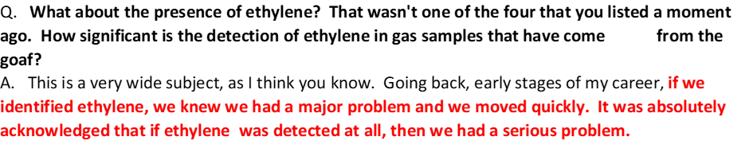

**SELF TRANSCRIPT**

**TRA.500.021.0049**



***MR HUNTER: Q. What we have here you understand to be the TARPs for spontaneous combustion in the active goaf –***

***A. Yes.***

***Q. -- for the longwall return and active goal seal zone?***

***A. Yes.***

***TRA.500.021.0062***

***Q. Can I ask you, firstly - you'll see in a number of places the TARP triggers involved the use of what I'll call "and" statements.***

***A. Yes.***

***Q. What's your attitude to the use of "and" statements in a TARP?***

***A. I don't favour it. I made the comment earlier that some indicators will show adverse signs when others don't.*** ***If we go to the evacuation TARP, which is obviously the most important one, "Ethylene equal or greater than 3 ppm and CO Make equal or greater than 53 litres per second".***

***So if CO make is not over 53, then the ethylene can be any value you wish. I think TARP values have to be stand-alone.***

***Q. Is it a particular issue when you've got a level 3 trigger, because to get to that point you've already identified that you're at level 2, and so you know there's a problem?***

***A. I've seen situations where there have been four indications, all with an "and", and three out of the four are showing evacuation and number four doesn't, and so we don't evacuate.***

***Q. Is there an issue with respect to where the measurements are taken, for example, the longwall return?***

***A. Absolutely.***

***Q. We know it's a long distance from the face.***

***A. Yes.***

***Q. Is a better place to identify the products of spontaneous combustion the goaf stream?***

***A. I think it is a better place, in that it's undiluted or relatively undiluted, but that would not stop me monitoring at the 3-4 cut-through point.***

***Q. I wasn't suggesting that, but there doesn't appear to have been a TARP with respect to the goaf stream?***

***A. I understand that.***

***Q. In your view, should there have been?***

***A. I would have one.***

***Q. Why?***

***A. There's no point monitoring if you don't have a TARP, because the TARP triggers a response to the gas monitoring data, so if you don't have a TARP, there's no mechanism to make you respond.***

***Q. Tell me if you're not able to answer this, but if you look at the "Normal" TARP for the longwall return and you can see that the specified normal condition is "CO/CO2 less than 0.2" --***

***A. One thing I will say is I don't understand why CO/CO2 was used at normal and level 1 and then didn't appear at levels 2 and 3, but that's just my - I don't understand why if it was valid at normal and level 1, then it wasn't valid later.***

***CO/CO2 ratio - I looked at the gas evolution curves, and we have to bear in mind that CO2 is a seamgas, so there will be amounts of CO2 which are definitely not caused by spontaneous combustion, and we can't differentiate.***

***But the evolution curve is actually at source, so every monitoring point that we have is almost certainly diluted. CO/CO2 ratio, in the evolution curves I looked at, was about 100 degrees Centigrade.***

**LFI JUNE 8**

***Preliminary Report ‘Spontaneous Combustion TARP Trigger Review’ issued to Grosvenor Ventilation and Gas team. Report had been commissioned by Grosvenor and prepared by Darren Brady of Serinus Pty Ltd.***

***“Report details an assessment of the applicable Grosvenor gas monitoring data provided (tube bundle and gas chromatograph covering all three longwalls to date) and available gas evolution testing results to support the ongoing use of existing trigger levels where appropriate or make recommendations to change to more appropriate triggers based on detailed scientific justification.”***

***No triggers contemplated for Goaf Stream Spontaneous Combustion indicators***

***Withdrawal triggers not conservative enough***

***3. TARPs***

***GRO-6953-TARP Active Goaf Spontaneous Combustion does not contemplate response levels for monitoring at the goaf stream or localized heating indicators. For example, there was no response level required when the #96 shield Graham’s ratio exceeded 0.5 on the 21st May 2020 or for the goaf stream once the Graham’s ratio exceeded 0.5 on 25th May 2020.***

***It cannot be concluded that use of an IMT at this time would have led to a different response, as other Spontaneous Combustion indicators, such as CO make in the longwall return, had not escalated. However, it may have created a heightened sense of awareness and potentially better preparation of tube bundle monitoring points and emergency preparation seals in the event this did escalate.***

***Even if the recommendations from the report provided by Darren Brady in January 2020 had been implemented prior to the incident, it is important to note that while a goaf stream trigger would have been in place, it would not have escalated to Level 2 any sooner than 2nd June 2020 when the IMT at Grosvenor was first convened. The report recommended a Trigger 2 value for Graham’s ratio between 0.6 and 1.2 for the goaf stream, which would have first been triggered on 3rd June 2020. However, the recommendations from the report would have triggered a withdrawal of the mine on 6th June 2020.***

***The SSE at Grosvenor made an executive decision to proactively withdraw non-essential personnel from the mine on 6th June night shift despite Level 3 TARP not being reached. While this is to be commended, having a clear and conservative level of withdrawal would in future provide greater assurance that this decision would be repeated and not reliant on individual judgement.***

***It is further noted that with respect to the Spontaneous Combustion TARPs, that there is limited prescription of minimum actions and considerations to be taken in response to an event by the IMT. While it is important that the IMT have the ability to manage each event based on the dataset available and specific environmental conditions, a series of actions and considerations would aid in prompting the team to undertake that are most likely to control the event.***

***The decisions made by the IMT to mobilise additional inertisation units from external sources was somewhat delayed. It is recommended that the Spontaneous Combustion TARP could include a trigger at Level 1 to check for resourcing availability and Level 2 to mobilise to site immediately, well before any further escalation***

***7. The daily gas data review emails, received by a third party, were sent to a large distribution list which included Control Room Operators, Undermanager’s, UMM, Ventilation and Gas Team etc. During the investigation, it was evident that many on the distribution list were assuming the review and action of the emails was the accountability of someone else. Furthermore, there were several emails where data was highlighted in red, however there was no clear consensus on how this was then interpreted or acted upon. It is recommended that given the content of these emails, they added as an agenda item to the fortnightly Ventilation and Gas meeting, and in the event of an IMT situation, these be included in the daily meeting review.***

***Amend fortnightly Ventilation and Gas Meeting agenda to include review of third party analysis of gas and ventilation data***

***Conduct full review of all Spontaneous Combustion TARPs with consideration for:***

***• Darren Brady report (Jan 2020), including goaf stream triggers, retreat rate trigger, evacuation triggers***

***• Data analysis from 2020 Grosvenor SC event***

***• Any opportunity to include investigation triggers for SC indicators detected at a localised source not specifically defined by the TARP***

***• Seal pressure differential triggers in the active goaf TARP to aid in managing pressure differential impacted oxygen ingress paths.***

***The TARP should also capture the following opportunities for improvement:***

***• A series of actions and considerations that would aid in prompting the IMT to undertake that are most likely to control the event.***

***• Action prompting the ERZ Controller to immediately demarcate sampling locations determined by the IMT***

***• Action to ensure the same environmental monitoring device (i.e. Flir) is to be used across shifts***

***• Level 1 to check for inertisation and emergency sealing resourcing availability and Level 2 to mobilise to site immediately, well before any further escalation.***

***• Action to ensure preparation seals are available in each entrance to the district, including supply of all necessary materials such that these can be erected at short notice***

***Investigate system/process whereby the Undermanager must record all TARP levels reported and sign a record of any decisions made around the increase or decrease of TARP level***

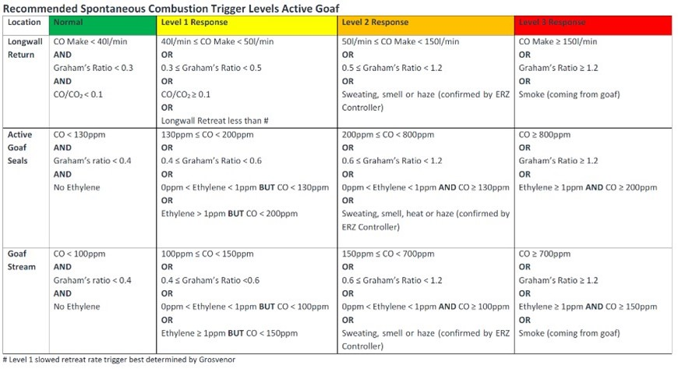

***Coal Mine Safety and Health Regulation 2017 reprinted removing ‘abandoned workings’ from s345 requirements. Note - Grosvenor had originally planned to class and treat C Heading roadway as abandoned workings.***