INCIDENT
INVESTIGATION
REPORT
GROSVENOR MINE
Coal (Australia & Canada)

Incident Number: 162084
Classification: HPH
Incident Title: Intersection of GM016B – Expected grouted borehole
Incident Date: 23 February 2017
Report Date: 8 March 2017

Incident Investigation Report Template 1 Overview / Executive Summary Error! Bookmark not defined.
2 Investigation Team 3
3 Persons Interviewed 4
4 What documents were examined 5
4.1 SHECMS documents (relevant parts) 5
4.2 Photographs 5
4.3 Statements 5
5 Facts 5
6 Review of previous similar incidents 6
7 Review of Critical Controls 7
8 Timeline of Incident 7
9 Direct Cause 8
10 Contributing Factors 8
10.1 Absent or Failed Defenses 8
10.2 Individual and Team Actions 8
10.3 Task and Environmental Conditions 8
10.4 Organisation Factors 8
11 Root / Basic Cause 9
12 Causal Analysis Chart 9
13 Findings / Conclusions 10
14 Preventative Actions / Recommendations 10
15 Investigation Report Sign –Off 11
15.1 Appendix A 12

UNCONTROLLED WHEN PRINTED 2 of 13

1 OVERVIEW / EXECUTIVE SUMMARY

Date & Time of the Incident: 23 Feburary 2017 at 24:00

Area of Incident: MG103 21ct

Incident Description:
Whilst mining in MG103 21ct B to C, SIS – GMO16B borehole had been intersected on nightshift. The grouting program had been conducted in August 2016 with the aim of fully grouted the hole. Upon intersecting the borehole in 21ct an unexpected high flow of 115 lt/sec entered the working face. Due to the methane make through the auxiliary fan, the fan tripped at 2% on the internal flow sensor. When the fan tripped the face crew made their way to the last open C/T. Once the panel had been degassed and ventilation restored, the survey of borehole identified that it was not fully grouted.

Details of the Injury: Nil Injuries.

Details of Damage: Nil

Actual Rating: Low (safety impact)

Potential Rating: High – High Potential Hazard

2 INVESTIGATION TEAM
Name | Position Title | Role in Investigation
Laine Webb | SHE Superintendent | Facilitator / lead
Neville Hutchison | Seamgas Manager | Participant
Scott Barker | Technical Services Superintendent | Participant
Mick Webber | Ventilation Officer | Participant
Matt Ramsay | Seamgas Drilling Superintendent | Participant
David Thomasson | Technical Services Manager | Participant

3 PERSONS INTERVIEWED
P
C
a
ul Irwin
h
ris Engleb
Name
recht
E
S
Posi
RZC
urface
C
oordinato
r
t
ion Title
G
Drai
as
ER
inte
n
age
Co
o
pro
gro
Role in Inv
Z
C in Distri
r
section
rdinated th
c
ess and pr
u
ting docu
e
stigation
c
t during
e
grouting
ovided
m
entation.

4 WHAT DOCUMENTS WERE EXAMINED
The Investigation Team examined the following documents:

4.1 SHECMS documents (relevant parts)
The following SHMS documents were reviewed:
- Arrow Energy / Grosvenor well handover notice;
- Decommission & Cementing of Vertical and Lateral Boreholes Instruction;
- Seamgas Department – Borehole Grouting Confirmation;
- Gas Field Services Daily Activity Reports ;
- Grouting records provided for GM016A, GM016B and GMV016;
- HMP for intersecting boreholes;
- BIN notice for intersection of GM016B; and • Statutory Report.
- GRO-7357-FRM- Gas Drainage Authorisation Form
- WRAC – Potential Borehole Intersection MG103 20CT 16B (Steel casing left behind)
- GRO-GFS-WO-14-RA V2 Cementing operations lateral operations

4.2 Photographs

4.3 Statements
No statements taken. Incident report submitted.

5 FACTS

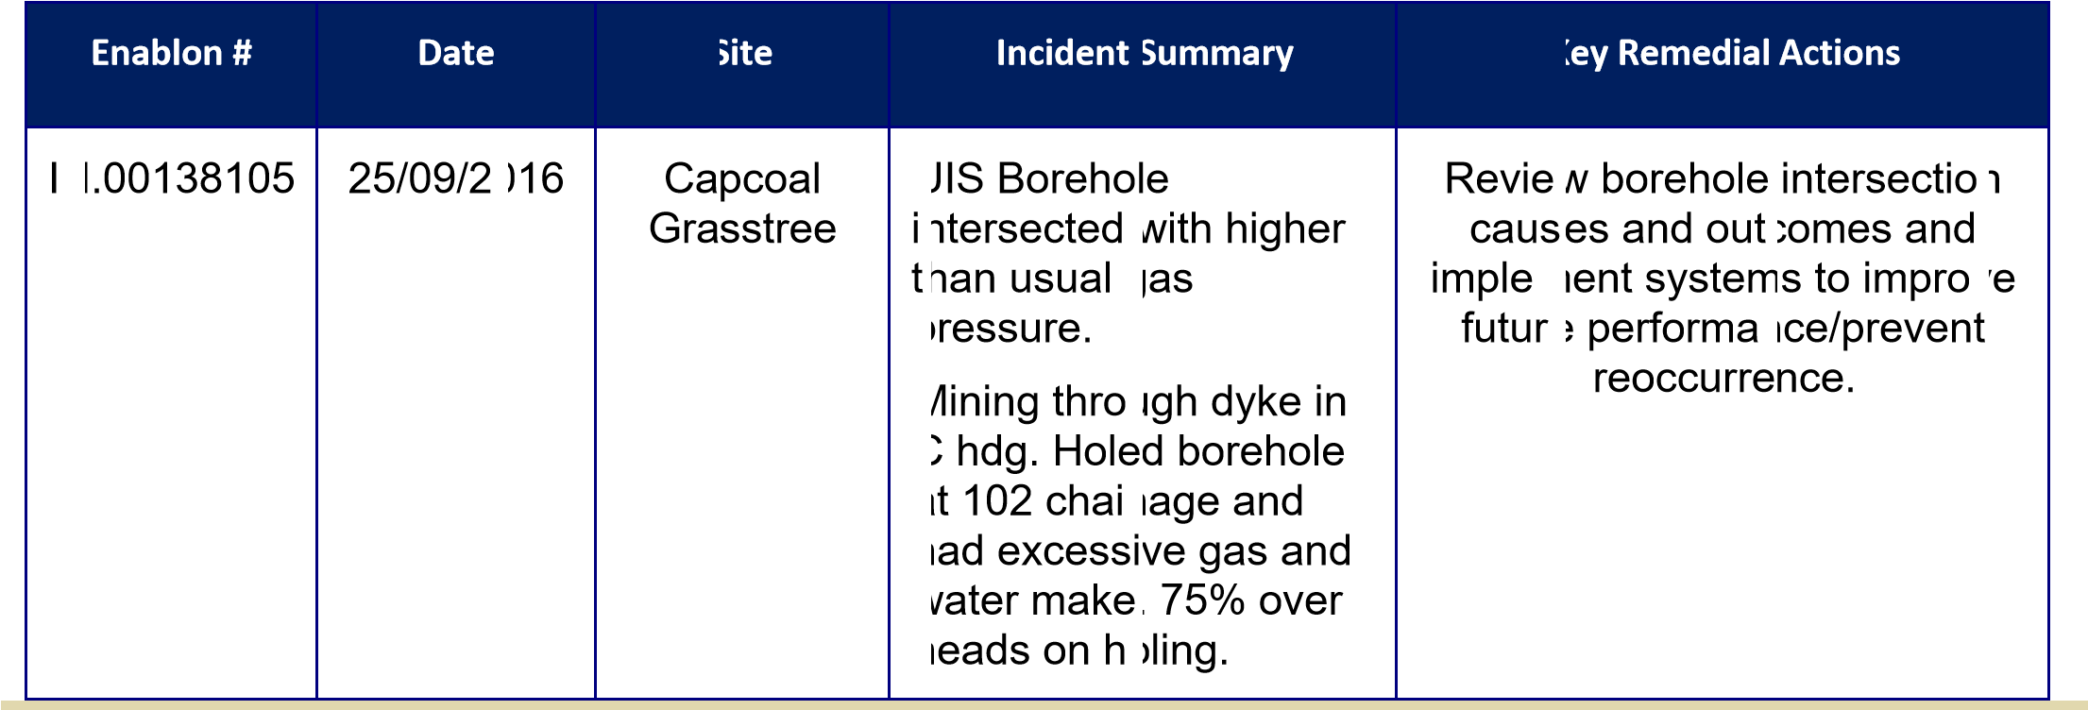
The following facts were found by the Investigation Team, based on observations and the content of statements provided:
 |  | Facts / observations
People | •  • | Persons at the face acted as per the requirement for when Auxillary fan stopped.  ERZC assessed the intersection, identified the severity of the situation, correctly informed relevant personnel and adequately degassed the heading prior to finishing shift.
Equipment | •  •  • | Auxillary fan is fitted with a CH4 sensor in the duct (tripping power to fan at 2% CH4). As a result of the fan tripping on approach to the borehole (GM016B), the heading gassed up quickly.  Continuous Miner / Shuttle car and associated face equipment were de-powered as the fan tripped (as planned).  Equipment was degassed as per the procedure.
Environment | • | Background general body CH4 levels prior to the incident (measured at the dogleg) were between 0.28 – 0.36%.
Procedures | •  •  •  • | HMP for intersecting boreholes.  BIN for intersection of GM016B.  Gas Drainge Authorisation Form, which included a scope of works for grouting.  Lack of a documented Grouting procedure (process).
Organisation | • | No formalised documented Grouting boreholes procedure / process.

6 REVIEW OF PREVIOUS SIMILAR INCIDENTS

IN.00075152 | 08/07/2015 | Grosvenor | BIN notice issued with last recorded flow of 55l/s. After intersection bore hole caused production delays and hazard of gas accumulation at face due to location of borehole. Borehole flow underground calculated at 90L/s which changes  ranking from mod to high. | Investigate alternative options for grouting SIS boreholes

7 REVIEW OF CRITICAL CONTROLS
During the causation analysis, did the Investigation Team identify the failure of any Critical Controls that were causal to this incident/hazard? If yes, please identify below:
LIST OF CRITICAL CONTROL FAILURES | IDENTIFIED FAILURE MODE
Grout any non-grouted Seamgas holes – Verify that accurate data has been entered into the Acquire database. | No formalised documented procedure for the grouting or validation process.

8 TIMELINE OF INCIDENT
 | TIME | EVENT
 | October 2014 | GM016 Vertical (V) and GM016 Laterals (A & B) SIS holes drilled by Arrow Energy
 | 29 July 2015 | GM016 V, A & B SIS holes transferred to Anglo - Grosvenor
 | 4 June 2016 | GM016 V, A & B bag samples taken
 | 17 June 2016 | GM016 V, A & B connectivity validated
 | 3 August 2016 | GM016 V, A & B Scope of Works including grouting quanitities issued
 | 16 August 2016 | Gas Drainage Authorisation Form with a scope of works was approved
 | 25 August 2016 | GM016 A grouted and V measured depth 412.3m top of grout
 | 31 August 2016 | GM016 B grouted and V measured depth 412.3m top of grout
 | 2 September 2016 | GM016 V grouted

 | 6 September 2016 | GM016 A Borehole Intersection Notice (BIN) issued – low flow <40L/s (grouted)
 | 8 September 2016 | MG102 Permit to Mine (PTM) issued
 | 12 September 2016 | GM016 A Intersected UG MG102 B 25 to 26ct – hole grouted
 | 13 September 2016 | GM016 A Intersected UG MG102 C 25 to 26ct – hole grouted
 | 28 November 2016 | MG103 PTM issued
 | 22 December 2016 | GM016 B BIN issued – low flow <40L/s (grouted)
 | 19 January 2017 | Risk Assessment was conducted as there was the potential to intersect an old Arrow Energy borehole containing 4 ½ inch steel casing that has been reported to have been left behind in the GM16B lateral
 | 23 February 2017 | GM016 B Intersected UG MG103 C 21ct – hole not grouted >115L/s  Tripped auxiliary fan

9 DIRECT CAUSE
Borehole had not been grouted as expected.

10 CONTRIBUTING FACTORS

10.1 Absent or Failed Defenses
The following absent or failed defences were identified:
Grouting borehole GM016B had been undertaken as a defence against intersecting live boreholes and removing the gas during the intersection process. This failed as a defence as infact a volume of gas had been trapped between the grouted ends of the hole.

10.2 Individual and Team Actions
The following individual and team actions were identified:
- CMW’s at the face acted as per the requirement for when Auxillary fan stops.
- ERZC assessed the intersection, identified the severity of the situation, correctly informed relevant personnel and adequately degassed the heading prior to finishing shift.

10.3 Task and Environmental Conditions
The following task and environmental conditions were identified:
Background general body CH4 levels prior to the incident (measured at the dogleg) were between 0.28 – 0.36%.

10.4 Organisation Factors
The following organisational factors were identified:
A risk assessment was conducted as there was the potential to intersect an old Arrow Energy borehole containing 4 ½ inch steel casing that has been reported to have been left behind in the GM16B lateral and this risk assessment didn’t indentify grouting as a risk.
There was a signed off Gas Drainge Authorisation Form, which included a scope of works for grouting.
The Decommission and Cementing of vertical and lateral boreholes instruction doesn’t provide any triggers to stop if the desire volumes are not achieved, it also allows for 100% loss of cement through this process.
Borehole grouting confirmation sheets don’t require Seamgas personal to validate and sign off. The only evidence of close out between Seamgas and the contractor completing the activities is the daily activity reports.
Data not fully uploaded into the aquire data base.

11 ROOT / BASIC CAUSE
GM016B had been grouted to remove the process of holing an open hole and having gas emitted at the face. The grouting of this borehole had failed to fully grout this section of the hole and therefore the miner holed into a hole with gas at pressure.

12 CAUSAL ANALYSIS CHART

Organizational Task / Individual / Team Absent / Failed Incident Factors Environmental Actions Defenses Conditions
Grouting borehole
CMW’s at the face
GM016B had been acted as per the done as a defence requirement for against when Auxillary fan
intersecting live
Background stops. boreholes and
No formalised general body CH4 ERZC assessed removing the gas
documeneted levels prior to the the intersection, during the
Grouting incident identified the intersection Intersection of high boreholes (measured at the severity of the process. flow borehole.
procedure / dogleg) were situation, correctly
This failed as a process between 0.28 – informed relevant
defence as infact a
0.36% personnel and
volume of gas had adequately been trapped degassed the between the heading prior to
grouted ends of finishing shift. the hole.

13 FINDINGS / CONCLUSIONS

Due to the implementation of grouting the borehole and reporting of expected grout in GM016B, operations issued a BIN with expected Low Flow (0 – 40L/S), when intersected by development the flow encountered 115 lt/sec (High Flow 80 – 120L/S). Upon investigation the grouting process appeared to be sporadic, which lead to inconsistent grouting records. This placed the development crew in a position of not being prepared for a high flowing hole and at a higher risk of managing the hazard.

The process of tabulating the BIN, executing the BIN and intersecting the borehole were as per the HMP.

14 PREVENTATIVE ACTIONS / RECOMMENDATIONS
The following key actions were identified to prevent recurrence and have been assigned as

detailed below in Enablon.
Hierarchy of

Task Description
Control
Develop a TARP for grouting
boreholes based on gas flow,
Administration geological conditions and operational requirements
Review & Update Decommission and
Adminstration cementing of vertical & lateral wells
Review and Update Seamgas
Department – Borehole Grouting Adminstration
Confirmation sign off sheet
Develop SWI for grouting boreholes considering all options (eg SIS, Arrow
holes, conduited) and consider gas
Administration flow, geological conditions, drilling artefacts and operational requirements

Task Assignee Due Date Task ID
Michael
20/04/17 Webber
Matt Ramsey 20/04/17
Matt Ramsey 20/04/017
Matt Ramsey 20/04/17

15 INVESTIGATION REPORT SIGN –OFF
The Incident Investigation Team submits this report as a true reflection of the information gathered. To maximize the preventive potential of the investigation report, the findings, conclusions and learning’s of the report should be distributed as appropriate.
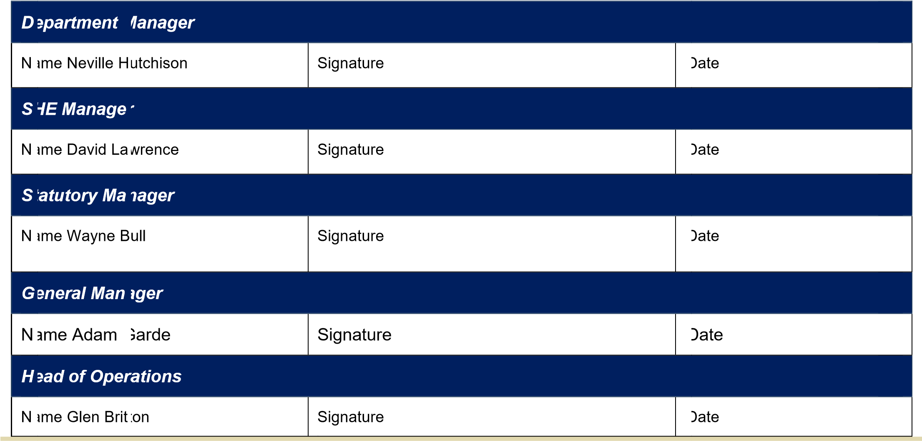

15.1 Appendix A
