GROSVENOR SUBMISSION. ISSUE 5 (11) SUBMISSION 3

UNDERESTIMATION of RISK and CONSEQUENCES of DEVELOPMENT METHANE HPI INCIDENT INVESTIGATIONS INVOLVING FLOOR HEAVE.

Whether the operational practices and management systems in existence at Grosvenor Mine, or at higher corporate levels, were apt to adequately respond to the mines understanding of the difficulties it was having with Longwall 104.

FINDINGS

- GROSS UNDERESTIMATION of the RISK POSED by METHANE HPI’s INVOLVING FLOOR HEAVE/METHANE INRUSHES.

There does not appear to have been a deep enough analysis of the potential risk.

REASONS

- On average the floor heave events occur roughly 50m behind the Continuous Miner.

- Roadways roughly 5m wide and 3m high or a cross section of 15m2.

- One Auxiliary Fan provides roughly 15m3/s and Two Auxiliary Fans 30m3/s.

- Therefore, it takes about 50 seconds for gas emitted 50 metres behind the Continuous Miner to reach the Continuous Miner with 1 Auxiliary fan.

- It takes about 25 seconds for gas emitted 50 metres behind the Continuous Miner to reach the Continuous Miner with 2 Auxiliary Fans.

- The time delay for the methane detectors needs to be added.

- The events last longer than 1 minute.

This is the graph from the HPI 1st of December 2018

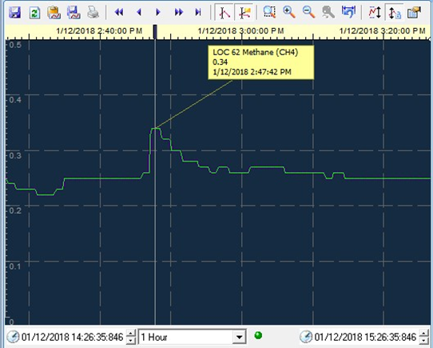
- Explosive concentrations of Methane will be in the fan ducting and Auxiliary Fan.

- A Methane Ignition will destroy the Auxiliary Fan and Vent Tubes/Ducting.

- All ventilation to roadways inbye the last open cut throughs would be lost with a Methane Explosion.

- If it is Off-Scale >5% Methane at the Continuous Miner as identified by the Hand Held Gas Detectors, it will be at least 5% in all the roadway from the Continuous Miner back to the Inrush at the Floor Heave.

- The amount of methane will be at least 5% of the volume of roadway and could be anywhere from 5% to 10% to 15% and above.

(50m x 15m2) x 0.05 (5%) = 37.5m3 of methane.

- Explosion would be a CONFINED EXPLOSION with greater velocity than the LW 104 Face ignition.

- If there were survivors from the Methane Ignition and Explosions, they would likely die due to lack of Oxygen to breathe and deadly concentrations of Carbon Monoxide and Carbon Dioxide.

- High chance that the Confined Explosion along the face and roadway could approach that necessary for a Coal Dust Explosion through-out the Mine.

- Possibility exists for all Coal Mine Workers Underground to die.

