Evidence that a spontaneous combustion heating in the smaller Pillars in TG 104 40 to 41 cut-through and a methane explosion in this location was the first overpressure event on May 6th 2020.

Ten days after the first shear on LW 104, evidence points to an advanced heating (spontaneous combustion event) at the rear of the longwall Tailgate with the confirmed presence of Ethylene from the 19th of March 2020 on.

Sean Muller (SIMTARS) comes to the conclusion that there were 3 separate heating events.

SUBMISSION CONCLUSION

THERE IS EVIDENCE THAT THERE IS ONLY ONE ADVANCED HEATING THAT BECOMES RE-APPARENT WITH MAJOR PLANNED VENTILATION CHANGES Mr MILLER IS NOT AWARE OF.

Much of the belief that there are 3 separate events, appears to stem from the apparent changes that occur from previous GC results in Mid-April and the start of May.

These time periods also coincide with barometric extremes as contained in the LFI for the June 8th Spontaneous Combustion Event and Methane explosion.

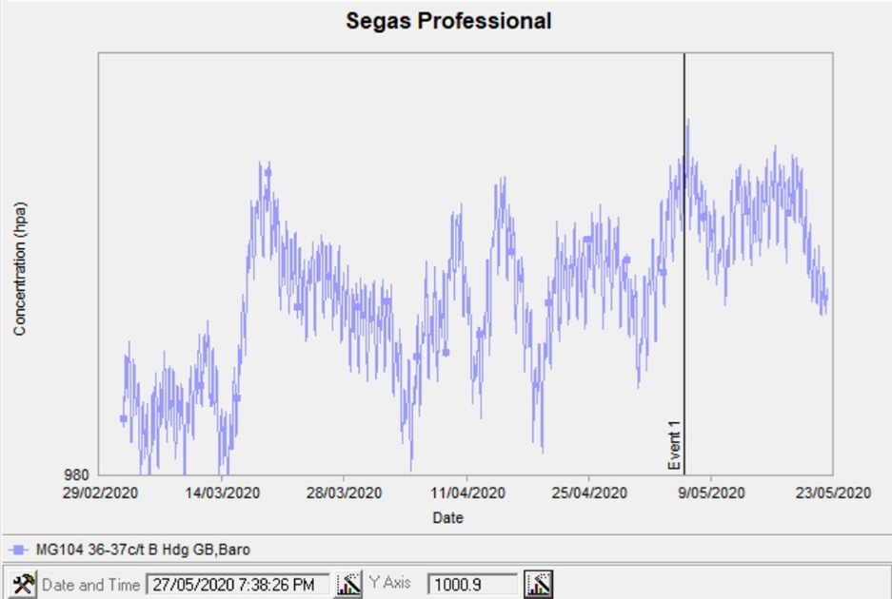

- When LW 104 takes its first shear on March 9th there is sharp rise from what appears to be a long period of low barometric pressure.
- Two sharp barometric falls in Apil. The first on approximately the 5th of Apil and the second on approximately the 20th of April.
- A “King” high barometer around the 4th to 7th May.

VENTILATION CHANGES

Mr Muller makes no mention that he is aware of planned ventilation changes on or around these dates.

MID APRIL

Apparent Planned Ventilation changes in regards to LW 104 Recovery

A cross block roadway at the outbye end of the section has two chute roads driven perpendicular to the retreating face to provide access points for the recovery of the face upon reaching the take-off chainage mark.

1st MAY 2020.

01/05/2020 Vent change for the LW104 Pre-Driven Recovery Road.
Changes included:
MG 103 1 c/t Dogleg changed from 38.6 to 40.5m3/s
104 X Drive Chute Road 2 changed from 28.5 to 35.6m3/s
Model shows 6m3/s drop to LW Return

2ND CHANGE TO GOAF FLOWS ON SAME DAY DUE TO

01/05/2020 17:00 Gas Drainage Authority (GDA) signed on 1 st May 2020 by Ventilation Officer and Gas Drainage Coordinator, permitting GR04VOOIO to be opened, suction applied and monitor for signs of flow.

THE CHANGE IN VENTILATION HAS AN IMMEDIATE AFFECT ON VENTILATION ON GOAF

MULLER REPORT EXTRACTS

It is evident from the gas well data that up to three separate heating events were present in the goaf of Longwall 104 between the 9th of March and the 6th of May. .

• An increase in oxidation is detected in late March peaking on the 27th of March as evident from data from GRO4L001, GRO4V002A and GRO4V003.
• An increase in oxidation is detected in mid-April, peaking on the 17th to the 19th of April as evident from the data from wells GRO4V006.5 and GRO4V007. Wells GRO4V005, GRO4V005.5, GRO4V006.5 and GRO4V007 were shut-in or reduced flow around this time, either temporarily or permanently.
• An increase in oxidation is detected in early May as evident from the data on wells GRO4V007, GRO4V008, GRO4V008.5 and GRO4V009 particularly in CO and methane free CO trends.

This same heating potentially existed at a similar intensity before the ignition on May 6th as indicated by the relative seam gas adjusted CO/CO2 ratio from the tailgate GC bag samples taken between the 4th of May and the 14th of May
The absolute values for these ratios are likely to be underestimated due to dilution by seam gas and excess nitrogen in the tailgate. The relative values indicate a step change prior to the event which persist after the event.

The CO make indicates that the size of this heating was relatively small on the basis that the absolute CO make value was around 30l/min during May and no obvious sustained increase in carbon monoxide generation was observed until early June.

CO/CO2 ratio and Graham’s ratio has been trended from 3-4 CT Tailgate GC bag samples as a way of comparing relative intensity to the goafstream samples during the periods where goafstream samples were not taken, and also prior to the event. These trends indicate a step change in heating intensity from May 5th which is sustained throughout May. See Figure 77 and Figure 79.

An analysis of the reprocessed goaf stream data indicates that a heating of serious intensity was present post ignition during May. This is evident from the reasonably consistent and Graham’s ratio values between 0.6 and 1.

This same heating potentially existed at a similar intensity before the ignition on May 6th as indicated by the relative seam gas adjusted CO/CO2 ratio from the tailgate GC bag samples taken between the 4th of May and the 14th of May. The absolute values for these ratios are likely to be underestimated due to dilution by seam gas and excess nitrogen in the tailgate.

The relative values indicate a step change prior to the event which persist after the event.

The CO make indicates that the size of this heating was relatively small on the basis that the absolute CO make value was around 30l/min during May and no obvious sustained increase in carbon monoxide generation was observed until early June.

Evidence that points to it being a Pillar fire in the smaller Pillars in TG 104 40 to 41 cut-through.

- SIMTARS deployed in June 2019 for an advanced spontaneous combustion event.
TRA.500.019.0004
- Most recently have you been deployed to Moranbah North mine in the last few months, or weeks?
- Yes. I was also, before that, deployed to Grosvenor in June.
Q. June of last year?
A. Yes.
2.The ventilation shaft changed from exhaust to intake before LW first shear.
3. Confirmed presence of Ethylene as early as 19th March ten days after the first shear.
Ethylene proved to have been detected multiple times by Grosvenor Mine from 7th April onwards.
MULLER REPORT MG103/TG104 C hdg 40-41ct
During the processing of the data the following observations where made:
• An increase in carbon monoxide and Graham’s ratio is noted at this location from March to early April.
• An increase in adjusted Young’s ratio is noted at this location during early June prior to the second event.
• On the 31st of March, the carbon monoxide (CO) integration was flawed. This resulted in a substantial under reporting of CO. With proper integration the result increased from approx. 55ppm to 90ppm.
• Between the 17th March and 9th of April, the CO result slowly increased and then decreased, with a peak of approx. 136ppm on the 3rd April.
• On both the 3rd and 4th April small ethylene peaks (<1ppm) were visible but not originally integrated. The CO result was approx. 136ppm and 130ppm, respectively.
• On the 7th of April, there was a sample run for this location with an ethylene peak. The Graham’s ratio was 0.18 and the CO was 99ppm. Unlike the samples on the 3rd and 4th of April the operator noticed and integrated the ethylene peak. A separate operator then ran the sample two more times.
. None of these sample runs appears to have been saved into the LW104 SPW file.
By the evidence of Muller SIMTARS the Mine also appears to have initiated action under the TARPS.
Q. This is back to slide 5. You were talking before about whether or not these hits for ethylene were picked up by the operator. We've only got the ones for 31 March and April with asterisks beside them. Does that indicate whoever was operating the GC or reviewing the data did spot these small amounts of ethylene?
A. Yes, that's right. If it doesn't have an asterisk beside it, it indicates that the operator identified that themselves.
Q. Similarly if we go to the results for the goaf seal at 39-40 cut-through, which is at the back left of the goaf, and the one on the maingate side at 38 cut-through, in particular the latter, we can see that whilst there were some that were missed, there were several that were picked up?
A. Yes, that's right, and you can note with those samples as well, they have relatively high CO even compared to the other samples that I'd shown in the goaf stream on the earlier table, so 147, 193 ppm CO. I'd imagine that was associated with some sort of TARP and they've identified the ethylene to go along with those samples as well. And there's also CO/CO2 ratios that exceed the 0.02, and some of those Graham's ratios are above 0.3, so you can see the higher or the more of those indicators that are present, they all seem to go together.
Q. So does that suggest to you that those detections, say, for 22 April for ethylene were genuine detections?
A. Yes.

01/05/2020 Vent change for the LW104 Pre-Driven Recovery Road. Changes included:
MG 103 1 c/t Dogleg changed from 38.6 to 40.5m3/s
104 X Drive Chute Road 2 changed from 28.5 to 35.6m3/s
Model shows 6m3/s drop to LW Return
2ND CHANGE TO GOAF FLOWS ON SAME DAY DUE TO

01/05/2020 17:00 Gas Drainage Authority (GDA) signed on 1 st May 2020 by Ventilation Officer and Gas Drainage Coordinator, permitting GR04VOOIO to be opened, suction applied and monitor for signs of flow.

THE CHANGE IN VENTILATION HAS AN IMMEDIATE AFFECT ON VENTILATION ON GOAF

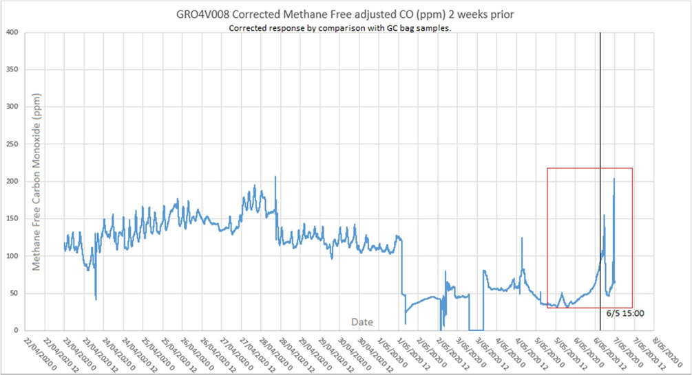

30/04/2020 09:47 Production A Crew Electrician lost Personal Proximity Device (PPD) on longwall (approximately roof support #102).

OVER THE NEXT 24 HOURS THIS CHANGE IS EVIDENT FOR METHANE MIGRATION TO THE FACE FROM THE GOAF

02/05/2020 14:30 Gas 'MT formed following continual stoppages and delays from periods of elevated methane in the tailgate. 24 minutes slow down and 303 minutes of stoppages last 24 hours. 6 new actions raised.
FIVE AND A HALF HOURS LOST.
6 NEW ACTIONS ON TOP OF THE PREVIOUS NINE AND WHAT WAS IN ACTION PLAN?

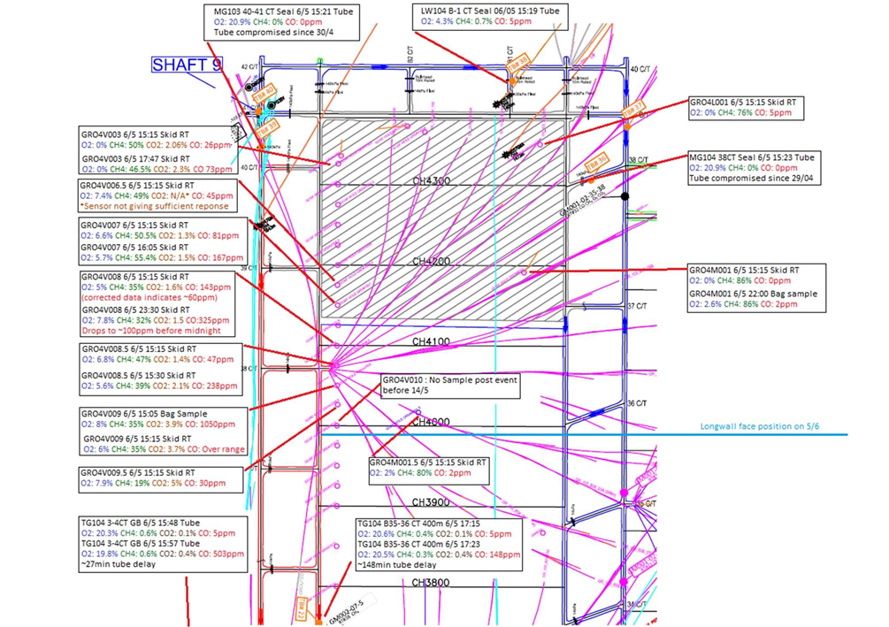

SAMPLE POINT | PRE-EXPLOSION | POST EXPLOSION | DIFFERENCE
MG 103 40-41 CT | TUBE COMPROMISED 30th APRIL. NO READINGS
GRO4V003 | 26 | 73 | 46
GRO4V006.5 | 45 | No reading | Unknown
GRO4V007 | 81 | 167 | 86
GRO4V008 | 60 | 325 | 245
GRO4V008.5 | 47 | 238 | 191
GRO4V009 | 1050 | Off Scale | Unknown
GRO4V009.5 | 30 | No reading | Unknown
TG104 3-4CT | 5 | 503 | 498
TG 400m outbye | Figures not stated Lower than TG104 3-4 CT

• GRO4V009.5 CO2 increases to over 5% (over range) minutes after the explosion, CO only increases to a maximum of 30ppm. This atmosphere indicates efficient combustion from methane burning.

• GRO4V009 CO increases from 80ppm to 1000ppm shortly after the ignition. This is indicated by the analyser recording over range and confirmed by a bag sample. Ethylene/ acetylene and Hydrogen is part of this sample. The relatively high CO concentration indicates a higher proportion of inefficient combustion from coal potentially in an oxygen diluted and or depleted atmosphere. CO2 also increases from 1.4% to 3.7%. This indicates that this location contains a mix of product of efficient combustion (methane combustion) as seen at location GRO4V009.5 and relatively inefficient combustion of coal or coal dust.

• Post event CO increase is also noted at GRO4V008.5, GRO4V008, GRO4V007, GRO4V006.5 and GRO4V003 indicating that combustion/ oxidation product or reporting to these locations.

RSH.032.002.0016
• A spike of increased CO and CO2 is measured in the tailgate RT and tube post event. After this spike recedes, the CO in the tailgate appears to be slightly higher than pre ignition.

• The post blast spike of carbon monoxide at TG104 3-4CT tube is higher than that measured at the TG 400m outbye tube.

• The post blast CO2 spike at the TG400m outbye tube is slightly higher at its peak than the TG104 3-4 CT tube.

• The CO level detected in the goaf wells peaks at GRO4V009 and decreases the as the distance from the face increases. This indicates that the explosion was located towards the face region.

