5. What the evidence establishes about the following matters prior to 6 May 2020, and whether they may have contributed to the occurrence of the serious accident:
6. Whether the mine’s ventilation system, which involved a downcast fan at the rear of the goaf, may have led to the leakage of air past the goaf seals and otherwise contributed to the ingress of oxygen to the goaf.
8. Whether the ventilation arrangement in the longwall tailgate was causing leakage through to the C heading resulting in additional oxygen in the goaf.

As well as holding Mine Deputy Certificate of Competency, I also have the Ventilation Officer Competency, after I successfully passed the first Queensland Mine Ventilation Officers Course (which forms nearly half competency modules for Mine Managers Competency).
With some further studies I obtained the “Associate Diploma in Mine Ventilation” University of New South Wales.

The Little Britton Longwall Ventilation Arrangement is a system of ventilation not used anywhere in the world that I can find.
There is absolutely no doubt there was significant and inevitable problems with spontaneous combustion using the "Little Britton" Longwall Ventilation Arrangement.
This being most likely in the area of 39-40 cut-through C Hdg TG 104.

From the evidence of Sean Muller (SIMTARS), Andrew Self (Consultant) and Basil Beamish (Consultant Spontaneous Combustion) I reference the following
- Ethylene was detected in LW 104 (after 10 days mining) starting on the 19th of March following high CO readings being recorded on the 17th of March. (I point out that CO is produced before Ethylene during spontaneous combustion events)

- “Despite the lack of obvious signs of accelerating oxidation immediately prior to May 6, the possibility that the ignition source for the first event was from spontaneous combustion should not be dismissed” ... TRA.500.019.0055

- It was absolutely acknowledged that if ethylene was detected at all, then we had a serious problem. You don't get ethylene, generally speaking, at much less than 100 degrees Centigrade.
I think that ethylene may appear occasionally and then go away, and that doesn't mean it was never there in the first place. TRA.500.021.0050
There are some people believe that it can be in a goaf without being a result of spontaneous combustion, but I've yet to see the evidence.

- Pillar Heatings are difficult to detect due to low surface temperatures of the pillar, often no visible “GLOW”, and being inaccessible if in or around a goaf, and the products of combustion being diluted.

From first principals of Mine Ventilation and Control of Spontaneous Combustion, it is obvious that Little Britton Ventilation Arrangement runs an EXTREME RISK of inducing a spontaneous combustion heating by either Pillar Heating or heating in the periphery of the goaf
The Principals are taught and assessed in Training Courses for Mine Managers and Ventilation Officers, as well Mine Deputies; as I can attest.
If a Ventilation Officer or Mine Manager student submitted the Grosvenor Mine Design as part of their Assessments, they would fail in my experience and opinion.

In a post made before Mr Sean Muller (SIMTARS) evidence at the Grosvenor Inquiry, I made the following observation.
“There are few of the design criteria for control of the goaf, and minimizing the risk of a spontaneous combustion event, Grosvenor Senior Officials have not completely ignored.
If I was looking for the most likely location of potential spontaneous combustion, evaluating “Little Britton” from Ventilation Design and Spontaneous Combustion First Principles.
I would look no further than in the area of MG103/TG104 C hdg 39 to 41ct marked in attached diagram.”
https://www.qldminingcrisis.com.au/2021/03/18/britton-ventilation-arrangement-in-grosvenor-mine-designed-to-maximize-potential-losing-control-of-goaf-and-initiating-spontaneous-combustion/

I then wrote a further post about how I generated the

https://www.qldminingcrisis.com.au/2021/04/05/how-i-generated-3-colour-possible-grosvenor-longwall-goaf-gas-explosibility-diagram-lw-104-little-britton-ventilation-arrangement/

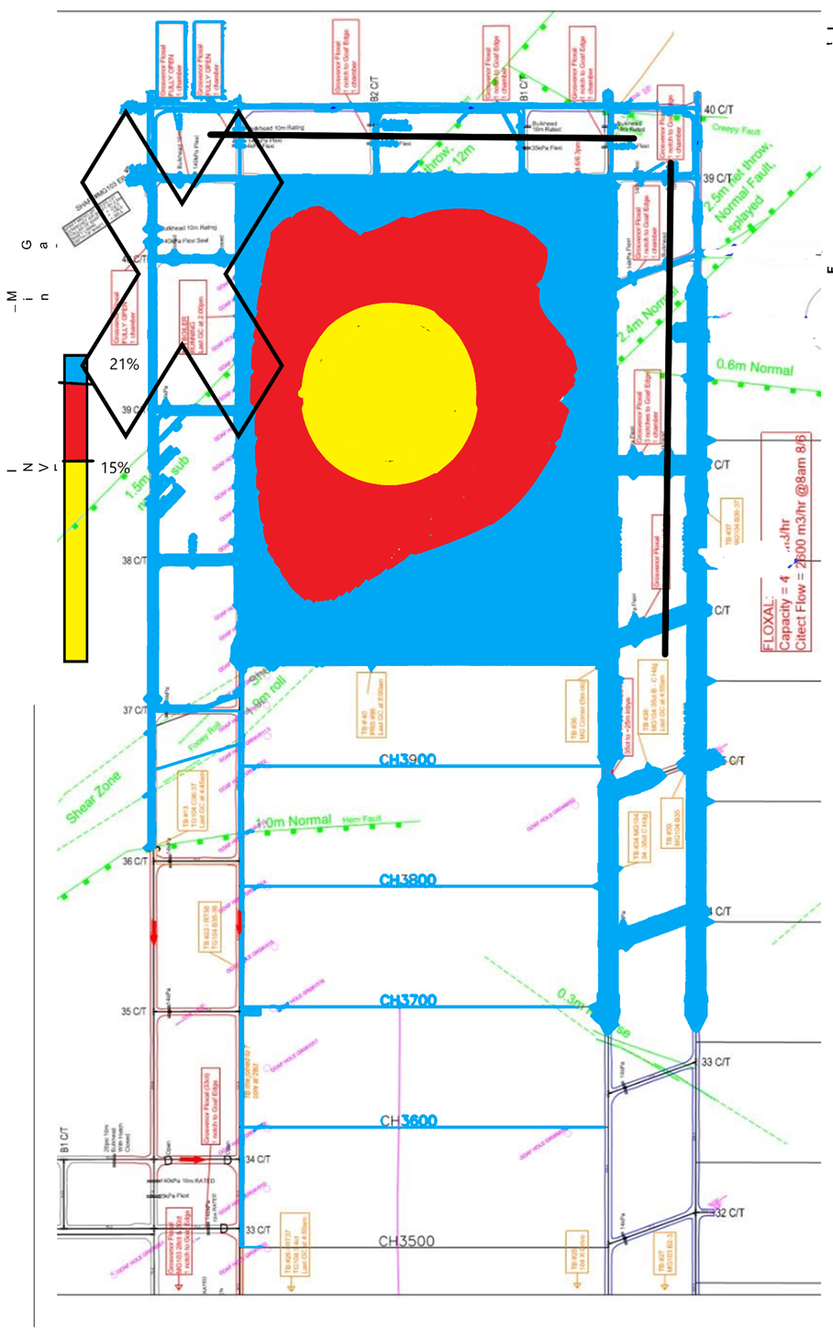

Mr Muller in his evidence identifies that the was Ethylene detected by the gas monitoring system as early as the 19th of March (10 days after LW104 commenced mining) TRA.500.019.0014.
Q. One of the ones where you did identify ethylene was for 19 March - I think there were two on that date. I'm just going to jump forward a number of slides. Is this which is slide 11, part of the GC data that's been output for I think it's the second sample taken on 19 March?
A. Yes, that's what we would call a chromatogram, so that is a zoomed-in view
Further on he also talks about CO at 39-40 cut-through C Hdg TG 104.
Q. Similarly if we go to the results for the goaf seal at 39-40 cut-through, which is at the back left of the goaf, and the one on the maingate side at 38 cut-through, in particular the latter, we can see that whilst there were some that were missed, there were several that were picked up?
A. Yes, that's right, and you can note with those samples as well, they have relatively high CO even compared to the other samples that I'd shown in the goaf stream on the earlier table, so 147, 193 ppm CO.
Q. So does that suggest to you that those detections, say, for 22 April for ethylene were genuine detections?
A. Yes.

Andrew Self in his evidence said this about Ethylene.

Q. What about the presence of ethylene? That wasn't one of the four that you listed a moment ago. How significant is the detection of ethylene in gas samples that have come from the goaf?

A. This is a very wide subject, as I think you know. Going back, early stages of my career, if we identified ethylene, we knew we had a major problem and we moved quickly.
It was absolutely acknowledged that if ethylene was detected at all, then we had a serious problem.
However, ethylene does not come off at low temperatures. You don't get ethylene, generally speaking, at much less than 100 degrees Centigrade. I said earlier on that at 100 degrees Centigrade, I think it's all over, we've lost this battle, so we're really into damage control.
I think that ethylene may appear occasionally and then go away, and that doesn't mean it was never there in the first place. . TRA.500.021.0050

Q. Do you get ethylene, though, under ordinary circumstances out of a goaf where there isn't a heating of coal going on?
A. There are some people believe that it can be in a goaf without being a result of spontaneous combustion, but I've yet to see the evidence.

TRA.500.021.0092
Q. I just want to take you to this one in relation to ethylene. Does it remain your position that any evidence of ethylene should be taken as elevated temperature?
A. It should be taken as elevated temperature. It should be taken seriously.

Q. The point that you made to Mr Hunter in relation to other possibilities, such as green timber and old diesel engines, is that that doesn't mean that the presence of ethylene should not be taken seriously, but, in fact, that it should always be taken seriously and that then investigations should occur as to if there are any other possibilities to explain it?
A. That is my stance, yes.

Critical Controls/Elements are for spontaneous combustion are referenced in NSW TRG Development of a spontaneous combustion principal hazard management plan for underground coal mining operations.
- Grosvenor Mine would in my estimation run the highest Differential Pressure of any Coal Mine in Queensland Longwall History.
- Grosvenor Mine appears to run at a high Main Fan pressure for a Coal Mine of relatively small size.
- Grosvenor Mine with its 600 to 700Pa positive pressure from the 2 forcing fans alone. gives a higher differential pressure than that referenced being required for Pillar Fires
- It is nearly Twice Newlands Mine Pillar Heatings in 1998 (400Pa).
- It is 3 to 4 times the following reference of the NSW TRG.
- Differential Pressures as low as 250Pa and 115Pa respectively in some Queensland in NSW are sufficient
- It is at least 10 times the recommended Longwall Face Differential
- A critical control could be defined as keeping the pressure difference across the longwall face to less than 50 pa, to ensure that air leakage into the goaf is minimised while ensuring that there is adequate face ventilation.

I referenced TRG Development of a spontaneous combustion principal hazard management plan for underground coal mining operations, in a post on the 5th of April.
Peter Newman, the current Chief Inspector of Coal Mines should be well aware of Lalehan Pillar Heating in 1982, as he informed me he was a Mining Engineer at Laleham in 1982 when this heating occurred.

Laleham Colliery (Blackwater)
During 1974 and 1975, serious heatings were experienced in pillars between the main intake and return roadways and in July 1975, a serious heating was detected in the goaf of a pillar extraction panel.
In 1982 the problem was not entirely solved until the pressure differential was removed on 25 September 1982.
Newlands – 1998
A number of small heatings took place near the portal entries in April and May of 1998 before the longwall mining commencement. Newlands re-classified the seam as having a high propensity.

Contributing factors to the heatings were considered to be:

- a sustained pressure differential of 400Pa across coal pillars that contained a large amount of open fractures
- air migration through the fractures
- high ventilation quantities concealing any products of the heating from monitoring devices located outbye.

https://www.qldminingcrisis.com.au/2021/04/05/coal-pillar-fire-references-from-development-of-a-spontaneous-combustion-principal-hazard-management-plan-for-underground-coal-mining-operations/

A critical control could be defined as keeping the pressure difference across the longwall face to less than 50 pa, to ensure that air leakage into the goaf is minimised while ensuring that there is adequate face ventilation.
Several common themes emerge.
- Pillars subject to pressure differential between intake and return roadways
- Differential Pressures as low as 250Pa and 115Pa respectively in some Queensland in NSW are sufficient
- Pillars are small and subject to geotechnical stress
- Difficult to detect as there is no red hot coal visible, it is contained in the pillar.
- Surface Temperatures can be as low as 30 degrees and inside the pillar temperature 300C and over detected.
- Such heatings may be difficult to detect until well advanced because of their relatively small size and the dilution of gaseous products by high volume airflows.

1)

3. Basil Beamish in his evidence talked about spontaneous combustion in Pillars in areas of high pressure differentials. TRA.500.022.0053

Q. Let me recast the question. If coal has been heated to a temperature in excess of or about 530 degrees, would you expect for there to be observable phenomenon, and I think the one that you identified both today and in your report is "glowing" - you would expect the coal to glow; is that correct?
A. The hot spot itself won't be on the surface. You will not see that glow. We have had pillar heatings in the past, in solid coal, fractured solid coal, which is what we're talking about here, fractured solid coal. The glow was sitting in from the free surface, and it was just that someone happened to walk past and was looking at the right direction at the right time, and they saw the glow, so --

Q. And what about a heat haze, Dr Beamish? If coal was heated to a temperature in excess of 530 degrees, would it produce a heat haze?
A. Not if it is in away from the free surface.

Q. So is it a fair summary of that passage, then, that phenomena such as heat haze, possibly smoke, possibly glowing, possibly odour may be present but are unlikely to be observable because, in your scenario, we have a relatively small particle or pocket of coal that's some distance from the face of either the coalface or the roof?

We know now that the Grosvenor has to employ 2 fans in a forcing arrangement to provide roughly 50m3/s at around a positive pressure of 600 to 700Pa.

This is through a downcast shaft delivering refrigerated air from behind the Tailgate, then past 20PSi (140kPa) goaf seals along the back of the goaf.

Then past the other newly installed 20Psi seals down 104 Maingate and then mixes with air coming from the mains and then goes into the longwall face.

Oxygen is being pushed into the goaf at each and every one of these seals

The greatest pressure differential possible for the mine to dream up and create has been achieved.

What is the pressure differential across the Seals at the back of the longwall face?

In particular C Hdg 40 to 41 c/t MG 103?

I have included links to a number of articles I have posted.

https://www.qldminingcrisis.com.au/2021/03/08/grosvenor-mine-case-study-in-how-not-to-design-construct-develop-and-manage-a-thick-seam-gassy-coal-mine-grosvenor-mine-ventilation-system-could-not-cope-with-methane-in-first-few-hundred-metres/

https://www.qldminingcrisis.com.au/2021/03/24/my-grosvenor-spontaneous-combustion-scenario-ethylene-detected-in-march-and-april/

https://www.qldminingcrisis.com.au/2021/04/05/the-theories-advanced-by-various-expert-witnesses-over-the-last-3-weeks-to-justify-their-theory-do-not-account-for-known-facts-at-grosvenor-ethylene-was-first-detected-39-to-41-c-t-c-heading-this-ar/

https://www.qldminingcrisis.com.au/2021/03/20/little-britton-longwall-ventilation-arrangement-at-grosvenor-mine-lw-104-how-does-it-compare-with-design-guideline-mdg1006/

https://www.qldminingcrisis.com.au/2021/04/05/coal-pillar-fire-references-from-development-of-a-spontaneous-combustion-principal-hazard-management-plan-for-underground-coal-mining-operations/

https://www.qldminingcrisis.com.au/2021/03/10/ventilation-arrangement-grosvenor-lw-104-can-anyone-even-give-it-a-name-who-dreamt-this-up/

