Statement of Wayne David Sellars
1 . My name is Wayne David Sellars and I reside at an address known to the Queensland Coal Mining Board of Inquiry.
- I was injured in the serious accident that occurred at the Grosvenor coal mine on 6 May
2020.
- At the time of the accident, I was employed as a shearer driver by OneKey Resources Pty Ltd. I was deployed to the Grosvenor coal mine, working on longwall 104.
- I was originally employed, and deployed to Grosvenor, by a company called Mastermyne. OneKey Resources took over the labour hire supply contract from Mastermyne and from that time I was employed by OneKey.
- The accident occurred during my fifth year of working at the Grosvenor mine. I had been working there since the time they first started coal mining and had worked on all longwall blocks, namely longwalls 101, 102 and 103, prior to longwall 104. Prior to working on longwalls, I had worked in development at the mine.
- I had been employed as both a miner driver and a shearer driver.
- Prior to my employment at Grosvenor I had worked for just over five years at the Newlands coal mine.
- Prior to Newlands, I was at Crinum East mine, and before that was at Oaky North. I have been in the coal mining industry for close to 1 3 years in total.

Longwall 104
9. had been working at longwall 104 from the time of first coat on 9 March 2020. I was part of the team that cut first coal on that day.

Methane gas exceedances prior to the serious accident
10. We had quite a number of methane exceedances on the longwall prior to the serious accident. Some occurred when I was on shift, other times I heard about it when I returned to the mine.
IL We were informed about the exceedances at the start of tour meetings and at toolbox talks. On each occasion, we were told about what controls had been put in place to deal with the exceedances. We were not informed of any failures at the mine that were considered to have continued to the exceedances.
12. We knew there were many exceedances during longwall 104. Us workers regularly spoke between ourselves about the amount of gas in the longwall.

Bi-di cutting
- Most of the time, we cut bi-directionally. A couple of times, we reverted to unidirectional cutting which did help with the exceedances, although they kept occurring.
- The shearer had an automation feature which caused it to automatically slow down as gas levels increased. Sometimes we would get the call to pull up and just let it clear, or the shearer was also programmed to just stop and sit there until the gas got back down to the percentage that it was set at and then it would start cruising along again.
1 5. In the lead up to 6 May 2020, I recall there were some local ventilation controls installed on the face such as butcher's doors and brattice, a Sherwood Curtain, and some venturis trying to get some ventilation moving around.
16. I recall there was methane coming up through the floor, it was pretty much a constant bubbling out of the floor along the longwall face for about two thirds of the face. The maingate end wasn't too bad, but around the faulted area we had a number of trips on the shearer due to floor gas. There were times when the sensors in the cutting drums stopped the shearer cutting. We understood that was because of methane coming out of the floor at those times. When that happened, we would have to wait for the methane
2
to clear before we could start the shearer back up. This mainly occurred around the tailgate end. Through the faulted area wasn't so bad because we were so far into the stone because of the throw of the fault, it was when we got to the tailgate side of the fault that we started to get a few trips on the drum.

Strata
- There was a lot of bad roof in longwall 104. The roof varied in thickness which meant that there were roof falls which we had to deal with.
- In the lead up to 6 May 2020, we had been managing a fault through the face which was bigger than any other fault I had seen on the other blocks and it grew in size as we retreated outbye.
- To manage mining through that fault, we were told to keep the face tight, which meant keeping the chocks up against the face and manually bringing the chocks in over the shearer as we cut.
- We would sometimes request to revert to uni-di cutting to manage the strata issues from mining through the fault. Uni-di cutting makes it easier to control the roof supports and protects the workers, including by keeping us out of the dust. It is harder to manage strata issues while cutting bi-di because you cannot see what is happening behind you (when cutting into the maingate) or in front of you (when cutting into the tailgate).
- We were usually overruled about cutting uni-di, although there were a few times, especially when we were managing that fault, that we were allowed to use uni-di. The problem was that as soon as we started to manage the issue, we were told to go back to bi-di.

Face consolidation
- Sometimes we would ask to be able to pump the face to manage it. There were occasions when Mick Copland, the longwall co-ordinator, attended the face and agreed we needed to pump but would return later and say we could not pump after all. I do not know who

made the decisions on those occasions, other than that it would have been someone more senior than him.
- There were a lot of cavities in longwall 104. The mine would use carbofill to plug the bottom of a cavity in the roof, rather than filling the cavity to pressure. This meant that there would still be a cavity above the carbofill plug. I was personally involved in carbofill operations on several occasions.
- I was also involved with the pumping of PUR on occasions. We would drill the holes and assist with the preparation for pumping. After pumping was completed, we did help clean up. That process varied depending on how much gear there was. Usually, the clean up process took less than an hour.
- After the clean up was completed, we would just go straight back in and start cutting again. We did not do a fire watch after any of the PUR campaigns on longwall 104.
The serious accident on 6 Ma 2020
- I recall the day of 6 May 2020 clearly. It was the last day of my tour. I was on the afternoon shift, which started at 9.30am.
- In terms of gas levels, we were having a good day of mining. We managed to get in and out of the tailgate about three times. We did a floor clean up on the last run in, pulled the shearer back to the transition start and shut the shearer off.
- Shortly before the accident, the panline had pushed out and we were about to go in and start moving the tailgate chocks. We had to move them manually because of the poor roof conditions.
- At that time, it was time for our break. We call a break "crib" because we have our breaks in an area of the mine known as a crib room.
- Two other workers had come down onto the longwall face to relieve us for crib, including a worker who is known to the Inquiry as Injured Coal Mine Worker 3.
- Other workers, known to the Inquiry as Injured Coal Mine Worker 2 and Injured Coal Mine Worker 4, were also on the longwall face near me at the time.
- I recall that Injured Coal Mine Worker 3 was standing beside me on my right hand side, on outbye side of the tailgate. Injured Coal Mine Worker 2 was behind me, just on the inbye side of me. Injured Coal Mine Worker 4 was a bit further out from Injured Coal Mine Worker 3.
- I was just about to do a quick handover with Injured Coal Mine Worker 3 so we could go for lunch. At this time I believe I was located around the transition point at chock 125.
- I recall that, just before the incident, I was beside the shearer, standing on the feet of the pontoon on the front of a chock, in between where the mimics are. I was facing the goaf.
- All of a sudden, there was a pressure wave and the ventilation changed direction and stalled. The air was dead still. There was no noise associated with the first pressure wave.
- The power dropped as that pressure wave went through. All the lights went out and the pumps, mimics and AFC stopped. It was completely dark, except for our cap lamps.
- The pressure wave was strong but I was able to keep myself upright because I held on to the mimic and tombstone near me.
38 1 remember saying to Injured Coal Mine Worker 3 words to the effect of "they're not going to like this, this is another HPI". The methane level must have exceeded 2% for the power to have dropped.
- After I said that, there was a second pressure wave. It happened about 10 or 15 seconds after the first one. As the second pressure wave occurred, I heard a clap like a rock being dropped from a height onto another rock.
- Almost instantly, I saw blue flame, which engulfed me for what must have been a split second but felt, at the time, like an eternity. I tucked myself up as much as I could, closed my eyes and held my breath. I remember thinking to myself, "This is it. What's on the other side?". I then thought, "Fuck this, I'm not dying here".
- Then it stopped. There were no more flames.
- I opened my eyes. It was pitch black and very still. I kept holding my breath. I was thinking that I could not take a breath because there would be gases around me. However, I could not find my self rescuer, so I ended up taking a breath.
- Injured Coal Mine Worker 3 was there in front of me, and I just grabbed onto him, I don't know if I grabbed his belt or what was left of his pants.
- Injured Coal Mine Worker 2 was standing behind me, just screaming.
- I reached out towards him too, but I don't know if I managed to grab him or not. He came out with us though.
- I started yelling "go, go, go" and we started walking out.
- We walked all the way to the drifty. My deputy, Adam Maggs, came towards us and assisted us as we came towards the maingate.
- I recall the trip to the surface. It would have taken about 30 minutes. I remember worrying that there would be another explosion before we got out of the mine.

Treatment
- I was transferred from the mine to Moranbah Hospital. I was sedated and put into a druginduced coma. I was transferred to the RBWH that night. I had two debriding surgeries and was put on dialysis for kidney failure in the first couple of days.
- I spent three weeks in ICU, then was on the burns ward until 10 July 2020. Two weeks later, I was re-admitted to hospital for blood clots in my lungs. To date, I have had ten surgeries. I will have between three and seven further surgeries this year. I wear various burns suits and masks for up to 23 hours a day and will do so for the next two years at least.
51 . I am under the care of the following teams: surgical, respiratory, scar management, hand specialist, psychological and several physiotherapists and occupational therapists. I have appointments five days a week.
This statement is true to the best of my knowledge and belief,
Signed: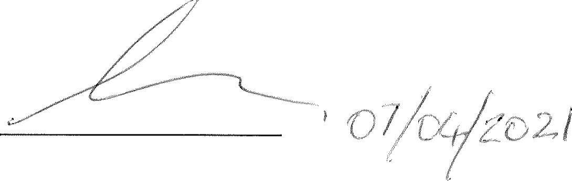
Wayne David Sellars

