TECHNICAL
REFERENCE GUIDE

DEVELOPMENT OF A SPONTANEOUS
COMBUSTION PRINCIPAL HAZARD
MANAGEMENT PLAN FOR
UNDERGROUND COAL MINING
OPERATIONS

Document control
Published by NSW Resources Regulator
Title: Technical Reference Guide: Development of a spontaneous combustion principal hazard management plan for underground coal mining operations
First published: March 2021
Authorised by: Chief Inspector
CM9 reference: DOC21/80224

AMENDMENT SCHEDULE
Date | Version | Amendment
March 2021 1 Original version
This guide supersedes MDG 1006 Spontaneous Combustion Management Guideline and MDG 1006-TR Technical Reference for Spontaneous Combustion Management Guideline.
© State of New South Wales through Department of Regional NSW 2021. You may copy, distribute, display, download and otherwise freely deal with this publication for any purpose, provided that you attribute the Department of Regional NSW as the owner. However, you must obtain permission if you wish to charge others for access to the publication (other than at cost); include the publication in advertising or a product for sale; modify the publication; or republish the publication on a website. You may freely link to the publication on a departmental website.
Disclaimer: The information contained in this publication is based on knowledge and understanding at the time of writing (March 2021) and may not be accurate, current or complete. The State of New South Wales (including the Department of Regional NSW), the author and the publisher take no responsibility, and will accept no liability, for the accuracy, currency, reliability or correctness of any information included in the document (including material provided by third parties). Readers should make their own inquiries and rely on their own advice when making decisions related to material contained in this publication.
Contents
1. Introduction 5
1.1. Acronyms 6
2. Fundamentals of spontaneous combustion 7
3. Developing and documenting a PHMP for spontaneous combustion 10
3.1. Scope and context 10
3.1.1. Mine details relevant to spontaneous combustion 12
3.1.2. History of spontaneous combustion events at the mine/in the jurisdiction 12
3.1.3. Interaction with other plans and overall safety management system 13
3.1.4. Documenting the scope in the PHMP 14
3.1.5. Consultation process 14
3.2. Analysis methods 14
3.2.1. Identifying hazards 14
3.2.2. Assessing the risks associated with spontaneous combustion 15
3.2.3. Known spontaneous combustion risks 16
3.3. A control management system for spontaneous combustion 17
3.3.1. Hierarchy of controls 17
3.3.2. Known prevention controls for spontaneous combustion 17
3.3.3. Known mitigation controls for spontaneous combustion 17
3.3.4. TARPs and monitoring 19
3.3.5. Documenting the control management system in the PHMP 20
3.3.6. Incident management 20
3.4. Measuring the effectiveness of controls 20
3.4.1. Documenting critical controls and how they will be measured in the PHMP 21
3.4.2. Information, training and instruction 21
3.5. Plan assurance: review, audit, continual improvement 21
4. References 22
Appendix A: Plan implementation: roles and responsibilities 24
Statutory and other roles 24
Appendix B: Locations of heatings and case studies 30
Locations in the mine where heatings may develop include: 30
Mine design: control measures 39
Case studies 41
Appendix C: Spontaneous combustion technical reference guide updates 72
Modelling of the combustion process 72
Liners, inhibitors, fly ash, foams and gels 72
Magnetic resonance detection 74
Gas analysis 74
Hazard assessment 77
Laboratory testing 79
Radon detection 79
Containment and inertisation 79
Segregation of parts of the mine 81
Controls on stowage 81
Production of gases not related to heatings 82
Monitoring locations 82
Air free analysis 83
Management of an incident 84
Appendix D: References for appendices 94

1. Introduction
This document provides mine operators with guidance on developing and documenting a principal hazard management plan (PHMP) for spontaneous combustion in underground coal mining operations. Technical detail in the main body of this guide is kept to a minimum and further technical information is signposted throughout this guide.
This guide supersedes MDG 1006 Spontaneous Combustion Management Guideline and MDG 1006TR Technical Reference for Spontaneous Combustion Management Guideline.
This document should be read in conjunction with:
- NSW WHS Acts and Regulations (including Mining and Petroleum Sites)
- NSW codes of practice:
  - Work health and safety consultation, cooperation and coordination (August 2019),
  - How to manage work health and safety risks (August 2019),
  - Safety management systems in mines (February 2015).
- NSW Resource Regulator’s guidance material, for example:
  - Guide - Preparing a principal hazard management plan (January 2020).
- Australian and International Standards in related fields, for example:
  - AS ISO 31000: 2018 Risk Management — Guidelines
  - AS/NZ ISO 45000: 2018 Occupational Health and Safety Management Systems – Requirements with guidance for use
  - AS 3980:2016 Determination of gas content of coal and carbonaceous material— Direct desorption method.
- Cliff, D., Brady, D., & Watkinson, M. (2018). Spontaneous Combustion in Australian Coal Mines. Redbank, QLD: SIMTARS.
- The technical reference and case study information attached to the appendices of this guide.

1.1. Acronyms
ACARP: | Australian Coal Industry’s Research Program
AS: | Australian Standard
CCM: | critical control management
CMS: | control management system
ICMM: | International Council on Mining & Metals
ISHR: | Industry Safety and Health Representative
ISO: | The International Organisation for Standardisation
PCBU: | person conducting a business or undertaking
PCP: | principal control plans
PHMP: | principal hazard management plan
SMS: | safety management system
SSHR: | Site Safety and Health representative
TARPs: trigger action response plans
WHS: work health and safety

2. Fundamentals of spontaneous combustion
Spontaneous combustion describes the process of self-heating of coal by oxidation. After exposure by mining, coal undergoes a continuous exothermic oxidation reaction when exposed to air.
A hazard exists when, in confined areas, the rate of heat accumulation due to oxidation exceeds the rate of cooling by ventilation or environment (figure 1). The coal can then increase in temperature until combustion takes place leading to the emission of toxic and explosive gases together with propagation to open fire. The self-heating will then become a potential ignition source for an explosion if exposed to a flammable mixture of gas.
Figure 1: Schematic of the spontaneous combustion heat balance process
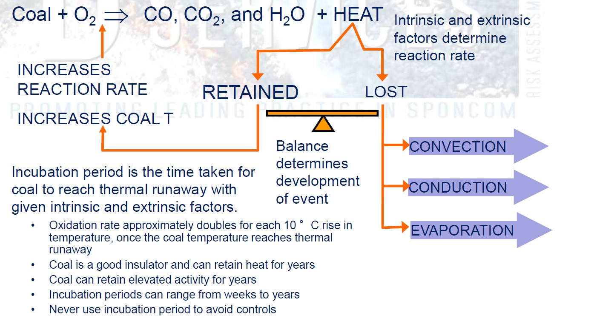

Spontaneous combustion of coal occurs as follows:
- Oxygen (from airflow and ventilation) reacts with coal. This is called oxidation.
- Oxidation produces heat. This is called an exothermic reaction.
- If this heat is lost to the surroundings (mine environment), then the coal mass will cool.
However, if the mine environment favours the heat being retained, the coal mass will increase in temperature and the oxidation rate will increase, leading to spontaneous combustion. Significant amounts of heat can also be generated when the coal absorbs moisture.

Heat generated is lost by some or all of the following mechanisms, depending upon the temperature and physical conditions of the mine:
- Conduction through the solid coal mass.
- Conduction and radiation to the ventilating air.
- Evaporation of moisture.
- Convection through the solid coal mass and ventilating air.
The oxidation process is complicated and not fully understood, but the following stages occur as the temperature of the coal increases:
- The absorption of oxygen by the coal and formation of oxycoal without the production of carbon monoxide. This is a reversible process.
- As the temperature increases through the range 30º to 40ºCelsius, the coal/oxygen complexes break down and produce carbon monoxide and carbon dioxide. This reaction occurs irrespective of the presence of atmospheric oxygen.
- Further increases in temperature are associated with increased rates of oxidation and the production of increased quantities of carbon monoxide and carbon dioxide.
There are two conditions of oxidation equilibrium that can occur:
- If the quantity of air flowing over a coal surface is very small, then the rate of oxidation is low. This is the condition that occurs in high resistance air paths, such as through goafs and in sealed areas.
- If the air quantity is large, the heat due to oxidation is lost as quickly as it is generated and this cooling effect may be enough to prevent any significant rise in temperature. This is probably the condition that occurs in almost all the low resistance intake and return airways.
Should this equilibrium condition be destroyed by either an increase in airflow in the first case, or a decrease in airflow in the second case, then the temperature will rise and spontaneous combustion may result.
The oxidation process is illustrated in figure 2 where the mass of a coal sample is monitored as a function of coal temperature. The figure shows how temperature increases initially are lower until the point where thermal run away occurs where the increase in temperature accelerates. All coals are liable to spontaneous combustion if the conditions are right.

Figure 2: Adiabatic self-heating incubation curves for bituminous coals G (moisture content 11.7%) and H (moisture content
5.0%). Modified from Beamish and Theiler (2019)
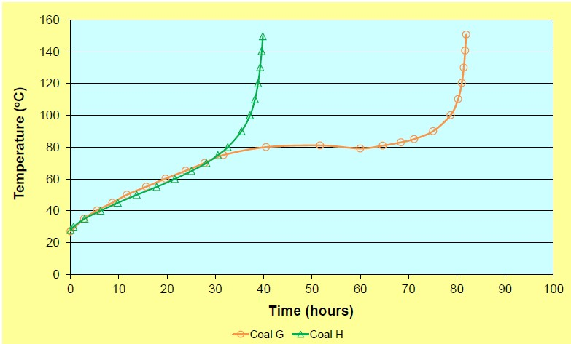

3. Developing and documenting a PHMP for spontaneous combustion
The PHMP for spontaneous combustion should be developed following the steps detailed in the NSW Resources Regulator’s Guide – Preparing a principal hazard management plan. After initially describing the scope and context of the plan, a comprehensive hazard description should be developed within the context of the risk management approach. The associated risks are then identified and a control management system is developed that includes planned assurance activities for continual improvement. Workforce representation is an important element of each of the stages.
This section further outlines the types of risk-based tasks and information that should be included in developing and documenting a PHMP for spontaneous combustion.

3.1. Scope and context
The first step is to provide a definite or clear description of the nature of the hazard under investigation. It defines the parameters for the future stages of the plan, including the analyses and risk assessments and the development of the risk control strategy.
Scoping activities consider which locations are in/out, what plant and equipment will/won’t be considered, the people and organisational entities to be included/excluded, and the activities and tasks that will/won’t be considered.
The following matters must be considered in developing the control measures to manage the risks of spontaneous combustion:
- the potential for spontaneous combustion to occur in the material being mined, including by:
  - evaluating the history of the mine in relation to spontaneous combustion
  - evaluating any adjacent or previous mining operations in the same seam
  - conducting scientific testing.
- mine ventilation practices
- the design of the mine
- the impact of gas generated by spontaneous combustion on mine environmental conditions.

Establishing the scope and context for a spontaneous combustion PHMP may also include:
- identifying objectives for the plan
- reviewing the geotechnical, operational and organisational (etc.) environment or context in which the hazard exists
- exploring the nature of the hazard unique to the mine
- defining how the hazard interacts with other potential hazards on site.
An example of a scope for spontaneous combustion PHMP is shown in Table 1.
Table 1: An example of a template that may be used to develop a scope for spontaneous combustion PHMP
Description | Included | Excluded
Locations or physical area | All underground areas with the potential for spontaneous combustion: sealed/unsealed, face, outbye, development panel. | - coal stockpiles  - spoil heaps
Plant and equipment | All equipment underground  (owned/contracted), including those directly involved in managing spontaneous combustion:  - gas drainage system  - inertisation systems  - ventilation systems  - dust management systems (e.g. scrubber fans, venturis)  - seals, stoppings and ventilation control devices  - monitoring systems
People and organisational entities | All people underground.
Activities and tasks Mining operations and maintenance
activities.

Unwanted event scenarios | Potentially fatal single and multiple events involving spontaneous combustion in sealed areas, unsealed goaf, at extraction face, in outbye areas, in development panel due to:  - less than adequate design  - less than adequate geological/ geotechnical knowledge  - inappropriate operational practices  - time dependent or mining-induced effects  - unexpected geological or geotechnical conditions  - power outages | • Spontaneous combustion in surface mine workings

3.1.1. Mine details relevant to spontaneous combustion
Information may include:
- Regional overview – including proximity to other mines, regional infrastructure and support resources, as well as information on any limitations to access to the surface above the mine.
- Geotechnical information related to the mine – this identifies any factors that may influence the inherent reactivity of the coal or cause problems when mining that could increase the risk of spontaneous combustion.
- Mine organisational information – outlines the personnel in key roles and their responsibilities. (See section 3.5 for more details)

3.1.2. History of spontaneous combustion events at the mine/in the jurisdiction
It is important to recognise the characteristics of past events at the mine or other mines within the region. The case studies in Cliff, Brady and Watkinson’s (2018) technical guide Spontaneous Combustion in Australian Coal Mines and those appended to this guide are a good starting point.

Information may include:
- particular locations - goaf incidents, stowage, pillar heatings
- factors that increase/decrease the likelihood of such events at the mine in comparison to past events such as changes in mining method or ventilation system.
Using incident reviews to better understand the nature of hazards Collect and analyse all incidents to derive:
- the unwanted event scenarios that will be included or excluded in the scope
- the initiating event scenarios that describe the point where the situation became unsafe (e.g. elevated temperature oxidation). Identifying and highlighting the initiating event is very important as it raises awareness of the point at which operations are unsafe and helps increases the focus on what is required to keep operations safe.
- the root causes of the initiating events (e.g. failure of a gateroad seal).
- the actions taken to address the event and whether these treatment actions were effective.

3.1.3. Interaction with other plans and overall safety management system
PHMPs form part of the safety management system (SMS) for a mine. For more information about safety management systems see the Safety management systems in mines code of practice (2015).
Before writing the PHMP, the mine operator should consider how the PHMP is to be integrated with other plans. In particular, it would be expected that the following plans would interact closely with the spontaneous combustion PHMP:
- ventilation control plan
- fire and explosion PHMP
- emergency plan

- strata PHMP (e.g. the impact of roof coal integrity on spontaneous combustion).

3.1.4. Documenting the scope in the PHMP
- Provide a description of the context in which the hazard exists at the mine.
- Provide a description of how the implementation of measures under the PHMP for the area will be co-ordinated with other PHMPs and control management plans.

3.1.5. Consultation process
When managing risks, the mine operator must consult with workers and other duty holders at the mine. This includes other persons conducting a business or undertaking (PCBUs) such as contractors. Details are found in the Guide – Preparing a principal hazard management plan (section 3.4). Further guidance on consultation, cooperation and coordination can be found in the:
- NSW code of practice: Work health and safety consultation, cooperation and coordination (August, 2019), published by SafeWork NSW
- Guide: Contractors and other businesses at mines and petroleum sites
- Consulting workers fact sheet.

3.2. Analysis methods
Unless hazards are identified and risks assessed properly, no amount of risk management will ensure a safe place and system of work. Unidentified hazards and risks can lead to serious consequences.

3.2.1. Identifying hazards
The Regulation says that the potential for spontaneous combustion to occur in the material being mined is to be assessed by:
- evaluating the history of the mine in relation to spontaneous combustion
- evaluating any adjacent or previous mining operations in the same seam
- conducting scientific testing to establish reactivity of the coal and factors that can influence it.
See section 3.2.3 below for details.⁹

3.2.2. Assessing the risks associated with spontaneous combustion
It is a requirement of the Regulation that a risk assessment must be conducted to identify all aspects of risk to health and safety associated with spontaneous combustion.
The risk assessment must be conducted by a person or group that is competent to conduct the assessment, having regard to the nature of the hazard. The Guide – Preparing a principal hazard management plan (section 4) provides further details regarding the need for competent persons, a comprehensive and systematic process and choosing the risk assessment techniques.
For spontaneous combustion, methods may include:
- geotechnical hazard mapping (forecast pre-consolidation)
- undertaking the risk assessment separately for each area of the mine that has distinct circumstances (e.g. first workings vs. secondary extraction, or normal extraction height vs. top coal caving).
The following documents may be useful:
- NSW code of practice: How to manage work health and safety risks (August, 2019),
- National Minerals Industry Safety and Health Risk Assessment Guideline¹⁰, and
- RISKGATE, an interactive online risk management tool designed to assist in the analysis of priority unwanted events unique to the Australian Coal Mining industry.
For further information on managing risks under the Regulation, including specific obligations for conducting risk assessments, see Managing risks in mine and petroleum operations.
Risk analysis methods should be documented and maintained and should:
- Describe the methods used at the site to identify the level of risk, threats, controls and consequences (e.g. risk assessments, bow-tie methodology).
- Describe scientific testing methods used to assist in the evaluation of the risks.
- Justify why they were valid and reliable methods.
- Include a record of the most recent risk assessments

10
http://www.nost.edu.au/icms_docs/286339_National_Minerals_Industry_Safety_and_Health_Risk_Assessment_Guideline_-
_Jim_Joy.pdf

3.2.3. Known spontaneous combustion risks
Typical geological and mining factors influencing and controlling spontaneous combustion are described below in figure 3.
Figure 3: Geological and mining factors influencing and controlling spontaneous combustion
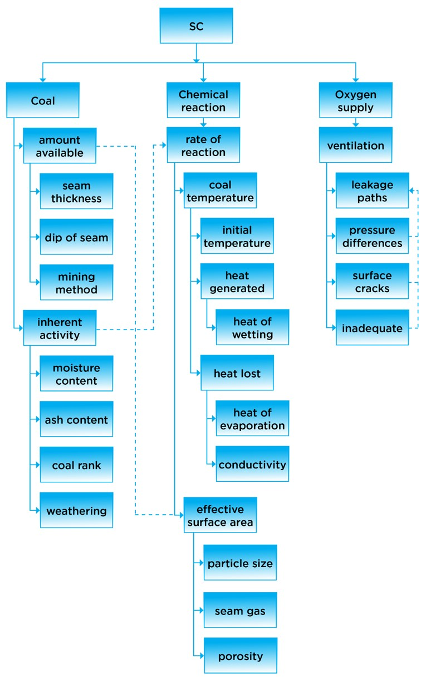

3.3. A control management system for spontaneous combustion
A key component of a PHMP is the identification of controls, activities and organisational systems used to manage the risks associated with spontaneous combustion. Information must be presented in a way that demonstrates the mine operator has met its obligations regarding the adequacy of the measures to be implemented.
This overarching collection of controls, control monitoring, support and verification activities and organisational systems deployed to manage unacceptable risk to as low as reasonably practicable is termed a ‘control management system’. For further details see Guide – Preparing a principal hazard management plan (section 5).

3.3.1. Hierarchy of controls
The mine operator needs to apply the hierarchy of controls set out in the work, health and safety laws. It must try to eliminate risks so far as is reasonably practicable. If elimination is not reasonably practicable, the risk must be minimised, so far as is reasonably practicable.
Where reasonably practicable, the more effective control measures should be used first. More than one type of control measure at a time can be used. The control measures used should be proportionate to the risk. Control measures include equipment, processes, procedures or behaviours to minimise risk. For further details see the Guide – Preparing a principal hazard management plan (section 5.2).

3.3.2. Known prevention controls for spontaneous combustion
Elements of mine design aimed at preventing spontaneous combustion include:
- roadway, pillar and extraction panel design
- ventilation (including managing pressure differentials) and ventilation control devices ◼ proactive inertisation.

3.3.3. Known mitigation controls for spontaneous combustion
A range of reactive/mitigating controls for spontaneous combustion include:
- atmospheric monitoring

- digging out accessible small heatings such as stowage
- flooding
- ventilation control
- inertisation
- use of gels and foams
- sealing and grouting (both permanent and rapid or emergency)
- pressure balancing.

Spontaneous combustion example: preventative and mitigating controls
The following are examples of preventative and mitigating controls used to manage a potential spontaneous combustion event in unsealed goaf (active or inactive). The consequence is worker injury or fatality in the underground mine environment.
Preventative controls:
- Goafs designed to minimise the propensity of spontaneous combustion (e.g. use of barrier pillars/segregated blocks; reduce the potential for interactions between seams and the surface).
- Geotechnical hazard mapping (forecast pre-consolidation) for unsealed goaf (e.g. faults).
- Design, implementation and maintenance of gas drainage system to prevent damage to pipes (including roof fall that damages drainage lines).
- Design, implementation and maintenance of gas drainage to address any gas build-up in stubs and cavities.
- Use of inertisation systems to minimise the ingress of oxygen into goaf areas (including reticulation systems, gag docking stations, access points for safe delivery of inertisation materials to the areas required).

Mitigating controls:
- Firefighting equipment including fire hydrants, fire depots, fire blankets, foams, water lines in fire resistant material, appropriate fire extinguishing agents for range of possible fire types.
- Withdrawal conditions
- Emergency escape (self, aided and assisted) systems (e.g. lifelines, fresh air bases.
refuge bays, mines rescue capability, compressed air breathing apparatus CABA, refilling stations, self-contained self-rescue [SCSR] cache).
- Ventilation and gas management to control accumulations of flammable mixture in the goaf adjacent to the mining operations and to ensure withdrawal of people if there is a suspected ignition source in the goaf.
- Emergency response (emergency sealing capability, emergency inertisation capability, incident management capability, robust mine environment monitoring system – pre and post incident).
Source: RISKGATE (www.riskgate.org/ ; ACARP project C20003)

3.3.4. TARPs and monitoring
Trigger action response plans (TARPs) summarise the overall mine environment monitoring arrangements and include planned actions ready to implement when certain trigger or alarm points are detected by monitoring. TARPs should be put in place only after a risk assessment has verified the selection of the most effective control measures. There are a range of detection mechanisms for spontaneous combustion, including both gaseous and physical indicators of spontaneous combustion.
Monitoring alone is not a control. The control is the action that is triggered when the monitoring system detects a change and activates a trigger/alarm.
TARPS represent a staged response to a situation that may deteriorate, from simply being abnormal through elevated oxidation to requiring withdrawal and sealing part or all of the mine.
TARPS should specify the actions/responsibilities required by all workers at each level.

The first level of a TARP may not be set to detect the onset of spontaneous combustion but rather the deviation of operating conditions from normal that may lead to spontaneous combustion (e.g. leakage of air into a goaf).
When spontaneous combustion is coupled with the risk of explosion there is the potential for catastrophic harm. The evacuation/withdrawal of workers TARP must be set such that people can evacuate safely before the risk of explosion eventuates. In this case, the TARP should be set around the combination of the potential for a flammable atmosphere and spontaneous combustion as an ignition source to exist. Generally, evidence that spontaneous combustion has exceeded the critical temperature of 100ºC is used as evidence that an ignition source can exist.

3.3.5. Documenting the control management system in the PHMP
- Identify and describe threats, controls and consequences.
- Use of schematics (e.g. bow-tie diagrams).
- Justify the use of controls.

3.3.6. Incident management
In addition to the TARP process outlined above, the management of any spontaneous combustion incident should be included within the emergency management plan. Details for emergency planning are contained within the NSW code of practice for emergency planning for mines. A key element of the emergency response is the incident management process. The NSW Mines Rescue Incident Command and Control System is an example of how to establish and operate an incident management system. Other guidance can be found in AS3745:2010, Planning for emergencies in facilities.

3.4. Measuring the effectiveness of controls
A critical control is a control that is crucial to preventing an event or mitigating the consequences of an event such that its absence or failure would significantly increase the risk despite the existence of other controls. As part of measuring the effectiveness of controls you should ensure no new hazards have been introduced. For further details see the Guide – Preparing a principal hazard management plan (sections 5.3 and 5.4).
The International Council on Mining and Metals (ICMM) has published a number of reference documents on critical controls.

3.4.1. Documenting critical controls and how they will be measured in the PHMP
It is imperative that critical control check lists are compiled to enable a site to validate that a control has been properly implemented and is functioning as designed. These checks must be carried out at a frequency sufficient to ensure the controls are remaining effective.
For example:
A critical control could be defined as keeping the pressure difference across the longwall face to less than 50 pa, to ensure that air leakage into the goaf is minimised while ensuring that there is adequate face ventilation. If the control is operating as designed, then pressure differential monitoring will identify that the pressure difference is as specified. The control is effective if monitoring of the goaf via gate road seals, sewer returns/goaf streams identifies that the oxygen concentration is within the expected range and the concentrations of any products of oxidation are within the range expected.

3.4.2. Information, training and instruction
The mine operator must ensure that the PHMP describes the arrangements for providing suitable and adequate information, training and instruction required by the WHS Regulation in relation to the principal hazard.
The national training competencies outline suitable training for workers in spontaneous combustion management.

3.5. Plan assurance: review, audit, continual improvement
The Guide – Preparing a principal hazard management plan (sections 6 and 7) details the processes for the following:
- performance standards
- audits
- reviews; and
- continuous improvement.

documents have described the CCM framework, including the Critical Control Management: Implementation Guide (ICMM,
2015a) and the Good Practice Guidance on Occupational Health Risk Assessment (ICMM, 2015b)

4. References
Australian Government. RII - Resources and Infrastructure Industry Training Package (Release 3.0). Retrieved from < https://training.gov.au/Training/Details/RII >.
Coal Services. (2017). Mines Services Incident Command and Control System (ICCS) Guide. Retrieved from < https://www.coalservices.com.au/wp-content/uploads/2017/11/ICCS-Guide-2014-1.pdf >.
Cliff, D., Brady, D., & Watkinson, M. (2018). Spontaneous Combustion in Australian Coal Mines (2018 ed). Redbank, QLD: SIMTARS.
Hassall, M., & Harris, J. (2017). Risk Controls Knowledge: Determining leading practice from case study analysis (ACARP report: C25036). Retrieved from: < https://www.acarp.com.au/abstracts.aspx?repId=C25036 >.
Hassall, M. E., Joy, J., Doran, C., & Punch, M. (2015). Selection and optimisation of risk controls (ACARP report C23007). < Retrieved from: http://www.acarp.com.au/abstracts.aspx?repId=C23007 >.
ICMM. (2015a). Critical Control Management Implementation Guide. Retrieved from:
< http://www.icmm.com/document/9722 >.
ICMM. (2015b). Health and safety critical control management good practice guide. Retrieved from: < http://www.icmm.com/document/8570 >.
NSW State Government. (Jan 2015). Emergency planning for mines – Code of Practice. NSW Department of Trade and Investment, Regional Infrastructure and Services, Mine Safety. Retrieved from < https://www.resourcesregulator.nsw.gov.au/__data/assets/pdf_file/0007/543913/NSW-code-ofpractice-Emergency-planning-for-mines.pdf >.
NSW State Government. (Feb 2015). Safety management systems in mines – Code of Practice. NSW
Department of Trade and Investment, Regional Infrastructure and Services, Division of Resources and Energy. Retrieved from <
https://www.resourcesregulator.nsw.gov.au/__data/assets/pdf_file/0008/543941/NSW-code-ofpractice-Safety-managment-systems-in-mines.pdf >.
NSW State Government. (June 2016). Consulting workers: Fact Sheet. Department of Industry – Resources and Energy, Mine Safety. Retrieved from <
https://www.resourcesregulator.nsw.gov.au/__data/assets/pdf_file/0008/537290/consulting-workersfactsheet.pdf >.
NSW State Government. (September 2020). Managing risks in mining and petroleum operations guide: Guide. NSW Resources Regulator. Retrieved from
< https://www.resourcesregulator.nsw.gov.au/__data/assets/pdf_file/0003/541533/GUIDE-Managingrisks-in-mine-and-petroleum-sites.pdf >.
NSW State Government. (Jan 2020). Guide – Preparing a principal hazard management plan. NSW Resources Regulator. Retrieved from <https://www.resourcesregulator.nsw.gov.au/__data/assets/pdf_file/0009/691614/Guide-Preparing-aprincipal-hazard-management-plan.pdf>.
NSW State Government. (July 2018). Airborne contaminants principal hazard management plan.
Department of Industry – Resources Regulator. Retrieved from
<https://www.resourcesregulator.nsw.gov.au/__data/assets/pdf_file/0003/823422/AirborneContaminants-PHMP-Guide.pdf>.
NSW State Government, Safe Work NSW. (Aug 2019). How to manage work health and safety risks – Code of Practice. Retrieved from
<https://www.safework.nsw.gov.au/__data/assets/pdf_file/0012/50070/How-to-manage-work-healthand-safety-risks-COP.pdf>.
NSW State Government, Safe Work NSW. (Aug 2019). Work health and safety consultation, cooperation and coordination: Code of practice. Retrieved from <
https://www.safework.nsw.gov.au/__data/assets/pdf_file/0013/50071/Work-health-and-safetyconsultation,-cooperation-and-coordination-COP.pdf>.
Standards Australia. (2010). Planning for emergencies in facilities (AS 3745:2010). Sydney, NSW: SAI Global Ltd.
Standards Australia. (2016). Determination of gas content of coal and carbonaceous material: Direct desorption method (AS 3980:2016). Sydney, NSW: SAI Global Ltd.
Standards Australia. (2018). Risk management: Principles and guidelines (AS ISO 31000:2018). Sydney, NSW: SAI Global Pty.
Standards Australia & New Zealand Standards. (2018). Requirements with guidance for use -
Occupational health and safety management systems: Requirements with guidance for use (AS/NZS ISO 45001:2018). Sydney, NSW: SAI Global Pty.

Appendix A: Plan implementation: roles and responsibilities

Statutory and other roles
Table 2 provides an example of the allocation of tasks to people responsible for the spontaneous combustion PHMP. It may be used as a guide for this process.
Table 2: An example of the allocation of tasks to people responsible for the spontaneous combustion PHMP
Role | Accountabilities for this document
The mine operator • Establish the development and implementation of
the PHMP for spontaneous combustion.
- Monitor the effectiveness of this PHMP.
- Provide appropriate resources to implement this PHMP.
- Specify functions and responsibility and provide training.
Mining engineering manager | - Monitor the effectiveness of this PHMP.  - Approve changes to this PHMP, and associated standards and procedures.  - Monitor performance of persons in carrying out responsibilities under this PHMP.  - Approve all final driveage layouts before submission to the Regulator for approval.  - Review spontaneous combustion conditions in conjunction with life of mine plan and annual budget.  - Perform any duties specifically required by this PHMP.  - Establish that all individuals with functions and responsibilities under this plan are trained and competent to carry out those responsibilities.  o Establish that all workers are aware of, and understand their responsibilities as stated in the plan, and that these responsibilities are included in their position descriptions.
- Establish that training material is developed and provided for all functions of the plan.
- Establish that any systems and procedures are developed and implemented in accordance with the requirements of the plan.
- Establish that the plan is monitored, audited, reviewed at intervals not exceeding 12 months, or if a specific event occurs as defined in the plan. Any changes should be conveyed to the workforce. o Establish that all risk-assessment processes are formally documented. o Verify that any corrective action undertaken has been conducted.
- Co-ordinate remedial action necessary in the event of any emergency occurring underground.
- Sign off on the panel reviews as soon as practicable.
- Establish that sufficient resources are allocated.
- Comply with any other requirement of the PHMP for spontaneous combustion for this function.
Ventilation officer • Set high and low alarms to monitor gas levels.
- Direct the installation of appropriate monitoring of gas levels and air quantities.
- Maintain knowledge of current industry standards in inertisation.
- Monitor the effectiveness of this PHMP.
- Recommend changes to this PHMP.
- Monitor performance of procedures required under this PHMP.
- Liaise with the mine planning engineer and statutory officials with respect to spontaneous combustion issues.
- Update training packages as required.
- Provide advice on spontaneous combustion matters to mine officials as required.
- Report to mining engineering manager any relevant matters that the ventilation officer cannot remedy.
Undermanager/ senior shift mining supervisors | - Participate in review of this PHMP as required.  - Assess effectiveness of this PHMP.  - Monitor performance of persons in carrying out responsibilities under this PHMP.  - Monitor performance of procedures required under this PHMP.  - Monitor for indications of spontaneous combustion.  - Report to the ventilation officer any relevant matters that undermanager cannot remedy.  - Document in the undermanager’s reports any abnormal or unusual conditions which may be relevant to mine ventilation, mine monitoring and spontaneous combustion and bring such details to the attention of the ventilation officer.  - Perform any duties specifically required by this PHMP.  - Check the installation of monitoring stations is in accordance with the PHMP for spontaneous combustion.  - Check the strata support is installed in accordance with the mine support plans.  - Ensure corrective action for the above if required.  - Respond to alerts from section mining supervisors.  - Record details and notify appropriate supervisors of any spontaneous combustion with the potential to injure people or cause significant downtime.
Technical services manager • Facilitate the implementation of the PHMP for
spontaneous combustion and ensure it is updated and modified as necessary:
  - Assist the mining engineering manager in identifying the resources required to meet the requirements of this plan.
  - Liaise with the technical experts such as geologists and geotechnical workers regarding any additional information or investigation that may be warranted for the compilation of the hazard plans.
  - Review the system before the mining of any new section of the mine along with a review at the completion of the section. o Oversee intermediate reviews as required.
  - Determine the nature, location and frequency of monitoring. o Organise internal/external reviews.
  - Comply with any other requirement of the PHMP for spontaneous combustion for this function.
- Ensure short term and long-term planning adequately considers spontaneous combustion risk.
- Report to the ventilation officer and mine planning engineer any features that may affect spontaneous combustion risk.
- Ensure surface boreholes are sealed to standard and supply a list of locations of boreholes to the ventilation officer and survey.
- Provide appropriate resources to implement this PHMP.
- Perform any duties specifically required by this PHMP.
All supervisors (e.g. deputies) | - Participate in review of this PHMP as required.  - Monitor for indications of spontaneous combustion in area of responsibility.  - Report to undermanager and/or ventilation officer any relevant matters deputy cannot remedy.  - Participate in training as required.  - Perform any duties specifically required by this PHMP.  - Check the installation of monitoring stations is in accordance with the PHMP for spontaneous combustion.  - Facilitate corrective action for the above if required.  - Respond to alerts from section workers.  - Record details and notify shift supervisor of any spontaneous combustion with the potential to injure people or cause significant downtime.
Manager of electrical engineering • Participate in review of this PHMP as required. • Monitor performance of persons in electrical department in carrying out responsibilities under this PHMP.
- Monitor performance of electrical related procedures required under this PHMP.
- Oversee the procedures for maintenance and calibration of the gas and ventilation monitoring systems are carried out.
- Ensuring the monitoring system has an automatic fail safe alarm system.
- Report to the Ventilation Officer any relevant matters that the electrical engineer cannot remedy.
Control room operators | - Participate in review of this PHMP as required.  - Respond appropriately and promptly to any gas monitoring warning level or alarm, other ventilation alarm, or failure of part of the monitoring system.  - Comply with applicable procedures as required under this PHMP.  - Report to the Ventilation Officer any relevant matters that the CRO cannot remedy.  - Participate in training as required.  - Perform any duties specifically required by this PHMP.
Mine surveyor • Maintain plans of surface and underground
boreholes.
- Maintain a plan updated monthly of stowage locations.
- Ensure surveying of underground roadways is undertaken.
- Check that the roadways are driven to design and in relation to orientation and dimensions.
- Ensure surveys are carried out and transferred onto suitable plans for filing and reference purposes and roadways are plotted as constructed.
- Ensure all boreholes are shown on section hazard plans.
- Comply with any other requirement of the PHMP for spontaneous combustion for this function.
Training coordinator | - Assist in developing relevant training modules, including CROs.  - Deliver training as required.  - Maintain records of training.
All employees and contractors • Report suspected spontaneous combustion indicators to a mining supervisor.
- Comply with procedures to minimise risk of spontaneous combustion.
- Participate in training as required.
- Perform any duties specifically required by this PHMP.

Appendix B: Locations of heatings and case studies
This information is not included in Cliff, Brady and Watkinson’s (2018) technical guide: Spontaneous Combustion in Australian Coal Mines.
6
An appreciation of the characteristics of spontaneous combustion and an understanding of the places in the mine where heatings may develop is critical to the development of an effective spontaneous combustion management plan. Prevention, early detection, and control of the spontaneous combustion risk will not be effective unless the potential hazards and locations are correctly identified.

Locations in the mine where heatings may develop include:

1. Longwall extraction area
The diagram below (figure 4) indicates typical locations of heatings in the longwall goaf.
Figure 4: Typical longwall spontaneous combustion sites (Liang et al, 2019)
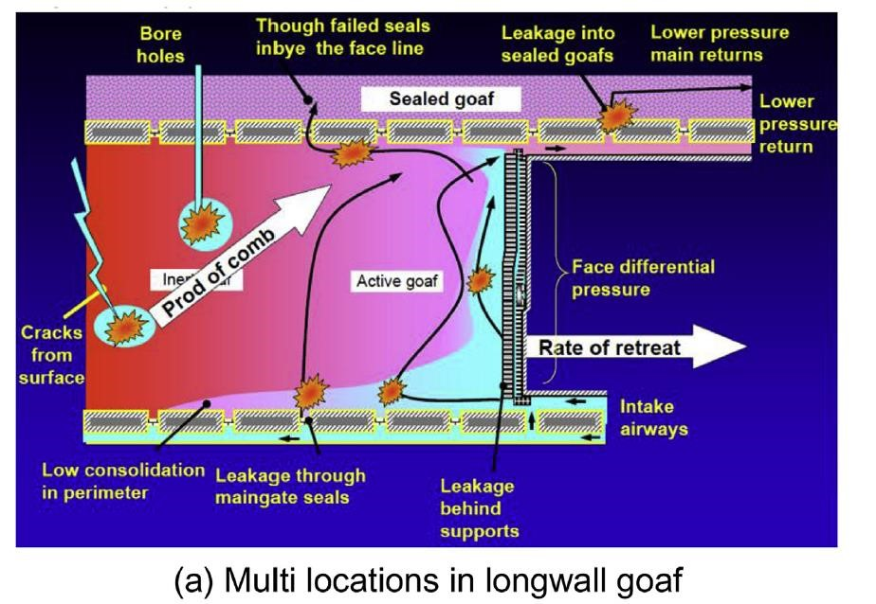

The conditions required to initiate a heating are more likely to exist in a goaf than in other parts of the mine. The risk of heating in an active longwall goaf is greater as there are several flow paths available into areas that cannot be sealed by strata consolidation. The major factor preventing heatings is the exclusion of oxygen by accumulation of seam gases.
Spontaneous combustion in the active longwall goaf may be caused by air drawn behind the roof support line or leakage through a goaf edge seal. The area of greatest risk is the edge of the goaf where there is rib spall, voids, incomplete caving and close proximity to ventilated roadways. Air permeability is higher and high ventilation pressure and poor containment can allow air to enter the goaf.
Heatings are unlikely to develop in a fully caved area because the fallen rock buries the potential heating location and air permeability is low. (Consolidated area) Replenishment of oxygen in the fully caved area is unlikely to be adequate to sustain spontaneous combustion.
In mines where longwall gate roads have to be heavily supported, goaf formation alongside chain pillars may be delayed or incomplete resulting in cavities extending a considerable distance into the goaf. Air may flow into the goaf due to pressure differences and densities around the panel (where bleeders are used) or into and across the goaf behind the longwall face. This was believed to be an issue at Moranbah North in Queensland and at Dartbrook in NSW.
Sub-critical extraction systems, (associated with limited surface subsidence) designed with stable chain pillars, may result in voids above the caved area permitting increased airflow paths across the goaf. Rider seams in the area where there are voids pose a risk of spontaneous combustion. The distance of rider seams, both above and below the seam being mined, can vary over the extent of the mine. In some areas of mining a rider seam may not be a factor, but can become a factor if breakage of the rider into the goaf occurs. The propensity of the rider seams can vary, therefore as the mine advances, regular laboratory testing programs for spontaneous combustion propensities should include the rider seams as well as the primary seam. The circumstances where rider seams exist in either the immediate roof or floor horizons and how these might interact with the goaf should be evaluated. Note: the presence of any pyritic carbonaceous shales and high sulfur areas should also be evaluated in terms of their spontaneous combustion hazard likelihood, particularly if the coal measures are part of a marine sequence. Several major spontaneous combustion events in underground coal mines have occurred due to this situation.
Active long wall panels have an unsealed side adjacent to the goaf where the longwall face equipment is located. Oxygen can enter the extracted area due to face ventilation airflow and barometric pressure changes. Barometric variations exceed the ventilation pressure difference across the face and can have a significant effect by moving air, in and out of the goaf, by expansion and contraction.
In an active longwall panel, there may be sufficient oxygen to allow oxidation to take place approximately 150 metres to 400 metres into the goaf from the long wall face. The distance will vary according to the frequency and severity of barometric changes, dip of the seam and direction, natural inertisation processes and the standard of containment structures.
If operating conditions result in a protracted delay in long wall face retreat, there is a risk of spontaneous combustion developing in the goaf. The importance of any protracted delay in longwall face retreat should be incorporated as a trigger in the TARP.
Figure 5 shows areas in a longwall extraction area where spontaneous combustion may develop if preventative measures such as the standards for stoppings and seals and ventilation pressure difference are inadequate.
Figure 5: Longwall goaf - hazards
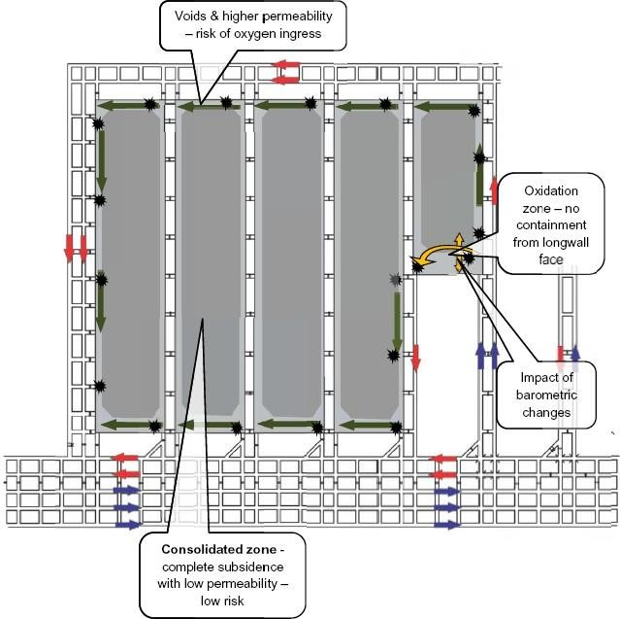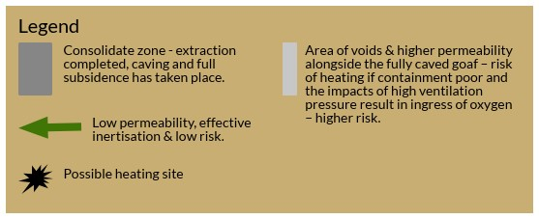

2. Bord and pillar extraction areas
B5
The system of continuous miner extraction requires stooks to be left to protect operators in the working area. This ensures broken coal in the goaf and may result in delayed caving.
Similar to a longwall, spontaneous combustion is controlled by:
- the consolidated zone where complete caving takes place
- inertisation as a result of containment, seam gases and oxidation
- a regular and progressive extraction rate
- minimisation of pressure differences across and alongside sealed areas
- inspection and maintenance of seals and seal sites to control leakage
- sampling and analysis of sealed area atmospheres.
Deficiencies in any of these control measures will increase the risk of spontaneous combustion.
Spontaneous combustion in sealed areas may be caused by air leaking into, or through, seals or the sealed area having an oxygen-rich atmosphere.
Heavy weighting, seam structures and roof control problems may result in additional coal being left in the goaf. Incomplete extraction may delay caving, encourage greater air movement in the goaf and cause coal to be exposed to the risk of heating.
The rate of extraction with continuous miners is normally less than that of a longwall system.
Where discrete panels are developed with each panel having a barrier on three sides, containment and inertisation is effective except for the working area adjacent to the goaf.
Pillar extraction of one side of the panel on the advance, as has been practiced in several places, increases potential for air ingress into the goaf and increases the time available for the air to react with the coal.
Partial extraction systems are being adopted more often. Where such systems are used, caving may be incomplete and irregular, leading to voids and potential air paths in the extracted area. Stable pillars may be left and spans reduced to sub-critical. This results in voids in the goaf where air can flow and may increase the risk of spontaneous combustion developing within the goaf.
Error! Reference source not found.6 shows a system of panels isolated by barriers and typical locations where heatings can occur. With low depth of cover, or other seam workings within close proximity, there is the risk of interconnectivity through cracks and those areas of risk could extend to all goaf edges.
Heatings will only develop if inertisation is ineffective.
Figure 6: Continuous miner isolated panels - hazards
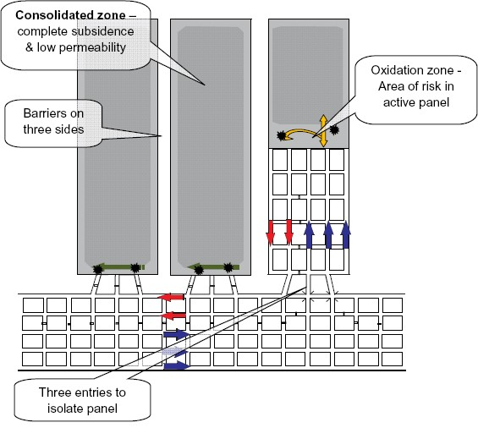

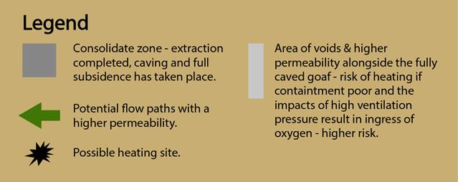

Continuous miner interconnected pillars - hazards 7 shows an arrangement where panels are not isolated by barriers and instead have reduced to manageable size by a line of stoppings. Areas of risk where heatings may occur in the goaf are shown. This assumes no interconnectivity from the surface, boreholes, or workings in another seam.
Heatings will only develop if inertisation is ineffective.

Figure 7: Continuous miner interconnected pillars - hazards

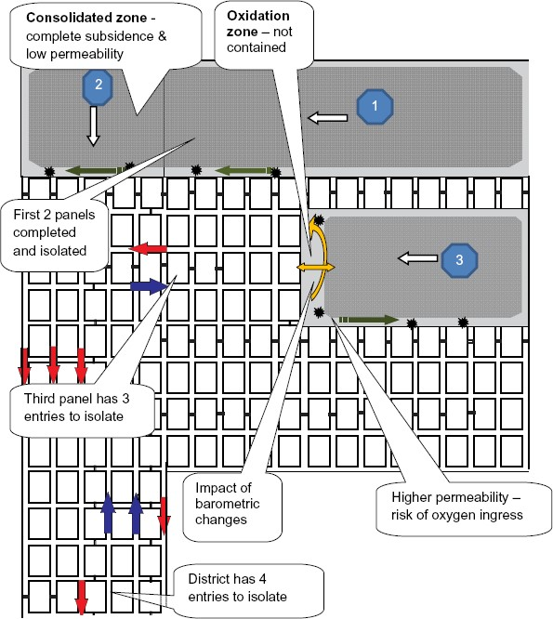Possible heating sites

3. Stowage (fallen tops and dumped coal)
3
A heating may develop in coal stowage or fallen top coal. Stowage can be likened to a surface stockpile where a heating develops. Conditions that favour the development of a heating in stowage include:
- limited ventilation flow across the stowage or fall
- height and mass of the stowage
- ingress of moisture
- ineffective inspection
- drying out of fines leading to cracking, air ingress and greater surface area of coal fines exposed.
Long term storage of coal in a bin may self-heat given the right conditions.

4. Rib side pillar
3
Pillar heatings, (see figure 8) particularly where adjacent to ventilation stoppings, are generally caused by:
- high-pressure differential between intake and return airways and along a length of roadway
- fracturing in the rib side
- crushing of pillars
- presence of broken coal as accumulations or behind lagging. Flow of air to underlying or overlying workings
- air crossings with high differential pressures
- coals with high propensity
- leakage paths associated with cracks, cleat, fractures, faults, joints, friable seam bands, and unsealed boreholes
- box cut entries where the mine fan is located in the box cut and near the intake roadways result in high ventilating pressure in ground that may be damaged by blasting during construction of the box cut.
Shotcrete or an equivalent sealing material is sometimes applied to control rib and roof stability and to reduce leakage paths, particularly around return airway entries from box cuts, highwalls, drifts and shafts intersecting seams. The shotcrete is sometimes a contributing factor to either inhibiting the discovery of heatings by masking the heat present behind it or reducing air leakage to a degree where oxygen is supplied but heat is not removed during the oxidation of the coal. Cracks in shotcrete allow egress of air into the return airways from the intakes. These cracks in shotcrete require regular inspection for indication of changing gas emissions or radiation of heat.
Heating sites tend to be near and on the intake side of the stopping in the highest pressure difference area, i.e. closest to the mine entries. Such heatings may be difficult to detect until well advanced because of their relatively small size and the dilution of gaseous products by high volume airflows.
Figure 8: Typical spontaneous combustion sites in roadway pillars (Liang et al, 2019)
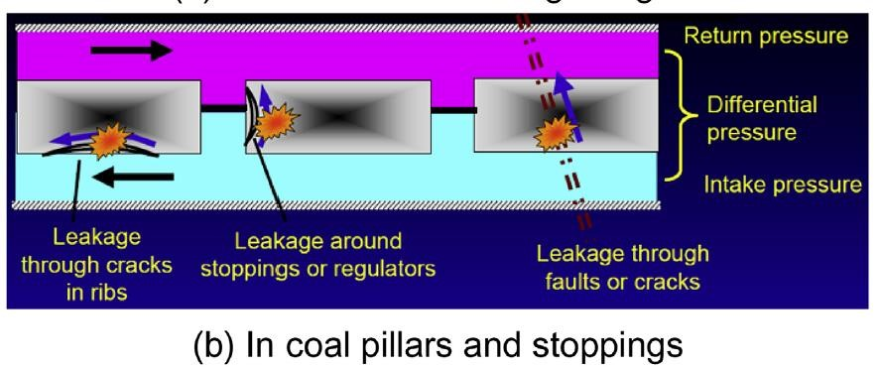
Figure 9: Typical spontaneous combustion sites in roadways (Liang et al, 2019)
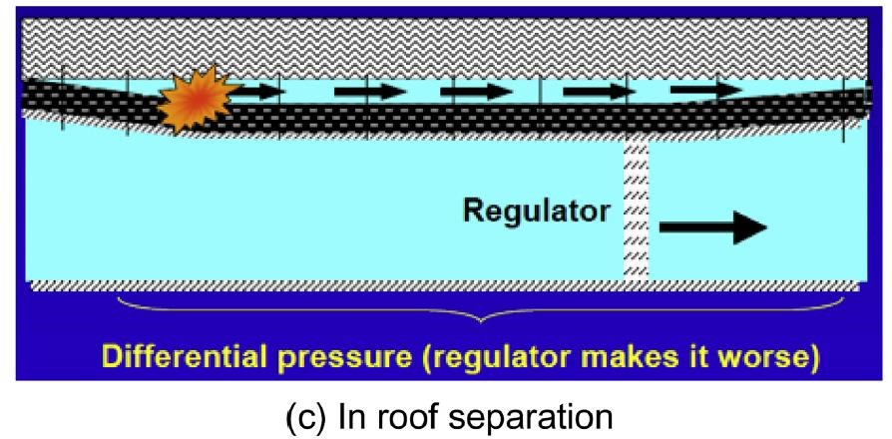

5. In situ coal
Heatings may occur in roof or floor coal that has been cracked or broken by convergence. Top coal or floor coal left in the mining process may be subject to heating under favourable conditions. The assessment of these circumstances need to be recognised by using appropriate evaluation test methods for quantifying the accelerated self-heating effects.
A heating has been known to take place in top coal in situ in the roof. The coal was a few metres thick and subject to convergence and cracking. An adjacent area may have fallen, exposing one face of the top to air ingress. The top coal fell and burst into flame. Edges of the roof fall from where the fall originated were hot enough to turn water from fire hoses into steam (Aberdare North Tunnel 1970).

6. Reduced extraction rate and/or unplanned disruption
5
Continuance of a rapid rate of retreat ensuring that coal in the goaf is sealed or immersed in an inert atmosphere before accelerated oxidation occurs, is an effective means of preventing spontaneous combustion in a goaf.
An unplanned disruption to mining, or significantly reduced extraction rate could result in an increased risk of spontaneous combustion. These events can occur due to geological and geotechnical factors, industrial action and slowness in moving a longwall after panel completion.
Means to increase the rate of retreat include:
- reschedule planned maintenance
- operate weekend shifts that may not be planned for production.

7. Use of wood
Many mines with a propensity for spontaneous combustion have minimised the use of wood supports particularly in areas where full caving does not occur. This reduces the quantity of carbonaceous fuel if a heating does occur.

Mine design: control measures

1. Control measures for longwall extraction
7
Control measures in longwall extraction include:
- enclosing the goaf as the longwall retreats with effective seals
- minimising pressure differential/air flow across the elevated risk areas of a goaf
- maintaining a constant rate of longwall retreat
- prompt recovery of longwall equipment at panel completion
- monitoring the longwall tailgate goaf atmosphere as the longwall retreats
- monitoring the goaf atmosphere adjacent to the ventilated roadways
- inspecting seals, longwall return and goaf edges
- optimisation of self or externally applied, inertisation of goaf
- controlling goaf management systems particularly in respect to drawing oxygen into the goaf (this includes ensuring sufficient capping and eventual sealing of boreholes when not in use).
In an active longwall, the goaf alongside the working area cannot be enclosed and there is a risk of spontaneous combustion developing should there be a protracted face delay. Reliance on the incubation period and rate of retreat is the normal control. Having a TARP should be considered.
The time taken for a heating to develop (incubation period) is unpredictable and variable. It depends upon factors such as the properties of the coal and the environmental conditions. Appropriate laboratory testing techniques are available and should be considered to evaluate the minimum incubation period for coal under site-specific conditions. This requires considering provision for inertisation and rapid sealing in the event of a protracted production delay that results in a heating.
Accelerating the rate of extraction by extending operating time is a control that has been used for many years in both longwall and continuous miner extraction.
The system shown in figure 5 is most common for Australian longwalls. Bleeder roads have the advantage of ventilating the future tailgate for the successive longwalls and avoiding the drivage of single entry development for gate roads. They do provide a risk of air passing into the goaf from the adjacent bleeder road if containment and inertisation are not effective.
An option for a longwall mine with a high propensity for spontaneous combustion is to drive single entry roadways either side of the block, or to leave barriers between sets of gateroads.

2. Control measures for bord and pillar extraction
Similar to a longwall, spontaneous combustion is controlled by:
- complete caving
- effective inertisation
- a regular and progressive extraction rate
- minimising pressure differentials across sealed areas
- inspecting and maintaining seals and seal sites to reduce air leakage
- sampling and analysing sealed area atmospheres.
Figure 6 shows a most effective system of containing the goaf. The panels are of such a size that extraction will proceed reasonably quickly and there are only three entries into the extracted area that will need to be sealed on panel completion. This would be appropriate where there is a high propensity of spontaneous combustion.
In some circumstances it may not be possible to plan continuous miner extraction panels as in Continuous miner interconnected pillars - hazards 6. There may be pillars already formed from earlier workings or there may be other constraints on mine planning. Large areas of pillars can be reduced into manageable panels by placing stoppings so that the panel width is reduced and there are a minimum number of entries to seal off on completion, or before completion in the event of a heating.
Figure 7 shows a method of dividing a large area into a number of smaller panels that are capable of being isolated quickly in the event of spontaneous combustion. Several variations to this theme are possible. The extent to which panels need to be reduced in size and barriers provided for isolation depends upon the propensity for spontaneous combustion and the efficiency of inertisation.

3. Withdrawal conditions
As described above, TARPS should be established to control spontaneous combustion events. Should control not be effective then the spontaneous combustion PHMP in conjunction with the emergency response PHMP should establish a withdrawal conditions TARP. This TARP should define triggers that indicate the potential for an ignition source (in this case, spontaneous combustion with the potential to ignite a flammable atmosphere) and a flammable atmosphere to coexist. The flammable atmosphere may be created by normal mine seam or goaf gas or in extreme cases the spontaneous combustion event may generate the atmosphere itself (e.g. Ulan, 1990). It is generally considered that once a spontaneous combustion event has exceeded a temperature of 100ºCelsius that it has the potential to become an ignition source. In setting a TARP for withdrawal, the reliability of the monitoring system to detect these conditions at an early stage needs to be considered. The more remote the monitoring to the potential site of the spontaneous combustion, the more conservative the trigger should be.

Case studies

Liddell – October 1971
The seam mined was the Liddell. Several heatings had occurred in the mine (figure 10). Two heatings in bord and pillar extraction panels resulted in the panels being sealed. Roof falls invariably contained 0.5 metres or more of top coal and were another source of heatings. The background level for carbon monoxide was around 3ppm and a concentration of 8ppm usually indicated a heating.
Before 1969, there were several heatings in the ribsides of pillars separating the main intake and return (figure 10). These were dug out and the pillar treated with water infusion. An attempt was made to affect a more permanent solution by balancing the pressures around the pillar. No. 2 Heading return was placed on intake pressure.
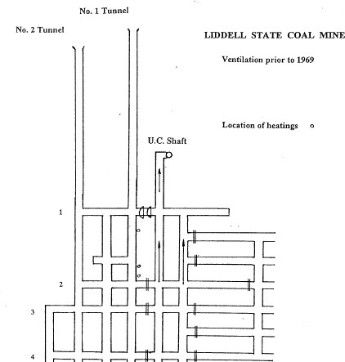
Figure 10:

Entry roadways into Liddell State Mine as at 1969

In September 1969, another heating took place in the ribside of the pillar between the intake and return. The heating was dug out and the pillar infused with water. No. 2 Heading was sealed off completely between No. 1 and No. 4 cut throughs and daily inspections and regular sampling was carried out.
In October 1969, smoke issued from the edges of the seals and the carbon monoxide concentration rose from 1.04% to 2.53% on successive days. The temperature was 44ºCelsius. Leaks around the seals were repaired, the pillar ribs united and carbon dioxide injected into the area. There was improvement over the following weeks but there were signs that heating was not under control. A rescue team entered the area and found a heating in the ribside showing as white ash and a red glow. The seals in No. 2 Heading were breached and a rescue team hosed and dug out the heating. Water infusion was carried out again.
Figure 11: Location of heatings at Liddell State Mine 1964-1973
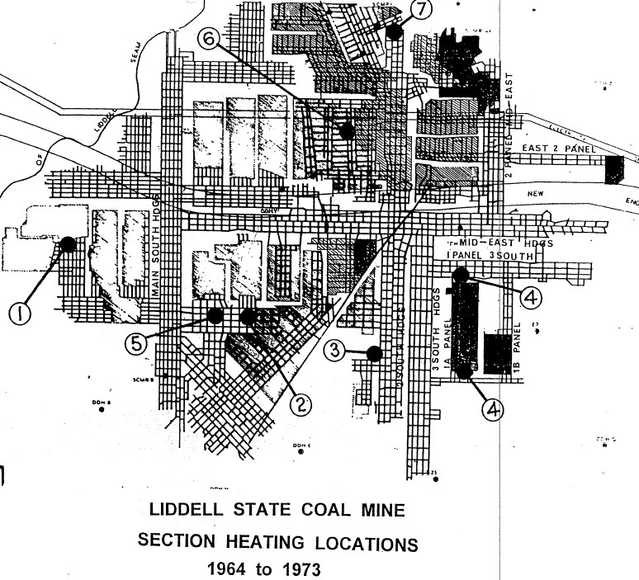

In December 1969, a new return airway was driven and the pillars between No. 1 and 2 Headings were put on intake pressure (figure 11). Inspections and monitoring were carried out on a regular basis. For 22 months there were no indications that anything was unusual until a fire broke out on 21 October 1971. The mine was evacuated and sealed.
A pre-shift inspection of the mine at 9.30pm on Sunday 24 October 1971 determined that there was nothing abnormal. A deputy later said that there was some haze that he thought was diesel smoke in the transport road. The first transport left the surface at 12.10am on Monday 25 October 1971 and at No 5 cut through, the driver stopped the transport when he noticed an unusual smell. Smoke was found issuing from No. 1 and 3 cut throughs into the belt heading but was too thick to allow entry to locate the source.
Brattice stoppings were erected across the main intakes below No. 1 cut through and a hole in the No 3 cut through stopping was enlarged to clear the smoke. The smoke was forced back to the second ventilation door at No 1 cut through but was not cleared beyond that point. Fire hoses at this stage were being directed at the smoke.
At 1.00am the concentration at the fan was 10ppm but there was no fire smell. At 2.30am some burning material was seen falling from the roof at the intersection of No. 2 Heading and No. 1 cut through and it was obvious that a fire was in the top coal.
At 4.00am the carbon monoxide level at the fan had risen to 50ppm and the situation was becoming worse. A rescue team was sent to open a stopping at No. 4 cut through to short circuit the ventilation. The team had just left the fresh air base (FAB) when a fall occurred outbye flooding the FAB with dense smoke and catching the standby team uncoupled. Both teams eventually retreated in nil visibility across the No. 2 cut through to No. 5 Heading and fresh air. The fall had occurred in the intersection of No. 1 cut through and No. 2 Heading and was a mass of flame.
Attempts to fight the fire with water and foam were unsuccessful. During a 40-minute period when foam ran out, results improved. Variations to ventilation made no improvement. There was a sudden increase in black smoke at the fan shaft (figure 12). The heavy smoke from the fan was soon followed by flames rising to a height of about 15 to 20 metres. Soon after, the fan stopped and, the fan building collapsed. The mine was then sealed.

Figure 12: Fire emitting from fan shaft
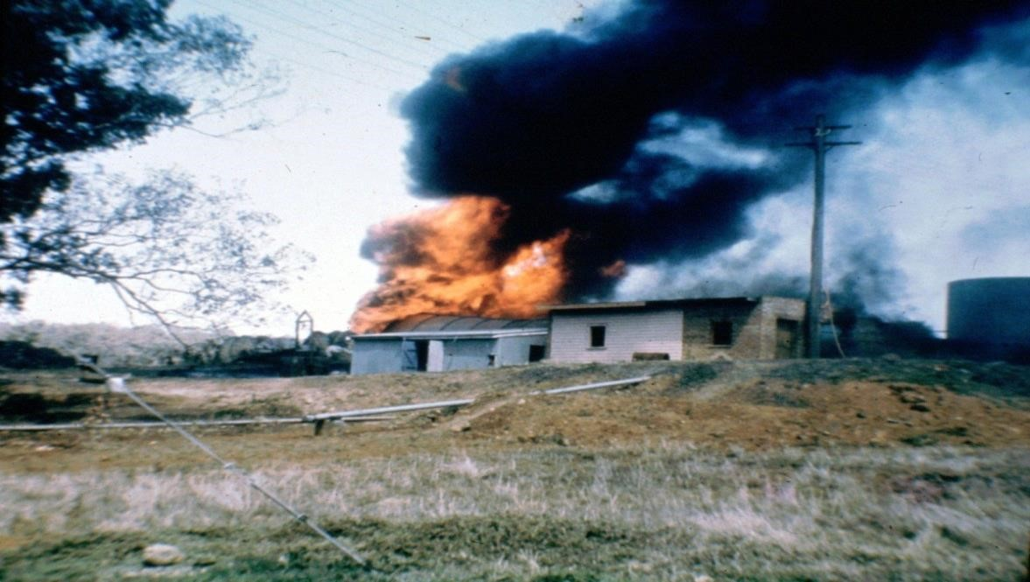
Contributing factors to the heating that occurred near the entries of the mine were determined to be:
- General nature of the Liddell seam coal.
- Porous nature of the coal, particularly near the outcrop.
- Pressure difference between intake and return (about 500 pascals).
- Relatively small size of pillars between intake and return (22 metres).

Kianga No.1 – September 1975
About 5.10pm on Saturday, 20 September 1975, an explosion occurred in the Kianga No. 1 underground mine. Thirteen men died. The men were engaged in sealing a heating in the No. 4 section of the mine at the time of the explosion (figure 13). The magnitude of the explosion was such that sections of the main conveyor were blown out of the mine. Belt rollers were blown 200 to 300 metres from the tunnel mouth.
A deputy starting a pre-shift inspection on 20 September entered the return at 7.30am and noticed a slight haze. He walked inbye for two pillars without noticing anything unusual and then returned to the surface to take observations at the fan. He saw no smoke but attributed a fire smell to a fire that had occurred previously in a bolter shunt outbye of the fan shaft. Nevertheless, he was still suspicious and immediately reported the haze and smell to his manager.
The manager and the deputy went underground to 2 North return and then 4 North where, in the return, smoke was obvious and the fire smell more obvious. Gas readings were taken with 25ppm carbon monoxide detected.
Construction of the brick seals began at 11.30am. Readings of 80ppm carbon monoxide and 1% methane were noted. About 5.10pm, ‘popping’ was heard, lights flickered and an explosion occurred.
About 3 metres of the bottom section of a 4.2 metre seam was mined by continuous miners. The seam was gassy and liable to spontaneous combustion. The goaf was partially ventilated. Eight rows of pillars had been developed and three rows of pillars extracted. This was about six months’ work.
Evidence of a heating had been discovered in the goaf area of 4 North. There appears to have been a large body of methane in the goaf with 3% to 4% found at the edge of the goaf at 7 cut through. Over the six hours before the explosion, a barometric drop of not less than 5 millibars occurred.
The use of a Beckman gas analyser at the mine was a considerable improvement on methods generally in use in Queensland at the time. The normal signs of sweating, fire smell and haze were not reported in 4 North return before the discovery of smoke.
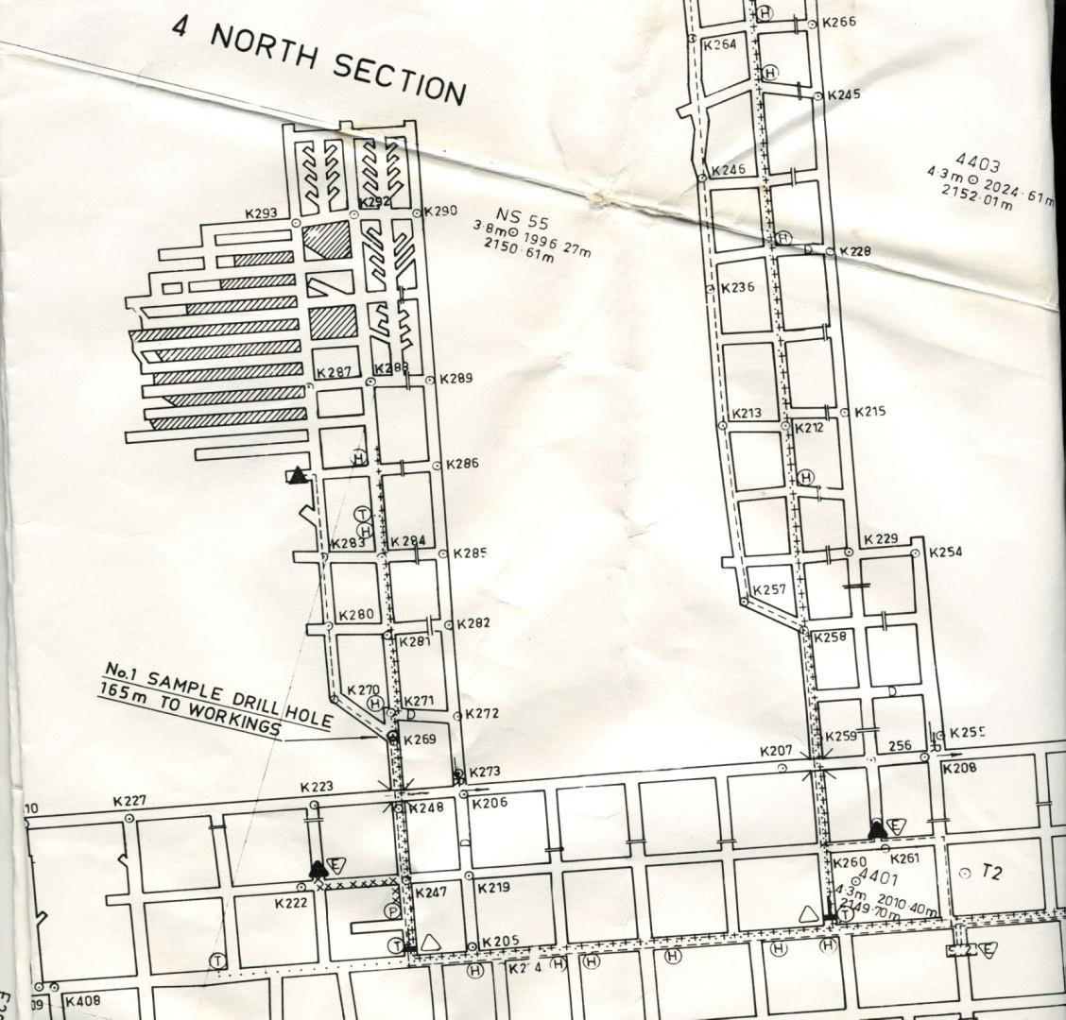
Figure 13:

Kianga Mine plan

Leichardt Colliery – December 1981
Leichardt Colliery was near Blackwater in Queensland. Mine entries were two vertical shafts equipped with winders. The mine had a history of outbursts and high methane emissions. (Methane 16m3/ tonne) The 6 metre thick Gemini seam was mined at a depth of cover of about 400 metres. Mining in the Gemini seam began in 1969 and spontaneous combustion problems were not experienced until 1981.
A deputy on a pre-shift inspection discovered a smoke haze at the pit bottom of No. 2 Shaft at 6.20am on 29 December 1981. Further investigation revealed thick smoke coming from the main east return and that 10ppm carbon monoxide was present in the return shaft.
At 11.30am on 29 December, the incident management team (IMT) decided no further action would be taken until a detailed analysis of the atmosphere was available. Gas samples were dispatched to Brisbane where Australian Coal Industries Research Laboratories Ltd were asked to supply a gas chromatograph.
About 8.40pm, the first results were obtained from Brisbane. The chromatograph was damaged in transit and failed to function for about nine hours.
On the basis of the gas results, a rescue team was sent underground at 12pm to establish the source of the heating. The first team entering the mine detected thick smoke and about 800 ppm carbon monoxide at No. 4 cut through on the east belt road. Smoke reduced visibility to an intolerable level and the team retreated to the adjacent track road. The team continued inbye to No. 5 cut through and again encountered thick smoke and high temperature.
An exploration across No. 5 cut through revealed the source of the heating in a pile of slack coal in a stub end in the right hand rib of the belt road inbye No. 5 cut through. Open flame was visible in a number of areas over a distance of about 5 metres. They determined the fire was poorly ventilated but relatively stable and the gases produced were non-explosive.
Mine rescue teams fought the fire during the remainder of the day. At midnight, the area was declared safe and they continued to hose down the heated zone for another 12 hours before the slack coal was loaded out. This was completed by 4.30am on 31 December 1981.

Laleham No. 1 - 1982
Laleham Colliery was about 40 kilometres south of Blackwater in Queensland. The 3.7 metre thick Pollux seam was being worked. During 1974 and 1975, serious heatings were experienced in pillars between the main intake and return roadways and in July 1975, a serious heating was detected in the goaf of a pillar extraction panel.
On 4 May 1982, a deputy on a routine inspection of outbye intake roadways discovered smoke and 150 ppm carbon monoxide on a Drager tube. Subsequent investigations revealed dense smoke and carbon monoxide in excess of 3000 ppm issuing from an inaccessible area of intake roadway.
This incident resulted in the closure of the mine for about seven days and required a major reorganisation of the ventilation network that was not completed until 25 September 1982.
Monitoring showed that the situation was very serious with the atmosphere in the sealed area either explosive or potentially explosive on several occasions. The major flammable contribution to the explosive atmosphere was hydrogen, which reached a peak of 4.57% on 8 May 1982. This abnormally high concentration may have been due to the injection of water onto the heated zone that may have produced water gas.
Attempts were made to inject water into the barrier pillar between the approximate site of the heating and the main intake roadway. At the same time, attempts were made to gain access to the site by loading out a fall. This was abandoned due to boggy floor, heavy roof and a clear indication the fire area was increasing. It was then decided to seal the area. While this was being done, four long holes were drilled through the barrier pillar and these were connected to hoses for water infusion.
The final sealing was accomplished on 5 May 1982. By this time, the atmosphere coming from the fire area contained thick, black smoke with a strong, tarry odour.
Holes were drilled from the surface to intersect roadways affected by the fire, and to fill the voids with concrete slurry. Despite 1562m³ of concrete slurry being used to affect a seal, high levels of carbon monoxide were still being produced.
An attempt was made to inject the pillar with bentonite grout and concrete slurry and when this proved unsuccessful, a further six holes were drilled from the surface to fill any remaining voids with fly ash. Although a total of 360 tonnes of fly ash was used, high levels of carbon monoxide continued to be liberated from cracks in the pillar. These areas were treated by the injection of bentonite and cement grout. The problem was not entirely solved until the pressure differential was removed on 25 September 1982.

Moura No. 2 – April 1986
Moura No. 2 mine was in the Moura coalfield in the south eastern part of the Bowen Basin in Queensland. There were five economically exploitable seams, varying from about 2.1 metres to 7 metres in thickness. Seam thickness in the ‘D’ seam worked varied from 2.4 metres to greater than 6 metres. Extraction panels were driven off main headings and several methods of extraction by continuous miners were used, including mining of bottom coal and partial extraction.
At 6.40am on 19 April 1986, a deputy on a routine inspection of the face area of 5NW pillar extraction unit sampled 13ppm carbon monoxide and 0.09% carbon dioxide. At the same time, the mine monitoring system recorded 12 ppm carbon at a monitoring point about 800 metres outbye the face of 5NW. Determinations made closer to the goaf edge detected 40 ppm and a slight haze.
At 11.45 am, a ‘non-typical’ gob stink was noted with a definite smoke haze visible in the beam of a cap lamp. By about 2.15pm, 90 ppm carbon monoxide was detected at the goaf edge. The smoke haze was heavier and a gob stink clearly evident.
Sealing of the area was affected by bricking up the openings in four preparatory seals. This was completed by 5.10am on 19 April 1986. All workers were withdrawn from the mine. During sealing operations, gases were monitored. The highest level of carbon monoxide detected in the east return was 150 ppm. Monitoring of the atmosphere behind the seals was not possible and the mine was shut down until 5.30am the next day when an inspection revealed the atmosphere had passed through the explosive range.
Monitoring of the atmosphere behind the seals continued over the weeks that followed and indications were that the area was stable. A seal was breached on 10 May 1986 and a rescue team entered via an airlock. After advancing about 200 metres they reported carbon monoxide levels in excess of 3000 ppm. A tube bundle line was advanced to this point and the team retreated. Monitoring of the atmosphere continued during the following weeks and when the carbon monoxide level dropped to about 1100 ppm, a second attempt was made on 24 May 1986.
Rescue teams constructed brattice stoppings immediately outbye of the goaf edge and the panel was ready for reventilation on 2 June 1986.
After a detailed inspection by rescue teams, the seals were breached on 2 June 1986. A team of 28 miners, fitters and electricians began a well-executed recovery operation, which was completed by
7.15am on 3 June 1986.

New Hope – June 1989
New Hope No.1 mine mined the Bluff seam using bord and pillar methods with splitting pillars and taking the bottoms on retreat. The seam is around 9.1 metres thick and dips at 1 in 2.8. The seam contains a low level of methane.
The primary indicator of spontaneous combustion was the detection of carbon monoxide. Background levels in panel returns were typically 1 to 2 ppm. The mine had installed a Maihak UNOR 6N analyser with a tube bundle system. This was augmented by hand-held monitors.
On Wednesday 31 May 1989, the afternoon shift deputy noticed a reading of 4 ppm of carbon monoxide in the return for WL1 A section. He established that this was a continuous reading and not due to diesel vehicle emissions. He noted this in his report but took no other action.
On 1 June 1989, the day shift deputy noted the monitor was showing 6 ppm. Further inspection revealed 30 ppm carbon monoxide immediately after passing through the stoppings. As they went further into the panel they found the oxygen content of the air was decreasing evenly across all three roadways and that carbon monoxide content was rising. This rise was greatest in the belt road and three pillars inbye of the stoppings 45 ppm carbon monoxide was found. By 10am the carbon monoxide content in the supply road had risen to 45 ppm. Workers were withdrawn from the panel and Flygty seals placed.
Four days later, the atmosphere was 89 ppm carbon monoxide and 17.9% oxygen. The situation seemed stable. Workers were detailed to erect permanent brick stoppings directly outbye the Flygty stoppings. Falls were occurring in the waste workings that were thought to cause damage to the Flygty seals.
On Tuesday 6 June, 101 ppm carbon monoxide and 16.6% oxygen was recorded and on Wednesday, readings were 130 ppm carbon monoxide and 16.1% oxygen. Mining in the WL1 B section continued and the erection of brick seals progressed.
Samples collected at 7am on Thursday 8 June indicated 66 ppm hydrogen. Production in 1B was stopped and all efforts were devoted to completing the brick seals. The stoppings were completed by 12pm on Friday and production recommenced in 1B section. At 4.30pm the GC results indicated 250 ppm carbon monoxide and 200 ppm hydrogen with 14.4% oxygen. Because of the rapid rise in hydrogen, all workers were withdrawn from the mine.
By 14 June, the oxygen concentration had fallen to 11.5%, the carbon monoxide was 389 ppm and hydrogen was 307 ppm. Workers re-entered the mine and brick stoppings were bond-creted to ensure that the seals were airtight. As the fire, gas and oxygen concentrations fell, the frequency of sampling decreased until gas chromatographic analysis was discontinued on 4 July. No evidence of an activity has since been detected.

Lemington – January 1991
A spontaneous combustion event took place in the goaf area of panel 131 (figure 14). There was no seam gas and the working height was between 3 and 4 metres. The 6 heading panel had three intakes and three returns, with flanking returns.
The fire was caused by spontaneous combustion and activated when mining restarted after a two month break in production. The area was eventually sealed by a line of stoppings a pillar length outbye the goaf edge. An ‘inert-rich’ atmosphere developed within the sealed area that extinguished the fire.
The mine was evacuated during the crucial phase when remote tube monitoring indicated that the sealed area atmosphere passed through the explosive range.
Events reported were:
- 3 September 1990: Pillar extraction in 131 east panel ceased when the continuous miner was buried in a goaf fall.
- 17 September 1990: A continuous miner was set up in the section. Mine ventilation was increased to levels required by statutory limits. 50ppm carbon monoxide was detected in the return at the goaf edge. The Lira tube bundle system showed no cause for alarm.
- 18 January 1991: Production restarted on afternoon shift splitting pillars. Low levels of carbon monoxide were detected at the goaf edge, peaking at 80 ppm.
- 21 January 1991: Production on three shifts. Low levels of carbon monoxide (70 ppm) were detected in the return at the goaf edge.
- 22 January 1991: Production on three shifts. Low levels of carbon monoxide. (70 ppm) detected in the return at the goaf edge. At 4.00am, the Lira detected carbon monoxide above the background level (22 ppm).
- 23 January 1991: Production on three shifts. Low levels of carbon monoxide (70 ppm) were detected in the return at the goaf edge. Carbon monoxide incursion on afternoon shift, increase by a significant fall in the barometer.
- 24 January 1991: At midnight heavy smoke was detected in 6 heading return. Production did not restart. Workers were withdrawn to a fresh air area. At 7.00am they decided to seal the area. Seal construction commenced at 11.00am and was completed by 9.25pm. Continuous monitoring within the sealed area by the mobile lab commenced at 5.00pm. All workers were out of the mine by 10.05pm.
- 26 January 1991: Monitoring indicated the area had passed through the explosive range.
- 28 January 1991: Pre-shift inspection of the mine with a view to restoring power. Bag samples were taken from the sealed area. Maintenance work commenced to resume production.
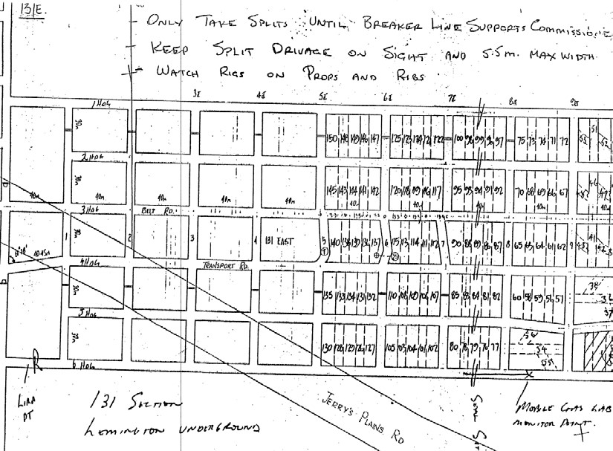
Figure 14:

Lemington mine panel plan

Ulan – August 1991
There was a heating in the longwall block at Ulan in December 1990 (figure 15) that had reappeared in a minor form on several occasions. Management was in the process of trying to control that heating through improved sealing of the bleeder roadways when another major event occurred.
Events were:
- 9 July 1991: a rise in oxygen was noted behind seal 23 and a rise in carbon monoxide. The rate of seal repairs increased.
- 4 August 1991: Hydrogen was first detected.
- 7 August 1991: 2250 ppm carbon monoxide was detected in the goaf and hydrogen increased to 0.25%.
- 8 August 1991: About 6.15pm, smoke was noticed on longwall 5 face and a red glow reflecting on the coal rib-side was observed > 3000 ppm, 2% carbon monoxide and 2% methane in the longwall 6 tailgate at 21 cut through.
- At 6.25pm, Drager readings at L2 6 were 7000 ppm carbon monoxide and 4% hydrogen.
- At 6.30pm there was an alarm at the fan. Evacuation of workers began at 6.40pm.
- At 7.55pm, Drager readings at the fan were carbon monoxide > 3000 ppm, 2% carbon dioxide and 2% methane.
The mine was then sealed. Subsequently, the area suspected of heating was flooded and the atmosphere inertised by the introduction of gaseous nitrogen.
The Ulan seam was believed to have a low liability to spontaneous combustion. There was no seam gas. The bottom 3 metre section of the 10 to 14 metre thick seam was worked. Gate road stoppings were constructed from plasterboard.
The main contributing factors to the heating were considered to be:
- lack of appreciation of the liability of the seam to spontaneous combustion
- inappropriate ventilation layout
- lack of understanding of spontaneous combustion initiation
- incorrect interpretation/ analysis of monitoring results
- insufficient monitoring information
- inadequate ventilation standards
- lack of predetermined action plan
- unclear definition of responsibilities.
The mine resumed operations in March 1992.
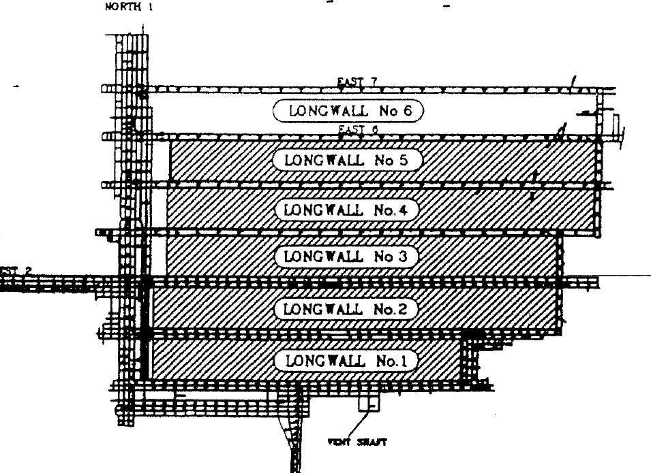
Figure 15:

Ulan No.3 Mine plan

Huntly West, New Zealand – September 1992
Huntly West was a state-owned mine developed in the Waikato region of New Zealand. The Kupakupa seam was mined and was a sub-bituminous coal with a very high propensity to spontaneous combustion. R70 = 10 to 16.5.
The depth of cover was about 300 metres. The seam was up to 6 metres thick with an undulating pavement and a number of structures. The coal deposit had varying thickness and roof and floor gradients. The roof and floor lithology was weaker than the coal and the optimum roadway stability was achieved with a coal roof and floor. Methane drainage was practised and the returns contained 0.4% methane.
Initially coal was won on development only. Trials on total extraction and hydraulic mining failed. There was a history of spontaneous combustion in roadway sides and junctions. Longwall equipment was purchased in 1986 and the longwall commenced in September 1991. There were problems with face guttering and frequent spontaneous combustion issues in the longwall goaf (figure 16).
Vapourised liquid nitrogen was routinely injected into the longwall goaf from pipes through trailing longwall supports at the rate of 100 – 100 m3/hr. It was common for carbon monoxide to exceed 1000 ppm after sealing the longwall.
Events were:
- 11 November 1991: longwall sealed due to heating.
- 13 February 1992: longwall reventilated.
- 24 March 1992: fall on face and heating in goaf.
- 18 April 1992: longwall reventilated.
- 5 May 1992: longwall sealed due to heating.
- 14 May 1992: Longwall reventilated and resealed five hours later.
- 30 June 1992: longwall reventilated then resealed 30 hours later.
- 29 June 1992: longwall reventilated.
- 15 July 1992: longwall sealed.
- 16 September 1992: fire observed at No. 4 seal (see plan for location).
- 18 September 1992: fire out, minor smoke cleared, 48-hour evacuation.
- 19 September 1992: inspection determined all okay.
- 20 September 1992: high carbon monoxide in east returns.
- 20 September 1992: fighting fire with water and foam failed. Roof fall at No.4 seal. In seam sealing attempts failed. It was sealed at the surface with tarpaulins and nitrogen pumped into the mine. The main fan was stopped.
- 23 September 1992, 4.45 pm: atmosphere explosive 9.5 % methane.
Figure 17 shows the resulting damage to the mine transport portal.

Figure 16: Huntly West Mine plan
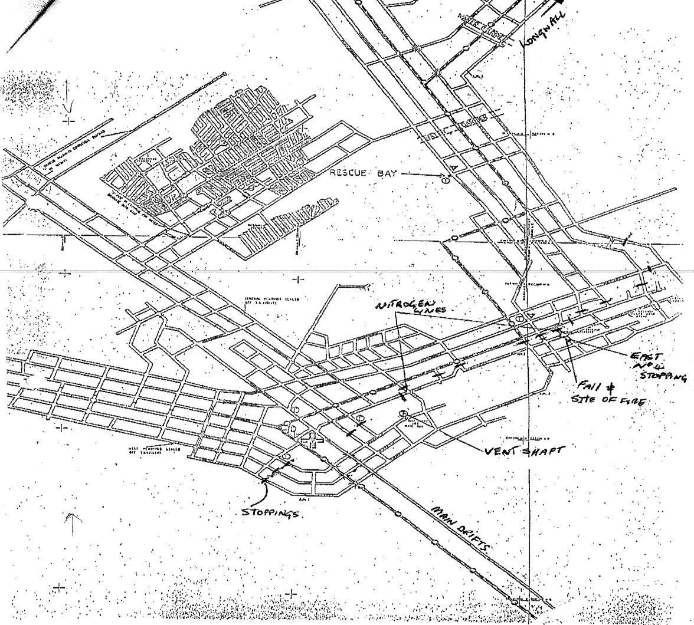

Figure 17: Blast damage to mine transport drift
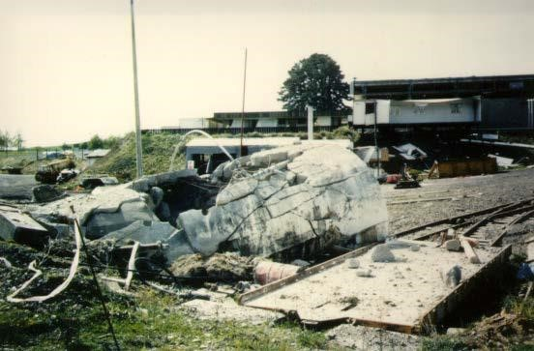

North Goonyella - 1997
North Goonyella is a large, longwall operation mining the Goonyella middle seam. Due to the seam thickness, significant quantities of roof coal are left in the goaf. At the end of 1997, the mine operated two longwalls, numbers 3 and 4 south concurrently.
Three south longwall was only 9 metres from the take-off line while four south face was just outbye 9 cut through. An advanced heating was detected in the goaf of LW3.
On the afternoon of the 28 December 1997, a deputy detected 25 ppm of carbon monoxide in the general body of 6 cut through in longwall 4 tailgate. This reading was followed up with bag samples from the longwall 3 goaf out of the 5 and 7 cut through seals. The 6 cut through seal sample pipes were blocked with mud and water. The manager ordered the evacuation of the mine at 5.55pm on the 29 December 1997 following the confirmation of the results of these bag samples. The bag sample results were as follows:
 | H2 | CO2 | C2H6 | O2 | CO | CH4
7 c/t | 0.4% | 14.0% | 0.08% | 3.15% | 0.13% | 2.09%
5 c/t | 0.43% | 4.6% | 0.05% | 14.86% | 0.12% | 0.90%

This event is generally recognised as the most serious spontaneous combustion event to have occurred in Queensland since the Moura No. 4 explosion. Following a few months after the trials of the Tomlinson
Boiler it was to be a crucial event in proving the ability of low flow inertisation techniques to treat serious goaf heatings. A heating that would have historically resulted in the loss of at least the section and possibly the mine’s ability to produce for many weeks was controlled over a period of five days.
The following is a plan of longwall numbers 3 and 4 south panels north Goonyella (figure 18).
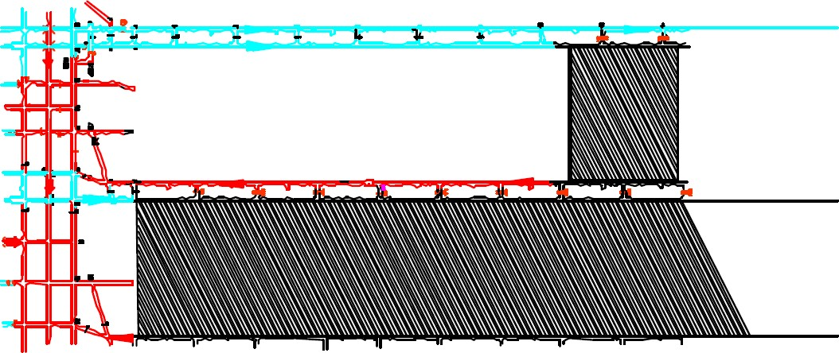
Figure 18:

North Goonyella plan of LW3 and LW4

Heating location

Newlands - 1998
The Upper Newlands seam varies in thickness from 6 to 7 metres, with the lower 3 metres mined. The predominant seam gas was methane in concentrations of above 95%. Early tests on the Upper Newlands seam classified it as having a ‘moderate to high propensity’ for spontaneous combustion.
A number of small heatings took place near the portal entries in April and May of 1998 before the longwall mining commencement. Newlands re-classified the seam as having a high propensity.
Contributing factors to the heatings were considered to be:
- a sustained pressure differential of 400Pa across coal pillars that contained a large amount of open fractures
- air migration through the fractures
- high ventilation quantities concealing any products of the heating from monitoring devices located outbye.
The heatings were first contained by water injection and later by injection of both silicate resin and strata seal products. Injection varied in depth and direction in relation to the cleat direction for maximum results.
Temperature monitoring of roof and rib surfaces along with in seam measurements showed that a surface temperature of 30 to 35 degrees was an indicator of higher heat below the surface.
Temperatures below the surface ranged up to 300 degrees. The 30 degree trigger was a valuable tool for the identification of further hot spots. Atmospheric monitoring, including minigas readings and bag samples was also used in the system for detection.
The following is plan of Newland entries (figure 19).
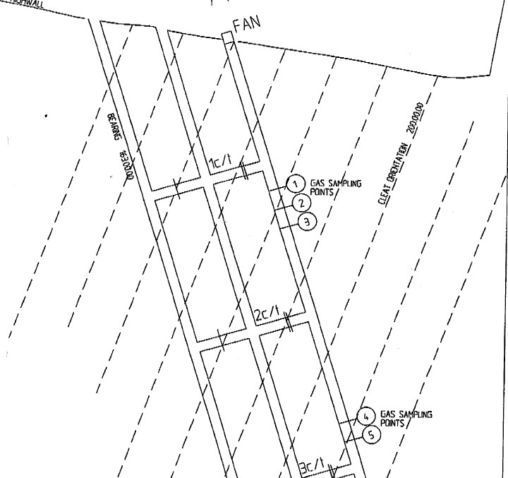
Figure 19:

Newland’s mine entries

Wallarah – August 2001
A heating took place in the Great Northern seam in August 2001. The seam was not considered to be a spontaneous combustion risk in underground mining. This was the first recorded event despite the seam being mined for many years.
The exact site of the heating was not determined but considered to be in an area of old waste workings influenced by a ventilation connection between Wallarah and Moonie Collieries near Lake Macquarie NSW.
Increased readings of carbon monoxide had been detected in Moonie Colliery dating back to March 2001. In the period leading up to the increased readings, two changes occurred that may have had an influence on the detection of gases. These were:
- improvements to ventilation at Moonie resulting in an increase in airflow through the connection from 4m3/s to 20m3/s.
- reduction in water flow into the Wallarah goaf from Moonie Colliery.
Checks on the Wallarah goaf showed no signs of heating.
The estimated size and shape of the void and the inability to successfully seal or isolate from the Wallarah seam (40 metres above) led to the decision to deviate from the normal process of nitrogen inertisation and instead, use the Mineshield unit to deliver carbon dioxide. Pumping of carbon dioxide ceased on 2 September. Since then, gas readings have been safe and stable.
The following diagram shows the influence of variations in the barometer on the atmosphere in the area (figure 20). It represents the results of sampling of the atmosphere in the mine via a borehole.
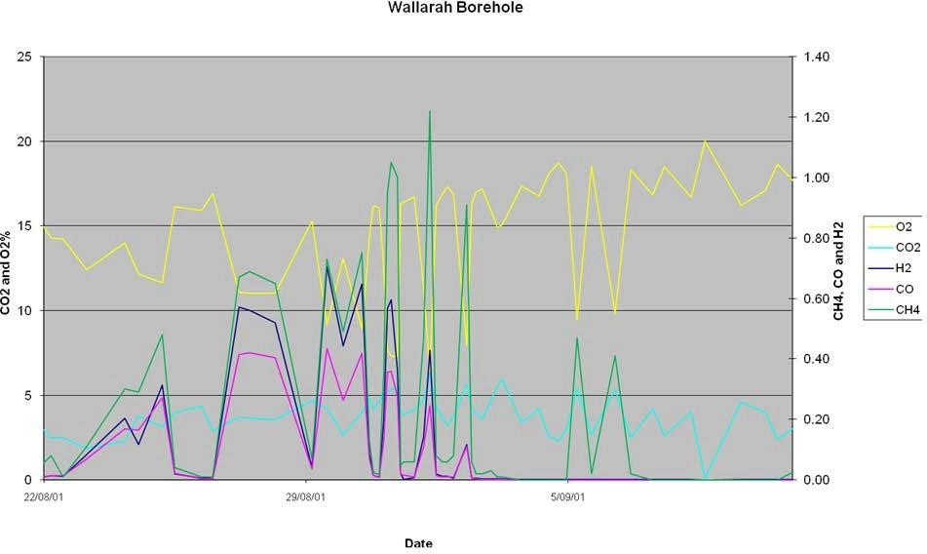
Figure 20:

Wallarah effects of barometer on mine atmosphere

Beltana – December 2002
Beltana mine is in the Hunter Valley NSW. Mine entries are from the highwall of an open cut. The return highwall entry had an axial primary ventilation fan installation.
On 15 December 2002, physical indications (smell) and products of combustion from a heating (high carbon monoxide) were detected in the first pillar between the intake and return highwall entries of the longwall 1 panel tailgate. The maximum differential pressure experienced during the life of the pillar was 250Pa, and pillar dimensions were 30 by 90 metres.
The heating had developed from airflow through open joints in the coal pillar and roof, and via blast- induced fracturing from the highwall. These entries were also immediately adjacent to the endwall and therefore subjected to stress concentrations.
Over several weeks, the heating was brought under control by sealing off the air paths using 6 metre drill holes and microfine cement grout injection. Also applied to the ribs and areas of roof in and adjacent to the fractured zones was a flexible surface sealant (cement in a latex binder).
Five metre long temperature probes and gas sampling holes were also installed during these remediation measures. Temperature monitors recorded peaks of 67ºCelsius, whereas comparison of gas samples with gas evolution test results indicated the gas resulted from coal temperatures of
350ºCelsius. Thermographic camera imaging was unable to detect any heat source or warm gas release.
After Christmas 2002, the gas sampling indicated no detectable products of combustion other than small carbon monoxide values. These fluctuated with barometric pressure and air temperature (night versus day).
Temperature probes continued to show elevated temperatures, so in May 2003, seven 47 millimetre diameter inseam boreholes were drilled at lengths between 20 and 40 metres into the pillar along different axes in an attempt to locate the heat source. This was unsuccessful and water was injected for one-and-a-half days to remove remnant heat, followed by microfine cement injection to seal any further potential leakage paths.
Further remnant fire gases could not be found and temperatures remained at normal background levels until the area was sealed and access lost in March 2005.

Beltana – March 2003
On 31 March 2003, off scale values of carbon monoxide were detected using hand-held gas instruments from open cleat cracks in two pillars each side of the overcast structures separating intake and return airways of longwall 1 maingate panel.
These pillars were the third and fourth pillars inbye from the highwall entries, had dimensions of 17 by 30 metres, and were subjected to a pressure differential of 115Pa at the time of heating discovery (this was also the maximum pressure differential during the pillars life to-date).
Gas sampling indicated approximately 150ºCelsius heating temperatures. Thermographic camera imaging was capable of identifying hot/warm gas release from the open cleat.
A 20 metre long, 47 millimetre diameter hole was drilled in each pillar and water injected for one-and-ahalf-days. These holes were then microfine cement injected. Leakage paths were identified through each pillar using smoke tubes and visual inspection and targeted for drilling with short holes and grout injection. The pillars continued to remain benign, and access was lost for inspection when the area was sealed in March 2005.

Newstan - 2005
A heating took place in a sealed longwall goaf that was remote from the operations. The ventilation circuit was such that the main returns were adjacent to the seals of the longwall goaves.
Normally, the goaf of each longwall block would become inert because of the liberation of seam gas. On this occasion, loss of inertisation was caused by interconnection from the goaf to surface cracks. The depth of cover was about 110 metres.
The location of the heating was derived from extensive surface drilling and associated monitoring and was adjacent to a fault system. At the time of mining with the longwall, the fault had resulted in a large fall and a resultant cavity on the face.
The Mineshield was used to inject nitrogen into the goaf and stabilise the heating. However, oxygen from the surface was being continually drawn into the underground workings via the interconnection of the subsidence and goaf cracks by the negative pressure generated from the main mine fan.
The long term solution was to inject fly ash to seal the cracks to the surface and to reverse the ventilation underground. This involved placing the longwall seals on intake ventilation. The result of these two actions was to reduce the pressure differential across the seals of the longwall that was allowing oxygen access to the heating. This allowed seam gases to build up and naturally inert the goaf.

Dartbrook - 2006
The heating took place in the second active longwall block in the Kayuga seam (figure 21). Bag samples from 13 cut through and 10 cut through stoppings indicated unusual hydrogen levels. Subsequent samples indicated the presence of ethylene. The mine was evacuated on 19 January and tube bundle locations established into the goaf at 10, 11 and 13 cut through stoppings. Subsequent samples indicated ethylene.
The mine was re-entered on 21 January with limited activities. The mine was again evacuated and further inertisation took place with a reduced mine fan speed.
The mine was re-entered on 18 February 2006 with limited activities taking place.
A mine with high seam gas content, the ratio of hydrogen to carbon monoxide is considered a very useful indicator.

Figure 21: Dartbrook Mine plan Kayuga seam
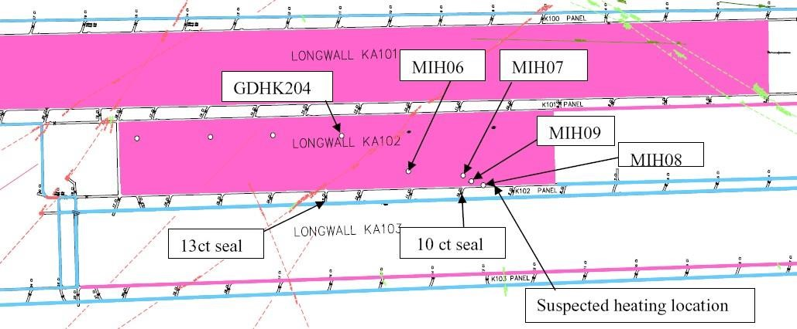

Case study: Coal stowage spontaneous combustion event
At 11.23pm a carbon monoxide alarm of 7.1 ppm activated on the site gas monitoring system at a 4 gas environmental monitoring station (EM04), located in the mains. The control room operator reviewed the trend and noticed a gradual rise in levels, as per the TARP. He then notified the undermanager for the shift as he was unable to contact the deputy for the area. The undermanager, who was in the process of leaving the surface to head into the underground, went to the location and investigated the alarm. On entering the area to inspect EM04, the undermanager could detect odours of spontaneous combustion. His hand-held gas detector was also fluctuating between 7 – 10 ppm carbon monoxide. At 12am the undermanager notified the control room operator of his findings. The control room operator contacted the two other outbye deputies to assist with locating the source of the carbon monoxide and smell.
The undermanager and the two out-bye deputies began an inspection of the main returns, one working from the inbye end, one in the middle and one from EM04 working inbye. This inspection found a small section of glowing coal in a stub (stowed coal). No other gasses other than carbon monoxide were detected during the inspection.
Absent or failed defences:
- No stowage management plan in place.
- Method of excavating coal from floor for a conveyor-tripper drive area.
- Material not compacted when stowed.
- Material stowed too high.
- Stowage of coal was not identified as a hazard, as such controls were not identified or considered.

Individual or team actions:
- Plan not made to remove stowed coal.
Task or environmental condition:
- Stubs unable to be ventilated (removing the heat) where material was stowed.
- Stowed material extracted from the bottom of the seam.
- Floor coal is more reactive than the upper seam.
Organisational factors:
- Complacency with spontaneous combustion likelihood and coal being stowed in the underground workings.
- Floor coal not identified as being more reactive than the upper seam.
Basic cause:
The material contained predominantly dry coal (mined with a jack pick on an Eimco as opposed to a continuous miner). It was not compacted and heaped at a height greater than 1.5 metres in a nonventilated area, and left in the underground workings.
Recommendations:
Formalise stowage standard for mine to cover:
- Height of material to be stowed.
- Inhibitors (stone dust or other sealant) to be applied for permanent stowage.
- Process for permanent and temporary stowage.
- Controls to be in place to manage coal stowage.
Significant lessons:
R70 testing completed on run of mine coal has produced a consistent rating of propensity being in the medium to high range. However, traditional R70 testing is conducted on a dry basis and is not a fair representation of in pit propensity. Recent modified R70 testing takes into consideration the moisture content of the coal and consequently determines a much longer incubation period for the coal to reach thermal runaway. This type of testing has been conducted on 13 samples taken from in-pit (2013-2017), including some from slack coal on the ground left in completed panels. All except two samples showed that due to the high inherent moisture content, it was unable to reach thermal runaway in a realistic timeframe. Two samples from the bottom half of the seam in two different panels reached thermal runaway in 118 to 139 days and 74 to 89 days, respectively. However, there were other samples taken from the same location in these panels that did not reach thermal runaway and were consistent with other samples taken, showing variability in the coal in the floor horizon.
Stowage underground was not uncommon, however it was normally predominantly stone (greater than 90 %), cut with a continuous miner adding water to the coal, then stowed wet in ventilated areas and compacted to a certain degree by load haul dump machines, wheeling over the top as it was being stowed. The material that was stowed from the tripper drive excavation had none of these traits:
- Predominantly coal material.
- Mined out dry with trencher and jack pick – no added water.
- Dumped, pushed up and heaped greater than 1.8 metres into a stub with little ventilation.
The results of the past R70 testing, particularly due to the high moisture content, suggested that spontaneous combustion was unlikely. This created a complacent attitude towards the likelihood of spontaneous combustion occurring at the underground operation. This led to no stowage management plan being in place.

Mannering Colliery 2015
On Thursday 25 June 2015 a ‘heating event’ was confirmed in 18 cut through of the West Headings in the Great Northern Seam (GNS) at Mannering Colliery (figure 22). This was discovered after a lengthy and difficult search initially triggered by a low-level carbon monoxide alarm spike from the tube bundle monitor point at the GNS entry to the upcast shaft of the mine. The indicators found at the site included heat haze, sweating and a ‘benzene’ smell, with elevated levels of carbon monoxide recorded by hand- held gas detectors. Before this event, there were no known recordings of spontaneous combustion occurring at Mannering Colliery throughout its more than 50-year life. In addition, there were very few known recorded occurrences of spontaneous combustion in the Great Northern Seam workings throughout its extensive mining history, although spontaneous combustion events had been known to occur in stockpiled coal on the surface.
The depth of cover to the Great Northern Seam was generally in the range of 150 to 210 metres and there was typically about 30 metres of interburden between the Great Northern Seam and the underlying Fassifern Seam. In situ gas contents range from 1.6-2.75 m3/t for the Great Northern Seam and 2.4-3.5 m3/t for the Fassifern Seam. The seam gas composition was predominantly methane

(>95%). R70 self-heating rate test results indicated an intrinsic spontaneous combustion propensity rating of medium to high for the Great Northern Seam, dependent on the ash content. However, the incubation period for this coal was strongly dependent on a number of site-specific parameters and other coal properties. The mine ventilation arrangements in place for more than the past two years, since placing the mine on care and maintenance, consist of a reduced flow of approximately 130 m3/s at a collar pressure of around 600 Pa. Typically, much of the underlying Fassifern Seam workings ventilation air returns up through inter-seam staple shafts and flood ventilates the old Great Northern Seam workings before returning to the upcast shaft. The mine has five inter-seam staple shafts that were still in use to some extent. Very few areas of the mine, either in the Great Northern Seam or the Fassifern Seam were effectively sealed. This is typical of the district, which has been mined for more than 100 years.
The mine used a Maihak 10 point tube bundle monitoring system. The bottom of each of the staple shafts was monitored to capture all Fassifern Seam workings return air just before entering the Great
Northern Seam workings. In addition, five other fixed locations were monitored within the Great
Northern Seam workings, including the top of the upcast shaft, which captures the total mine return air. Mine atmosphere monitoring also included the mining supervisor underground inspections and hand- held monitoring. Bag samples were typically taken monthly from the top of the upcast shaft.
The initial downstream gas readings of the heating event at location 4 (figure 22) indicated a Graham’s ratio of 2.54, with ethylene present. The general information in the SmartMate software indicated that for European coals this would correspond to a serious heating. It is also noted that all mines should establish their own levels and that older coals can produce a higher Graham’s ratio. None of the literature values take into consideration the status of hot spot development.

Figure 22: Mannering Colliery heating site
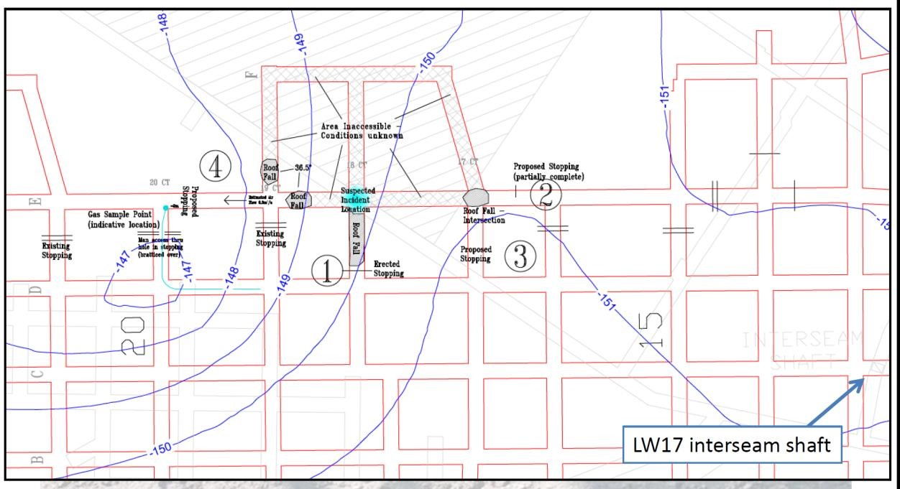
An assessment of possible explosive mix scenarios were performed throughout the day based on the makes of the various gases and oxygen consumption rate. Given the status of seal-up preparations at that time, the only option available to control the air reaching the hot spot was to lower the previously installed rolled up flexible stopping at location 3 (figure 22) and restrict the ventilation entering the heating site in preparation for a final sealing at location 4 (figure 22) on the downstream side of the heating. The response to this ventilation control was expected to be a decrease in the gas indicator ratios and a decrease in the oxygen concentration. The response from the implementation of the ventilation intervention of completing stopping #3 was almost immediate with a rapid drop in the ethylene/ethane ratio recorded within about three hours. A drop in the Graham’s ratio was delayed by almost 12 hours. The ongoing drop in both the Graham’s ratio and the ethylene/ethane ratio provided confidence in being able to take additional time to organise the final seal-up of the area, particularly as no explosive mix was developing and the oxygen content began to drop noticeably. This was also supplemented with nitrogen injection into the area. Note the carbon monoxide/carbon dioxide ratio was also added to the hot spot tracking diagram (figure 23) at this stage to provide further confirmation of the success of the ventilation intervention. A scaling factor of 60 was applied to bring the value into the same Y-axis range.
The Graham’s ratio response was also delayed. All gas indicator readings continued to decrease after Stopping #3 was completed and about two-and-a-half days later the final seal at Stopping #4 was completed with additional nitrogen injection. The Graham’s ratio initially increased, but then gradually decreased over time following the seal-up (figure 23). However, the ethylene/ethane ratio continued to progressively decline indicating that the hot spot was diminishing. Continued monitoring of the sealed area atmosphere recorded the oxygen content decreasing to below 3% and the gas indicator ratios continued to decline, indicating the event was successfully controlled.
Figure 23: Hot spot tracking diagram
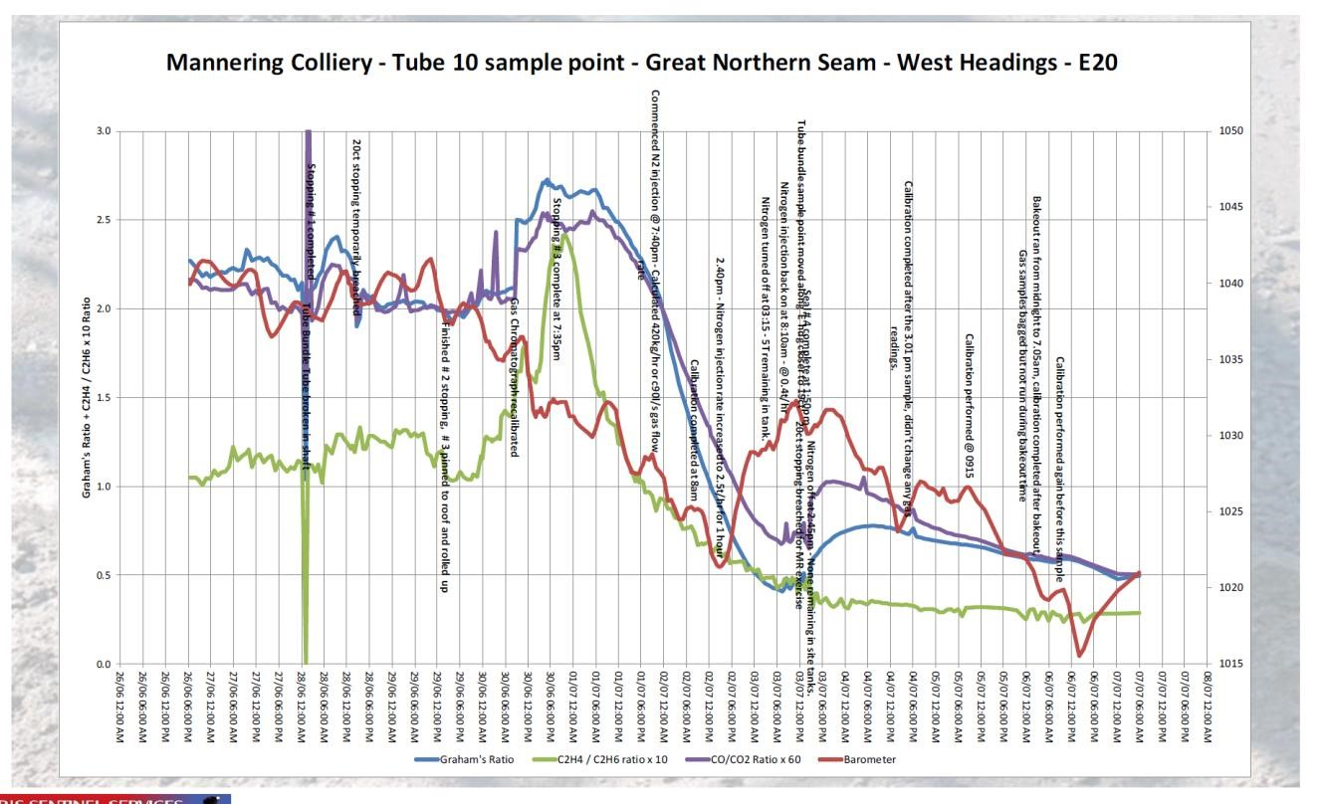

Case study: Longwall heating detected by smell
Early signs of coal oxidation occurred in an underground coal mine. A longwall superintendent identified a tarry/coal burning smell at the tailgate of a longwall face. Further investigation and bag samples confirmed that the oxidation was not occurring within the goaf. The mine identified the oxidation to be around a bulkhead at the fault-disturbed zone. The mine established an incident management team to manage the situation. The mine pressure grouted the fractured strata with strata binder to reduce air paths, which stopped the oxidation process.
Observations:
- Incident not detected due to elevated gas concentrations but due to smell.
- Oxidation due to leakage through/around a bulkhead in fractured ground.
The smell was also the first indication of coal burning in Dangerous incident IncNot0034437.

Mineworkers reported a burning smell at an underground coal mine. On investigation, burning coal embers were identified, which were ignited by a dislodged roller that was running in fines at a roadway underpass. The heating was cooled and extinguished by a water hose. The dislodged roller was most likely caused by a vehicle contacting the underpass guards.

Case study: North Goonyella 2018
The description of this event is based on the press releases from Peabody Energy. We gratefully acknowledge their permission to republish the details.
On 1 September 2018, during a scheduled longwall move from the 9 North panel to the 10 North panel, an area of the North Goonyella Mine, in a remote area of the Bowen Basin in Australia, began registering elevated gas levels caused by oxidation of some coal. Mine management quickly assessed the facts, took appropriate steps, removed workers from underground, contacted the Queensland Mines Inspectorate and independent industry and scientific experts, and began mobilising resources to correct the situation.
Over a number of weeks, the company worked with industry experts, and in consultation with the inspectorate, to take extensive steps to treat the oxidation from the mine surface. Subsequently, elevated carbon monoxide detected from within the mine indicated oxidation of coal, which can occur when coal is exposed to oxygen for an extended time period. In subsequent days, services such as power, ventilation and water management activities continued. By 16 September, gas levels lowered at times to the point of allowing temporary re-entry by a limited number of workers for inspection and other activities. Surface activities continued, and mine personnel remained at the ready for resumption of the longwall move. (Major equipment and some shields had been moved to the new longwall panel, with about half of the shields and some ancillary equipment remaining to be moved from the completed panel area.) Gas levels remained variable through this period, with subsequent signs of elevated temperatures and low-level oxidation of coal. The company advanced a progressive plan in an attempt to reduce levels and enable work to resume the longwall move, including drilling additional inertisation holes, pumping additional nitrogen and liquid nitrogen near the face from multiple units and sealing a portion of the mine near the completed longwall area – all from the surface.
On 27 September, mine workers saw dark smoke coming from the mine, indicating a fire in a portion of the underground area. Nobody was underground at the time, and all workers on mine property were safely removed to a perimeter exclusion zone.
In consultation with the inspectorate, Peabody initiated a plan to extinguish the fire and contain impacts at North Goonyella Mine. By 2 October, the mine reported that early indications showed this plan had yielded visible results, with only a slight amount of what appeared to be either steam or white smoke emanating from one mine shaft.
The mine’s review of the incident concluded that areas of the mine demonstrated both elevated methane levels and elevated carbon monoxide levels following completion of coal production in the 9 North panel. During the longwall move sequence, a change in gas management focus to reduce elevated methane levels in the 9 North panel, including changes to the mine's ventilation system to increase airflow, inadvertently intensified the oxidation of coal that was likely causing elevated carbon monoxide levels.
Despite sustained efforts to manage the oxidation from the mine surface, including use of nitrogen to create an inert environment within the 9 North panel goaf (the mined-out area in the panel), the oxidation accelerated into a spontaneous combustion event that eventually resulted in the fire.
As a result of the actions taken to evacuate workers in advance of the fire and other controls in place, the incident did not result in any injuries.
By 30 September, a comprehensive plan had been developed. Elements of the plan included:
- implementing use of a mobile GAG unit – a specialist piece of equipment that generates high-moisture inert gases to displace oxygen supply at a fire zone
- installing temporary seals into mine openings following completion of risk assessments and using remote-control equipment to pump a fire-resistant expandable material called Rocsil
- ensuring the area was further isolated by additional drilling and sealing of the old longwall panel
- working with air quality monitoring experts on a voluntary program of environmental monitoring at North Goonyella, including regular site visits and boundary inspections to assess and analyse air quality data from key points
- ensuring all aspects of the exclusion zone and other safety protocols were in place and observed and using strict risk assessments for all anticipated plan components.
The company implemented its multi-part plan from the surface. The company permanently sealed the area where high methane levels were concentrated. Three of the mine's five openings remain temporarily sealed to reduce air flow into the mine.
Extensive monitoring was undertaken and was expected to be helpful in later stages of the incident management. The company used existing bore holes to expand gas level monitoring of the mine. A grid of 35 specialised inground monitors was put into place to identify heated activity within the mine workings. Seismic monitors were in place since 3 October. They did not detect abnormal activity. Specialised cameras provided limited visibility into certain sections of the mine.
Due to the risk of storm activity over the spring and summer days, and as per Peabody’s standard procedure, the mine operated under severe weather trigger action response plan (TARP) protocol to ensure worker safety. Activities on site continue under approved, specific risk assessments.
Peabody President – Australian Operations George Schuller said, "While this was a highly unusual combination of events, Peabody is making changes in systems, processes and training, where warranted, to put into place the improvements needed to successfully move forward from this incident. For example, we have already begun installing remote control ventilation systems at mine entrances."
Throughout the incident Peabody's incident management team worked alongside the inspectorate and industry experts to ensure it used the best people and resources.

Discussion of key initial learnings
As a result of Peabody's comprehensive review, the company developed initial lessons and steps to improve the longwall move process and other mining activities.
- Peabody reviewed ventilation controls and design used during the longwall ‘take-off’ process to minimise the amount of air that entered the longwall panel goaf and interacted with exposed coal remaining within the goaf. Ventilation controls that were put into place in advance of the longwall take-off process may have permitted higher-than-expected volumes of ventilation air to enter the goaf during the longwall take-off process, resulting in oxidation. Gas management and ventilation changes were made in and around the 9 North panel tailgate area in response to elevated levels of methane, which inadvertently intensified the oxidation.
- Evaluate decision-making processes to address the challenges of remotely managing an underground incident solely from the surface. For instance, as the incident approached late September and treatment of the oxidation event escalated, including injection of nitrogen from the mine surface into the 9 North panel goaf, fluctuating gas readings led North Goonyella mine workers and expert third-parties to believe that the treatment plan was likely working due to purging gases from the goaf.
- Peabody also believed that the system used to monitor and analyse available mine gas data could be improved and better coordinated to identify early stages of oxidation events. Additional training to the appropriate mine workers was implemented to recognise fire gas indicators, gas management and spontaneous combustion, and provide an understanding of a mine's ventilation history, with a focus on identifying ventilation trends and key indicators of oxidation and developing heating for longwall mines.
- Peabody modified the longwall removal planning process to reduce the number of days to complete the longwall take-off process to allow for earlier commencement of final sealing, incorporating additional contingency planning in the event the target cannot be achieved. The amount of time the North Goonyella mine's 9 North panel was idle increased the propensity for oxidation to occur in the longwall panel goaf. Peabody considered additional contingency measures, including installation of pre-drilled holes at the appropriate locations immediately behind the longwall chock line to allow oxygen inhibitors to be injected when longwall advance stops to mitigate against oxidation.
- Peabody improved the Sealing Management Plan to provide greater clarity around the required steps for sealing the longwall panel (particularly in relation to how these steps interact and relate to the longwall move and re-installation plan). The improved plan provided for the allocation of resources to ensure the sealing management plan is followed as described. Peabody will also provide additional training for underground personnel prior to sealing operations commencing.
- Peabody honed its system for the management of TARPs to provide clearly defined trigger points, clear explanations of actions to be taken if trigger levels are reached, and improved methods, training and communications involving changing TARPs. Application and progression of TARPs during the longwall take-off process varied from that set out in the Sealing
Management Plan, and communication of TARPs was found to be inconsistent. TARPs describe actions that must be taken by mine personnel in response to observation of certain conditions or triggers (e.g. gas levels) that deviate from normal. TARPs should clearly define their applicability and the required action items when trigger points are reached.
- Peabody reviewed the principal hazard management plan (PHMP) for spontaneous combustion and emergency response around the provision of clear and concise guidance in relation to gas readings. The company will also implement a regime for reviewing the PHMP at established intervals and updating as required.
- Within the Site Incident Management Team (SIMT), Peabody appointed an independent facilitator whose role will be to assist the SIMT in the decision-making process (rather than the technical aspects of SIMT decisions). The SIMT was comprised primarily of North Goonyella mine management personnel, though various other parties also provided input into the SIMT's decision making process. At times, it was challenging for the SIMT to coordinate and address differing viewpoints from multiple stakeholders. Although these outside parties each play critical roles in responding to a mine emergency, the varied viewpoints need to be effectively managed and facilitated during an incident.
- Peabody installed quickly closable remote ventilation control devices at each mine drift as they progressed through the reventilation process. In addition, Peabody evaluated options to remotely isolate portions of the longwall panel to provide an option to quickly close these devices after all personnel have been evacuated from the panel. Peabody's ability to quickly seal the panel to extinguish the oxidation event before it developed into a fire was impaired once the mine was evacuated and exclusion zones were put in place. Once an oxidation event develops into a spontaneous combustion event, it is difficult to extinguish from the mine surface. The smaller the area of the mine that is sealed from the source of combustion, the less oxygen is available to support it and the quicker it begins to cool, which should facilitate expeditious recovery. These types of devices could be closed by personnel as part of an evacuation sequence, or through remote means. Emergency seals, which can be installed at chute and gate roads at longwall panels, will also be considered as part of an emergency sealing process (27/03/2019).
Source: May 24, 2019 /PRNewswire/ -- Peabody (NYSE: BTU) today announced it is proceeding with the ventilation of the first segment of the North Goonyella Mine in consultation with the Queensland Mine Inspectorate as part of a comprehensive phased reventilation and re-entry plan and expected longwall production in 2020.

Appendix C: Spontaneous combustion technical reference guide updates
This section contains sections of the former MDG 1006-TR Technical Reference for Spontaneous Combustion Management Guideline not covered in Cliff, Brady and Watkinson’s (2018) technical guide: Spontaneous Combustion in Australian Coal Mines and more recent advances in applied research.

Modelling of the combustion process
Shi et al. (2015) have developed computational fluid dynamics (CFD) models that incorporate the impact of goaf drainage. The studies show that the areas of highest spontaneous combustion potential near the working face tend to be near the top of the seam whereas, in the deep goaf it will be the bottom of the seam most likely to spontaneously combust.
Xia et al. (2014) have modelled the effect of the expansion of the gas near a spontaneous combustion event in a goaf and the development of a pressure gradient which modifies the gas flow and thermal transport in the goaf. The model was calibrated against actual spontaneous combustion events in a Chinese coal mine.
Ren et al. (2012) report on the CFD modelling of a longwall goaf and the investigation of potential spontaneous combustion sites. The model was used to identify the optimum location to add inert gas, which in this case was 100 metres behind the face on the maingate side for a longwall with back by return ventilation. The model was validated against field data in terms of oxygen concentrations around the fringe of the goaf on both the maingate and tailgate sides.

Liners, inhibitors, fly ash, foams and gels
Researchers have tested materials to line or coat exposed coal surfaces.
Tosun (2017) found that an epoxy/fibreglass material was impermeable to oxygen and easy to apply. He experimented with a range of cheap polymer composite materials.
Thin spray-on liners – often organic polymers have also been trialled to act as sealants for exposed coal surfaces. One such trial was undertaken in the southern coal fields of NSW where the primary purpose was to prevent air ingress into gas drainage holes (Li et al., 2016)
Xi, Z. L. (2017) experimented with different types of coatings for exposed coal surfaces. Sixteen different types of coatings were tried including, gypsum, plaster, satin plaster, hydrated lime, cement and fly ash. Two gave satisfactory results in the laboratory, but the plaster plus water mixture when applied to a mine reacted with the pyrite in the coal. Only a mixture of cement, fly ash and water applied to a thickness of at least 7 millimetres proved impermeable to air and maintained its structure in the underground coal mining environment.
Qin et al. (2014) found that by mixing fly ash with an aqueous three phase foam containing nitrogen produced a highly stable foam with excellent fire extinguishing capabilities and preventing spontaneous combustion.
Lu et al. (2018a) demonstrated that high expansion foam applied to the top of a goaf is capable of extinguishing a fire at the top of a goaf, by sharply reducing the temperature of the fire source. The foam was applied in batches at timing of less than the half-life of the foam.
Lu et al. (2018b) developed and applied a foam-gel mixture to a number of coal mine fires in China with great success. The mixture was used to coat the surface of the exposed coal reducing air ingress and increasing heat transport away from the fire site.
Ren et al. (2016) described the application of a foam gel to cover dangerous areas in a goaf. The composition of the mixture is proprietary. The foam is formed first and then a second additive is used to create a gel from the foam. The key material is a polymer. Nitrogen is used to assist in the foaming. Stabiliser is added to reduce the decay in the foam and water loss. The foam is used to penetrate deep into the goaf. As the foam decays the liquid forms a gel which then coats the exposed coal. The proponents claim it has vastly superior water holding capacity when compared to foam or gel alone. The gel is stable for at least 76 days. The gel has been applied successfully to a number of mines. The mixture can be applied through boreholes either in seam or from the surface.
Zhou et al. (2016) developed a gel/mud composite that when applied to coal surfaces inhibited the oxidation potential of the coal.
Xi et al. (2018) demonstrated the effectiveness of self-hardening thermoplastic foams to inhibit the selfoxidation of coal. The foam absorbs the heat from the coal and fuses into a colloid which seals cracks and gaps within the coal and forms a thin layer on the surface of the coal. The colloid may destroy active functional groups reducing the production of carbon monoxide and interferes with the free radical chain chemistry reaction of coal.
Slovak and Taraba (2012) found the application of calcium chloride solutions (0.1 M) was an effective inhibitor of low temperature coal oxidation. Tang (2018) reported on a similar effect using magnesium chloride. Qi et al (2016) suggested that mixing the halogen inhibitor with catechin, copolymer, solvent and surfactant greatly enhanced its capabilities over a longer time than the existing halogen inhibitors.
Tang (2017) carried out laboratory testing of a series of phosphorous containing flame retardants (PFRs) – phosphates of various sorts. Coal samples were immersed in 5 % solutions of the PFR. It was found that the PFRs interfered with the carbon monoxide generation process and the efficiency of this interference increased with temperature. The PFRs appear to reduce the heat generated by the coal and thus elevate the effective ignition temperature.
Ma et al. (2016) demonstrated that a poly (acrylic acid)/sodium alginate absorbent mixed with ascorbic acid inhibitor was highly efficient in retarding the oxidation of coal by removing heat and chemically interrupting the free radical chain reactions.
Cheng et al. (2017) demonstrated the potential for an intelligent gel (a graft copolymerisation of corn straw, 2-acrylamide-2-methylpropanesulfonic acid and acrylic acid to form a hydrogel) when mixed with expandable graphite to extinguish fires by covering the surface of the burning coal and smothering it. It was also shown to prevent the oxidation from accelerating to inhibit the oxidation of hydroxyl groups within the coal.

Magnetic resonance detection
If coal seams contain iron compounds they will exhibit magnetic properties. These properties will disappear if the coal temperature exceeds the Curie temperature (Xiong et al., 2017).

Gas analysis
Liang et al. (2019) published a review of index gases for the forecasting of spontaneous combustion. Table 3 below extracted from their paper indicates the hierarchy of gas evolution during oxidation of coal as a function of temperature. They identify ethane and ethylene as having potential for indicating temperature as they are evolved at about 110ºCelsius for low rank coals and 150ºCelsius for high rank coals. Propane appears above 120ºCelsius by comparison. The paper summarises single gas indices, as well as composite indices such as carbon monoxide make, Graham’ ratio and other oxygen deficiency based ratios. The paper contains a table (Table 3) comparing trigger values for the most common ratios as well as advantages and limitations very much in line with those outlined by Cliff, Brady and Watkinson (2018) in their technical guide on Spontaneous Combustion in Australian Coal Mines. The paper also summarises the strengths and weaknesses of the various gas detection and analysis techniques, consistent with those reported by Cliff, Brady and Watkinson (2018).

Table 3: Temperature evolution of gaseous products (Liang et al 2019)
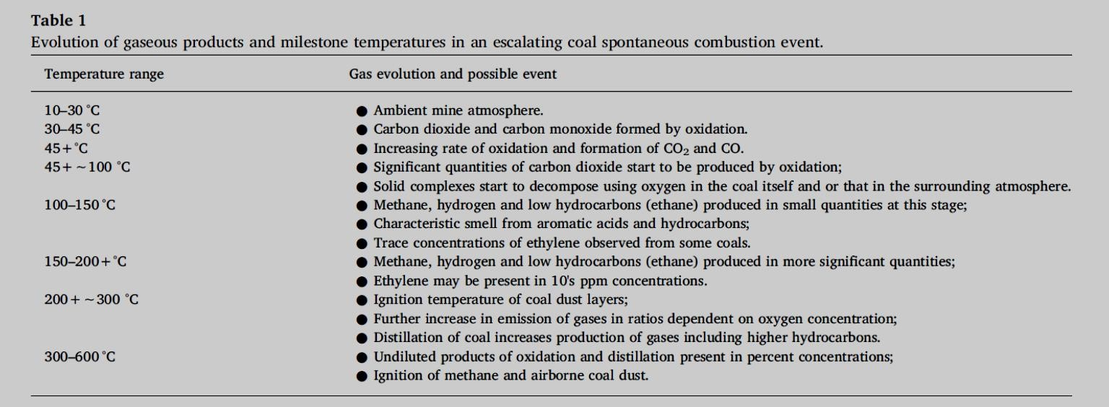
Note: Hydrogen from gas evolution studies is detected at temperatures as low as 60°C. The table is a guide only and individual evolution testing needs to be conducted for each coal seam
Adamus et al. (2011) documented the use of the temperature dependant evolution of C1 to C4 hydrocarbons and hydrogen as a method to determine the combustion temperature of coal. They document the variety in the application of various ratios. In the Ukraine for example ethylene to acetylene ratio is mandatory. In the Czech Republic the occurrence of ethylene, propene or acetylene is included in Regulations. Figure 24 below depicts the laboratory-based gas evolution curves found for an OKC Coal, note the logarithmic scale used for gas concentration. The order of evolution confirms the traditional fire ladder.

Figure 24: Laboratory based gas evolution curves (Adamus et al. 2011)
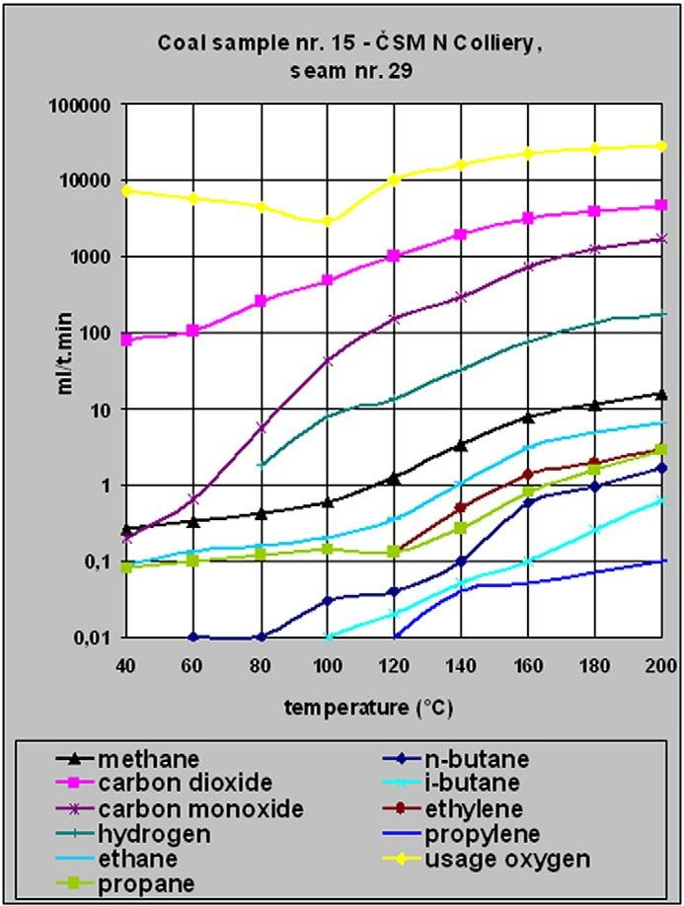
Guo et al. (2019) also promote the use of higher hydrocarbons to indicate the temperature of coal oxidation. The interrelation between the concentration of the hydrocarbons evolved as a function of coal temperature is coal rank dependent. The concentration of aliphatic hydrocarbons was also shown to be dependent upon the oxygen concentration. Olefinic hydrocarbon generation was not affected by the free oxygen concentration. They propose a composite index of the ratio of olefinic to aliphatic hydrocarbons. This ratio increases with increasing coal temperature. Seam gas that is dominated by aliphatic hydrocarbons will impact upon the usefulness of these ratios.
Xie et al. (2011) developed a system for enhancing the capacity to detect ethylene through the use of an enriching system. The enriching system uses a carbon molecular sieve to adsorb the ethylene. A measured volume of gas is passed through the molecular sieve. The ethylene is then desorbed by heating the molecular sieve with a measure flow of nitrogen passing through it. The concentration of ethylene is measured at timed intervals until there is no detectable ethylene being emitted. The total volume of ethylene desorbed is then calculated and related back to the original sample. The system was trialled at a number of Chinese coal mines. The system demonstrated a factor of 10 increase in sensitivity when compared to raw sampling of the samples.

Hazard assessment
Lang and Bao (2010) propose a comprehensive hazard evaluation system for spontaneous combustion of coal. Figure 25 below outlines the hierarchical structure of the evaluating indicators.
They established a process for rating each of the indicators, the overall level of the hazard is a function of the individual indicators. The indicators are weighted based upon the judgement of a panel of five coal mine safety experts from the China University of Mining Technology using the Analytic Hierarchy Process. A computer program was then developed to calculate the hazard evaluation. A five-tier classification system was used to then define the level of hazard due to spontaneous combustion for the mine. The rating was related to the incubation period for a spontaneous combustion event to occur at the mine.

Figure 25: Hazard evaluation system (Lang and Bao. 2010)
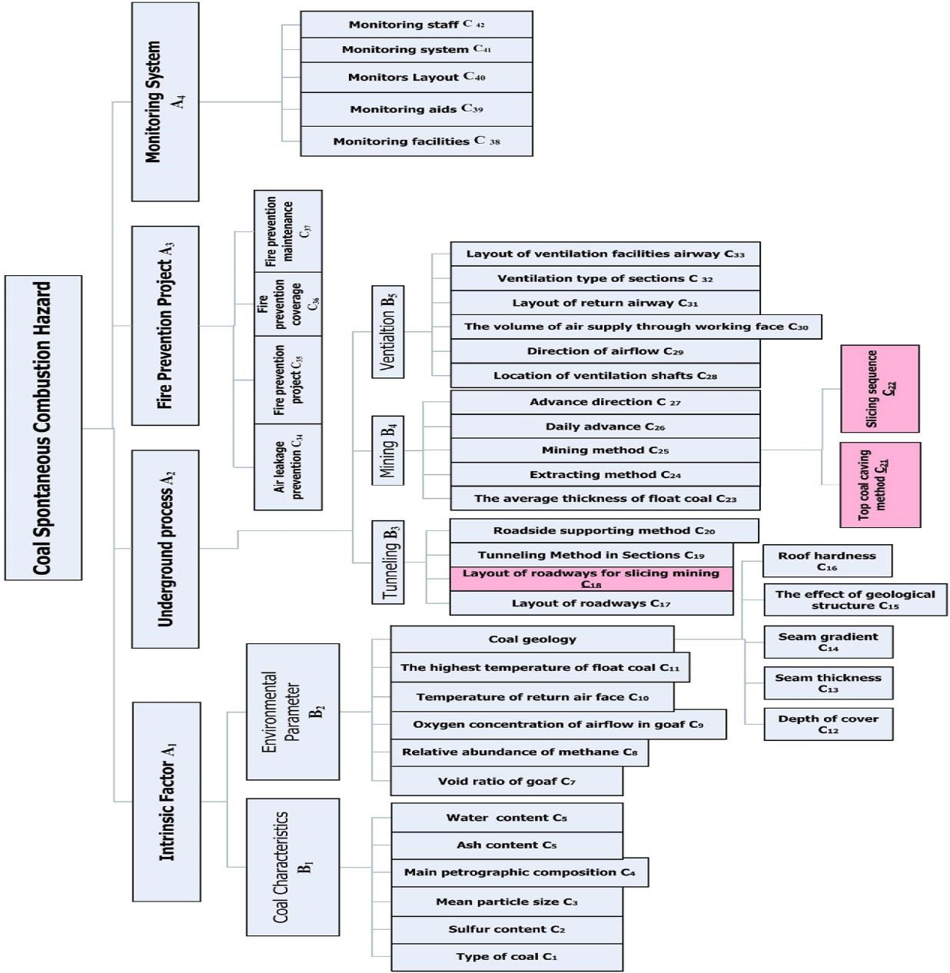

Laboratory testing
Yuan and Smith (2012) demonstrated that there is an optimum ventilation rate for a coal pile to produce the maximum rate of temperature rise. As the coal particle size increases, the temperature at which the coal achieves thermal runaway increases.
Beamish and Theiler (2017) highlight the limitations of standard laboratory spontaneous combustion tests that do not allow for the effect of included moisture or pyrites. The presence of moisture can significantly retard the oxidation of the coal and pyrites can accelerate it. Note: Not all pyrite is reactive. It needs to be present in a form (size and morphology) that enhances the surface area of the pyrite to increase its oxidation reactivity. Reactive spongy pyrite is most commonly associated with marine influenced coal sequences.
Deng et al. (2015) undertook spontaneous combustion studies on a 15 tonne reactor. They confirmed that oxidation occurred slowly below 70ºCelsius and accelerated rapidly beyond 100º Celsius. They found that the temperature of the coal could be predicted by using ratios carbon dioxide to carbon monoxide, methane to ethane, ethylene to ethane, propane to ethane. When the coal cools the temperature drops rapidly from 450ºCelsius to below 250ºCelsius the cooling rate decreases.

Radon detection
Radon detection continues to be widely practised in China as a technique for detecting the location of underground coal mine fires. Radon emissions from coal are strongly temperature dependant and travel through the overlying strata to the surface. The location of underground hot spots can be determined by identifying and plotting the geographical spread of radon emissions detected over the surface area above a heating (Zhou et al., 2018).
Wu et al. (2012) outlined a case study using radon to detect the location of a spontaneous combustion event at a Chinese coal mine. They estimate that the system can operate on mines at least 800 m below the surface. They outline the scientific basis for the detection of radon. Essentially as the coal temperature increases the radon temperature increases but the rate and absolute concentration of radon is coal specific. The radon is collected on the surface above the mine in cups spaced at 10 to 20 metre intervals. The location of the heating as identified by the cups was verified by drilling boreholes.

Containment and inertisation
Natural inertisation of the atmosphere within the goaf takes place through oxidation of carbonaceous material and displacement by seam and strata gases. The oxygen content should be 2% or less for oxidation to cease.
In seams where the coal is highly reactive and/or there is liberation of significant quantities of gas into the goaf from the strata, remnants of seam mined or seams above or below, inertisation can occur quickly. Where the coal is not very reactive and there is little or no seam gas, this process may take some time.
The natural inertisation process can be assisted by adding inert gas such as nitrogen or carbon dioxide.
Inertisation of an extracted area requires stoppings and seals to be placed in access roadways to contain the inert gases and to prevent other sources of air ingress from above and below the seam. Sources where air ingress may take place include:
- workings above and below the seam, particularly extracted areas where strata may be disturbed and cracked due to subsidence effects
- uncapped surface to seam boreholes
- exploration or service boreholes that may be capped but are within the subsidence affected zone
- water bores
- shallow workings and subsidence cracks.
In an active extraction panel, containment of the goaf alongside the working area is not possible. Reliance is placed upon the incubation period to prevent the risk of spontaneous combustion. The rate of advance of the extraction unit and the development of caving is usually enough to prevent the development of heatings. Additional controls may include monitoring and provision for inertisation.
Extraction systems that use partial ventilation through the goaf should be avoided. Ventilation of all parts of the goaf is difficult to achieve and cannot be verified.
Where gas make in a seam is very high and attempts at containment result in an unacceptable increase in gas in surrounding roadways, consideration may be given to the release of the gas to reduce the pressure within the goaf. Gas wells placed near the edges of the extracted area are a viable option. The risk of spontaneous combustion must be considered in conjunction with other major hazards at the mine and a total systems approach adopted.
The best form of inertisation of the extracted area is flooding. This excludes oxygen and cools any incipient heating. Other inertisation methods reduce oxygen but do not cool the heating site. An option to reduce goaf void space is the introduction of water, inertisation gases, and fly ash slurries or washery slimes.

Segregation of parts of the mine
In a mine that is prone to spontaneous combustion, extracted areas should be segregated so that they are of manageable size. Consideration should be given to limiting the length of longwall panels, the number of openings into the goaf and the number of successive long wall panels to avoid large numbers of stoppings being required to contain the goaf. The number of successive extraction panels could be reduced by leaving barriers periodically.
Even with a high standard of stoppings and seals, there is a limit to the size of the containment area. If a large number of stoppings and seals are relied upon to contain the area and allow it to inertise, there may be difficulty in lowering the percentage of oxygen in the sealed area to safe levels. Even seals constructed to a high standard will leak. The combined leakage from a large number of seals may not be offset by the natural inertisation processes. Another reason for segregation is to rapidly seal parts of a mine where a heating may develop.
Mines should assess the need for segregation that is supported by a risk management approach.

Controls on stowage
Accumulations of carbonaceous materials in roadways should be avoided. Such accumulations may come from fallen top coal, dumped material or convergence in top or bottom coal.
This material is best cleaned up and removed from the mine. Where this is not a practical option, the material can be stowed underground in a manner that controls the risk of spontaneous combustion, i.e.
by sealing in specially driven roadways, or by spreading in thin layers along the roadway and compacting.
Figure 26: Stowage stored up against stopping
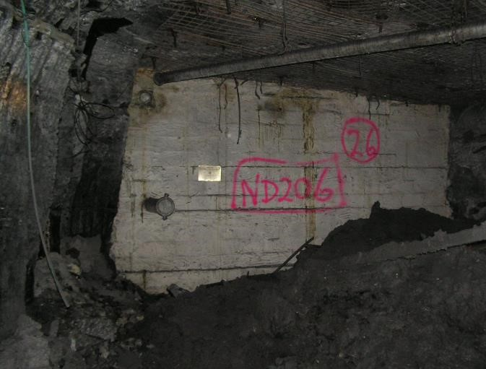
Figure 26 above shows stowage against goaf stopping impeding access.
The dumping of stowage material, carbonaceous or not, against stoppings and seals enclosing the goaf is to be avoided. Stowed material in these areas will impede inspection, sampling and repair of stoppings and roadway surrounds.
If stowage must be placed underground and the roadway is not to be sealed, it should be placed in such a manner that it is ventilated and can be inspected easily without a person having to crawl over spoil heaps.

Production of gases not related to heatings
False alarms may be generated where the above mentioned gases are produced by means other than spontaneous combustion activity. Examples are:
- use of galvanised iron as sample pipes
- acid mine water on galvanised iron producing hydrogen and carbonates producing carbon dioxide
- carbon monoxide and carbon dioxide from vehicle emissions
- unplanned stowage of chemicals and oils
- oil shales (volatile emissions).
Westthorp and Phillips (2017) demonstrated that trace levels of ethylene in longwall goafs may be due to the use of timber cribs during the longwall recovery process. Green timber was shown to generate ethylene under oxidising conditions.

Monitoring locations
The location of monitoring points at strategic locations is of major importance. A single sampling point some distance from the source provides an indication only and can often lead to either an over estimate or under estimate of the seriousness of the hazard.
Points must be sited where heatings are likely to develop. There needs to be little dilution of flows between the heating and the detectors. Consideration must be given to layering of methane and warm combustion gases which may rise up dip in a sealed area.
Ideally, sampling points should be in panel returns, behind stoppings and seals and in the main body of the ventilation circuit. All sampling points should be clearly located on the mine ventilation plan.
In identifying the location and number of monitoring points, the ability to determine where the contaminant is originating is important.
Figure 27 below shows the suggested locations for the recommended minimum number of environmental monitoring points for a longwall panel. It includes surrounding roadway and goaf monitoring points for the current and adjacent longwall blocks. Recommended sites for goaf sampling are shown. Location and frequency of sampling should be based upon results of atmospheric analysis, stability and an assessment of the hazard.
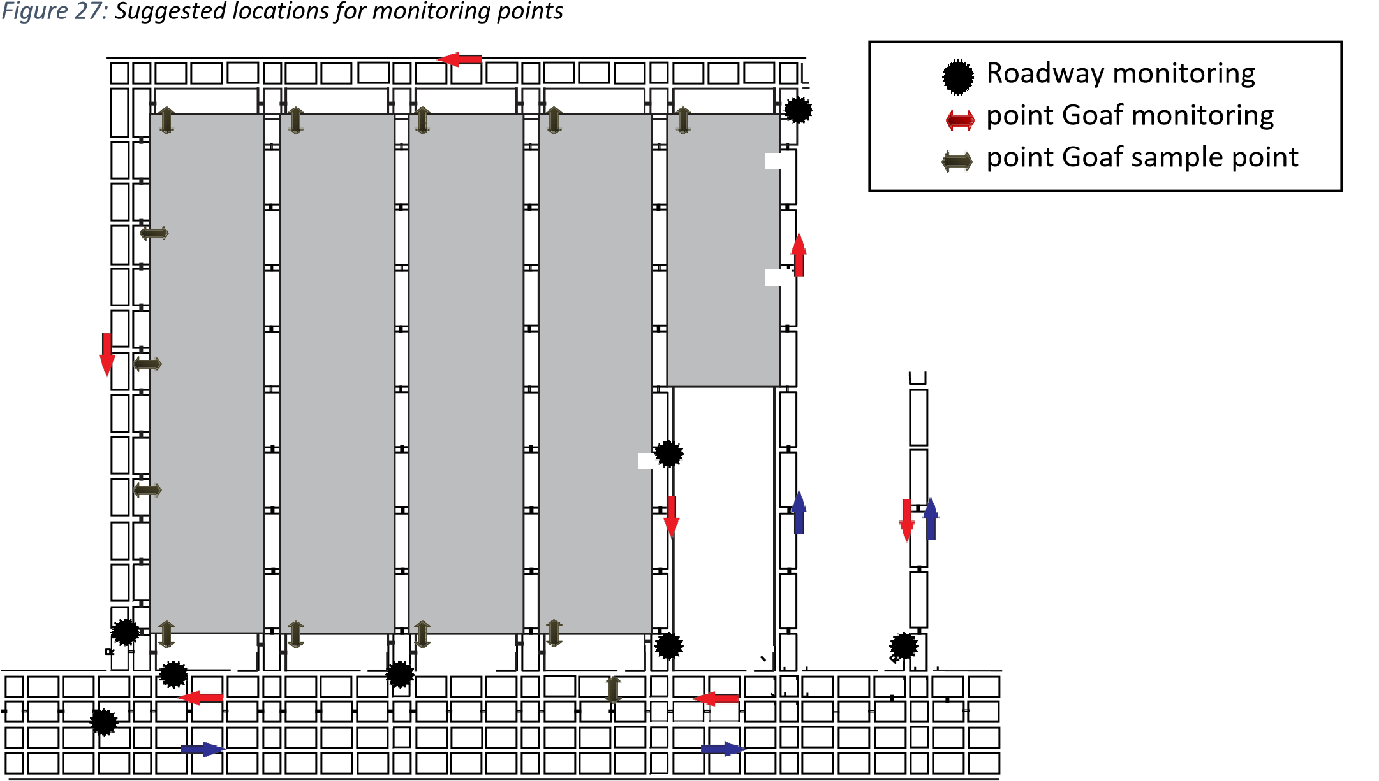

Air free analysis
The following information, in relation to ‘air’, assumes that air contains 20.93% oxygen and 79.07% nitrogen (including inerts).
In many situations the atmosphere of interest is diluted by being mixed with other atmospheres, particularly fresh air. In some cases, it is possible to remove the impact of fresh air through adjusting the gas concentrations. This can be achieved in a number of ways.
- Assuming all the oxygen present is due to the diluent gas
In this case the gas concentrations are adjusted by removing the oxygen concentration and the associated nitrogen concentration (based upon 3.778 times the oxygen concentration). The residual gases are then normalised to 100 %. This is also used to estimate what the ultimate concentrations of gases would be if all the oxygen present was converted using the conversion efficiency of the sample.
For example: Assume the fringe of a sealed area contains only the seam gases methane and carbon dioxide and no air contamination (i.e. 80% methane and 20% carbon dioxide). Assume then that the seal breathes in and that the atmosphere at the fringe behind the seal now contains 50% seam gas (40% methane and 10% carbon dioxide) and 50% air contamination (10.465% oxygen and 39.535% nitrogen + inerts). To determine what the seam gas component concentrations are without the air contamination using this method is commonly termed an ‘air free’ calculation. The air free calculation calculates the air contamination based on the normal air/ oxygen ratio of 4.778 and applying the resulting factor to the remaining components. The result would then be an air free concentration of 80% methane and 20% carbon dioxide (i.e. the original concentrations).
However, if an oxidation/heating occurs behind the seal then the reaction process will consume part of the oxygen in the air concentration. The consumption of the oxygen would produce carbon monoxide and carbon dioxide and also result in an excess nitrogen concentration (relative to the original normal nitrogen/oxygen air ratio). The air free calculation using this method can sometimes be useful in monitoring the level of oxidation products to assist in determining if the process is continuing, or if increased/ decreased levels are purely the result of air moving between the sealed areas as a result of diurnal atmospheric pressure influences.
- Identifying the degree of dilution through trending or comparison with other gas samples
For example: It may be possible to use gases such as methane to indicate the degree of dilution. Methane may be expected as a goaf/seam gas to be in a range of values and yet is much lower due to dilution. This dilution is simply worked out based upon the ratio of the expected value to the actual value. The dilution factor is then applied to all gases other than oxygen and nitrogen. The oxygen and nitrogen concentrations are then calculated by difference, scaling them as per the original diluted gas mixture.
This technique is most reliable when the degree of dilution can be confirmed by other gases.
This technique can be used for adjusting the effect of barometric pressure as well. Where concentrations of gases are affected by barometric pressure the variation can be analysed to identify what the diluent gas mixture is. This diluent can then be removed and the residual gases scaled appropriately.
Automatically carrying out air free analysis is not recommended. It is best carried out only when the nature of the diluent atmosphere is confirmed, and by experienced personnel. For example: any attempt to air free an atmosphere that is close to fresh air will lead to wildly inaccurate estimates of the residual gases, due in part to the limitations on accuracy/reproducibility of the gas analysis.

Management of an incident
See Code of Practice Emergency Planning for Mines, NSW Department of Trade and Investment, Regional Infrastructure and Services, 2015.

Location of surface activities
The surface environmental monitoring analysers, the surface control room, muster room and the main fan controls should be located away from the mine entries where they are not at risk from an underground explosion or products of combustion. A 60 degree angle on both sides of the direct line of the seam entry is generally considered to be the area at risk of effect from an underground explosion. Noxious and explosive gases may accumulate in or near facilities located alongside mine entries.

Monitoring under emergency conditions
The need to monitor under emergency conditions should be considered. Analysers that are suitable for normal operating mine environments may not be suitable for emergency conditions where gas levels exceed the range of the analysers.
The ability to monitor from the locations required under conditions that may negate access to underground workings should also be considered.
Surface access may be required to sample the atmosphere in the area of the heating by means of surface to seam boreholes. In a major event it is possible tube bundle lines could be damaged.

Inertisation
Shi et al. (2015) found that liquid nitrogen could also be used economically to reduce ambient temperature and humidity and reduce the potential for heat stress.
Liu et al. (2018) developed a technique that efficiently sublimates dry ice creating carbon dioxide gas using circulating water as the heat supply.
Caley (2017) outlined the use of a liquid nitrogen based vapourising system, similar to that installed at Newstan in 2006, to inert a sealed panel at Kestrel Colliery. The unit consists of a series of liquid nitrogen tanks and a vapouriser as shown in the figures below. 150 millimetre diameter wrapped pipe was run from the surface installation via a borehole to the final seal locations underground. This system was found to be cost effective for short term inertisation use.

Ambient air vapouriser
The ambient air vapouriser, as shown in figure 28 below is a nitrogen plant that can be set up on the surface of a mine site, perhaps for a longer term solution after the initial requirement was met by the NSW Mine Rescue mobile inertisation unit. A typical unit would have the following specification:
- 2 x 45,000l (30 tonne) liquid nitrogen storage vessels
- 2 x vapouriser units, one operating and one on standby
- Fully automated operation
- Rates controlled by orifice plates, min 0.5t/hr. to max 5t/hr.
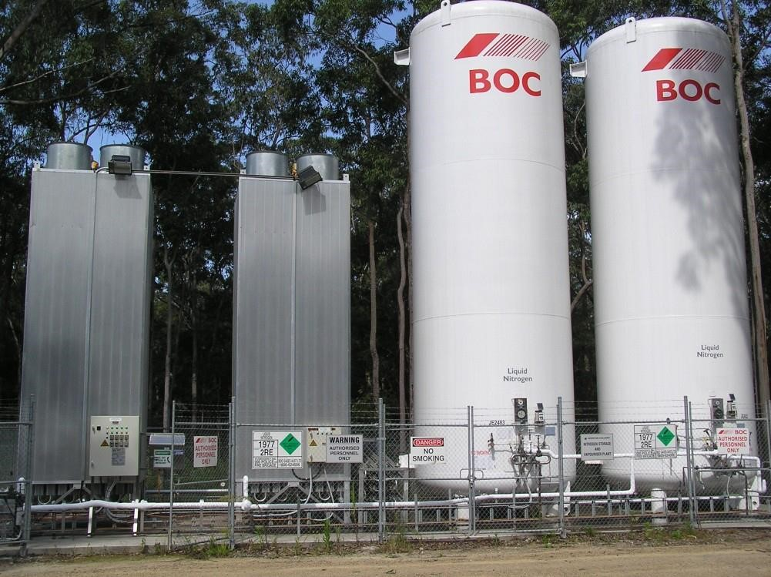
Figure 28:

Ambient air vapouriser

Pressure Vessels

Vapourisers

A telemetry system monitors operation 24 x 7 and when tanks are depleted they are refilled by a nitrogen supplier. Figure 29 below shows the control pane land orifice plate that meters the flow of N2 down a borehole.

Figure 29: Control panel and orifice plate for flow rate control

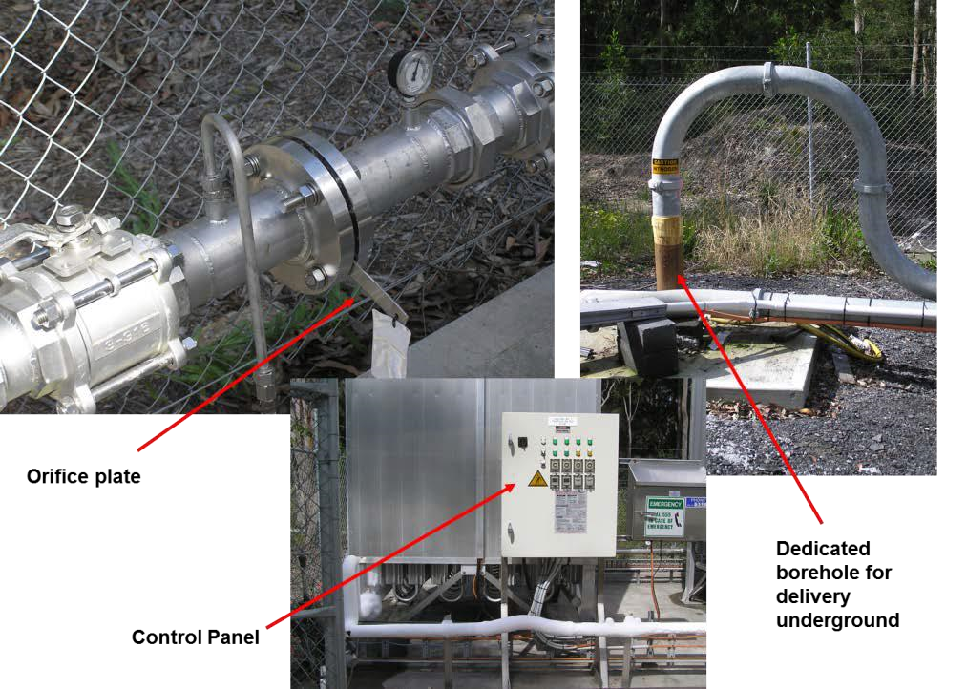

Rapid sealing
Provision for rapid sealing of parts of the mine is an important element of a spontaneous combustion management plan.
During the withdrawal process there is the possibility of isolating the part of the mine affected by rapid sealing such as closing doors etc. if this contingency has been foreseen and effective provisions put in place. If not, any actions taken to control or ameliorate the effects of the heating after withdrawal of people will have to be developed and designed and carried out remotely. This may be difficult and time consuming.
If there is surface access to the area above the heating site, the option of sealing the panel or part of the mine is available by using fly ash or other roadway filler. This also allows water or an inert gas to be introduced into the affected area from the surface by means of the Mineshield (nitrogen), Tomlinson boiler, Floxal unit or other means.
When making provision for sealing mine entries, the risk of explosion needs to be considered. Sealing the entries may have to be done without placing personnel in front of the entries where they may be harmed by an explosion.

Remote sealing
If workers are withdrawn from the mine because of a serious spontaneous combustion event, sealing of the affected part of the mine will allow and facilitate recovery of the remainder of the mine. Techniques for remote sealing include:
- injection of fly ash through boreholes
- injection of roadway filler materials such as Rocsil
- inflatable seals
- remotely operated fire doors.
Several proprietary products are available for roadway filling, inflatable seals and remotely operated doors. Some are described here. Users are advised to research the specifications of these products and satisfy themselves as to the suitable application for the task.

Fly ash
Fly ash is a by-product of coal combustion. It is a fine powder, light to dark grey in colour. Boiling/ melting point is > 1400ºCelsius. Specific gravity is 2.05 to 2.8. It is non-flammable. About 20% to 40% of particles are below 7 microns in diameter. The material is composed primarily of complex aluminosilicate glass, mullite, hematite, magnetite spinel and quartz. Silica-crystalline as quartz is 1 – 5% and mullite 1 – 5%. It does not decompose on heating.
The fly ash is readily available from power stations and can be injected through boreholes to underground roadways in a wet or dry state (figure 30). It has been used successfully in both forms in a number of events.
The angle of repose of fly ash when taken straight out the power station is about three degrees from the horizontal. When the ash has cooled and taken up some moisture the angle of repose is about 11 degrees from the horizontal.
Fly ash can be placed dry in a way that gets the angle of repose up to 40 degrees from the horizontal and still get a very good seal in the roadway. This is achieved by first putting down the hole about 40,000 litres of water. Dry fly ash is then pumped into the roadway. Another 5000 litres of water is placed and then more fly ash. This causes the ash to bank up on a steeper angle of repose.
For a roadway 3.5 metres high and 5.2 metres wide, on a level course, about 400 tonnes of fly ash would be required to plug the roadway (figure 31).
Fly ash placed wet is first pre-mixed in a slurry plant as shown in figure 30, to achieve the optimum pulp density for pumping down the borehole. There is less chance of blocking and wet fly ash can be pumped a greater distance. The following picture is a fly ash wet slurry plant.
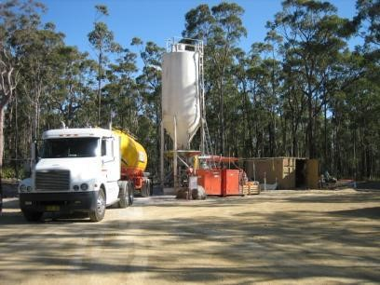
Figure 30:

Surface plant for pumping fly ash seals

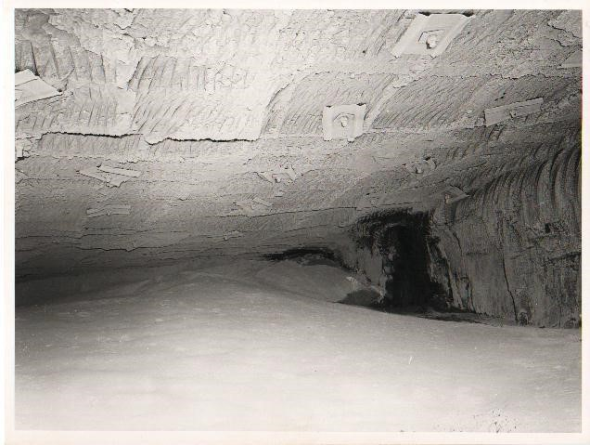
Figure 31:

Fly ash seal in underground roadway at Newstan

Roadway filler material
Examples of roadway filler materials are the Rocsil and Carbofill products. To fill a roadway via a borehole, two hoses are attached to a catenary wire and lowered into the borehole. Nozzle heads and check valves on hoses discharge two chemicals into the roadway. As the two chemicals mix, the foam expands at about 10 to 1 and then to 35 to 1 as it sets. The phenolic foam sets to ultimate strength in about 5 minutes. Bulkheads or barriers are not required in the roadway to contain the foam.
The plug formed is estimated to be 5 to 6 metres wide. A description of the material flow properties is that it flows like lava, i.e., flows and sets with fresh material building on that previously discharged and set. Material strength when set is about 2 mpa. It is a sealant that should fill the roadway without voids. The material does not support combustion and has been used extensively for cavity filling and the control of spontaneous combustion.

Inflatable seals (figure 32)
The shaft plug void sealing system (VSS), is designed to provide emergency and short-term sealing of an intake or exhaust shaft. The Shaft Plug can be installed remotely using a long boom crane and is also suitable for horizontal or inclined applications.
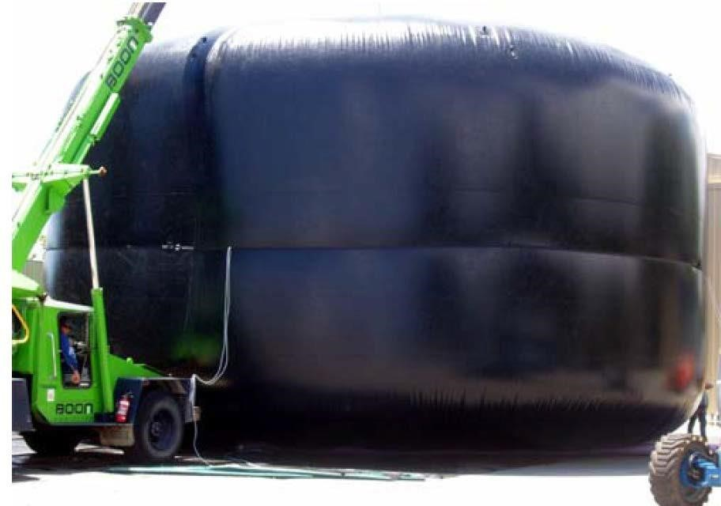
Figure 32:

Inflatable shaft seal

The Ventstop ventilation control unit for use in underground roadways, as shown in the picture below (figure 33), has these features:
- Suitable for any size or shape of roadway
- Portable and reusable
- Available in standard or FRAS (fire retardant anti-static) fabrics
- Continuous air trickle or bottle feed
- Available with sleeves through the seal.
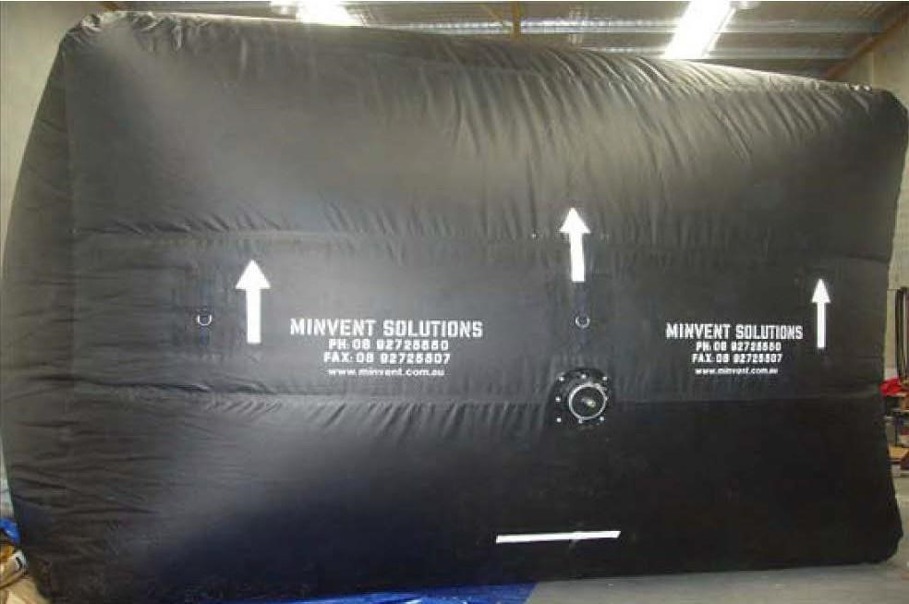
Figure 33:

Inflatable roadway seal
-

Ventstop

Both the inflatable shaft seal and roadway seal require periodic topping up with compressed air to maintain the seal. In this regard they should be regarded as a short term solution. For a longer term solution, an option is to fill the bag with a foam material.

Remotely operating doors
Doors that are capable of being remotely operated to close off an airway in the event of an emergency are available from a number of manufacturers. Issues in the successful design and operation of these doors include:
- Surface access
- Energy sources and means to operate doors remotely in an emergency
- Elimination of interference with door closure due to services in the roadway
The following figures (34 and 35) illustrate a system of remote door operation installed in a Queensland mine.
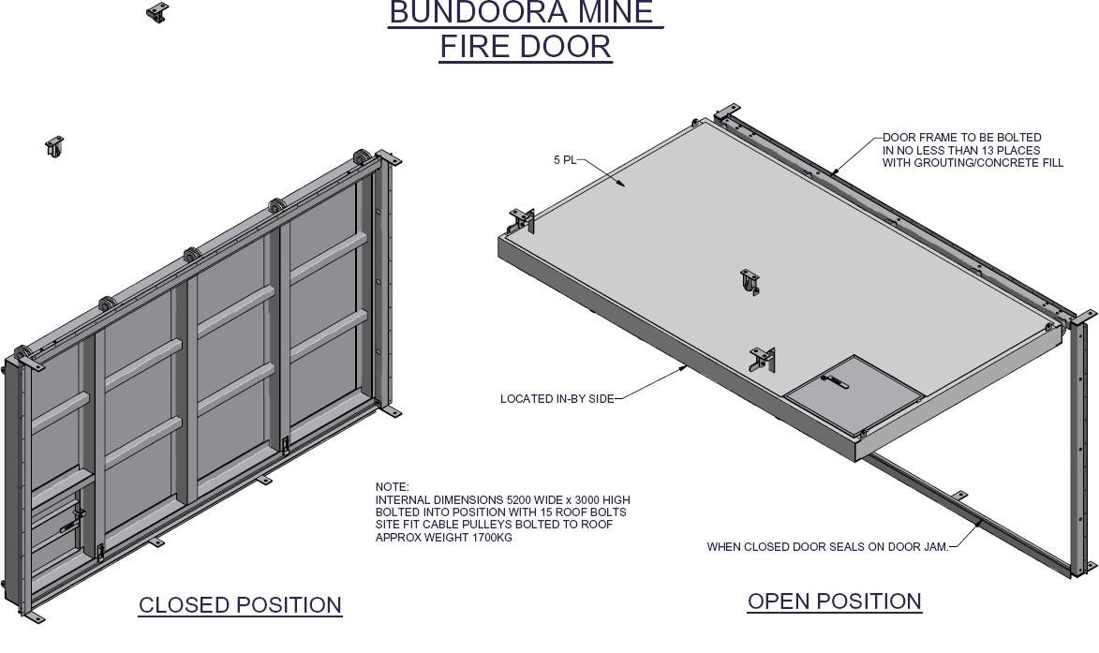
Figure 34:

Remotely operated door

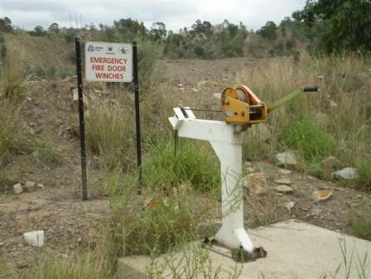
Figure 35:

Surface located winch to activate door

Attached to the door is a manual winch, operated from the surface of the mine but which can also be configured to be operated from a location within the mine such as an outbye cut through, etc. The door resides in the open position and if required, (emergency), the winch firstly lifts the door slightly and the roof latches let go and allow the self-locking door to be lowered to seal the area.

Appendix D: References for appendices
Adamus A, Sancer J, Guranova P and Zubicek V (2011) An investigation of the factors associated with interpretation of mine atmosphere for spontaneous combustion in coal mines, Fuel Processing Technology, 92 (2011) 663-670
Beamish B. B, and Theiler J (2017) Recognising the deficiencies of current spontaneous combustion propensity index parameters, The Australian Mine Ventilation Conference, Brisbane, Queensland, Australian Institute of Mining and Metallurgy, 2017, 113-117
Caley (2017) using Liquid Nitrogen for the Inertisation of goafs, The Australian Mine Ventilation
Conference, Brisbane, Queensland, Australian Institute of Mining and Metallurgy, 2017, 35-40
Cheng W, Hu W, Xie J and Zhao Y (2017) An intelligent gel designed to control the spontaneous combustion of coal: Fire prevention and extinguishing properties, Fuel, 210, 2017, 826-835
Deng J, Xiao Y, Li Q, Lu J and Wen H (2015) Experimental studies of spontaneous combustion and anaerobic cooling of coal, Fuel, 157, 2015, 261-269
Guo X, Deng C, Zhang X and Wang Y (2019) Formation law of hydrocarbon index gases during coal spontaneous combustion in an oxygen-poor environment, Energy Sources, Part A: Recovery, Utilization, and Environmental Effects, 41(5), 626-635
Lang L and Fu-Bao Z (2010) A comprehensive hazard evaluation system for spontaneous combustion of coal in underground mining, International Journal of Coal Geology, 82(7), 27-36
Li Z, Saydam S, Mitra R and Chalmers D (2016) Potential use of thin spray-on liners for gas management in underground coal mines, Journal of the Southern African Institute of Mining and Metallurgy, 2016, 116(12), 1091-1100
Liang Y, Zhang J, Wang L, Luo H and Ren T (2019) Forecasting spontaneous combustion of coal in underground coal mines by index gases: A review, J Loss Prevention in the Process Industries, 57, 2019, 208-222
Liu W, Qin Y, Yang X, Wang W and Chen Y (2018) Early extinguishment of spontaneous combustion of coal underground by using dry-ice’s rapid sublimation: A case study of application, Fuel 217, 2018, 544–
552
Lu X, Zhu H, Hu C and Zhao H (2018) Investigation on the performance and application of a new design of foam generator used for fire extinguishment in underground coal mines, Combustion Science and Technology, 190:11, 2003-2017, DOI: 10.1080/00102202.2018.1480016
Lu X , Zhu H, Hu C, Zhao H and Huo Y (2018) Flow characteristic investigation of inhibition foam used for fire extinguishment in the underground goaf , Process Safety and Environmental Protection, Volume 116, May 2018, 159-168
Ma L, Wang D, Wang Y, Xin H, Dou G and Xu C (2016) Experimental Investigation on a Sustained Release
Type of Inhibitor for Retarding the Spontaneous Combustion of Coal, Energy and Fuels, 30, 2016, 89048914
Qin B, La Y, Li Y and Wang D (2014), Aqueous three-phase foam supported by fly ash for coal spontaneous combustion prevention and control Advanced Powder Technology 25, 2014, 1527-1533
Ren T, Wang Z, Nemcik J, Aziz N and Wu J (2017) Investigation of spontaneous heating zones and proactive inertisation of longwall goaf in Fenghuangshan Mine, 12th Coal Operators' Conference,
University of Wollongong & the Australasian Institute of Mining and Metallurgy, 2012, 212-220.Xi
Ren W, Guo Q and Wang Z (2016) Application of foam–gel technology for suppressing coal spontaneous combustion in coal mines Natural Hazards, 2016, 84:1207–1218
Shi G, Liu M, Wang Y, Wang W and Wang D Computational Fluid Dynamics Simulation of Oxygen
Seepage in Coal Mine Goaf with Gas Drainage Mathematical Problems in Engineering, Volume 2015,
Article ID 723764, http://dx.doi.org/10.1155/2015/723764
Shi B, Ma L, Dong W and Zhou F (2015) Application of a Novel Liquid Nitrogen Control Technique for
Heat Stress and Fire Prevention in Underground Mines, Journal of Occupational and Environmental
Hygiene, 12:8, D168-D177, DOI: 10.1080/15459624.2015.1019074
Slovak V and Taraba B (2012) Urea and CaCl2 as inhibitors of coal low-temperature oxidation, Journal of Thermal Analysis and Calorimetry, 2012, 110, 363-367
Tang Y (2017) Inhibition effect of Phosphorus Flame Retardants on the Fire Disasters Induced by
Spontaneous Combustion, Journal of Spectroscopy, 201, Article ID 7635468
Tang Y (2018) Experimental investigation of applying MgCl2 and phosphates to synergistically inhibit the spontaneous combustion of coal, J Energy Institute, 2018, 91, 639-645
Tosun A (2017) Development of a technology to prevent spontaneous combustion of coal in underground coal mining. J South African Institute of Mining and Metallurgy, 117, December, 1133-1138
Westthorp E and Phillips J (2017) Findings from the preliminary testing to determine alternative sources of ethylene within sealed areas of underground coal mines, The Australian Mine Ventilation Conference, Brisbane, Queensland, Australian Institute of Mining and Metallurgy, 2017, 203-205
Wu J, Wu Y, Wang J and Zhou C (2012) Radon measuring to detect coal spontaneous combustion fire source at Bulianta mine, Shandong, 12th Coal Operators’ Conference, University of Wollongong and the Australian Institute of Mining and Metallurgy, 2012, 300-304
Xi Z, Wang X, Wang X, Wang L, Li D, Guo X and Jin L (2018) Self-hardening thermoplastic foam for the inhibition of coal oxidation at low temperatures, Combustion Science and Technology, accessed online https:/doi.org/10.1080/00102202.2018.1539967
Xia T, Zhou F, Liu J, Kang J and Gao F (2014) A fully coupled hydro-thermo-mechanical model for the spontaneous combustion of underground coal seams Fuel 125, 2014, 106-115
Xie J, Xue S, Cheng W and Wang G (2011) Early detection of spontaneous combustion of coal in underground coal mines with development of an ethylene enrichment system, International Journal of Coal Geology, 85, 2011 123-127
Xiong S. Q and Yu C.C (2013) Characteristics and mechanisms of rock magnetic increasing in underground coal spontaneous combustion area-take Wuda coal mine of Inner Mongolia and Ruqigou coal mine in Ningxia as examples Chinese Journal of Geophysics-Chinese Edition, 56(8), 2827-2836
Yuan L and Smith A.C. (2012) The effect of ventilation on spontaneous heating of coal, Journal of Loss
Prevention in the Process Industries, 2012, 25(1), 131-137
Zhou B, Wu J, Wang J and Wu Y (2018) Surface-based radon detection to identify spontaneous combustion areas in small abandoned coal mine gobs: Case study of a small coal mine in China, Process Safety and Environmental Protection, 119, 2018, 223-232
Zhou P, Zhang Y, Huang Z, Gao Y and Song S (2016) Research on Mechanism of New Gel Composites in Inhibiting Spontaneous Combustion in Gob, Journal of Applied Science and Engineering, Vol. 19, No. 4, pp. 471478

NSW Work Health and Safety (Mines and Petroleum Sites) Regulation 2014. The Regulation defines a principal hazard as any activity, process, procedure, plant, structure, substance, situation or other circumstance relating to the carrying out of mining operations that have a reasonable potential to result in multiple deaths in a single incident or a series of recurring incidents.
See Chapter 2.2, Page 20 of Cliff, D., Brady, D., & Watkinson, M. (2018). Spontaneous Combustion in Australian Coal Mines. Redbank, QLD: SIMTARS - for a more detailed explanation of this process.
ACARP 2017
Sourced from ACARP 2017
See chapter 3 (page 57 onward) of Cliff, D., Brady, D., & Watkinson, M. (2018). Spontaneous Combustion in Australian Coal Mines. Redbank, QLD: SIMTARS - for more detailed information
Cliff, D., Brady, D., & Watkinson, M. (2018). Spontaneous Combustion in Australian Coal Mines. Redbank, QLD: SIMTARS
https://www.resourcesregulator.nsw.gov.au/__data/assets/pdf_file/0008/543941/NSW-code-of-practice-Safetymanagment-systems-in-mines.pdf
https://www.resourcesregulator.nsw.gov.au/__data/assets/pdf_file/0008/537290/consulting-workers-factsheet.pdf ⁹ Further details can be found in Chapter 3 (page 57 onward) of Cliff, D., Brady, D., & Watkinson, M. (2018). Spontaneous Combustion in Australian Coal Mines. Redbank, QLD: SIMTARS.
https://smi.uq.edu.au/project/riskgate
https://www.resourcesregulator.nsw.gov.au/__data/assets/pdf_file/0003/541533/GUIDE-Managing-risks-in-mine-andpetroleum-sites.pdf
Further details can be found in Chapter 3 (page 58-73) of Cliff, D., Brady, D., & Watkinson, M. (2018). Spontaneous Combustion in Australian Coal Mines. Redbank, QLD: SIMTARS.
Chapter 5 (page 121 onward) of Cliff, D., Brady, D., & Watkinson, M. (2018). Spontaneous Combustion in Australian Coal Mines. Redbank, QLD: SIMTARS; contains a detailed explanation of mine design parameters updated in Appendix 1 of this document
Chapter 7 (page 221 onward) of Cliff, D., Brady, D., & Watkinson, M. (2018). Spontaneous Combustion in Australian Coal Mines. Redbank, QLD: SIMTARS; contains a detailed explanation of available control techniques updated in appendix 1 of this document
For more details on monitoring systems see Chapter 6 (page153 onward) of Cliff, D., Brady, D., & Watkinson, M. (2018). Spontaneous Combustion in Australian Coal Mines. Redbank, QLD: SIMTARS updated in appendix 1 of this document.
Mines Rescue ICCS Guide, NSW Coal Industry, Coal Services, 2014.
Australian Standard AS 3745-2010 Planning for emergencies in facilities.
In 2015 the International Council on Mining and Metals (ICMM) released their good practice guide Health and Safety Critical Control Management that described how mining and metals industries’ risk management outcomes could be improved by focussing on those controls that are most critical for health and safety. A number of subsequent ICMM
Resources and Infrastructure Industry Training Package accessible at https://training.gov.au/Training/Details/RII
name withheld at company request
Source: Paper presented to Coal Operator’s Conference 2016 – Brendan Newham, Basil Beamish, Michael Brady and Matthew Fellowes, Interpreting the Status of an Underground Coal Mine Heating for Valid Risk Management and Control, in Naj Aziz and Bob Kininmonth (eds.), Proceedings of the 16th Coal Operators' Conference, Mining Engineering, University of Wollongong, 10-12 February 2016, 456-462.
Source: NSW Resource Regulator ISR19-19 Dangerous incident IncNot0034595

