SOP for Secondary

Extraction in Longwall 404
Oaky Creek North SOP
Document Number: SOP0318OCN LW404
Status: Approved
Version: 1 (22 August 2014)
Owner: Technical Services Manager

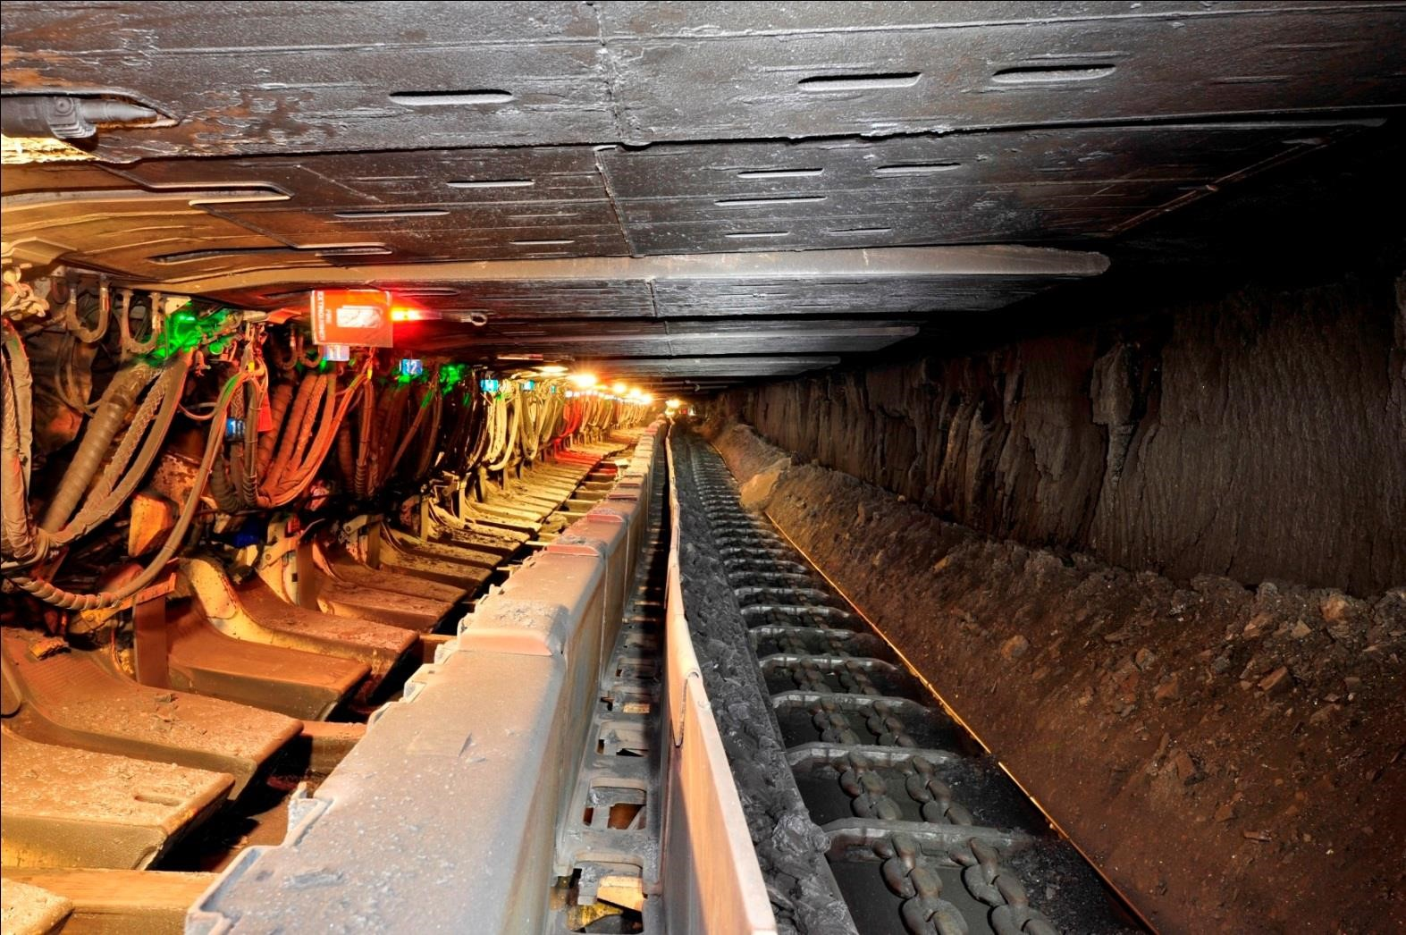

Table of contents
- Purpose ....................................................................................................................................... 4
- Scope ........................................................................................................................................... 4
- Date of Commencement .......................................................................................................... 5
- Coal Extraction .......................................................................................................................... 5
Introduction ........................................................................................................................................... 5
Operation of Longwall Equipment ......................................................................................................... 6
Salvaging of Longwall Equipment .......................................................................................................... 6
- Hazards and Controls ............................................................................................................... 6
Ventilation ............................................................................................................................................. 6
Quantity ............................................................................................................................................ 7
Seals & Stoppings ............................................................................................................................. 7
Expected Gas Sources ...................................................................................................................... 7
Atmosphere Ingress from Abandoned Workings .............................................................................. 7
Leakage Paths ................................................................................................................................... 7
Post Methane Drainage .................................................................................................................... 8
Spontaneous Combustion ................................................................................................................ 8
Gases ..................................................................................................................................................... 9
Acetaldehyde and Formaldehyde ..................................................................................................... 9
Carbon Monoxide ............................................................................................................................. 9
Hydrogen Sulphide ........................................................................................................................... 9
Mineral Oil Mist ................................................................................................................................ 9
Methane ........................................................................................................................................... 9
Nitric Oxide ...................................................................................................................................... 9
Sulphur Dioxide ................................................................................................................................ 9
Frictional Ignition ................................................................................................................................. 10
Gas Outburst ....................................................................................................................................... 10
Inrush and Water Management ............................................................................................................ 10
Surface Sources .............................................................................................................................. 10
In-Seam Water ................................................................................................................................ 10
Goaf Water ..................................................................................................................................... 10
Sumps and Pumps .......................................................................................................................... 10
Pumps............................................................................................................................................. 11
Lightning management ........................................................................................................................ 11
Emergency Response ........................................................................................................................... 11
Respirable Dust .................................................................................................................................... 11
Equipment Hazards .............................................................................................................................. 11
Longwall Restrictions ...................................................................................................................... 11
Conveyor Fire ................................................................................................................................. 12
Removal of Structure ...................................................................................................................... 12
Power ............................................................................................................................................. 12
- Geology ..................................................................................................................................... 12
- Geotechnical ............................................................................................................................ 12
Wide/High Drivage .............................................................................................................................. 13
Pillar Size ............................................................................................................................................. 13
Installed Ground Support ..................................................................................................................... 13
Roof and Floor Integrity and Horizon ................................................................................................... 13
Goaf Control ........................................................................................................................................ 13
Creep .................................................................................................................................................. 14
Surface Controls................................................................................................................................... 14
- Adjacent Workings .................................................................................................................. 15
- Document information ........................................................................................................... 16
- Site Approval ........................................................................................................................... 17
- Appendix .................................................................................................................................. 17
11.1 Ventilation & Gas Management Book ........................................................................................ 17
Purpose .......................................................................................................................................... 17
Scope ............................................................................................................................................. 17
Gas Makes ...................................................................................................................................... 17
Goaf Capture .................................................................................................................................. 20
Vertical Goaf wells ..................................................................................................................... 20
Horizontal Goaf Drainage .......................................................................................................... 21
Pre-Drainage................................................................................................................................... 22
SIS gas drainage ........................................................................................................................ 22
UIS Gas drainage ....................................................................................................................... 24
Gas Compliance ............................................................................................................................. 24
Ventilation ...................................................................................................................................... 26
11.2 Geology & Geotechnical Book .................................................................................................. 29
Purpose .......................................................................................................................................... 29
Scope ............................................................................................................................................. 29
Structures ....................................................................................................................................... 30
Machynlleth Fault....................................................................................................................... 30
Little Mach Fault ........................................................................................................................ 30
Minor Normal Fault .................................................................................................................... 30
Seam Geometry .............................................................................................................................. 31
Seam Dip ................................................................................................................................... 31
Cross-grade ............................................................................................................................... 32
Seam thickness .......................................................................................................................... 33
Seam Splits ..................................................................................................................................... 33
Depth of Cover ............................................................................................................................... 35
Roof Strength ................................................................................................................................. 36
First 0.5m Uniaxial Compressive Strength (sonic correlated) ...................................................... 36
Roof strength through faults in LW404 ....................................................................................... 37
Floor Strength ............................................................................................................................ 39
Floor strength through faults in LW404 ...................................................................................... 41
Lost Surface Boreholes .............................................................................................................. 43
Machynlleth Fault Flight Plans.................................................................................................... 44
Shield Operating Heights .......................................................................................................... 44
Shield Pressure Ranges .............................................................................................................. 45
Gateroad Support Installed ........................................................................................................ 45

1 Purpose
1-1 The purpose of this standard operating procedure is to manage the risks associated with the secondary extraction of Longwall 404 (LW404) and align with the requirements of the Coal Mining Safety and Health Regulations 2001 Section 318
1-2 If any significant change to this second workings process is necessary, then a review of the risk assessment conducted for this SOP must be conducted and this procedure amended. A copy of this procedure and a report of the risk assessment are to be forwarded to the Mines Inspector.

2 Scope
2-1 This Standard Operating Procedure (SOP) provides the standard operating processes required to manage the hazards associated with the secondary extraction of Longwall 404 at Oaky North Mine.
2-2 This Standard Operating Procedure makes reference to the hazards and controls identified from the Risk Assessment that was conducted in two parts on the 18th June and 8th July 2014. This Risk Assessment considered the hazards as specified in Section 317 of the Coal Mining Safety and Health Regulation (CMSHR) 2001 and any other hazards identified with the extraction of LW404 including:
- Any surface feature e.g. artificial structures and water hazards that may create a hazard if disturbed by the workings,
- Any other workings located in close proximity above or below or adjacent to the proposed workings whether in this or an adjacent mine,
- The known geology of the affected workings,
- The anticipated gas make,
- The pillar stability,
- The proposed method and sequence of coal extraction,
- The proposed methods for the following:
- Strata control and support,
- Ventilation,
- Controlling spontaneous combustion,
- Support methods necessary to control the edges of each goaf area in active workings,
- The suitability of plant and its controls used for the workings.
2-3 In particular, this SOP refers to methods for the following, as required by Section 318 of the CMSHR 2001:
- Coal extraction.
- Strata control and support.
- Ventilation.
- Controlling spontaneous combustion.
- Monitoring and recording extraction progress.
- The coal extraction sequence.
- Date of Commencement
3-1 It is intended to commence the extraction of LW404 on 27th August 2014.

4 Coal Extraction

Introduction
4-1 The method of extraction for LW404 is retreat method of longwall mining.
4-2 The hazards associated with longwall extraction are checked during retreat as per the Standard for Longwall Permit to Mine (STD0335OCN) with the Longwall split up into sections on a hazard/risk basis. The information from this review is inputted into the Longwall Permit to Mine (FRM0158OCN) form that assesses against the operational, geological/geotechnical and ventilation/gas management hazards and controls. This checklist must be authorised by the Underground Mine Manager, Tech Services Manager, and Longwall Superintendent prior to extraction in the assessed zone.
4-3 The Longwall is a DBT manufactured ‘clockwise’ unit.
4-4 The equipment used is detailed as follows:
Equipment | Manufacturer | Installed Power/ Rating | Quantity
Pump Station | SES | 3K200/53 – 200kW – 300L/Min (350 bar) | 1
Hi-set | SES | 3K-110 – 125kW – 129L/Min (420 bar) | 1
Shearer Water Pumps | SES | Hauhinco 3K150/80 – 200Kw – 625L/Min | 1
Monorail | DBT | 2 x 9kW Shunting trolley  2 x 4wd Shunting trolley | 1
Bootend | DBT | Track mounted | 1
BSL | DBT | 400kW | 1
Crusher | DBT | 400kW | 1
AFC | DBT | 855kW Morely Motor / Class 45 CST | 1
Shearer | Eickhoff | SL750, 620kW ranging arm 90kW haulage, 27kW pump | 1
Drums | SES | 2 x 1900mm x 1050mm Radial Tool Drums | 2
DCB | Ampcontrol | 7 x 3.3Kv | 1
CME | Ampcontrol | 4 x 110v | 1
Shields | DBT | 2 Leg x 1750mm x 1040 ton | 183
Control System | DBT | PM4 | 183
4-5 Bi-directional shearing is to be utilised as the normal operating procedure. Longwall Standards and TARPS further define the cutting process and controls.
4-6 Seam thickness varies between 2.0m to 2.2m. There is a progressive decrease in the seam thickness from the Face Line towards the Mains.
4-7 The entire seam section is planned to be extracted.
4-8 Figure 1 (page 15) illustrates the current workings and at Oaky North Mine.
4-9 LW404 panel is the fifth panel in the 400 Series to be mined and is 315m wide and approximately 2260 m long.
4-10 The DBT 2 x 1040t powered supports (Shields) have an operating range between 2.0 m and
2.65m. It is intended to extract the full seam.
4-11 The longwall is planned to operate 7 days per week with two production shifts per day. Planned maintenance is scheduled as determined by the equipment maintenance schedule, typically based around four maintenance windows totalling around 20 hours per week.
4-12 Trained operators familiarised with longwall operational procedures are to conduct operations on the longwall. The Longwall Superintendent is responsible for ensuring that operators and tradesmen are trained and familiarised with the operations and procedures developed in consultation with the workforce for the longwall. These include, but are not limited to: a) Coal extraction.
- Strata control and support.
- Ventilation.
- Controlling spontaneous combustion.
- Monitoring and recording extraction progress
- The coal extraction sequence and methods to be used.
  - Hazards identified in LW404 during development and exploration, as well as in previous longwall blocks are outlined in the operational procedures and hazard management plans. Hazards have been identified and controls discussed during the LW404 Second Workings Risk Assessment.
  - Standards, procedures and TARP’s relating to the coal extraction operations for LW404 are available on the Oaky North Document Management system, and are also listed in section 9, table 1 related documents on page 16.

Operation of Longwall Equipment
4-15 Longwall operation during extraction and associated activities are controlled by the Safety and Health Management System – listed in section 9, table 1 related documents on page 16. To supplement these procedures and standards, the hierarchy of risk management controls from Stop-Look-Assess-Manage (SLAM), Job Safety Analysis (JSA’s) and Formal Risk Assessment (WRAC) are used as required.

Salvaging of Longwall Equipment
4-16 At the completion of LW404, the removal of longwall equipment is to be controlled by Procedures for meshing bolting and longwall recovery operations.

5 Hazards and Controls
5-1 The LW404 Second Workings Risk Assessment considered hazards and associated risks relating to the extraction of LW404.
5-2 A risk assessment was conducted in two parts on 18th June and 8th July 2014 from which an action plan was developed and documented in Sitesafe.
5-3 The following sections of this document consider the hazards and control measures to manage the risks to an acceptable level and as low as reasonably achievable.

Ventilation

Refer to the Ventilation and Gas Drainage Reference Section in Appendix 1 for more information in this area
5-4 The following principle hazard management plans relate to ventilation gas management at OCN
- HMP0008OCN Mine Ventilation,
- HMP0009OCN Gas Management and Frictional Ignition,
- HMP0020OCN Irrespirable Noxious Atmosphere
- HMP0007OCN Spontaneous Combustion

Quantity
5-5 The quantity of the air available to the face throughout the extraction of LW404 will be approximately 50 to 55 m3/s and is designed to ensure methane dilution to less than 1% in the tail gate at planned production rates.
5-6 The standard system of ventilation (return via tail gate) with a homotropal belt road will be used.
5-7 A nominal 30m3/s as measured at 404MG dogleg regulator for the homotropal return and a nominal 50m3/s across the longwall face are planned. The total intake air will be a nominal
80m3/s

Seals & Stoppings
5-8 LW404 Final seals will be 345 KPa Type D seals constructed in the manner as detailed in the longwall sealing plans which will be finalised after conducting a specific LW404 risk assessment.
5-9 The location of the final seals in LW404 has already been identified and marked out.
5-10 The final sealing plan for LW404 and associated Risk Assessment will be submitted to the Mines Inspector at least 30 days prior to final sealing commencing.
5-11 Goaf seals rated at least 145 KPa Type C are to be installed around the perimeter of the LW404 goaf where the travel road has the potential to be used again.
5-12 Goaf seals shall be constructed in accordance with the requirements of Schedule 4 of the CMSHR 2001. Type C and type D seals will be used with an appropriate water head rating based upon contours and potential water head rating.
5-13 The back wall of any seal will be constructed before the longwall passes any main gate cross cut to minimise air-wash across the goaf.
5-14 A brattice wing will be maintained at the side of the main gate shields to minimise air-wash.

Expected Gas Sources
5-15 The seam gas in the LW404 panel changes during retreat. This is highlighted in the Gas and ventilation Book for LW404 – see appendix. The expected gas sources are rib emissions, coal on the conveyor belt, goaf gas ingress and gas emissions from the cutting process.
5-16 Gas levels are to be controlled by adequate ventilation and goaf gas drainage wells, and monitored through statutory inspections, the Tube-bundle system and real-time electronic monitoring.
5-17 Residual inseam gas content means the entire panel does not require specific Outburst management controls.

Atmosphere Ingress from Abandoned Workings
5-18 The previous longwall panels are adjacent to LW404. The tail gate of LW404 was the travel road of LW403. The goaf area is separated by a minimum type C seals.

Leakage Paths
5-19 Potential leakage paths of ventilation around the face installation road will be mitigated by the construction of rated VCD in the install road soon after commissioning. Brattice wings will be maintained at the main gate shields.

Post Methane Drainage
5-20 The Methane Drainage and Outburst Management Plan (HMP0010OCN) outline the protocols for gas drainage of the panel.
5-21 The use of goaf wells will mitigate goaf gas release into workings
5-22 It is expected that the goaf wells will be managed to produce a flow rate of a nominal 1500l/s.
5-23 Gas concentrations in tailgate will be monitored by real-time systems that are connected to the Safegas system that will alarm in the Communications Room should alarm levels be reached.
5-24 The tube bundle will monitor the tail gate gas levels and provide trends for spontaneous combustion detection.
5-25 Goaf wells will be drilled at a nominal 75m spacing and approximately 30m from tailgate. Holes are 230mm internal diameter.
5-26 Horizontal goaf wells (146mm diameter) will be used inbye 15 CT as a trial in the German Creek seam with a view to using on future longwall’s to improve gas management and capture.
5-27 A brattice wing will be maintained at the side of the main gate shields to minimise air-wash.

Spontaneous Combustion
5-28 The following principle hazard management plans relate to spontaneous combustion.
- HMP0007OCN Spontaneous Combustion,
- HMP0008OCN Mine Ventilation,
- HMP0009OCN Gas Management and Frictional Ignition,
- TAR0010OCN Spontaneous Combustion in active longwall goaf
  - The use of tube bundle monitoring points, along with the regular bag sampling regime, provides an early warning for any irregularities in goaf atmosphere composition.
  - All exploration boreholes intersecting the panel have been identified, and have been sealed.
  - The German Creek Seam has been tested using the R70 method and show a low to medium propensity for spontaneous combustion. However the management systems are geared towards accepting that spontaneous combustion could occur.
  - LW404 will extract the full seam. A small amount of coal will be left in the goaf grading the faults. This will be mapped and recoded on the daily geological face survey.
  - In order to control the leakage of gas through in-seam boreholes, a “Borehole Intersection
Notice” is issued prior to any intersections. This is all part of the ‘Permit to Mine’ Process
  - A bag sampling program is scheduled by the Ventilation Officer to monitor the active LW goaf. TAR0001OCN TARP for Spontaneous Combustion in an Active Goaf defines the triggers and responses.
  - All longwall bag samples are taken on the diurnal low barometer (usually around 0400 and 1600).
  - The Ventilation Officer may designate additional goaf atmosphere monitoring where required, and may also include an increased frequency of bag sampling or the continual monitoring of a seal using the tube bundle system.
  - A tube bundle line and real-time sensors for CO, CH4, O2 and CO2 are to be installed in the last return place of LW404.
  - Analysis of goaf stream bag sample results is conducted by an independent party for indicators of oxidation and trends and ratio’s.

Gases
5-39 The following gases are to be monitored as per Schedule 6 of the CMHSR 2001.

Acetaldehyde and Formaldehyde
5-40 Exhaust gases are emitted from all underground diesel vehicles and is monitored by monthly testing on each underground diesel vehicles.
5-41 Formaldehyde and phenols can be formed from the use of silicate and polymer chemicals in strata consolidation. A safe system of work is established for the use of such chemicals.
5-42 It is not anticipated that exposure to acetaldehyde and formaldehyde will be in excess of the allowable exposure limits in the mine’s underground environment.

Carbon Monoxide
5-43 Carbon monoxide (CO) is monitored by the Real Time and Tube Bundle Monitoring Systems, statutory inspections, as well as monthly gas bag sampling at all ventilation splits.

Hydrogen Sulphide
5-44 No occurrence of hydrogen sulphide (H2S) has been detected from exploration, gas drainage drilling or development within LW404. ERZ Controllers monitor for H2S during mining operations as per CMHSR 2001.

Mineral Oil Mist
5-45 Mineral oil mist may present a hazard where mineral oil is under pressure such as within the hydraulic circuits of some mining equipment. The majority of equipment on the longwall face, including the roof support circuits, uses a 95% - 5% water vegetable oil - synthetic emulsion.
5-46 The shearer is the only equipment that uses mineral oil under pressure. In the event of a blown hydraulic hose emitting mineral oil, correct isolation procedures are to be followed.
5-47 The occurrence of blown hoses is managed by routine and preventative maintenance inspections. It is not anticipated that mineral oil mist represents a hazard within the mine’s underground environment.

Methane
5-48 Methane (CH4) is currently monitored by the Real Time and Tube Bundle environmental monitoring system, the shearer monitoring system, statutory inspections, as well as monthly gas bag sampling at all ventilation splits.

Nitric Oxide
5-49 Nitric oxide emissions are controlled by the weekly testing of all underground diesel vehicles. DPM ventilation controls prevent the occurrence in measurable amounts.

Sulphur Dioxide
5-50 Sulphur Dioxide is emitted from all underground diesel vehicles and is controlled by weekly testing of these vehicles and the use of low sulphur fuel on site.
5-51 It is not anticipated that exposure to sulphur dioxide will be in excess of the allowable exposure limits in the mine’s underground environment.

Frictional Ignition
5-52 Frictional Ignition has been recognised as a major hazard in the Oaky Creek Coal Operations with events on both the Longwall faces and during first workings.
5-53 Principal Hazard Management Plan for Gas Management and Frictional Ignition (HMP0009OCN) and the Longwall Frictional Ignition Control (STD0222OCN) procedure outline the processes in place to control the hazards associate with frictional ignition.
5-54 Once per each production shift and audit of items listed in Frictional Ignition Audit Sheet (FRM0007OCN) is completed by the Longwall Mining Supervisor and Shearer Operator. This audit confirms that the controls as established are in order.
5-55 The Longwall Superintendent is responsible for ensuring longwall operators are familiarised with the appropriate procedures prior to cutting in a recognised frictional ignition risk area.
5-56 A Frictional Ignition TARP is used for Longwall operations.

Gas Outburst
5-57 The following relate to Outburst management
a) HMP0010OCN – Methane Drainage and Outburst
5-58 A gas profile of the area has been determined from exploration drilling and gas desorption rate testing and analysis. LW404 virgin gas content varies as shown in the gas and ventilation book – see appendix.

Inrush and Water Management

Surface Sources
5-59 The panel is overlain by gently undulating natural bush terrain and old Open Cut Workings (Aquila High Pit). Oaky Creek crosses the panel with a seasonal flow. Risk assessments were carried out as follows.
- Risk Assessment Second Working LW404 18th June 2014
- Risk Assessment Second Working review 8th July 2014
- Risk Assessment Mining Inrush source 5th August 2014 5-60 The mine has a PHMP detailing inrush management controls.

In-Seam Water
5-61 STD0337OCN Severe Weather and TAR0015OCN – Severe Weather Event provides controls for in-seam water potential. No major in-seam sources have been identified.

Goaf Water
5-62 Currently the recorded goaf water is stored adjacent to LW404. A submersible pump is installed in this goaf to control the water.

Sumps and Pumps
5-63 Temporary sumps may be constructed as required for handling nuisance water in the Maingate and Tailgate of LW404
5-64 The submersible pump in 400’s area goaf is capable of pumping 60 litres per second

Pumps
5-65 Air pumps are to be installed in the maingate and tailgate to control nuisance water. Both areas are inspected and maintained by the area ERZ Controller.

Lightning management
5-66 The risk posed by lightning is documented within STD0882OCN and XCN SD PRO 0033. The current controls include creating a gap in conductive mesh every pillar. Lightning protection is provided on all surface goaf wells and risers.

Emergency Response
5-67 Emergency Response is detailed within
- HMP0003OCN – Emergency Response.
- STD0364OCN – Emergency Response,
- TAR0016OCN – Emergency Response Trigger Action Response Plan.

Respirable Dust
5-68 The mines safety and health management system details the control of respirable dust to an acceptable level within the procedure MOP0089OCN.
5-69 Dust exposure is minimised by the use of shearer and shield automation systems that minimise the requirement for operators to be on the return side of the shearer.
5-70 Respirable dust sampling is conducted during the course of longwall extraction involving a routine schedule of personnel carrying personal respirable dust monitors.
5-71 Additional controls for minimising the generation of respirable dust and the risk of exposure to the workforce include dust suppression sprays at the following locations:
- Shearer drums and haulage system
- AFC
- Maingate drive.
- Crusher.
- BSL discharge at the boot end.
- conveyor
  - A variety of P2 dust masks and personal protective equipment are available to operators.
  - The tailgate will be continuously stone-dusted at all times while the longwall is producing.

Equipment Hazards

Longwall Restrictions
5-74 The shields can operate at extraction heights between 2.0 and 2.65m, which is suitable for the planned extraction range of 2.0 to 2.2m
5-75 Where necessary, a review of the equipment, including individual components, is undertaken.
5-76 Software is utilised as part of the longwall operations and control. If changes are made to the programs, suitable notification is made to the appropriate personnel in accordance with MOP027OCN – Changes to Software Systems.

Conveyor Fire
5-77 To reduce the risk of fire occurring in the LW404 belt road there are a number of controls in place, including STD0037OCN Fire Prevention and Control, statutory inspections by ERZ
Controllers, Real Time gas monitoring at the return end and segregation of the belt road from the travel road.
5-78 The use of a homotropal ventilation circuit means that products of combustion from a conveyor incident would not contaminate the working areas on the face.
5-79 A preventative maintenance program is in place for all underground conveyors involving scheduled shutdowns and running maintenance.

Removal of Structure
5-80 Removal of belt structure is controlled by general isolation requirements. Modular belt structure is also in place that allows the structure to be handled as individual components, thus managing the weight. There is also a monorail storage pod for structure.
5-81 Care must be exercised when accessing the non-walk side of the conveyor for structure removal.

Power
5-82 All electrical cables are hung to standard and comply with MOP0188OCN Electrical Cable Management.
5-83 Substations are set up adjacent to intake airways to maintain safe operating temperatures.
5-84 Electrical installations are inspected in accordance with electrical requirements.

6 Geology

Refer to the Geology and Geotechnical Reference Section in Appendix for more information in this area
6-1 The geology of longwall 404 is comparable to that experienced during the retreat of longwall 403 and therefore, similar mining conditions are expected.
6-2 The principal geological features are shown on the LW404 Strata Hazard Plan. This has been developed mainly from exploration and Gas Drainage boreholes, 3D seismic surveying (where available) and underground mapping during development. Full Interpreted Structure for LW404 is included in the Geology book – see appendix.
6-3 The geology book – see appendix, shows the known borehole locations in the LW404 panel. This plan indicates the status of each borehole i.e. cemented, uncemented, partially cemented, or lost as recorded in the sites borehole database (acquire).
6-4 The LW404 Hazard Plan is to be developed and issued prior to initial production. The Mine Geologist is required to complete regular mapping of the face and roadways in addition to inspections carried out by the ERZ Controllers and management personnel.

7 Geotechnical

Refer to the Geology and Geotechnical Reference Section in Appendix for more information in this area
7-1 The Strata Control Hazard Management Plan (HMP0005OCN) outlines the protocols used from identification to communication of strata related hazards.

Wide/High Drivage
7-2 Unplanned over-width/ over-height drivage greater than the standard development roadway dimensions are addressed in the primary support rules on development. Supplementary support has been installed in any areas.

Pillar Size
7-3 Both the maingate and tailgate are two headings gateroads. The minimum rib to rib dimensions for the maingate and tailgate chain pillars is 28m between headings. The pillars are designed, and reviewed, to ensure they withstand the stresses induced during first workings and the abutment stresses generated during retreat of the longwall. A depth of cover contour plan is included within the geology book – see appendix.

Installed Ground Support
7-4 The first 4 shields (i.e. gate end shield) at either end are fitted with an extended canopies as they are required to stand further back from the face over the Maingate and Tailgate drives, the 5th shield from either end is a line support but operates conventionally all other shields on the Longwall face are identical and operate in a IFS mode. The nominal beam tip to face distance when the shields are advanced, during normal operation, is 0.6m at hole zero and 0.7m at hole 1 in the relay bar extension.
7-5 The primary roof support design for the gate roads has been developed and installed in accordance with the Oaky North Support Rules and Action Response Plans (SCARP’s).
7-6 Secondary support has been installed in each gate road prior to longwall retreat.
7-7 Assessments and audits are undertaken to review areas requiring additional rib and roof support (including secondary support non-compliance issues, structure consolidation, over-height areas of the gateroad requiring construction of a false roof etc).
7-8 Roof monitoring instruments (predominantly 2/4-way TTs) have been installed along the length of the gateroads to provide a means of recording roof movement. Instruments are located, as a minimum, at every intersection and mid-pillar.
7-9 The TAR0030OCN – Strata Monitoring Devices identifies trigger levels for roof movement. This plan describes the frequency of telltale measurements as a function of strata status. The ERZ Controllers are familiar with their roles in relation to monitoring of the strata.
7-10 The Longwall Panel SCARP (TAR0007OCN) is an active document that may be updated during the second workings process as per the Strata Control Principal Hazard Management Plan (HMP0005OCN). The function of the SCARP is to provide continual monitoring and action responses to changes that may occur in the mining environment.
7-11 Faults have to be negotiated as part of longwall extraction. Prior to the longwall mining through structure the requirement for fault consolidation is addressed. These zones will be covered in detail as part of the permit to mine process.

Roof and Floor Integrity and Horizon
7-12 Roof and floor strengths have been developed and are shown on the Hazard plan. Areas identified as being of lower strength may present some operational difficulties.

Goaf Control
7-13 Due to the low likelihood of goaf hang-ups during extraction, it is expected that windblast will not cause problems or pose any undue hazards.
7-14 The goaf is expected to cave regularly as seen in previous blocks. Cyclic loading can be observed on monitoring systems but is not anticipated to create hazards to operations.

Creep
7-15 Creep is monitored on each production shift by the face crew personnel and corrective action taken as required. The Surveyor has installed chainage markers in the tailgate and maingate. ERZ Controllers are to complete shift reports detailing the chainage at the start and end of each shift in the Maingate and Tailgate. Also, a creep bar is installed in the Maingate to provide an indicator throughout the shift.
7-16 The Longwall Coordinator is to update a Creep Diagram in the Muster Area, which details the location of the face on receipt of production reports.
7-17 A TARP is in place to manage creep.

Surface Controls
7-18 A consequence of longwall extraction is the alteration of the surface features behind the longwall face, as a result of subsidence. The subsidence profile is measured monthly.
7-19 The Oaky Creek Coal Subsidence Management Plan details the processes for management of land above longwall extraction panels with the long-term objective to control effects on future land-use potential.

8 Adjacent Workings
8-1 No other mine workings exist in the immediate area adjacent to LW404 apart from the previously worked LW403 and the development roads for LW701 and 702. See Mine plan.
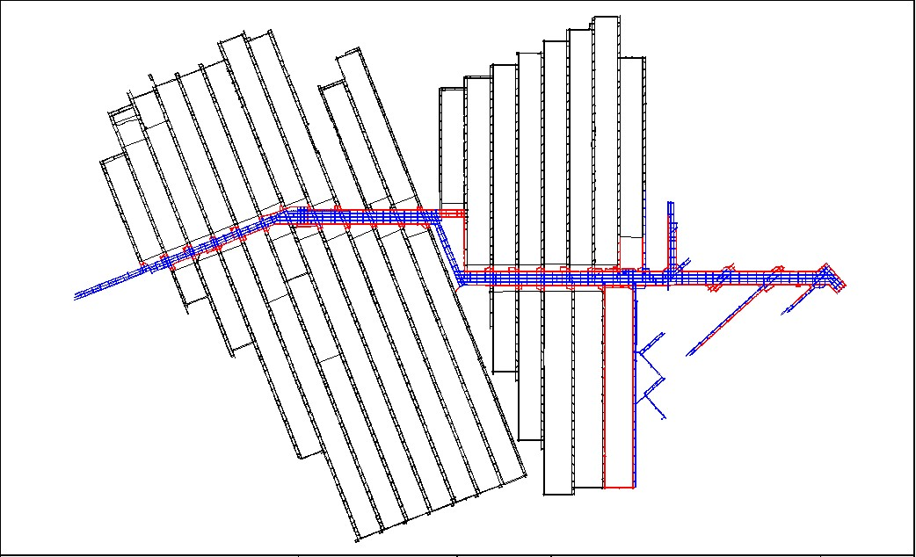

Figure 1 Oaky North Current Workings
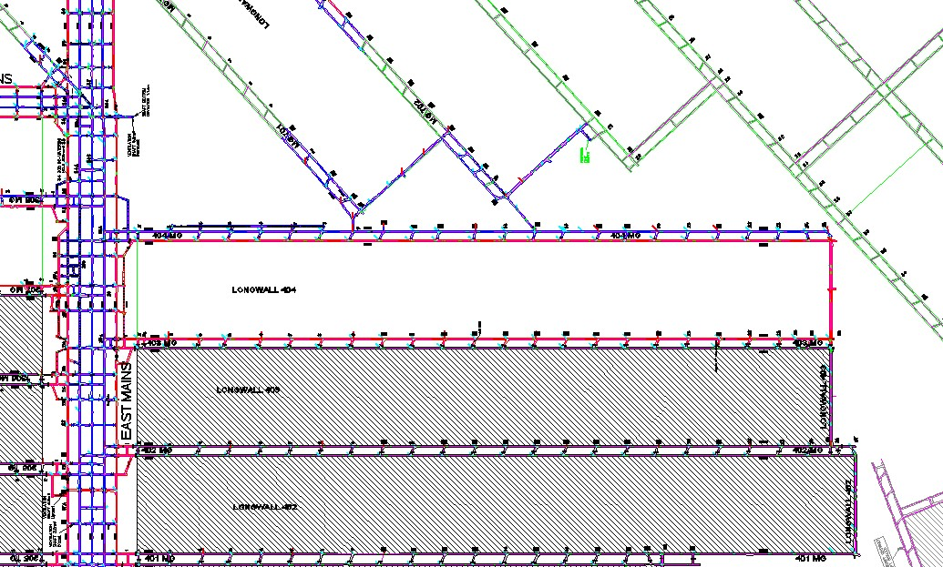
Figure 2 LW404 and adjacent planned workings

9 Document information
Table 1 Related Documents
HMP0001OCN | Methane Drainage and Outburst
HMP0003OCN | Emergency Response
HMP0005OCN | Strata Failure
HMP0007OCN | Spontaneous Combustion
HMP0008OCN | Mine Ventilation
HMP0009OCN | Gas Management and Frictional Ignition
HMP0020OCN | Irrespirable Noxious Atmosphere
HMP0020OCN | Irrespirable noxious Atmospheres
MOP0089OCN | Exposure to Respirable Dust
MOP0188OCN | Electrical Cable Management
MOP027OCN | New/Changes to Software Systems
MOP0370OCN | Recovery Mesh Installation and Longwall Boltup Primary Support
MOP0909OCN | Conveyor Electrical Installation
PLN0015OCE | Subsidence Management Plan
STD0155OCN | Intersection of Inseam Boreholes
STD0183OCN | Standard for Construction of 20 Psi Seal
STD0184OCN | Installation of Sprayplast Rated Stoppings and Seals
STD0188OCN | Construction of Bulkheads and Type D Seals
STD0222OCN | Longwall Frictional Ignition Control
STD0273OCN | Windblast
STD0326OCN | Intersection of Lost or Uncemented boreholes
STD0337OCN | Severe Weather
STD0364OCN | Emergency Response
STD0882OCN | Lightning
TAR0003OCN | TARP for Spontaneous Combustion in an Active Goaf
TAR0015OCN | Severe Weather Event
TAR0016OCN | Emergency Response
TAR0030OCN | Strata Monitoring Devices

Table 2 Reference Information
s317, 318, & 346 | Queensland Coal Mining Safety and Health Regulation 2001
Schedules 4 & 6 | Queensland Coal Mining Safety and Health Regulation 2001
 | Second Workings for longwall 404
 | LW404 Water Management

10 Site Approval
10-1 The Standard Operating Procedure was prepared as per Coal Mining Safety and Health Regulation 2001 Section 1.

 |  | Management Verification
SSE / Delegate | Position |  | Signature | Date
Gary Mitford | SSE |  |  | 22/08/2014

11 Appendix

11.1 Ventilation & Gas Management Book

Purpose
11-1 The purpose of this gas drainage reference book is to document the gas characteristics and anticipated conditions for the extraction of Longwall 404.

Scope
11-2 This gas reference book is applicable to Longwall 404 at Oaky North and will cover the known risk and conditions.
- Virgin gas
- Specific Gas Emission
- Gas Capture
- Gas Drainage
i. SIS gas drainage ii. UIS goaf drainage
- Gas compliance

Gas Makes
11-3 The current virgin gas content of the seam increases from 6.0m3/t to 8.6m3/t in a northerly direction. The gas content changes from 67% Methane mixture to 94% Methane in a northerly orientation. The residual gas in this area is Carbon dioxide. The total calculated gas reservoir is 10,841,516m3.
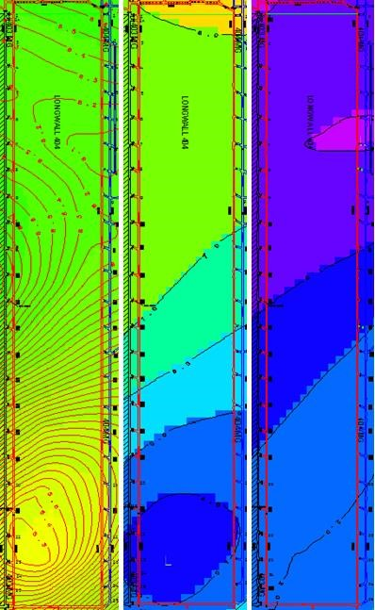

Figure 3 Virgin Gas Charts
Left: Total virgin gas contours. Showing increased gas make with the retreat of the 404 Longwall
Middle: Methane virgin gas contours. Showing increased gas make with the retreat of the 404 Longwall Right: Carbon Dioxide virgin gas contours .Showing decreased gas make with the retreat of Longwall

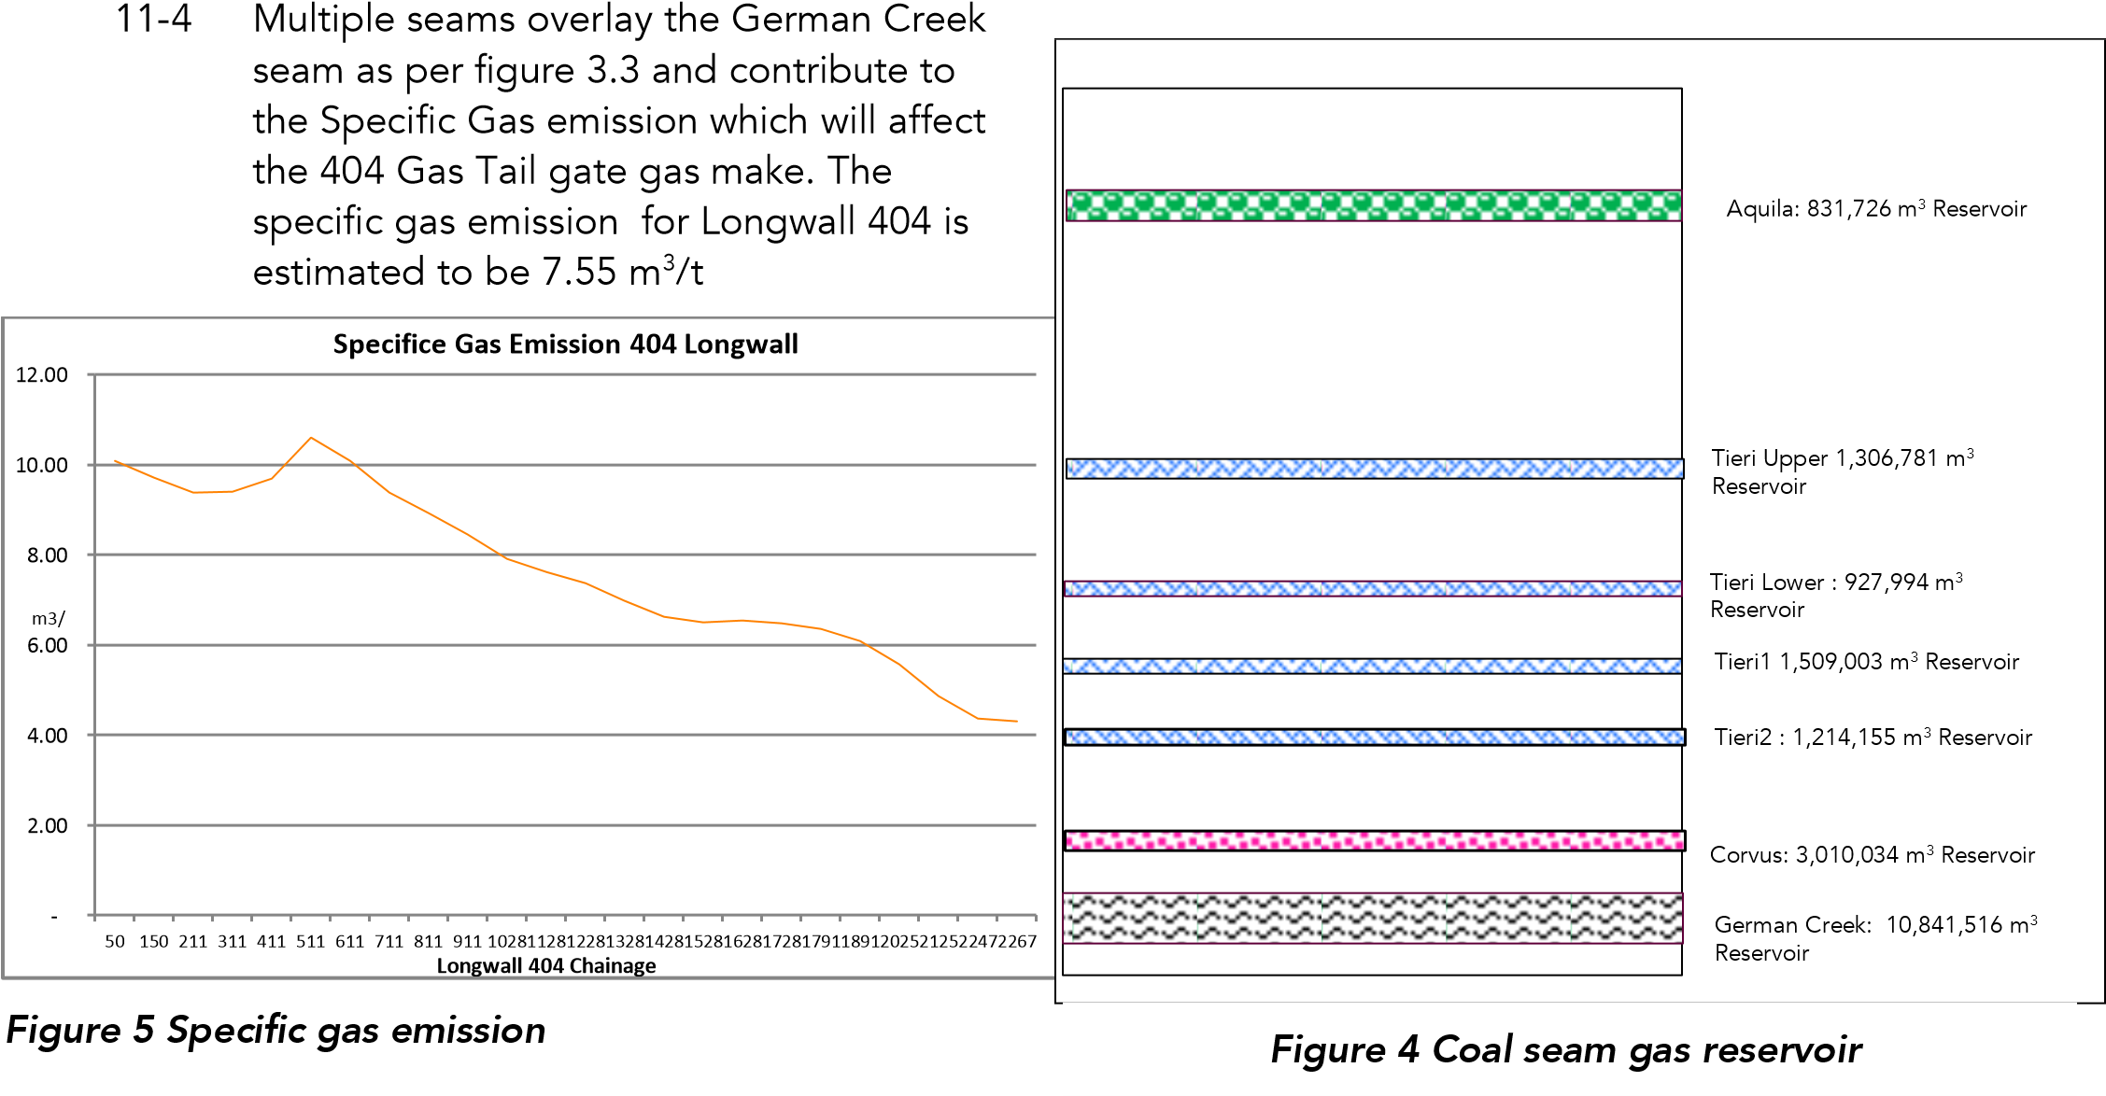

11-5 The following is the predicted tailgate gas make based on the following ascensions:
- The ventilation quantity in the Longwall at 50 m3/s
- Goaf capture is 70% of the total gas make
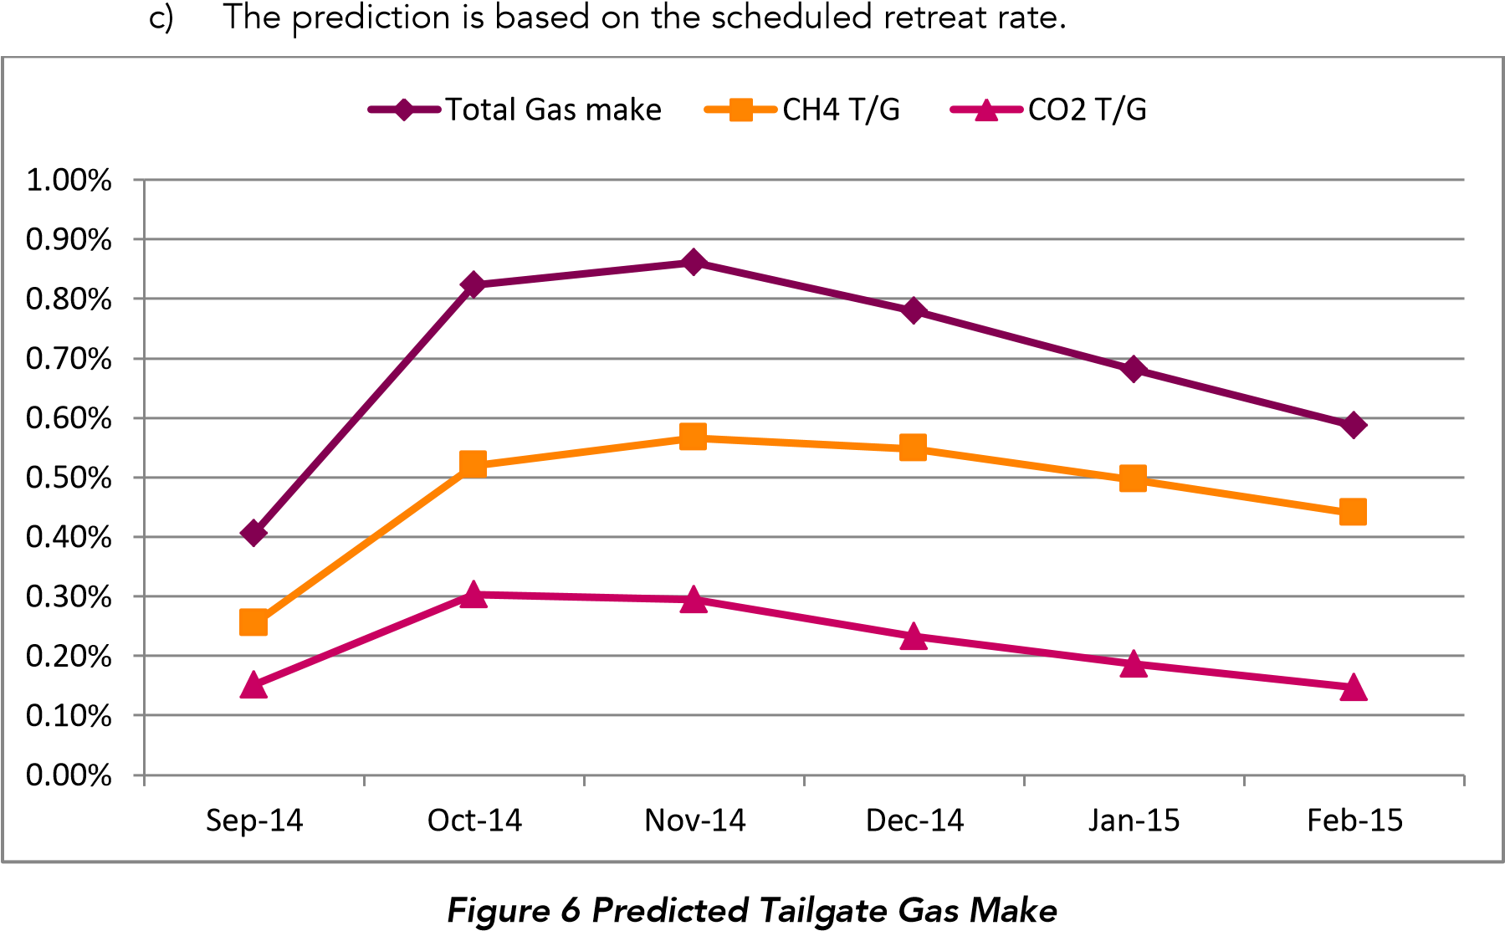

Goaf Capture

Vertical Goaf wells
11-6 The goaf drainage design employs 32 vertical wells (GDP). The following design parameters have been applied to the system.
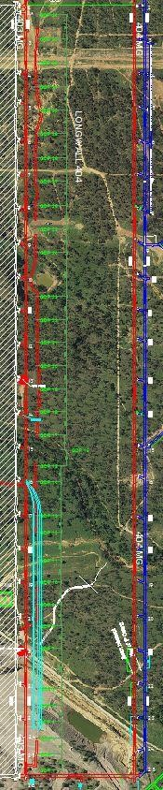
- 10 Inch diameter holes

Aquila Opencast GDP
1
-
spaced at 48m
6

Diversion Chanel
No GDP drilled
with in engineered
area. Horizontal
Goaf drainage to
be utilised in the
area

Oaky Creek, GDP
15
& GDP 16

GDP 23
-

GDP 34
spaced at 70 m

GDP8
-

GDP 23
average spacing
65
m

- Cased 50m into competent ground. Two GDP have been cased up to 50m above the German creek seam.
    - GDP 7 is located on the Aquila Highwall. Due to the fact that it is located on the Highwall and the area has been impacted by fracturing during opencast operations.
    - GDP 23 has been cased to a depth of 50m above the German creek seam. This was done to test if there is a decrease of oxygen levels and if there is an increase in gas capture.
- GDP’s have been offset 30m from the Tailgate gate road.
- Spacing for the first 6 GDP’s is 48m.
- The average spacing for GDP 8 up to GDP20 is 65m. Within this area there are two zones where GDP’s could not be placed due to surface restrictions.
- Spacing for GDP 20 to GDP 34 is 70m.
- The holes have been drilled 6 m above the seam depth.
- Vacuum plant by means of a 450mm
Ploy pipe is used to provide suction on the GDP’s. The vacuum plants operate at up to -40 Kpa. Venturis provide an alternative, if any delays are experienced by the vacuum plant.
11-7 The following surface structures impacts the placement of vertical goaf drainage holes. The spacing in this area has been increased or alternative methods of gas captured are employed.
- Aquila High open cut
- Bulbul diversion channel
- Oaky Creek

Figure 4.2- Surface plan GDP areas

Horizontal Goaf Drainage
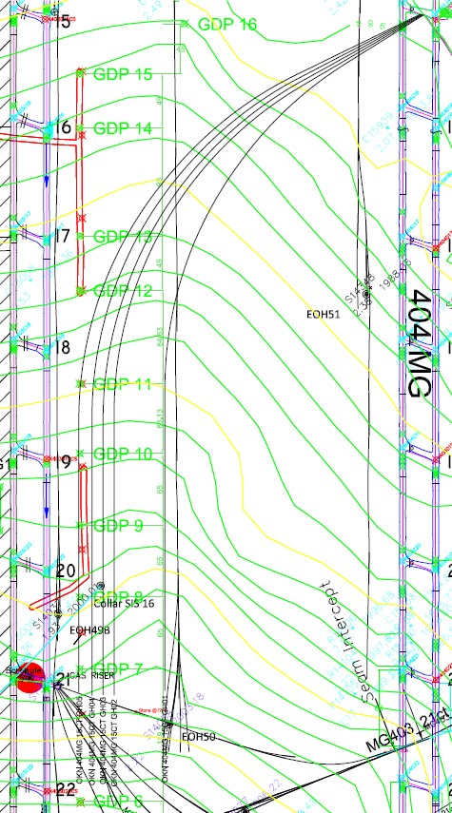
11-8 Horizontal Goaf drainage is used for gas capture in the area of the diversion channel where we do not have surface access for Vertical Goaf holes.

11-9 Design parameters are as follow:
- 5 Holes
- Diameter 100mm
- Average length 470m.
- 10 inch riser at 15c/t 404
- Connected to the vacuum plant, ring feed 450 mm poly line.

Figure 4.2- Designed HGH

Pre-Drainage

SIS gas drainage
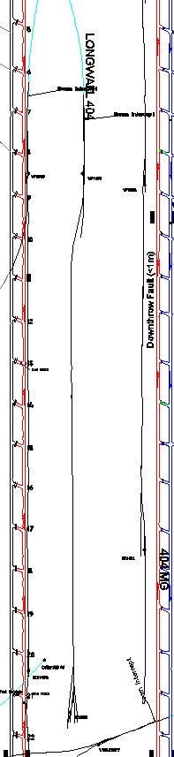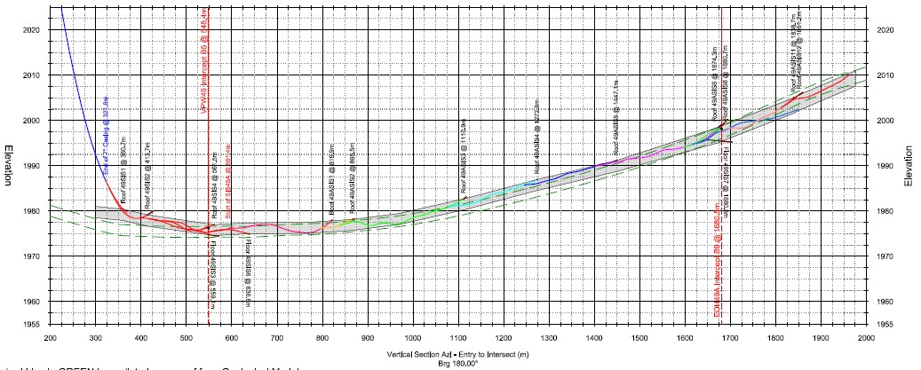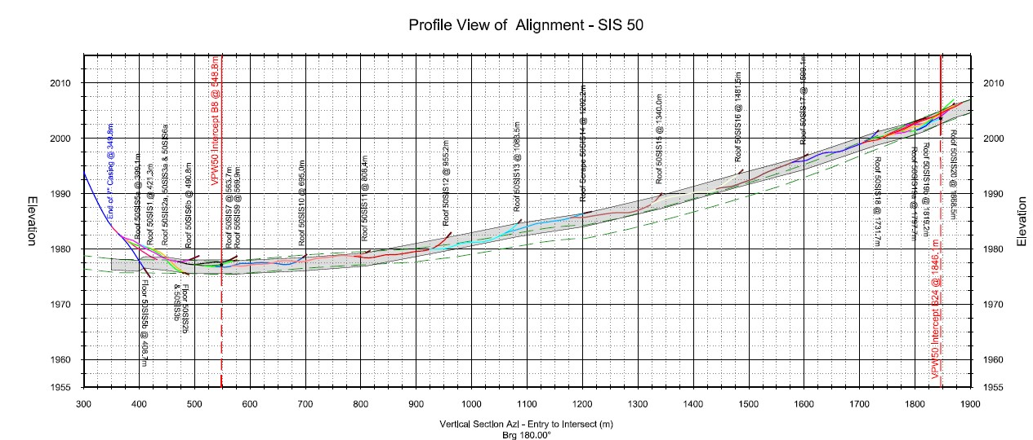
11
-
10

The

following SIS holes in the mining area of Longwall 404.

11
-
11

SIS

49:

a)

Online

August 2010

b)

Produced

5
,239,516 m
3

of seam gas.

c)

SIS49b has been intersected TG4
03
.

d)

Profile of SIS
49

11
-
12

SIS

50:

a)

Online August 2010

b)

Produced 1,772.234 m
3

of seam gas.

c)

SIS 50 has not been intersected.

d)

SIS 50 has not produce significant seam gas for the last
12
months. The last recorded flow was in May 2013

–

SIS 49 a

SIS

50

SIS 51

Figure
8

SIS 49 A profile view

Figure
9

SIS 50 profile view

Figure
7

3

–

404
Longwall
SIS holes in mining area

11-13 SIS 51:
- Online and producing seam gas since November 2011
- Produced 1,957,202m³ of seam gas up to date.
- SIS 51 has not been intersected.
- The last recorded flow for July 2014 was 6 l/s

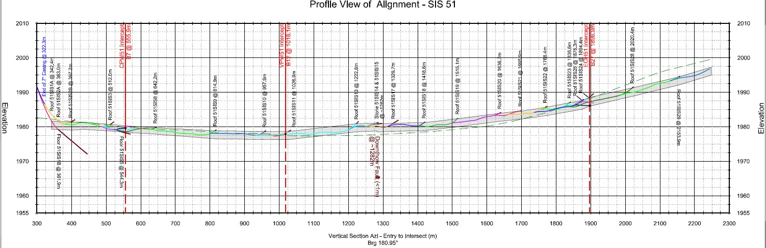
-

Figure 10 SIS 51 profile view

11-14 SIS 23 OC1
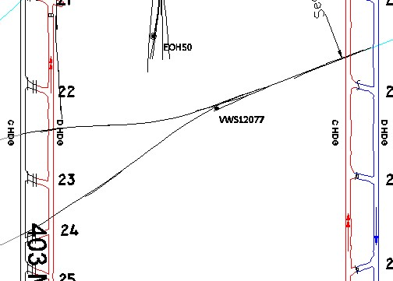
- Online April 2006
SIS23
OC1

- Currently the hole is inactive and not producing any gas make.
- SIS 23 has been intersected in Mg 404 and in MG 403. The hole is not pressurised and not building up pressure at the intersection point underground.

Figure 11 SIS 23 OC1

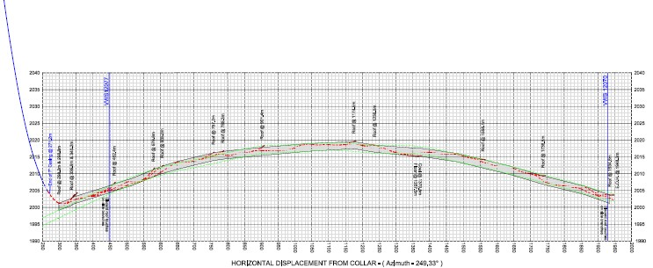

Figure 12 SIS 23 OC1 Profile view

UIS Gas drainage
11-15 The following UIS was used to drain the gas in Longwall 404. 11-16 UIS 403 21 c/t
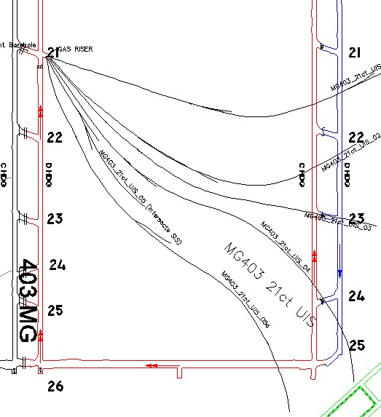
- Online and producing gas since
October 2012
- All the branches have been intersected in MG404.
- Cumulative gas drained is 2,475,240m³.
- Highest flow achieved was 206 l/s out of all the combined branches.
- The last recorded flow was below
1 l/s.

Figure 13 UIS 403 21 c/t

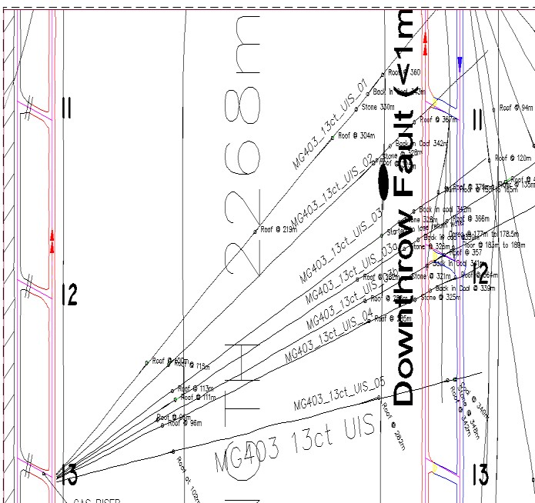
11-17 UIS 403- 13 c/t

- Online and producing seam gas
October 2012
- All the branches have been intersected in MG404
- Cumulative seam gas drained is 4,807,506m³.
- Highest flow achieved was 458 l/s out of all the combined branches.
- The last recorded flow for July
2014 was below 1 l/s. | Figure 14 UIS 403-13 c/t

Gas Compliance
11-18 A total of 5 compliance holes have been drilled in the Longwall 404 area. All the results have the area classified as a zone 1.

Table 3 Compliance Bores
Compliance bore hole |  | Gas content | Zone
 | Total m3/t | Date
C 13434 | 2.75 | 14/10/2008 | Zone 1
C 16107 | 2.33 | 02/04/20104 | Zone 1
C 14901 | 2.64 | 13/09/2011 | Zone 1
C 16108 | 3.08 | 21/04/2014 | Zone 1
C 16109 | 3.08 | 16/04/2014 | Zone 1
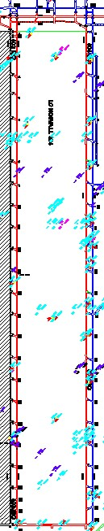 | 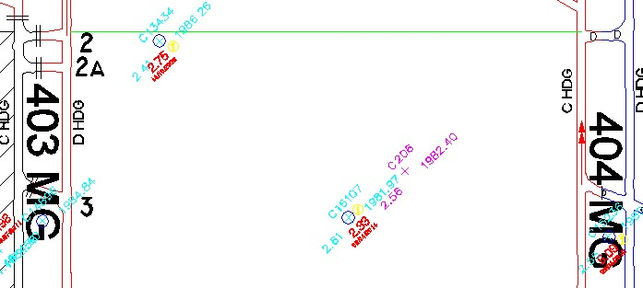

Ventilation
11-30 Long wall 404 Start-up Ventilation available to the face is 52m³/s
11-31 Homotropal Ventilation for Belt road 29m³/s management of the gas make and the heat from the belt will be diluted through the Main Gate dogleg
11-32 The Ventilation will remain the same from 15C/T outbye as 50psi seals shall be installed to segregate the drive-age between 404”D” to 702 face line
11-33 The segregation of the pillars will require type C seal as the water make from surface structures shall add to the water make in the panel from the back end of LW404.

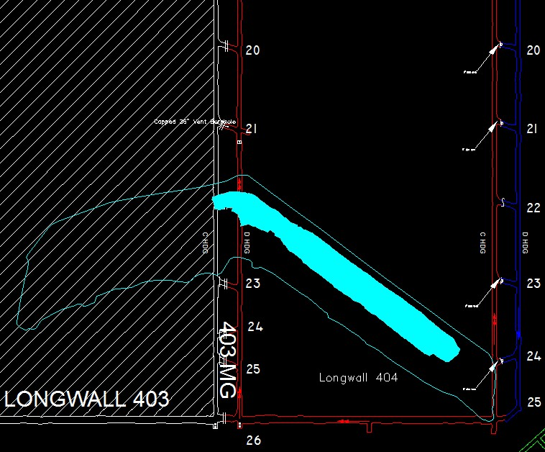

Figure 15 Back end of LW404
11-34 Water make from the block will increase as the long wall retreats and Goaf is formed
11-35 Predicted water quantity in the Aquila is 20ML
11-36 The management of the water make from behind the retreating Long Wall will be managed via 20psi seals and dam walls with pump arrangements set up in front of each seal site these shall be advanced as each new seal is erected

11-37 Air flow and Quantities shall be as per following Ventsim modelling

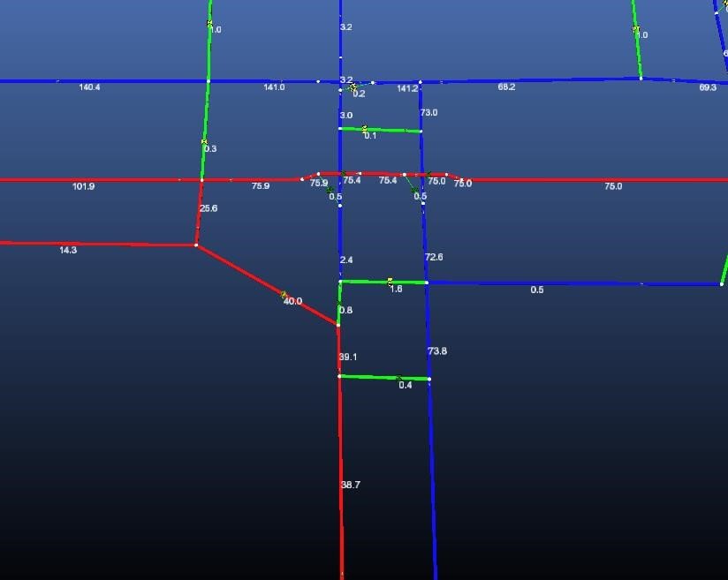

Figure 16 Main Gate Modelling Start of the Panel
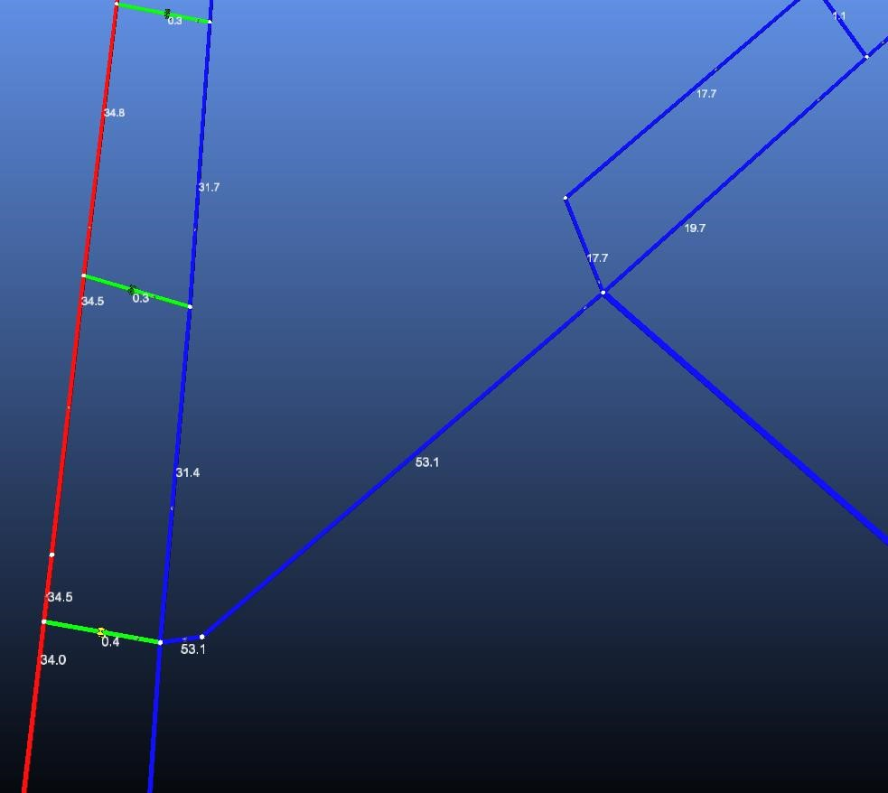

Figure 17 Modelling Mid-Block

Figure 18 Modelling Face Line

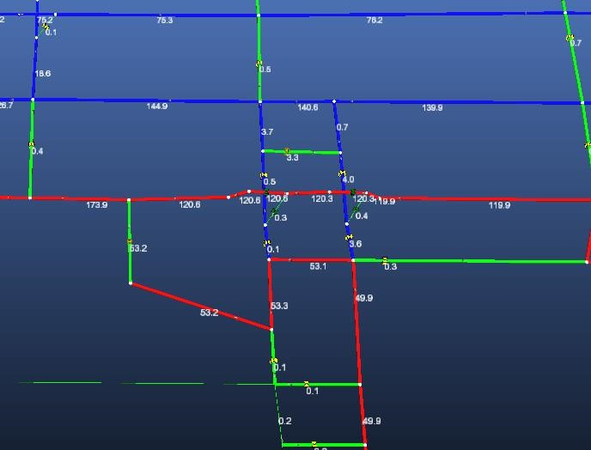
Figure 19 Modelling Tail Gate 404 Tail Gate Dog Leg

11.2 Geology & Geotechnical Book

Purpose
11-38 The purpose of this Reference Book is to document the known geological and geotechnical characteristics and anticipated conditions for the secondary extraction of Longwall 404.

Scope
11-39 This Reference Book is applicable to Longwall 404 at Oaky North and will cover the known geological/geotechnical risks and conditions including:
- Structure
- Seam geometry
- Seam splits
- Depth of cover
- Roof and floor Strength
- Lost exploration boreholes
- Shield Operating Heights
- Shield Operating pressures
- Gateroad support installed in either gate end.

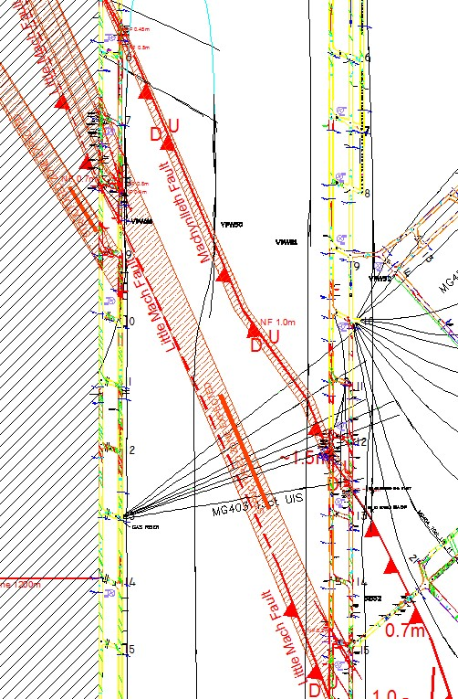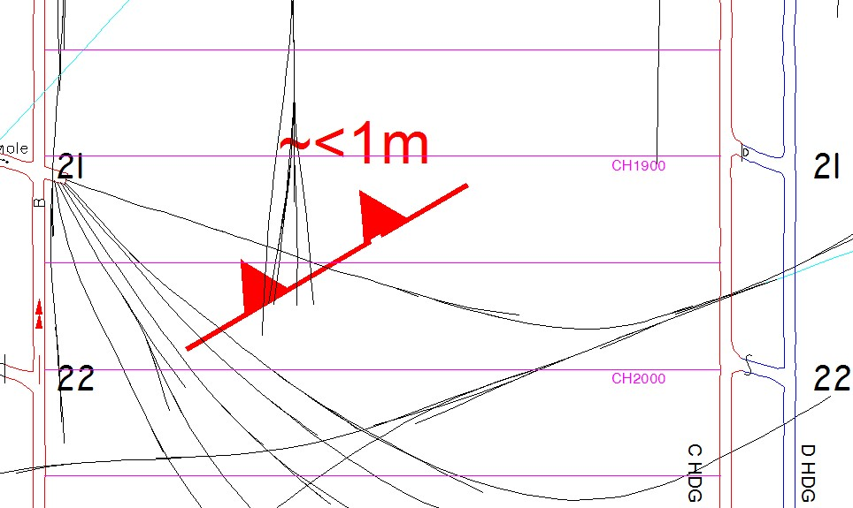
Structure
s

Machynlleth Fault

11
-
40

Normal Fault down
-
thrown to the
TG (1.0
–

1.5
m seam
displacement anticipated). On
LW404 face from ~1000m CH
–

0350
m CH.

Little Mach Fault

11
-
41

Mapped as a zone of shears and
normal faults in both the MG and
TG roadways
. Structure zone
minor displacement faults i.e.
(
less than ~1.0m, shears and
joints) anticipated.

Minor Normal Fault

11
-
42

Probable normal fault, less than
1
m displacement down
-
hrown to
the TG, as determined from
cross
-
block UIS holes at ~1900m
CH. The fault is

unlikely to be
laterally persistent.

Figure
20

Machynlleth and Little Mach Fault plan view.

Figure 21 Minor displacement normal fault plan view, at ~1900 – 2000m CH, as determined from UIS data.

Seam Geometry

Seam Dip
11-43 A seam fold exists across the 400 series panels including LW404. The axis of this fold is indicated below by the solid red line in Figure 5. The double headed arrow drawn at right angles to the axis of the fold indicates which way the GCWS is dipping. In this case, the seam is dipping towards the axis (i.e. the structure is a syncline).
11-44 The axis of the syncline extends to approximately 9c/t in the tailgate of LW404, this will be the low point of LW404 and water can be expected to accumulate here. From install road to ~9c/t
TG404 the GCWS dips north (in the direction of retreat) at ~1:32. From ~9c/t TG404 the GCWS dips south (i.e. seam rises in the direction of retreat) at ~1:63.
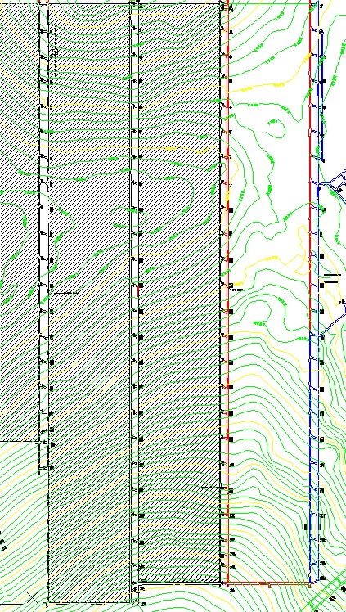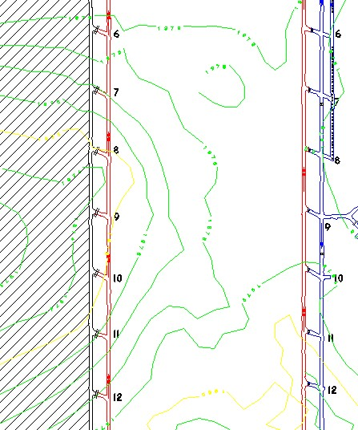

Figure 22 Top of seam contours – LW404.

Cross-grade
11-45 The area of greatest cross-grade extends from ~2267m CH – 2050m CH. At these chainages the TG is approximately 8 – 13m higher than the MG. Elsewhere only minor cross-grade is anticipated i.e. less than ~7m RL difference between the MG and TG.

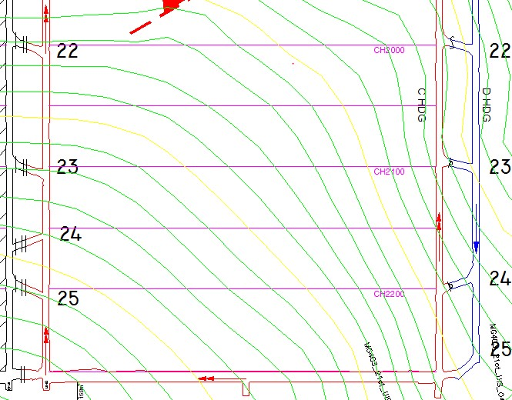

13
m RL difference TG
-
>
MG

Figure 23 Top of seam contours – LW404 (2200 – 2000m CH)

Seam thickness
11-46 North of the D-Ply Floor Split seam thickness is generally between 2.4 and 2.6m. South of the floor split and seam thickness decreases to 2.0 – 2.2m.
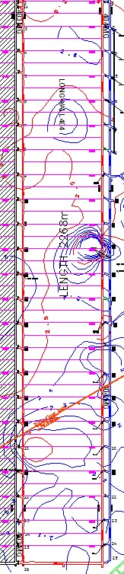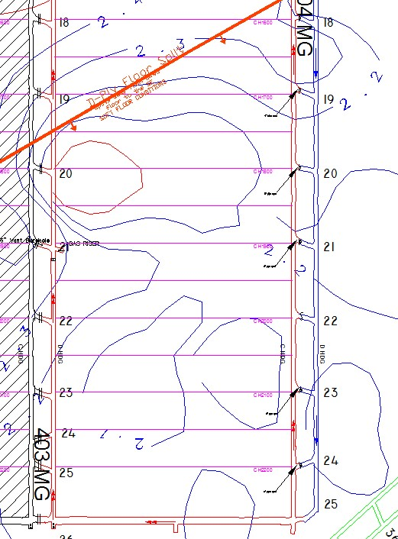

North of the D
-
Ply Floor split,

the
GCWS is generally 2.4
–

2.
6
m thick

Figure
24

Seam thickness contours
–

LW404

Seam Splits
11-47 The D-Ply Floor Split peels away from the main GCWS to the southeast. Generally, the split is less than 0.1m thick and peels away at ~1m into the floor every 250m south-east of the split line. The floor split results in seam thinning and potential soft floor conditions.
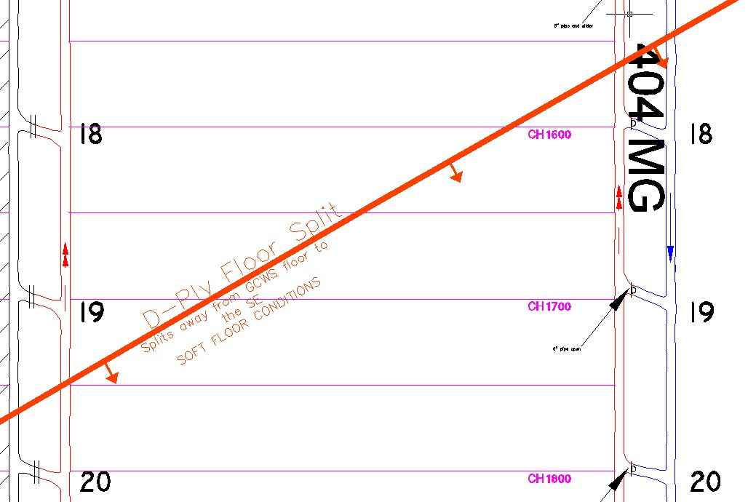

Figure 25 D-Ply Floor Split – LW404
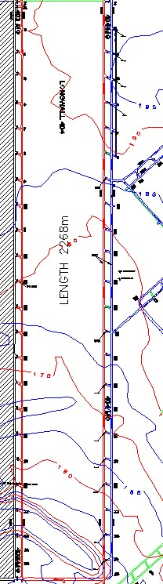
Depth of Cover

11
-
48

Away from the Aquila Open Cut pit on surface, the
depth of cover across LW404 varies from ~195m to
~170m.

m D.O.C contour
170

Aquila Open Cut

m D.O.C contour
190

Figure
26

Depth of cover contours
–

LW404

Roof Strength

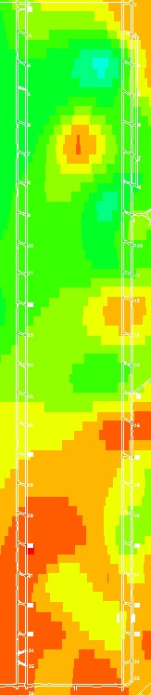
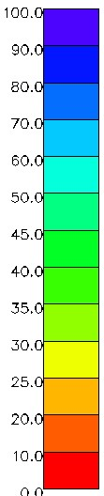
First 0.5m Uniaxial Compressive Strength (sonic correlated)
Figure
27

1
st 0.5m Roof
11-49 The contoured sonic correlated UCS data appears to show a general trend of improving roof strength outbye of 1300m CH. Inbye of 1300m CH the 1st 0.5m of immediate roof stone above the coal seam varies from 10 – 30 MPa. Outbye of ~1300m CH the 1st 0.5m of immediate roof stone above the coal seam varies from 10 – 60 MPa.

Strength (MPa) – LW404

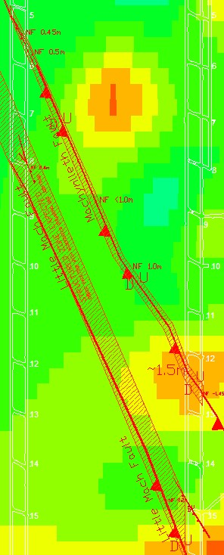
Roof strength through faults in LW404
Figure
28

1
st 0.5m Roof Strength (MPa)
First 0.5m Unconfined Compressive Strength
11-50 The contoured sonic correlated UCS plot (figure 9) shows that the first 0.5m of immediate roof stone across the Little Mach and Machynlleth Faults to be in the range of 25 – 45 MPa.

with Little Mach and Machynlleth Faults
–LW404
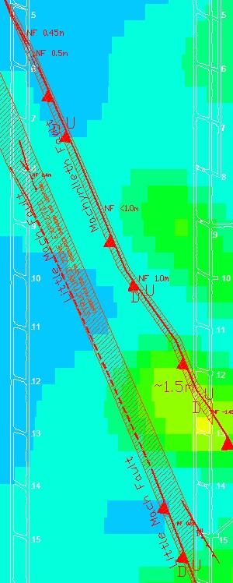
0.5m – 1.0m Unconfined Compressive Strength
Figure
29

0.5
-
1.0
m Ro
of Strength (MPa)
11-51 The contoured sonic correlated UCS plot (figure 10) shows that the second 0.5m of roof stone across the Little Mach and Machynlleth Faults to be in the range of 30 – 70 MPa.

with Little Mach and Machynlleth Faults
– LW404
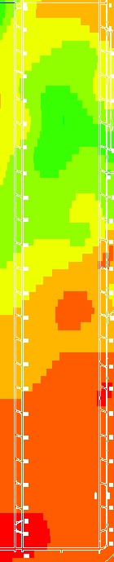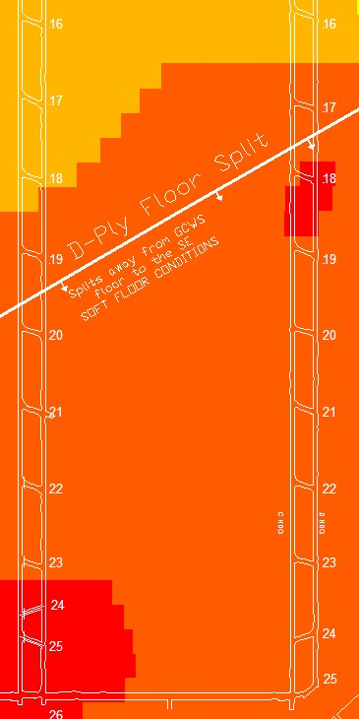
Floor Strength

First 0.5m Uniaxial Compressive Strength (sonic
correlated)

11
-
52

The contoured sonic correlated UCS data shows a
clear trend of decreasing floor strength inbye of
~1500m CH where the immediate 1s
t 0.5m of floor
stone is less than <20 MPa. Low floor strength in this
area is the result D
-
Ply Floor Split and low strength
interburden. Generally, longwall face supports have
the potential to punch into the floor when the UCS
value is less than 5MPa.

Figure
30

1
st 0.5m Floor
Strength (MPa) with D
-
Ply
Floor Split
–

LW404

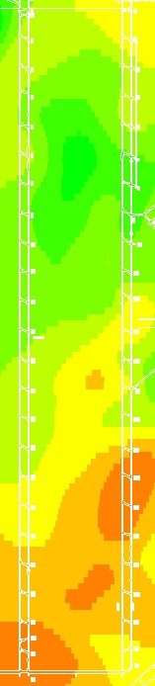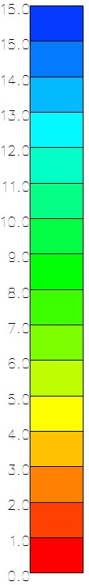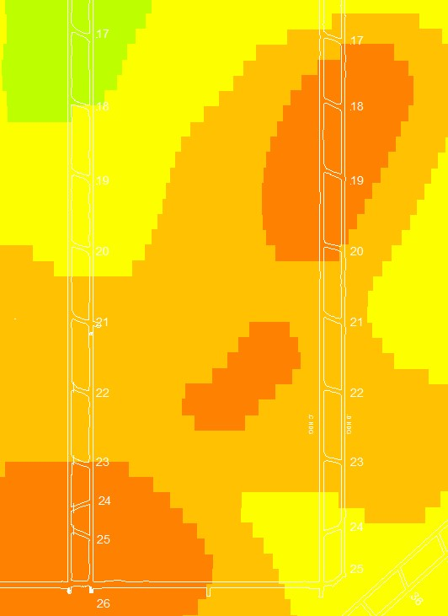
First 0.5m Floor Strength Index

11
-
53

Floor Strength Index, FSI, can be used to
assess the likelihood of floor heave. Values of
FSI less than about 2 can be

considered to be
a strong indicator of the onset of floor heave
around the longwall face. As can be seen in
figure 12
, FSI values of 2
–

4
have been
determined inbye of the D
-
Ply Floor Split in
LW404 and are similar to the values
determined inbye of the
split in LW403 and
LW402 where no major floor heave issues
were recorded.

Figure
31

1
st 0.5m Floor
Strength Index
–

LW404

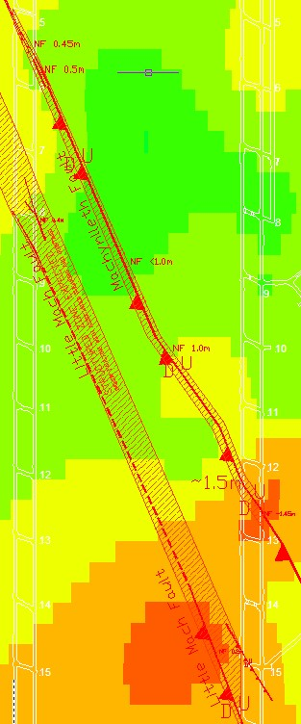
Floor strength through faults in LW404
Figure
32

1
st 0.5m Floor Strength (MPa) with
First 0.5m Unconfined
Compressive Strength
11-54 The contoured sonic correlated UCS plot (figure 13) shows that the first 0.5m of immediate floor stone across the Little Mach and Machynlleth Faults to be in the range of 20 – 40 MPa.

Litte Mach and Machynlleth Faults – LW404
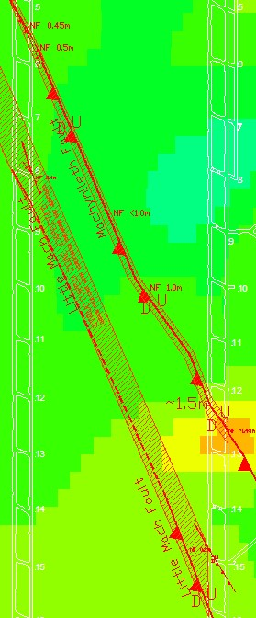
0.5m – 1.0m Unconfined Compressive Strength
Figure
33

0.5
-
1.0
m Floor Strength (MPa)
11-55 The contoured sonic correlated UCS plot (figure 14) shows that the second 0.5m of floor stone across the Little Mach and Machynlleth Faults to be in the range of 25 – 40 MPa.

with Litte Mach and Machynlleth Faults – LW404

Lost Surface Boreholes
11-56 Two lost boreholes, C283 and C206, are known to be present in LW404 Block (figure 15). Where these boreholes are intersected on the longwall face there is the potential for increased water and/or gas make.
11-57 C283 was drilled in 1977 and a lost borehole search was conducted 24/08/06. The cementing status of this borehole is unknown and information from the hardcopy borehole folder indicates that casing extends to a depth of 12m below surface.
11-58 C206 was drilled in 1977 and a lost borehole search was conducted 23/08/06. The cementing status of this borehole is unknown and information from the hardcopy borehole folder indicates that casing extends to a depth of 129.5m below surface.
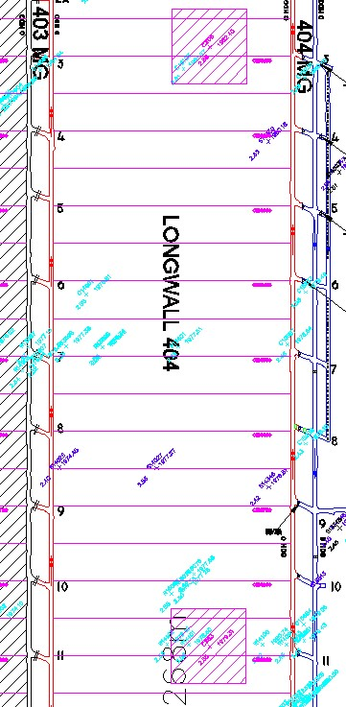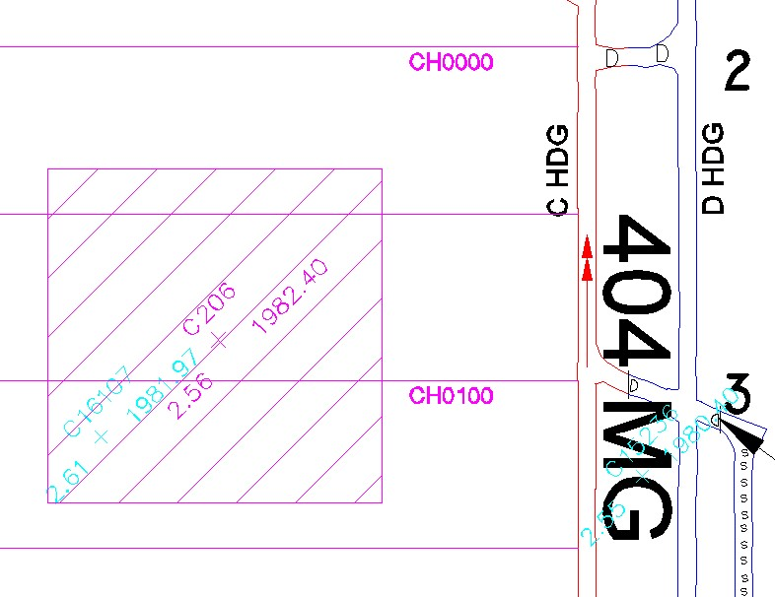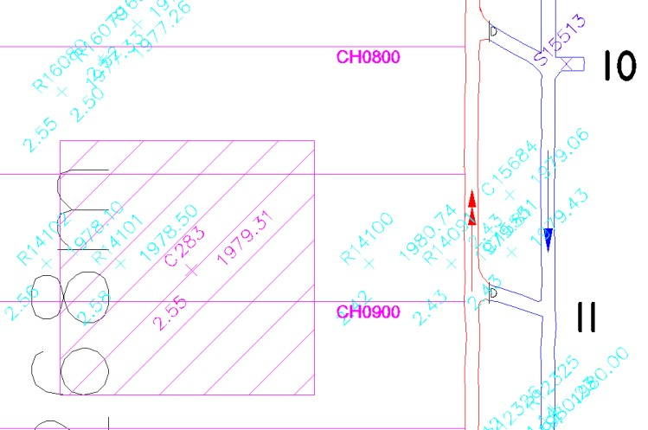

Figure
34

Lost Boreholes (C283 & C206)
–

LW404

Machynlleth Fault Flight Plans
11-59 Data for the Machynlleth Fault suggests that the magnitude of seam displacement decreases from the MG, where it was mapped as a normal fault (1.5m displacement), to the TG, where it was mapped as a structure zone of shears, joints and minor displacement normal faults. The Machnylleth fault is anticipated to track 1 shield every 3.5 shears. Mining conditions experienced while developing MG404 suggests that the Machynlleh Fault could cause poor roof conditions in LW404. Weak structured roof conditions where experienced are likely to occur on the footwall (MG side) of the Machynlleth Fault.

Table 4 Anticipated Machynlleth Fault conditions
CHAINAGE  (APPROXIMATE) | SHIELD  (APPROXIMATE) | FAULT DISPLACEMENT  IN METRES  (APPROXIMATE) | DATA SOURCE
1009m | MG | 1.5m | MG308 development mapping
0930m | 20 | 1.0m | SIS51
0790m | 76 | 1.0m | Surface structure definition boreholes
0688m | 101 | <1.0m | SIS50
0365m | TG | Zone of structure including shears and two normal faults down-thrown to TG (0.5m and 0.45m displacement) | MG307 development mapping

Shield Operating Heights

11-60 The 404 longwall will be mined using 1.75m diameter 1040 tonne DBT shields in conjunction with a PM4 hydraulic and electrical control system.
11-61 Nominated operating heights for the DBT wall on the 404 longwall block range from a minimum of 2.0m to a maximum of 2.65m. (see Figure 16) At heights above 2.8m the DBT shields will stroke out meaning at this height the shields will not be able to generate adequate pressures or loads into the roof. At heights below 2.0m shields will have reduced efficiency as the load ratio of the canopies is compromised. To date the lowest these shields have been operated is 2.1m while the nominated cutting height for the 404 longwall is 2.3m due to seam thinning in this area.
11-62 Gate road shields in the maingate and tailgate have a nominated cutting height of 3.2m in order to grade the longwall face with the gateroad profiles cut on development which are between 2.7- 2.9m in height.
11-63 This cut height will equate to an average of ~150mm of stone being cut in the face, with this value varying due to varied nature of the coal seam.

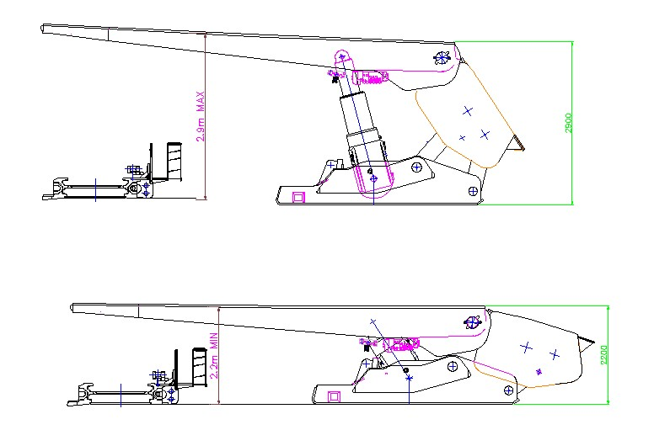

Figure 35 Shield fully opened at upper operating height and shield closed to lower operating height.

Shield Pressure Ranges
11-64 Set pressures for the DBT shields operating under the PM4 hydraulic system have been given the following operational parameters;

System pressure: Operates from 0 to 350 bar
High- Set pressure: Operates from 320 to 420 bar.
Yield pressure: 450 bar
11-65 High set is to be turned off when cavities are present in the roof to prevent shield canopies tipping up and shields extending beyond working height and stroking out.
11-66 High set will engage when system pressure drops below 320 bar when this function is enabled and ensures guaranteed higher loads generated into the roof. Gateroad Support Installed
11-67 Support installed in the gateroads varies between code yellow (standard 6 x 1.8m roof bolt pattern) to code red (6 x 1.8m roof bolt in addition to 2 x 4.3m cable bolts) with additional secondary support installed in the roof and ribs of these roadways in preparation for the longwall.
11-68 Secondary support consists of 4.3m roof tendons installed down the centre of the roadway or either side of the roadway depending on the allocated roof strength for the area and the support installed on primary development.

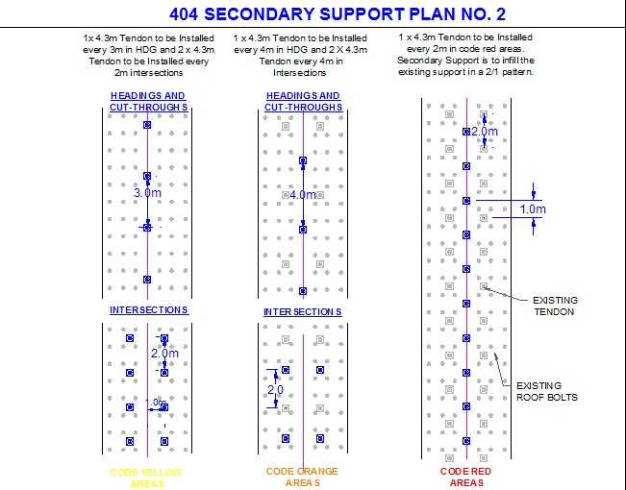

Figure 36 Typical secondary support installed in the MG roadway

11-69 Secondary rib support has been installed in the maingate roadway in preparation for the longwall consisting of additional 1.2m rib bolts with butterfly plates pinning cuttable plastic mesh to the walk side of the roadway.
11-70 On primary install support on the blockside has been installed using 1.8m cuttable fibreglass bolts with plastic plates and the pillar side supported using 1.8m steel bolts and plates. Where rib conditions had deteriorated due to structures or jointing for example steel plates and bolts may have installed on blockside. Where steel bolts have been installed on the block side these have been noted on the permit to mine and hazard plan.
11-71 Standing support consisting of timber link n locks is typically installed to protect gateroad seal sites and cuttable cans are installed in any stubs driven into the block in preparation for the longwall.
11-72 Upon longwall start up and goaf formation both gateroads are not anticipated to experience adverse conditions. From previous longwall experiences in this area, some superficial bagging of roof between bolts may be experienced in the first 15m of tailgate roof ahead of the goaf position.
11-73 Goaf conditions are likely to exhibit typical caving characteristics with initial proper goaf formation anticipated to occur between 20m – 30mm of retreat from longwall start up. Some cyclic weighting is anticipated in typical goaf caving processes however it is not anticipated that heavy cyclic loading will be experienced across the face on normal retreat.

