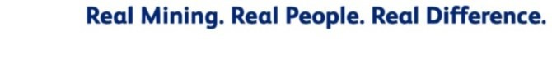
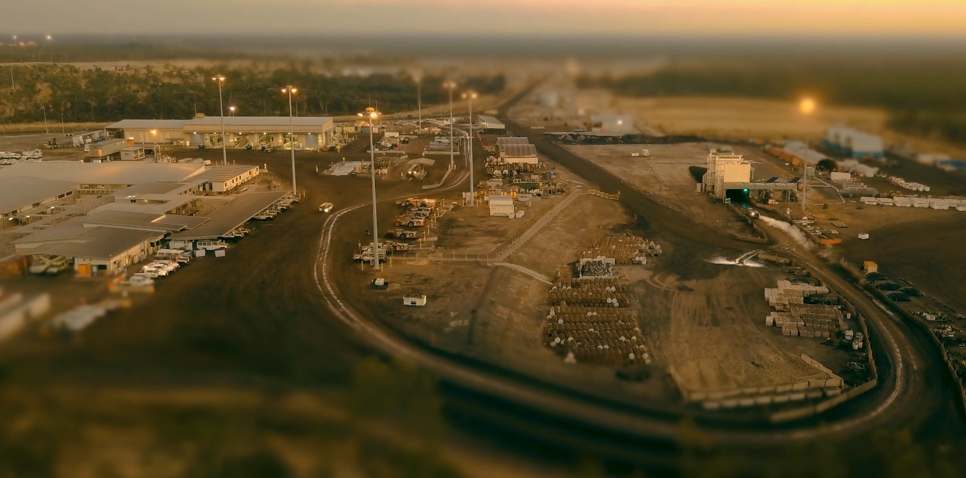
AAMC.001.017.0023
GROSVENOR MINE
ELIMINATION OF FATALITIES PLAN 2020
AAMC.001.017.0024

ELIMINATION OF FATALITIES END STATES – GROSVENOR
LEADERSHIP |  | CARING CULTURE
End States – Critical to Remain Fatality Free  Leaders display drive, accountability and passion for safety at all times  Safety leaders coach and influence on an ongoing basis across all levels  Met Coal leaders are acknowledged within the Mining sector for safety innovation and expertise |  | End States – Critical to Remain Fatality Free  Commitment to care for each other all the time  Safety mindset across all aspects of daily life – inside and outside the gate  Constantly monitoring, sharing and improving working conditions
PLANNING AND SCHEDULINGPLANNING AND SCHEDULING |  | RISK AND CHANGE MANAGEMENT
End States – Critical to Remain Fatality Free  Robust and challenged plans that encompass whole of mine  Plans and schedules resourced appropriately for level of activity required  Competent and capable supervision of tasks and team members |  | 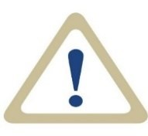  End States – Critical to Remain Fatality Free  Risks are appropriately assessed at all levels  Controls are commensurate with the risk are identified, and are applied, monitored and regularly improved  Critical Controls are established for all high risk activities and suitability of controls are regularly challenged  Change management is integrated into all process
LEARNING ORGANISATION |  | MONITORING AND ASSURANCE
End States – Critical to Remain Fatality Free  Proactively seek and implement opportunities for improvement  Sharing is inherent in safety culture  Use of high level control hierarchy is fundamental to approach for managing risk  Benchmarking activities constantly increase performance |  | End States – Critical to Remain Fatality Free  Integrity of controls for high level risk management are maintained 100% Internal and external assurance for critical & high risk hazards is routine  Met Coal appropriately resourced with regulatory compliances embedded
AAMC.001.017.0025
Enablon Action Plan – AP.00766189

ELIMINATION OF FATALITIES ACTIONS - GROSVENOR
LEADERSHIP |  | CARING CULTURE
2020 Actions  Integrate key elements from Safety Leadership  Program into How We Rock Up Matters Program  Integrate Living the Values elements into How We Rock Up Matters Program  Embed “Break Through Thinking” process driven from Leadership Team |  | 2020 Actions  Plan, communicate and rollout health initiatives to address high risk issues  Utilise 2019 survey data to identify opportunities for improvement of How We Rock Up Matters Program  Embed reward and recognition program focused on discretionary effort and display of values
PLANNING AND SCHEDULINGPLANNING AND SCHEDULING |  | RISK AND CHANGE MANAGEMENT
2020 Actions  AAOM in place and operational  Implement solutions to ensure surface activities are monitored and reported digitally (in line with UG standard)  Digitize work orders, statutory reporting, safety documents and integration with UG Tablets |  | 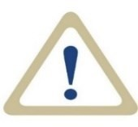  2020 Actions  Implement proximity detection technology trials focusing on mobile equipment  Fully embed the change management process at the worker level, including PUE/CC assessment for task changes  Ensure alignment of Critical Controls and associated monitoring activities across Met Coal UG operations
LEARNING ORGANISATION |  | MONITORING AND ASSURANCE
2020 Actions  Identify priority SHMS improvement areas and implement corrective action plans accordingly  Implement learning modules to improve organisational skills (e.g. LFI)  Embed revised LFI process to include review of applicable learnings from other Anglo operations and the wider industry |  | 2020 Actions  Maximise automation of monitoring activities for Critical Control effectiveness  Implement 5 year audit program for internal and external assurance and regulatory compliance  Embed process to monitor operational control effectiveness for all statutory management plans
AAMC.001.017.0026
LEADERSHIP
End State Goals
Actions
2020
Integrate key elements from
Safety Leadership Program
into How We Rock Up
Matters Program
Integrate
Living the Values
elements into How We
Rock Up Matters Program
Embed
“Break Through
Thinking” process
driven
from Leadership Tea
m
Leaders display drive, accountability and passion for safety at all times
Safety leaders coach and influence on an ongoing basis across all levels
Met Coal leaders are acknowledged within the Mining sector for
safety innovation and expertise
Owner: Kate Bachmann
Due Date: 31/12/20
Owner: Trent Griffiths
Due Date: 31/08/20
Owner: Trent Griffiths
Due Date: 31/12/20
AAMC.001.017.0027
CARING CULTURE
End State Goals
Actions
2020
Plan, communicate and
rollout health initiatives
to
address high risk issues
Utilise 2019 survey data to
identify opportunities for
improvement of How We
Rock Up Matters Program
Embed reward and
recognition program
focused on discretionary
effort and display of values
Safety mindset across all aspects of daily life
–
inside and
outside the gate
Commitment to care for each other all the time
Constantly monitoring, sharing and improving working conditions
Owner: Kate Bachmann
Due Date: 31/12/20
Owner: Sandra Thomson
Due Date: 31/12/20
Owner: Trent Griffiths
Due Date: 31/03/20
AAMC.001.017.0028
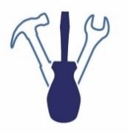
PLANNING AND SCHEDULING
End State Goals
2020
Actions
AAOM in place and
operational
Implement solutions to
ensure surface activities
are monitored and reported
digitally (in line with UG
standard)
Digitize work orders,
statutory reporting, safety
documents and integration
with UG Tablets
Robust and challenged plans that encompass whole of mine
Plans and schedules resourced appropriately for level of activity
required
Competent and capable supervision of tasks and team members
Owner: Peter Paganoni
Due Date: 31/12/20
Owner: Gary Needham
Due Date: 31/12/20
Owner: Rob Nowell
Due Date: 31/12/20
AAMC.001.017.0029
RISK AND CHANGE MANAGEMENT
End State Goals
2020
Actions
Fully
embed
the
change
management process at
the
worker level
, including
PUE/CC assessment for
task changes
Ensure alignment of Critical
Controls and associated
monitoring activities across
Met Coal UG operations
Risks are appropriately assessed at all levels
Controls are commensurate with the risk are identified, and are
applied, monitored and regularly improved
Critical Controls are established for all high risk activities and
suitability of controls are regularly challenged
Change management is integrated into all process
Implement proximity
detection technology trials
focusing on mobile
equipment
Owner: Peter Paganoni
Due Date: 31/12/20
Owner: Wouter Niehaus
Due Date: 30/12/20
Owner: Wouter Niehaus
Due Date: 31/06/20
AAMC.001.017.0030
LEARNING ORGANISATION
End State Goals
Actions
2020
Identify priority SHMS
improvement areas and
implement corrective action
plans accordingly
Implement l
earning
modules to improve
organisational skills (
e.g.
LFI, Fatigue
Mgt
, ORM,
Contractor Management)
Proactively seek and implement opportunities for improvement
Sharing is inherent in safety culture
Use of high level control hierarchy is fundamental to approach
for managing risk
Benchmarking activities constantly increase performance
Embed revised LFI process
to include review of
applicable learnings from
other Anglo operations and
the wider industry
Owner: Kate Bachmann
Due Date: 31/12/20
Owner: Sandra Thomson
Due Date: 31/12/20
Owner: Kate Bachmann
Due Date: 31/03/20
AAMC.001.017.0031
MONITORING AND ASSURANCE
End State Goals
Actions
2020
Maximise automation of
monitoring activities for
Critical Control
effectiveness
Implement 5 year audit
program for internal and
external assurance and
regulatory compliance
Embed process to monitor
operational control
effectiveness for statutory
management plans
Integrity of controls for high level risk management are maintained
100
%
Internal and external assurance is routine
Met Coal appropriately resourced with regulatory compliances
embedded
Owner: Logan Mohr
Due Date: 30/06/20
Owner: David Johnson
Due Date: 30/06/20
Owner: Kate Bachmann
Due Date: 31/12/20

