University of Wollongong
Research Online

Coal Operators' Conference Faculty of Engineering and InformationSciences

2005
Development of Innovative Goaf Inertisation Practices to Improve Coal Mine Safety
Ting Ren
University of Wollongong, tren@uow.edu.au
R. Balusu
CSIRO Exploration and Mining
P. Humphries
CSIRO Exploration and Mining
Follow this and additional works at: https://ro.uow.edu.au/coal

Recommended Citation
Ting Ren, R. Balusu, and P. Humphries, Development of Innovative Goaf Inertisation Practices to Improve
Coal Mine Safety, in Naj Aziz and Bob Kininmonth (eds.), Proceedings of the 2005 Coal Operators'
Conference, Mining Engineering, University of Wollongong, 18-20 February 2019 https://ro.uow.edu.au/coal/181
Research Online is the open access institutional repository for the University of Wollongong. For further information contact the UOW Library: research-pubs@uow.edu.au

Development of Innovative Goaf Inertisation Practices to

Improve Coal Mine Safety
T X Ren¹, R Balusu² and P Humphries¹

ABSTRACT
In combination with detailed field studies and goaf gas characterisation, computational fluid dynamics (CFD) models have been used to develop optimum and effective strategies for inertisation during longwall sealing operations to achieve goaf inertisation within a few hours of panel seal-off operation. This study has combined detailed analysis of the performance of various inertisation field trials together with CFD modelling results of different inertisation operations in order to develop the optimum inertisation strategies. A number of parametric studies were conducted on the base case CFD models that had been calibrated and validated based on the information obtained from previous inertisation studies and goaf gas monitoring. These studies included changes in inert gas injection locations, inert gas flow rates, seam gradients, and different inertisation strategies to investigate their effect on goaf inertisation. Studies indicate that the strategy of inert gas injection through the MG seal was not as effective as the alternative strategy of inert gas injection at 200 m behind the face. Innovative inertisation strategies have been developed and subsequently implemented at an underground coal mine in Australia.
Further investigations have been carried out in the development and demonstration of proactive inertisation strategies with the objective to suppress the occurrence of spontaneous heatings in active longwall faces, in particular under unexpected scenarios such as during slow retreat/face stoppage due to difficult geological conditions. Initial trials at two Australian longwall panels have demonstrated the great potential of this practice to contain the onset of heatings in the goaf.

INTRODUCTION
Goaf inertisation with inert gas has been used worldwide to control active fires and spontaneous heatings in underground coal mines. In Australia, nitrogen injection was used in number of mine fire incidents, with varying degrees of success. For instance, nitrogen was pumped into Moura No 4 mine after the explosion to render the mine atmosphere inert for rescue teams to enter and control an active fire created by the explosion (Lynn, 1987). Inert gas was also used at Ulan Colliery to control a major spontaneous combustion incident (Healey, 1995).
This technique is being deployed to lower the risk of potential explosions during longwall panel sealing off periods. In Australia, inert gas from Tomlinson boilers and drained inseam gas are being used in some mines for routine inertisation operations. The specific objective of inert gas injection operations is to reduce the goaf oxygen levels below the safe limit of eight per cent (ie with a factor of safety of 1.5 on the explosive nose limit of 12 per cent) before methane concentration reaches the lower explosive limit of five per cent. The inertisation schemes usually involved injecting inert gas through maingate (MG) or tailgate (TG) seals until goaf gas sampling results show that oxygen level was below eight per cent. In many cases it was found that the goaf oxygen concentration was above 12 per cent even after two to three days of inert gas injection and in some cases an explosive atmosphere was also present in the goaf during inertisation. There was a need to optimise inertisation operations to reduce the goaf oxygen levels, thus reduce the explosion potential as quickly as possible during longwall sealing off periods.

Recently, the occurrences of spontaneous combustion in longwall goafs have led to mine abandonment or production suspension in a number of underground coal mines worldwide. Proactive goaf inertisation for open goaf in active longwalls can be used to suppress the development of potential goaf heatings and ‘save’ time for the longwalls to advance beyond dangerous zones and to sustain normal production rate. This method is particularly important for reducing the risk of spontaneous heatings in active longwall goafs during slow face movement due to geological difficulties, ie faults/roof falls, roadway collapse or other production problems. Supported by ACARP and in collaboration with Australian underground coal mines, CSIRO is in the process of developing proactive inertisation strategies with the objective to reduce the risk of spontaneous heatings in active longwall faces, in particular under unexpected scenarios such as during slow retreat/face stoppage. Initial trials of the proposed proactive inertisation techniques in two Australian underground coal mines have shown promising results.
This paper provides a brief review of the traditional inertisation practices during longwall sealing operations in Australian coal mines and the applications of CFD models to understand the gas flow mechanics and distribution patterns in longwall goafs. The paper discusses the simulation results of various goaf inertisation strategies for face seal-off operations and active longwall goafs (proactive inertisation). Optimum inertisation strategies were developed and demonstrated in field demonstration studies.

REVIEW OF TRADITIONAL INERTISATION SCHEMES
Longwall goaf inertisation has been carried out on a regular basis in some Australian mines to reduce the potential risk of explosions during the panel sealing-off period. Traditionally liquid N₂ and CO₂ were used in most of the fire control inertisation operations. However, it was difficult and expensive to procure large quantities of the inert gases for routine longwall sealing applications, particularly in mines located at remote places of Australia. In 1997, the Tomlinson Boiler low-flow inertisation device and a high capacity GAG 3A jet engine system were demonstrated to the Australian mining industry as new practical tools for inertising underground mine atmosphere. The successful demonstration of these devices has improved the availability of inert gases for routine mine applications.
Over the last few years, there have been over ten applications of inertisation during longwall sealing operations. Analysis of the data from some of the mines showed that the inertisation schemes implemented were not effective in preventing the formation of explosive gas mixtures near the longwall finish line for up to two days after panel sealing. In one case, the goaf atmosphere near the finish line fluctuated widely and the oxygen concentration was over the 12 per cent level a number of times over the two week period after sealing. Results from another

- CSIRO Exploration and Mining, PO Box 883, Kenmore Qld 4069.
- MAusIMM, Principal Mining Engineer, CSIRO Exploration and Mining, PO Box 883, Kenmore Qld 4069.
mine showed that although the inertisation schemes employed at
that mine were relatively more effective when compared with results of other cases, oxygen levels in the goaf were still above 12 per cent for up to two days after panel sealing.
14.8
2.8
1.
6
TG
3
15.8
0.0
3.7
17.4
0.0
2.5
16.8
0.6
2.3
11.1
0.0
7.2
21.0
0.0
0.1
6
c/t
5
c/t
4
c/t
3
c/t
c/t
2
Gas(%)
Dip
LWFinishline
MG
FIG 1 - Gas distribution in the goaf – just before panel sealing in a typical case study.
TG
MG
14.7
2.5
2.6
4.0
27.0
2.2
5.5
22.7
2.1
19.3
0.1
1.0
17.1
1.8
1.1
1.4
0.0
13.4
c/t
6
5
c/t
c/t
4
c/t
3
2
c/t
Inertgas
i
nject
i
on
@0.5m
3
/s
Dip
LWFinishline
Gas(%)
FIG 2 - Gas distribution in the goaf – six hours after panel sealing, with traditional inertisation.
In a typical inertisation practice, inert gas is injected into the goaf, mostly through the MG seal immediately after sealing the panel. Recently, some mines started the practice of injecting inert gas simultaneously into both MG and TG seals or other seals depending on the oxygen levels at various locations around the goaf. The inert gas generator is normally set up at a temporary surface site above the longwall and one or two 150 mm diameter boreholes are drilled from the surface into the roadways for inert gas delivery.
In the typical case presented here, the maingate was used as an intake airway and the tailgate as return airway during longwall retreat operations. Airflow of 40 to 50 m³/s had been maintained along the face during longwall extraction. In this case, the panel orientation was such that the maingate intake was at a higher elevation compared with the tailgate roadway and the outbye tailgate corner was the point of lowest elevation. Methane gas emission in the panel was relatively low at the rate of about 300 L/s. After sealing off the panel, Boiler inert gas was injected into the goaf through the MG seal for inertisation.
Goaf gas distribution at various locations around the longwall panel during the inertisation period is shown in Figures 1 to 3. Figure 1 presents the goaf gas composition immediately before sealing off the panel and shows that the oxygen level was above the explosive nose limit of 12 per cent even at 6 c/t, ie at 400 m behind the finish line on maingate side. Gas distribution in the goaf six hours after sealing the panel is shown in Figure 2. Comparison of Figures 1 and 2 shows that fresh air/oxygen from the face finish line area was pushed towards 3 c/t and TG areas after introduction of inert gas through the MG seal. Figure 3 shows that the goaf O₂ level was above the safe limit of 12 per cent, 12 hours after panel sealing. Results showed that the goaf became completely inert two days after panel sealing.
In another typical case study, inert gas was injected through both MG and TG seals, immediately after sealing off the panel. Gas composition in the goaf after one day of inert gas injection is shown in Figure 4. Analysis of the results shows an increase in oxygen level to 15 per cent at 3 c/t seal, which indicates that high O₂ concentration pockets were still present in the goaf even when inert gas was injected through both MG and TG seals.
The review studies indicate that simply injecting inert gas through MG or TG seals does not achieve the objective of quick inertisation of longwall goafs. Analysis of results indicated that the effect of inert gas injection through the MG/TG seals on gas composition at inbye locations of the goaf was negligible for up to two days after sealing. There is a need for optimisation of inertisation strategies to achieve the desired objective of goaf inertisation within a few hours of sealing. This requires a detailed understanding of goaf gas flow mechanisms behind the longwall and the subsequent impact of inert gas injection on goaf gas distribution.

CFD SIMULATIONS OF LONGWALL GOAF GAS FLOW
TG
MG
7.4
17.4
2.4
1.8
30.3
2.3
2.1
28.8
2.3
17.9
0.8
0.6
13.7
1.4
1.
9
1.3
0.0
13.7
6
c/t
5
c/t
c/t
4
3
c/t
2
c/t
Inertgas
i
nject
i
on
@0.5m
3
/s
Dip
LWFinishline
Gas(%)
FIG 3 - Gas distribution in the goaf – 12 hours after panel sealing, with traditional inertisation.
Dip
TG
MG
3
9.1
3.4
3.5
10.4
4.3
2.1
4.4
14.3
1.9
15.3
0.1
3.9
1.5
0.1
13.7
3.7
0.6
10.2
c/t
6
c/t
5
c/t
4
3
c/t
c/t
2
Inertgas
i
nject
i
on
@0.5m
3
/s
LWFinishline
Gas(%)
FIG 4 - Gas distribution in the goaf – one day after panel sealing, with traditional inertisation.
CFD modelling has been used in the minerals industries in a
number of areas, including control of methane and spontaneous heating (Creedy and Clarke, 1992; Tauziede et al, 1993; SMRAB, 1997; Ren and Edwards, 1998; 1999), dust control (Aziz et al, 1993; Sullivan et al, 1993), diesel particulate emissions (Currie, 1994), mine fires and explosions (Lee, 1994), auxiliary ventilation layouts in rapid heading development (Moloney et al, 1998) and mineral processing (Fletcher et al, 1995). CFD codes have been used in Australia for development of goaf gas control (Balusu et al, 2001) and more recently goaf inertisation strategies (Balusu et al, 2002).
A commercial CFD package Fluent has been used for this study. Fluent is a finite volume CFD code that solves the Navier-Stokes equations for both incompressible and compressible flows. A key feature of this code is its user-defined function capability, or UDF, which allows the user to develop stand-alone C programs that can be dynamically linked with the solver to enhance the standard features of the code.
Gas flow migration in a longwall goaf is complicated process as many factors are involved, such as ventilation layout and intensity, gas emission rate and compositions (eg the presence of methane and carbon dioxide), face (seam) orientation and dip, gas buoyancy and goaf permeability. A range of CFD models have been developed to achieve a detailed understanding of the gas flow mechanics and distribution in longwall goafs. In addition to innovative CFD modelling, the study also involved extensive validation and calibration of initial models using data obtained from field studies and parametric studies to investigate the effect of various parameters on goaf flow patterns. Models were then used in the development of gas and spontaneous heating control strategies through simulation of the effectiveness of various designs and control techniques. The CFD modelling work generally involves a number of key stages, including: • field studies to obtain the basic information on panel goaf geometries and other parameters;
- construction of 3D finite element model of the longwall goaf;
- setting up flow models and boundary conditions through UDFs;
- base case model simulations;
- model calibration and validation using field measured data; and
- extensive parametric studies and development of optimum strategies.
A key part of the CFD models is the incorporation of longwall goaf permeability distributions and gas emissions via a set of UDFs that are linked to the solver. Flow through goaf was handled using custom written subroutines, which were added to the ‘flow through porous media’ modules of the basic code. In these subroutines/modules, flow through the porous goaf regions was simulated by adding a momentum sink to the momentum equations. The sink had viscous part proportional to the viscosity and an inertial component proportional to the kinetic energy of the gases. A number of subroutines were written to represent different ventilation and goaf gas emissions scenarios, which were then combined with the main CFD program to carry out the simulations.
Typically the CFD models are in 3D with 500 000 cells in order to capture the behaviour of goaf gas flow in a 250 m longwall panel up to 1000 m in the direction of face advance. Longwall CFD models can be constructed according to the actual mine layouts. The mesh used in the models was ‘refined’ with higher density mesh in the areas of interest such as areas next to the face and roadways. A typical geometry and mesh used in longwall goaf gas flow models is shown in Figure 5.

GOAF INERTISATION FOR FACE SEAL-OFF OPERATIONS
CFD models have been used to develop optimum and effective strategies for inertisation during longwall sealing operations to achieve goaf inertisation within a few hours of sealing the panel. The study has combined detailed analysis of the performance of various inertisation field trials together with CFD modelling results of different inertisation operations in order to develop the optimum inertisation strategies.
Parametric studies were conducted on the base case CFD models that had been calibrated and validated based on the information obtained from previous inertisation studies and goaf gas monitoring. These studies included changes in inert gas injection locations, inert gas flow rates, seam gradients, and different inertisation strategies to investigate their effect on goaf inertisation. The modelling results indicated that there were no major differences in goaf gas distribution between the injection of boiler gas and nitrogen; however, different inert gas injection points resulted in entirely different goaf gas distribution.
Figure 6 shows the oxygen distribution patterns within the goaf (at the level of mining) following the injection of inert gas through maingate and the third cut-through seal respectively with steady state simulations. It can be observed that following the injection of inert gas through the maingate (MG) seal, oxygen concentration level was reduced from 21 per cent to 17 per cent only within the immediate vicinity of the maingate seal. The air and gas mixture zone with 12 per cent to 14 per cent oxygen was pushed back deep into the goaf up to 200 m – ie the explosive zone was expanded to a wider area. Whilst as the inert gas was injected via the third cut-through seal, some 200 m behind the face finish-off line, the air and gas mixture zone was pushed towards the face finish line, narrowing down of the explosive zone in the goaf.
Figure 7 shows the oxygen distribution in the goaf for inert gas injection at different locations after 24 hours of injection (time-dependent simulations). Inert gas at a rate of 0.5 m³/s was injected through the MG seal and at 200 m behind the face
(through 3 c/t seal) on the maingate side respectively.
Analyses of the numerical results indicate that the strategy of inert gas injection through the MG seal was not as effective as the alternative strategy of inert gas injection at 200 m behind the face (ie through 3 c/t). Analysis of the various simulation results also indicated that longwall panel geometry, goaf characteristics, gateroad conditions in the goaf, goaf gas emission rates and composition, ventilation during panel sealing off period, chock withdrawal and panel sealing sequence would also have a significant influence on goaf gas distribution and inertisation.
Based on the results of various simulations, an optimum inertisation strategy has been developed taking into consideration the positive effects of various inertisation schemes and the field site conditions. Field demonstration studies of the optimum inertisation strategy were conducted in a longwall panel of the Newlands Colliery, one of the less gassy mines in Australia (goaf gas emissions in the range of 100 L/s to 500 L/s). It should be noted that effective inertisation of a sealed goaf may take a longer time in less gassy mines. Therefore, Newlands Colliery presented one of the difficult conditions for goaf inertisation, which was ideal for field demonstration studies.
The optimum inertisation strategy developed during the course of the project for Newlands Colliery site conditions basically involved:
- inert gas injection through tailgate 4 c/t and TG seals for two days before sealing;
- inert gas flow rate at 0.5 m³/s (boiler gas);
- inert gas injection through maingate 4 c/t (ie at 200 m behind the face finish line) for one day with door on chute road seal still open; and
- panel sealing and continuation of inert gas injection through maingate 4 c/t until oxygen levels in the goaf reduced below eight per cent.
Field demonstration study results show that the optimum inertisation strategy implemented at the field site was highly successful in converting the goaf environment into an inert atmosphere within a few hours of panel sealing. During these demonstration studies, results show that the goaf atmosphere was completely inert with oxygen concentration below five per cent at all locations in the goaf by the time of closing the doors on the final seals. Results also showed that oxygen levels in the goaf did not rise after stopping the inert gas injection, confirming the success of goaf inertisation.

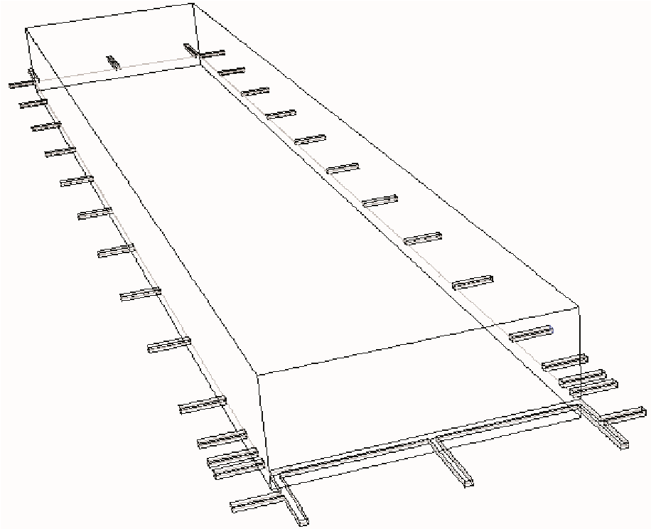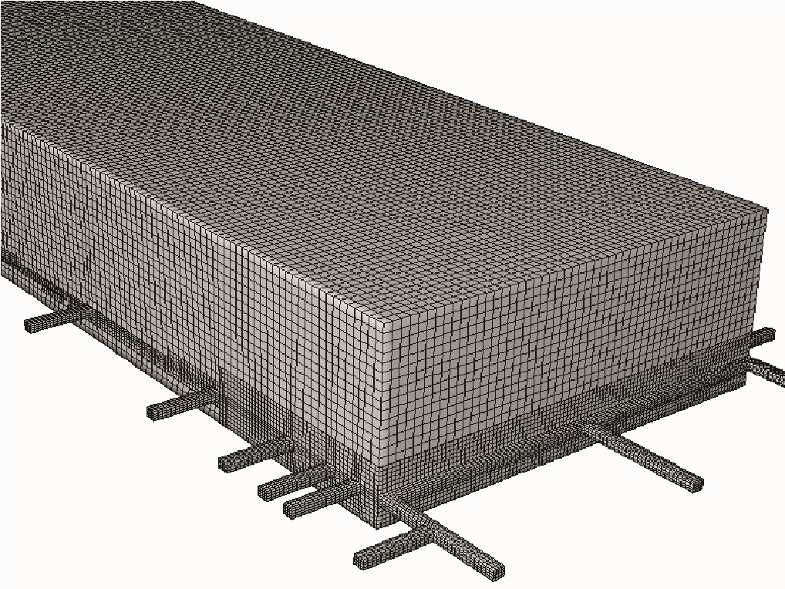
GOAF
MG
TG
FACE
FIG 5 - Typical model geometry and mesh used in the longwall CFD gas flow models.
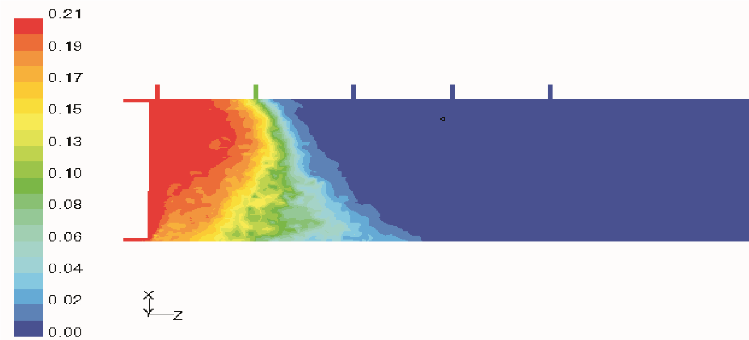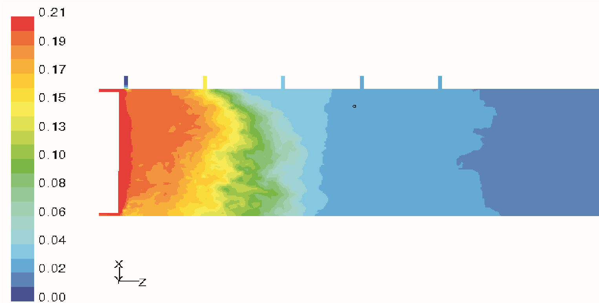
Tailgate(TG)
Inertgasinjectionat0.5m
3
/s
Inertgasinjectionat0.5m
3
/s
Tailgate(TG)
Maingate(MG)
a.Inertgasinjectionthroughmaingate
b.Inertgasinjectionthroughthirdcut-throughseal
Oconcentrationlevel(%)
2
FIG 6 - Oxygen distribution patterns in the goaf following inert gas injection at different locations.
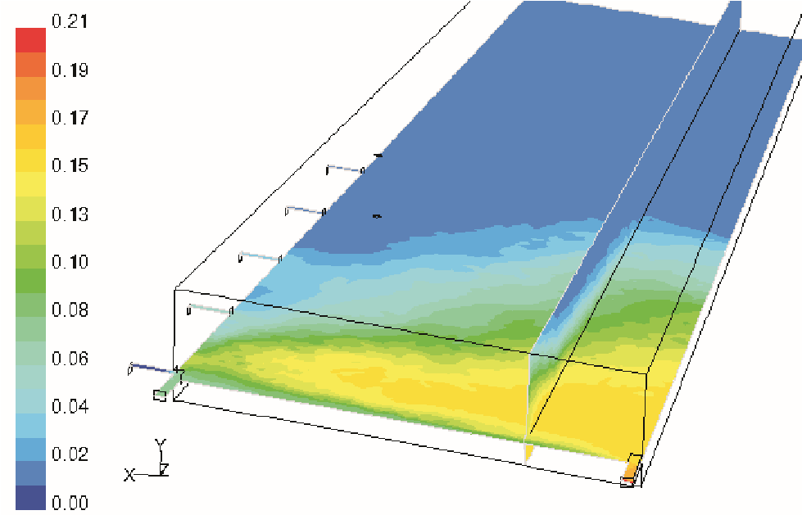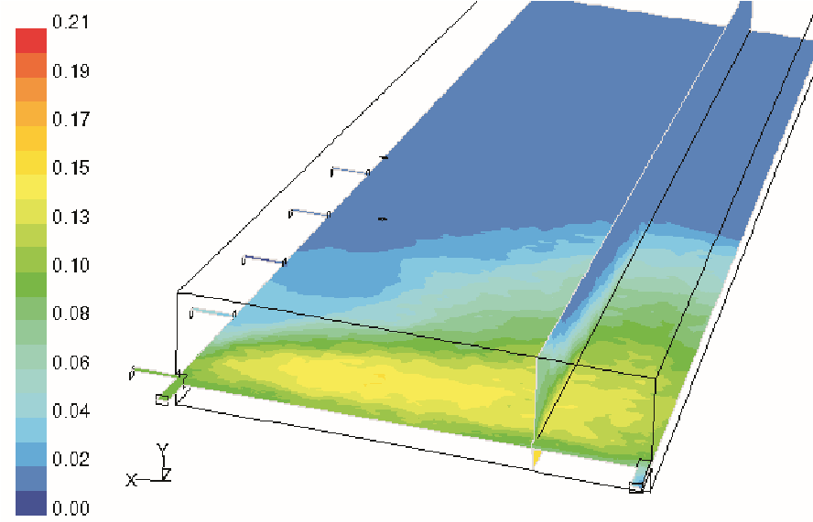
Maingate(MG)
Tailgate(TG)
Panelfinishline
=21
%
Inertgas
injection
location
Inertgas
injection
location
3
c/t
FIG 7 - Oxygen distribution in the goaf – with inert gas through MG seal and 3 c/t seal respectively (transient simulation one day after sealing).

PROACTIVE INERTISATION FOR ACTIVE LONGWALL FACES
An on-going project at CSIRO is the development and demonstration of proactive inertisation strategies with the objective to reduce the risk of spontaneous heatings in active longwall faces, in particular under unexpected scenarios such as during slow retreat/face stoppage.
CFD simulations were conducted for a range of longwall layouts and gas emission conditions based upon several Australian underground coal mines. These models were used to investigate the best inertisation strategies that could be deployed to narrow down the high oxygen level zones which are potentially liable to spontaneous combustion in the goaf. The investigation involved extensive parametric studies on inert gas compositions, injection locations, inert gas flow rates as well as the impact of goaf gas emissions, seam dips, face orientation and ventilation systems.

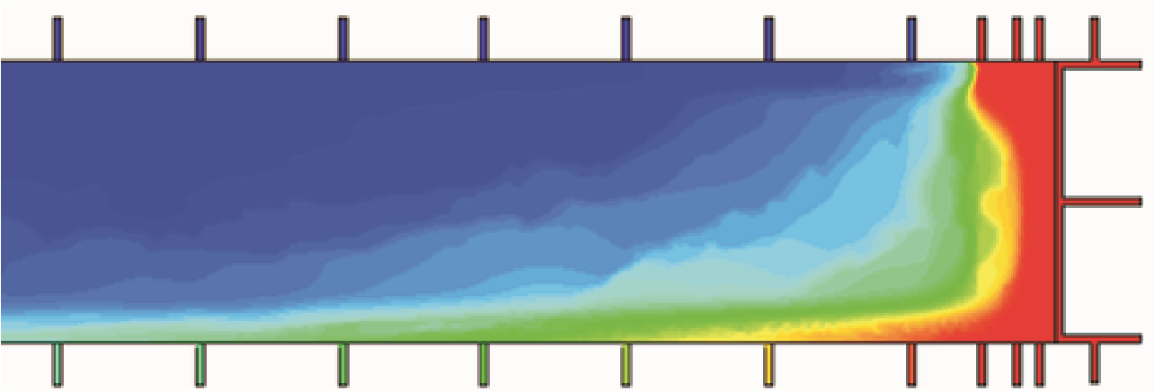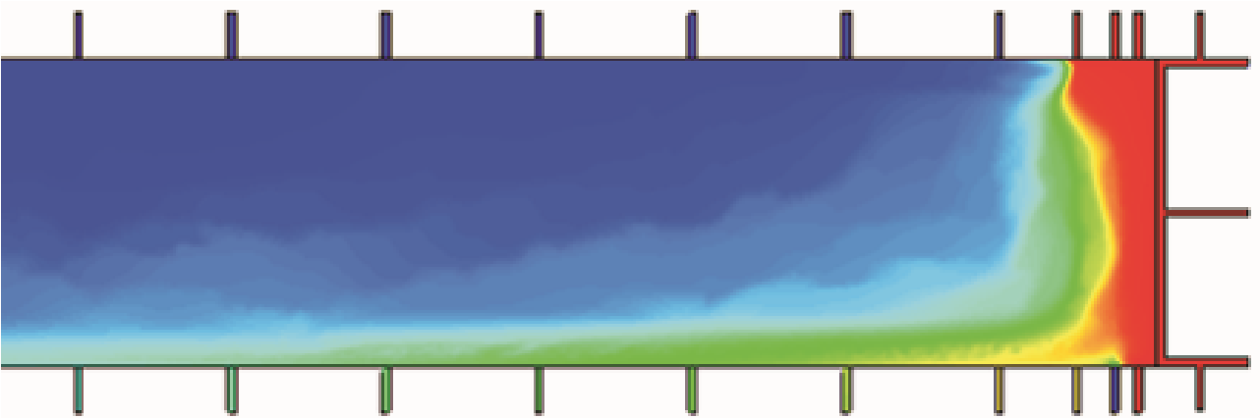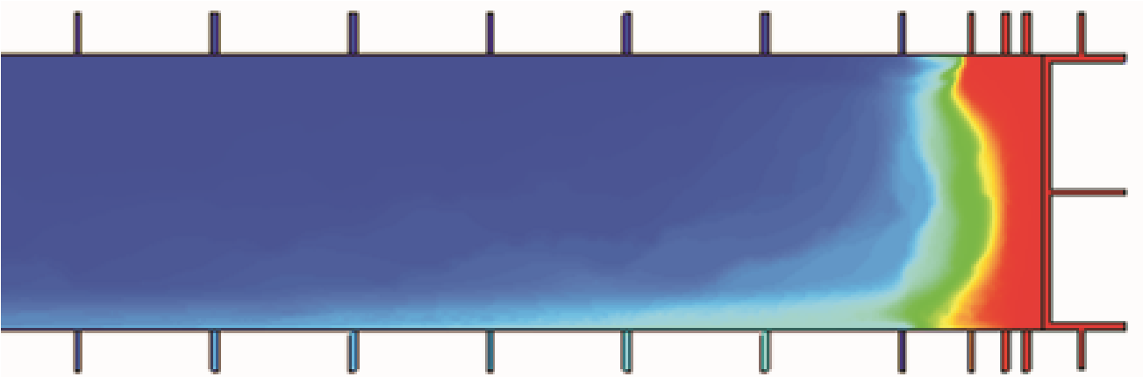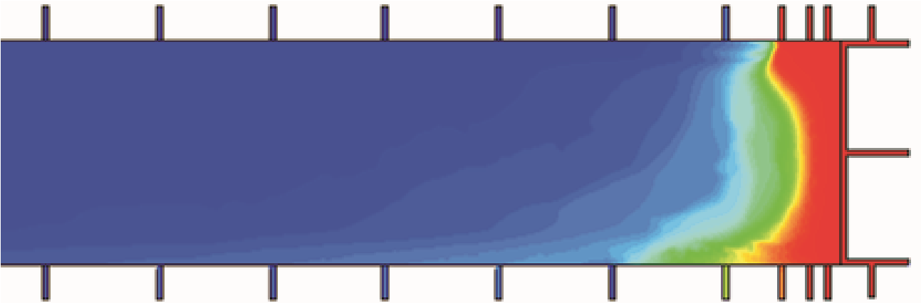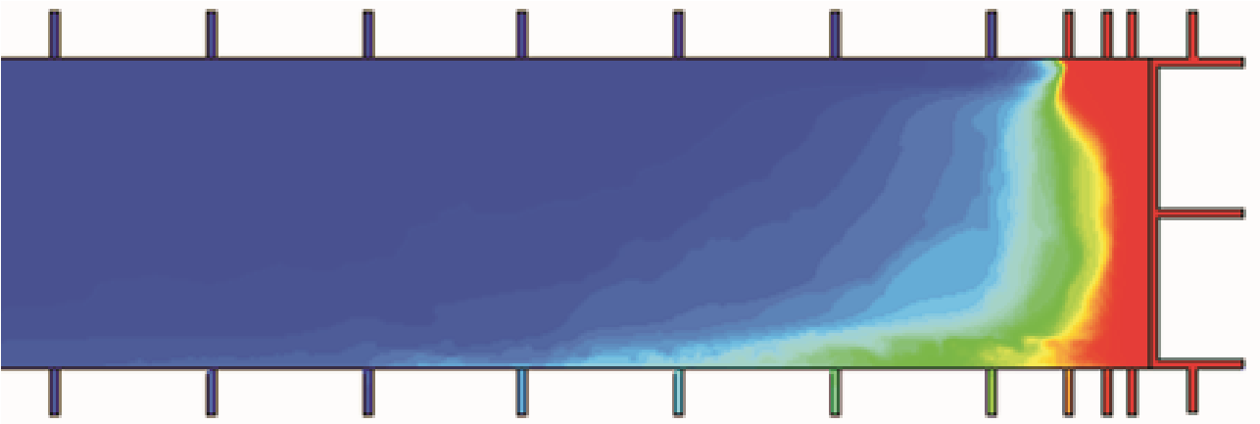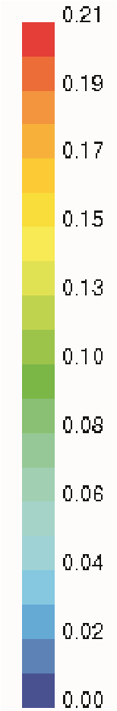
Basemodel
Boilergasat0.5m/s,30mbehindfaceline
3
Boilergasat0.5m/s,110mbehindfaceline
3
Boilergasat0.5m/s,200mbehindfaceline
3
Boilergasat0.5m/s,500mbehindfaceline
3
B
ac
k
return
Inertgas
injectionpoint
TG
OConcentrationlevel(%)
2
MG
Inertgas
injectionpoint
Inertgas
injectionpoint
Inertgas
in
j
ectionpoint
FIG 8 - CFD simulations of proactive goaf inertisation options in an active longwall.

Referring to the longwall layout in Figure 5, Figure 8 shows the goaf oxygen distribution patterns at the working level for the base model and inert gas (boiler gas) injection simulations at different cut-through seals on the maingate side. The face was ventilated with 45 m³/s of air using a modified form of back return system (a cut-through open on the tailgate for return air).
The results indicate that inertisation through cut-through seals close to the face line would not be effective – most of the inert gas will be diluted and blown away by the ventilation streams to the return; Inert gas injection through cut-throughs behind the face, ie at 200 m or beyond behind the face finish line, would result in better goaf inertisation. It can also be observed from the simulations that inertisation even at 500 m behind the face would achieve a better goaf inertisation than that at seals close to the face line.
CFD simulations were also conducted to investigate the effectiveness of goaf inertisation via surface goaf holes in case goaf access via underground roadways becomes difficult or impossible. This is the likely scenario if high level CO were detected in the return and underground workers had to withdraw or due to poor geological conditions/roadway failure, parts of the longwall working become inaccessible.
Figure 9 shows the CFD model layout based on a real case study of an Australian underground coal mine. Due to the collapse of tailgate, the face had to stop and as such signs of spontaneous heating were detected from the goaf. To suppress the development of spontaneous heating in the goaf and thus allowing time for the restoration of the tailgate, inert gas was injected via the vertical boreholes drilled from the surface, as shown in Figure 9.
CFD simulations were carried out to assist the formulation of an optimum strategy for goaf inertisation. Figure 9 also shows the oxygen distribution pattern within the goaf before inert gas inertisation. It can be seen that airflow has penetrated deep into the goaf and a large area can be liable to spontaneous heating.
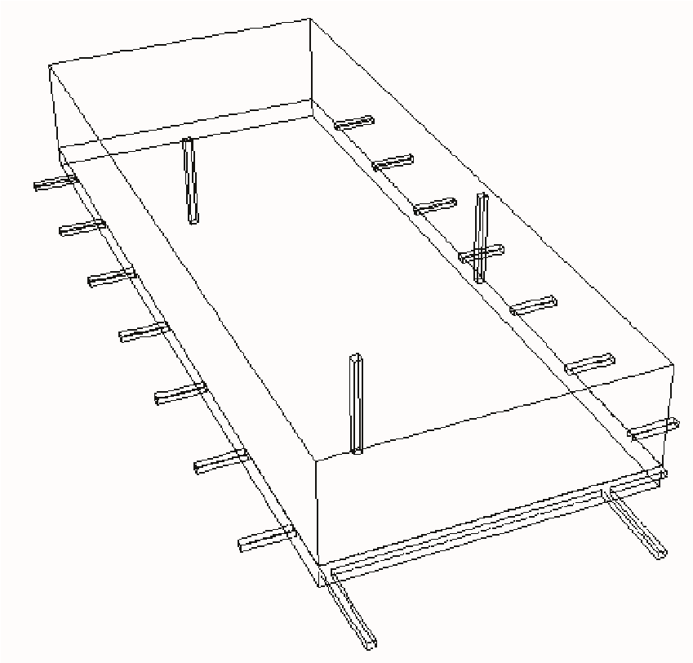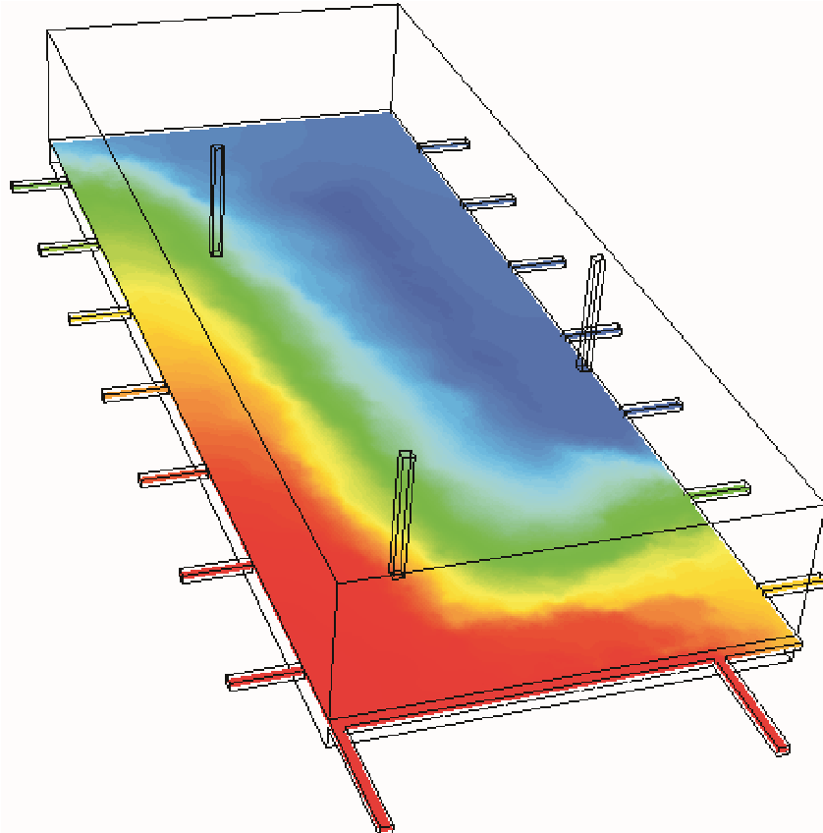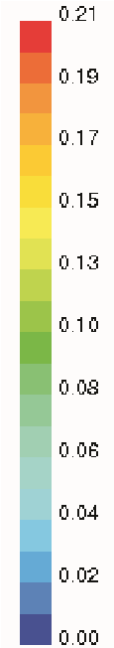
Goaf
Surfaceborehole
MG
TG
(
restored
)
FIG 9 - Proactive goaf inertisation via surface boreholes – base model and oxygen distribution pattern.
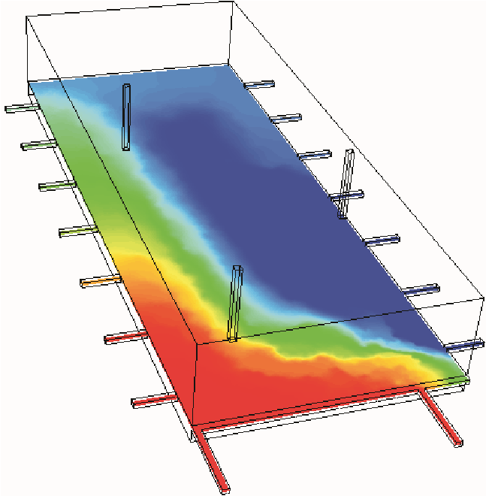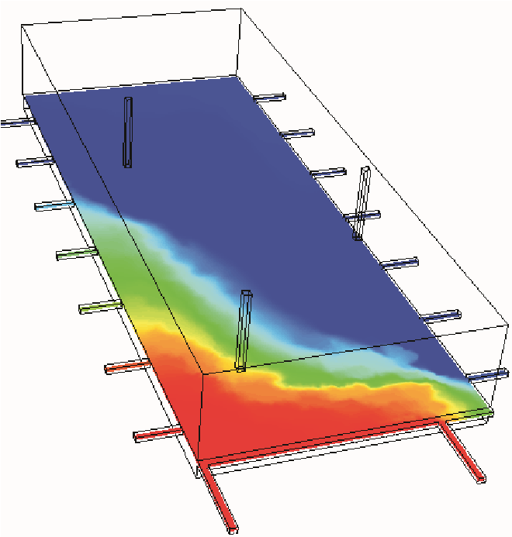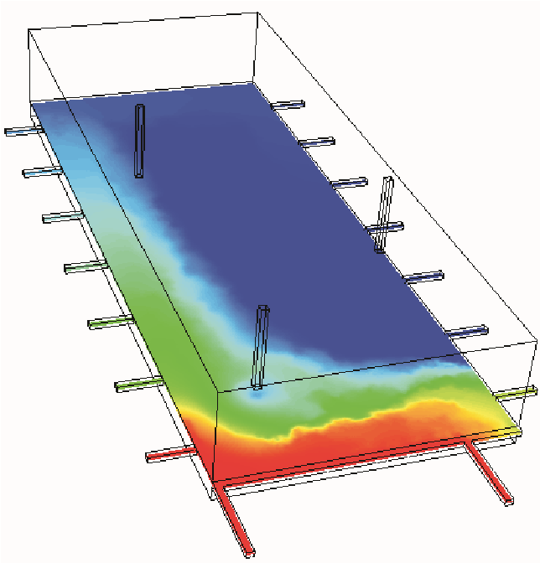
Inertisationborehole
tggh
1
-
Inertisationborehole
mggh1+mmgh
-
2
I
nert
i
sat
i
on
b
ore
h
o
l
e
-
mggh2+tggh
1
c
.Boilergasat0.5m/s+nitrogen
3
a.
Boilergasat0.5m/s(tggh1)
3
b.
Boilergasat0.25m/seach
3
(mggh1+mggh2) at 0.15 m /s³ (tggh1+mggh2)
FIG 10 - Proactive goaf inertisation with a combination of surface boreholes.
A range of parametric studies were carried out to investigate the effect of goaf inertisation via the surface goaf holes using nitrogen and boiler gas at different flow rates. Figure 10 shows the goaf oxygen distributions of selected simulations of inertisation strategies. In comparison with the base model, the results indicate that inertisation via surface goaf holes can be very effective in narrowing down the sponcom liable zones. A combination of deep goaf hole (mggh2) with goaf hole (mggh1 or tggh1) can further improve the effectiveness of goaf inertisation, as shown in Figure
10b and c. Studies are continuing in this area to investigate if low inert gas flow rates, ie at 0.15 m³/s, can be used to effectively suppress the development of spontaneous heating spots in the goaf.
The improved understanding of the inertisation process has been used in combination with detailed field trials to develop effective proactive inertisation strategies for two Australian underground coalmines, both experienced the threat of goaf heating following the disturbance of geological and operational problems. The implementation of the proactive inertisation strategies tailored specifically to the longwall panel has effectively suppressed the development of spontaneous heatings in the goaf and hence allowed the continuation of coal production.

CONCLUSIONS
In combination with detailed field studies, extensive CFD modelling work has been conducted to investigate the gas flow mechanisms within longwall goafs. These studies have greatly improved the fundamental understanding of goaf gas flow patterns and gas distribution in the longwall goaf and thus help the development of innovative goaf inertisation strategies for both panel seal-off operations and active longwall panels.
The optimum inertisation strategy implemented at the mine was highly successful in converting the goaf environment into an inert atmosphere within a few hours of panel sealing. This represents a major improvement to mine safety compared to typical inertisation practices that were able to achieve goaf inertisation within two to four days after sealing. The study demonstrated that it is feasible to completely inertise the longwall goafs within a few hours of sealing the panel by implementing optimum inertisation strategies.
Investigations have been conducted to develop proactive inertisation strategies to suppress the onset of spontaneous heating in the goaf behind active longwall panels. The studies indicated that inertisation through the cut-through seals at some 200 m behind the face would be more effective than that at close range immediately behind the face line. Goaf inertisation can also be carried out with surface boreholes when underground access becomes prohibitive or impossible. Knowledge obtained from the CFD modelling studies was used in conjunction with field studies to develop proactive goaf inertisation schemes for two Australian coal mines. The implementation of the proactive strategies has been proved highly successful in containing the development of heatings spots in the longwall goafs. Further studies are continuing in a number of areas, including the study of low inert gas flow rates for effective inertisation as well as the use of form injection to reduce the risk of heatings in the active longwall goafs.
The fundamental understanding of inert gas flow patterns and optimum inertisation guidelines developed during the course of the study greatly enhance the safety of coal mines.

ACKNOWLEDGEMENTS
The authors wish to thank ACARP for supporting the study. Thanks are due to the many Australian Coal Mines, management team and individuals for their support and generosity in providing useful information and ground support. The authors are also grateful to their colleagues at CSIRO for advice and assistance during the course of the studies.

REFERENCES
Aziz, N, Srinivasa, R B and Baafi, E, 1993. Application of computational fluid dynamics codes to develop effective gas/dust control measures in underground coal mines, The Australian Coal Journal, 42:19-27.
Balusu, R, et al, 2001. Goaf gas flow mechanics and development of gas and sponcom control strategies at a highly gassy coal mine, Australia-Japan Technology Exchange Workshop 2001, 2 - 4
December, Hunter Valley, Australia.
Balusu, R, Humphries, P, Harrington, P, Wendt, M and Xue, S, 2002. Optimum inertisation strategies, Queensland Mining Industry Health and Safety Conference 2002, 4 - 7 August, Townsville, Australia.
Creedy, D P and Clarke, R D C, 1992. Minimising firedamp risks on high production coalfaces: A computational modelling approach, in Proceedings International Symposium: Safety, Hygiene and Health in Mining, pp 192-203 (The Institution of Mining Engineers: Doncaster).
Currie, J A N, 1994. Measurement and control of diesel particulate emissions in underground coal mines, The Mining Engineer,
154(396):58-62.
Fletcher, C A J, Jancar, T, Matthews, B, de Guzman, M M and Tu, J Y, 1995. Computational simulation for mineral processing, in Proceedings APCOM XXV 1995, pp 361-370 (The Australasian
Institute of Mining and Metallurgy: Melbourne).
Gallagher, B, 2004. Southland heating and mine fire, International Longwall News, 13 February.
Healey, P, 1995. 1991 Ulan heating, in Proceedings Department of Mineral Resources Spontaneous Combustion Seminar, Mudgee, 6 - 8 November.
Lee, C J, 1994. Computational modelling of mine fires, The Mining
Engineer, July, pp 17-21.
Lynn, K P, 1987. Warden’s inquiry – Report on an accident at Moura No 4 underground mine on Wednesday, 16th July 1986’ (Queensland Government Press).
Moloney, K W, Hargreaves, D M and Lowndes, I S, 1998. Computational fluid dynamics (CFD) simulations in underground auxiliary ventilated headings, in Proceedings APCOM ‘98, pp 721-731 (The
Institution of Mining and Metallurgy: London).
Ren, T X and Edwards J S, 2000. Three-dimensional CFD modelling of methane flow through permeable strata around a longwall face, Trans Inst Min Metall, Mining Industry, Section A, Vol 109.
Sullivan, P and Heerden, J V, 1993. The simulation of environmental conditions in continuous miner developments using computational fluid dynamics, Journal of the Mine Ventilation Society of South
Africa, January, pp 2-11.
Tauziede, C, Mouilleau, Y and Bouet, R, 1993. Modelling of gas flows in the goaf of retreating faces. Paper Presented at the 25th International Conference on Safety in Mines Research Institutes at Pretoria, South Africa.

