Mackay District Office
P.O. Box 1801, MACKAY QLD 4740
Queensland Government Phone: (07) 4999 8512, Fax: (07) 4999 8519
Mine Name | Mine ID | Operator | Activity Type | Region | Activity Date
North Goonyella | MIOI 157 | PEABODY (BOWEN) PTY LTD | Investigation | Central | 12/07/2017
Vision: Our Industries Free of Safety and Health Incidents

Mine Record Entry
This report forms pan of the Mine Record under s68 of the Coal Mining Safety and
Health Act 1999. It must be placed in the Mine Record and displayed on Safety Notice Boards.
Note that inspection or audit activities conducted by the Mines Inspectorate are based upon sample techniques. It remains the primary responsibility of Mine Personnel to identify hazards, and risks associated with Operations and ensure those risks are at an acceptable level.
Site Safety & Health Reps Consulted: John Pearson
I, Mr Leslie Marlborough, Inspector of Mines and Mr Keith Brennan, Inspector of Mines attended North Goonyella coal mine today 12 July 2017 to investigate a complaint lodged regarding coal mine workers working in the return airway to conduct gas drainage drilling.
The meeting was attended by Mr Mike Carter, SSE, Mr Marek Romanski, UMM, Mr David Craft, Ventilation Officer, Mr John Pearson, SSHR, Mr Gavin Shields, Safety Superintendent and Miss Chloe Glazier, Gas Drainage Coordinator.
Mr Carter gave a very detailed explanation and update as to the status of the mine and the future plans going forward, The cunent Longwall, Longwall 9 North is at approximately 1700 chainage. Future plans were to mine LWIO North and then to mine LWIO South, with progressive Longwalls then being worked as LW9 South to LW6 South. The mine was intending to engage a contract development crew to open up the South Side developments and to commence development works for LWIO South, He explained that this contract would be awarded in the near future. He also explained that the mine was continuing to mine conventional LW without top coal caving. The Longwall was mining a cut height of 4.0 m which was proving successful and the mine was ahead of its production targets YTD He showed us a presentation that he was giving to the coal mine workers at North Goonyella (a state of the nation) which detailed the mine's current safety performance with a LTIFR of 1.4 and improving,
Mr Carter then passed over the Mr Romanski to explain an incident the mine had the previous day (Tuesday 11 July). Mr Romanski explained that, on the Tuesday, a maintenance shift it was necessary to conduct maintenance work on the Gas Engine and the surface gas lines. As a result, both the gas engine and the BIO Skids had to be stopped to allow the maintenance tasks to be completed. As a result of these activities the Methane level in the LW TG exceeded 2.5% with a peak value reached of between 13:00 PM and 16:00 PM. There was no production at the time and the LW operators were relocated to perform other activities outbye until the surface work was completed and the Methane levels returned to below 2.5%.
Inspector Marlborough advised that the mine should submit a report regarding this and a discussion was held regarding the goaf drainage infrastructure and how it was set up. Inspector Marlborough recommended that the mine organise to visit Moranbah North Mine as they have a good standard of surface infrastructure and in particular they have a T Piece on each goaf well on the surface that is connected to a venturi so that, should there be a need to shut down the gas drainage plant then the risers could be switched over the venturi to maintain some level of goaf drainage. Inspector Marlborough stressed that periodic maintenance on goaf drainage infrastructure is inevitable and the mine should review the system so that these exceedances did not occur as a result of planned maintenance work on the goaf drainage infrastructure.
Inspector requested the mine provide a copy of their completed investigation into the incident so that he could review the recommendations from the investigation to prevent reoccurrence. Mr Brennan ran through some of the documents that had been seized by Principal Investigation Officer Andrew Smith pertaining to the complaint.
Inspector Brennan then explained that the reason for the meeting was to Investigate a complaint that the Depaltment had received involving gas drainage drillers working in the returns and being exposed to respirable dust at an unacceptable level. At this time Inspector Brennan received a message which informed him of a personal issue and he had to leave to head into Mackay on an urgent matter. Inspector Marlborough then took over the meeting.
I, Inspector Marlborough explained that Inspector Brennan had been gathering the data and that this is what would be referred to. Mr Romanski stated that he was disappointed that no-one had raised the issue with him at the mine and had there been any issues raised then he would have addressed them.
Mr Carter showed on a plan of the mine where the drillers were working. He then drew on a whiteboard the ventilation layout of the work area. Mr Carter stated that inbye of the work area there was a set of balancing overcasts and that they had been temporarily stopped off to ensure that the Longwall return air did not pass over the drillers work site, only development returns.
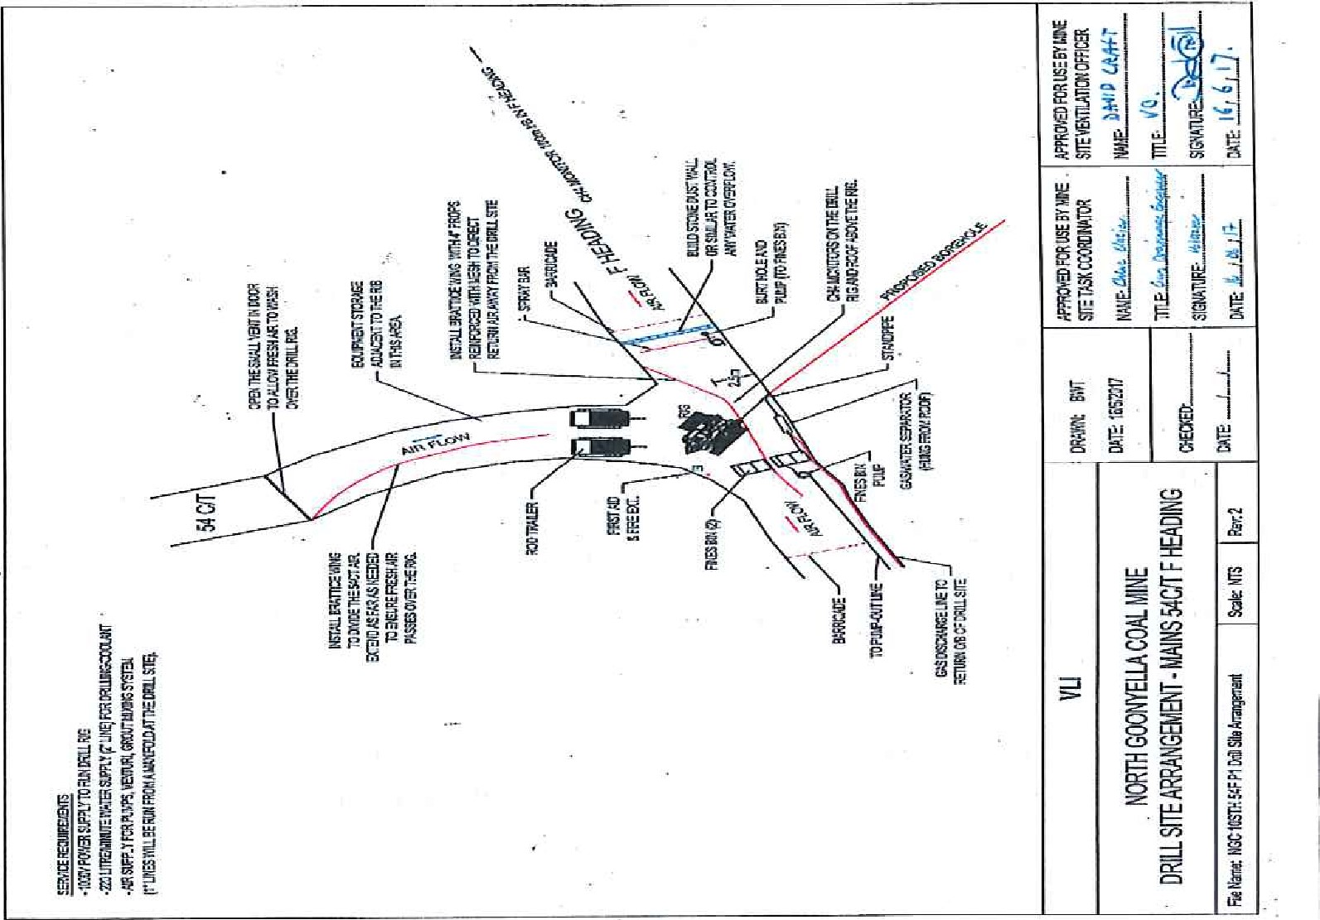
I asked what process had been followed in assessing the risk before drilling commenced. Mr Carter explained that a risk assessment (NG-TSE-RSK-GD041 — UIS Drilling in southern panels) had been conducted, A copy of this was supplied and it was reviewed by the group. It appeared to have a relevant cross section of coal mine workers including several of the contractors involved with the work, the Ventilation Officer and an ERL Controller. The content of the risk assessment was reviewed and, although it covered a wider area than simply dust exposure, dust exposure had been identified in each job step as a hazard with existing and proposed controls listed. Evidence was also presented where the proposed controls had been signed off as complete.
I asked whether there had been any monitoring completed of respirable dust prior to commencement as a background level before drilling commenced. It was confirmed that a PDM real time monitor was used for a baseline and there was static monitoring done. Copies of the results were provided and discussed. The drilling crews have been the subject of personal dust monitoring every 2 weeks while operating in the area and there have been no
exceedances. A discussion was held on the PDM real time monitor used and that it did not comply to Australian Standards but it was used to give a vety reliable guideline and was not used in place of personal monitoring. Mr Carter confirmed that dust monitoring had taken place whilst development operations had been on production. I suggested the mine consider inclusion on the dust monitoring reports the details of the metres cut in development when the monitoring was carried out.
I was informed by Mr Romanski that whenever there were drilling activities happening in the return there was an ERZ Controller present in the Zone at all times as it was classified by the mine as interfering with roof or sides. He stated there had been occasions when they could not drill because they did not have an ERZ Controller available.

I asked about an incident that had occured when an LHD operator had hit and damaged a VCD while operating in this return because he could not see where he was going because of dust. This incident was confirmed by Mr Carter and Mr Romanski. Mr Romanski explained that the incident occurred due to floor dust thrown up by the LHD operator who continued to drive the machine even though he could not see where he was going and eventually he hit a VCD. The incident occurred two to three pillars inbye of the drill site and the LHD was engaged in changing out fines pods for the drillers, not actually drilling. Mr Romanski stated that he had issued an instruction that the only times persons could work in the area outside of the ventilated area as shown previously was during shifts when the development panels were not producing or between shifts when there is no production in the ventilation panels. I pointed out that one of the controls identified in the risk assessment was to clean up bull dust in the return and that this incident suggested that there was still a considerable amount of bull dust on the floor in the area of the drilling activities. I recommended that the mine review these roads with a view to any further cleaning or watering of roads that may be required.
Mr Romanski again stressed that he had received no complaints from any of the coal mine workers regarding this issue and that had he received a complaint the issue would have been dealt with.
Mr Carter stated that John Pearson, SSHR had raised the issue with Mr Carter about working in the returns and as a result conducted an inspection of the area. Mr Pearson stated that he had inspected the drilling area. He had recommended that the spray bar could have been extended to improve its effect, which was done. He did not have any other concerns following his inspection of the area.
Mr Carter explained that whenever the drillers are drilling in the return they are issued with Cleanspace Respirable dust protection. I recommended that the mine continue with the sampling regime that they have established and in addition that they consider using the real time dust monitors regularly to audit the exposure of the individuals involved in the work.
Mr Carter stressed that the mine has worked hard to encourage all coal mine workers, including contractors, to be comfortable in their work environment and to feel confident in raising issues and concerns with the mine management without retribution and to be assured that their concerns would be addressed and appropriately dealt with. He expressed his disappointment that no one had come to him or his management team with any concerns regarding the VLI operations in the return that we had discussed.
From my observations and the discussions that were held it appears that the mine have addressed the risk involved with operating the drill rig in the return and have established controls to effectively manage the risk to coal mine workers from exposure to respirable dust.
I thanked Mr Carter and his eam for their openness and the frank discussions that we had.

Les Marlborough | Keith Brennan
Inspector of Mines | Inspector of Mines (Coal)
Central Region | Central Region
Entw

