Mine Name | Mine ID Operator | Activity Type | Activity Date
North Goonyella | MIO 1157 Peabody (Bowen) Pty Ltd | Site Meeting | 27/09/2018

Vision: Our Industries Free of Safety and Health Incidents

Mine Record Entry
This report forms part of the Mine Record under s68 of the Coal Mining Safety and
Health Act 1999. It must be placed in the Mine Record and displayed on Safety Notice Boards.
Note that inspection or audit activities conducted by the Mines Inspectorate are based upon sample techniques, It remains the primary responsibility of Mine Personnel to identify hazards, and risks associated with Operations and ensure those risks are at an acceptable level.
Site Safety & Health Reps Consulted: Mr John Pearson
Today, Thursday 27 September 2018 the following Inspectors attended North Goonyella Mine to attend a meeting in regard to progress on dealing with the spontaneous combustion event currently in progress.
Shaun Dobson - Deputy Chief Inspector
4 |  | Mackay Office
 | Queensland Government | P.O. Box 1801, Mackay QLD 4740  Phone: 07 4999 8512. Fax: 07 4999 8519
Richard Gouldstone - Inspector of Mines
Geoff Nugent - Inspector of Mines
Stephen Smith - Inspector of Mines
Meeting at 8:30am Thursday 27 September 2018
Attendees -
John Pearson (SSHR)
Andy Hislop (GM Metropolitan Colliery NSW)
Marek Romanski (UMM)
Nev Impson (Compliance Manager)
John Anger (SSE)
Martin Watkinson (SIMTARS)
Mike Carter (SSE Millennium)
Peter Baker (Peabody Operations Manager)
Sean Muller (SIMTARS)
Ross Bannerman (Peabody Legal Counsel)
Gavin Shields (HST Manager)
George Schuler (GM Peabody AUST.Operations)
Shane Fleming (Engineering and Maintenance Manager)
By dial in — Michael Brady (Consultant) Darren Brady (Consultant)
The Mine provided the following summary,
Last 24 Hours
i) Inertisation; LN2 set up ran out of feed at 16:00 ETA N2 1 1 :00 ii) Continued with inertisation iii) 2 hourly bag samples taken from TB14 , 25 and 26 iv) Gas Chromatograph and Simtars lab set up and operational
- DR 1265 GN2699 drilled to 294m started losing circulation. Preparing rig to resite at GN2703
- DR 1218 GN2702 ^{I} rat hole' drilled, about to start drilling at 06:00 vii) DR 1226 GN2701 reported at 06:00 to be at 362m
viii) Improved purity on Floxals 615,2 and 1, but reduced flow by approx 2001/s with
02<20/0 ix) Maintained exclusion zones
x) Bag sample taken from GN2693 at 00:24 showed Nil CO or Ethylene
Next 24
i) Maintain exclusion zones ii) Limit personnel access to site iii) Continue to drill GN2702, GN2701 GN2703 iv) Continue to sample TB14, TB24, TB25 and TB26
v) Prepare to plug MG chute as soon as GN2701 is complete vi) Define monitoring points; Face side of MG chute and 2ct A Hdg 9N Meeting Notes
e GN 2701 is expected to hole at 10pm tonight. The directional head is then to be deployed to 2703 MG9 2ct
e 2702 commence drilling 0600hrs 27/9/2018 Each hole takes approximately 3 days to drill
e TB 25 is sited in a ventilation current of 92 cubic metres/s and TB 26 in 41 Cubic metres/s close to the main ventilation fan.
e It is planned to sequentially plug GN2701 (MG Chute), GN2702 (Ahdg 1-2ct) and then GN2703 (2ct A-B) as they become available. Once the MG chute is plugged the products of the spontaneous combustion are predicted to travel inbye so the LW will then be monitored using TB27 MG9 and TB37 24-25ct.
- Liquid N2 supply ran out at 1600hrs 26/9/18 and the next delivery is expected at 1100hrs 27/9/2018 with further supply reported in transit.
- Reviewing secondary seals researching products and processes (cementitious
- Bag sample out of 2693 (80m above seam) showed no CO or Hydrogen but may not be representative of the atmosphere at seam level.
- GAG not placed on standby at this stage
- Products of the spontaneous combustion event were visible at the main fan evasee during afternoon of 26/9/2018 PM and again today at 0800hrs
- TG seal has the two outer walls constructed with a hatch and is sprayed but not
- The Mine currently have 2500m of TB line available and are sourcing more
- Strategy is about bringing the event under control by placing plugs in strategic positions
All people on surface are subject to a process for monitoring their position and readily available to be contacted. The 'old security hut' is the mustering point for emergency and accounting for people.
Darren Brady raised that the increase in Graham's Ratio could be associated with
Liquid Nitrogen injection stopping at 1600hrs 26/9/1 8
TB26 vacuum pressure dropped from -70kpa to -50kpa the cause of which is under investigation.
- H2/CO Ratio was influenced by changing Gas Chromatograph in use from NGC to SIMTARS unit.
- BOC N2 (4001/s) unit is anticipated to arrive Saturday 30/9/18 with the plan to place on hole GN2695.
The Inspectors were informed post meeting that the Mine intended to turn off power

underground.
Richard 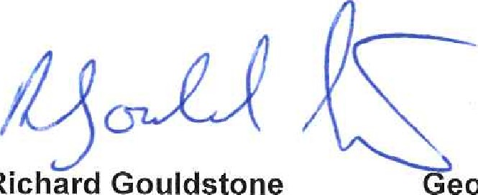Gouldstone eoff Nugent Shaun Dobson
Inspector of Mines Inspector of Mines Inspector of Mines
Stephen Smith
Inspector of Mines

