NOTICE OF CONFIRMATION TO THE MINES INSPECTORATE
AND INDUSTRY SAFETY & HEALTH REPRESENTATIVE OF A
HIGH POTENTIAL INCIDENT OR SERIOUS ACCIDENT
MINE: | North Goonyella | DATE: 29/08/2018
This notice* is made by or on behalf of the Site Senior Executive primarily** pursuant to section 198(4) or (5) of the Coal Mining Safety & Health Act 1999 to confirm the initial oral report to an inspector and an Industry Safety & Health Representative
NOTE: * Notice required within 48 hours or 24 hours in the case of a fatality: ** Also serves to report “Non-Reportable Incidents”

 |  | SECTION 1: INITIAL ORAL REPORT
Made by: | Neville Impson |  | Company Position: | Compliance Manager |  | Phone: | 0418 233 801
Made to: | Leslie Marlborough |  | Time: 19:13 |  | Date: | 28/08/2018
Made to: | Steven Woods |  | Time: 20:24 |  | Date: | 28/08/2018

SECTION 2: SERIOUS ACCIDENT
Is this Incident a SERIOUS ACCIDENT? |  | YES |  | Delete as appropriate
NOTE 1: | Act s.16: A SERIOUS ACCIDENT is one that causes (a) death or (b) a person to be admitted to hospital as an in-patient for treatment of the injury.  Also by definition it is a HIGH POTENTIAL INCIDENT
NOTE 2: | While not included in the definition of SERIOUS ACCIDENT, Act s.198(2)(iii) requires immediate notification of an accident “that causes a person to suffer an injury, causing or likely to cause, a permanent injury to the persons health”. This is also a HPI. (SERIOUS INJURY is not defined)

 | SECTION 3: PRESCRIBED HPI - TYPE BEING REPORTED
 | SCHEDULE 1 |  | SCHEDULE 2
 | Type No’s 1 - 9 | Type No.10 (a) – (p) | Part 1 | Part 2
Type no: | 5
NOTE 1: | Types 1-9 are HPI’s without qualification | Types 10(a) to (p) are HPI’s only if they “endanger the safety or health of a person” | Person not to interfere with site without inspectors permission | Investigation report to be provided to an inspector within 1 month
NOTE 2: | Some HPI types in Schedule 1 also qualify as types in Schedule 2, Part 1 and/or Part 2. See details on reverse of this form

SECTION 4: NON-PRESCRIBED/APPARENT HPI OR NON-REPORTABLE INCIDENT – NRI
TYPE A (apparent HPI): |  | TYPE B (NRI): | Delete which does not apply
NOTE: | Type A: Where a “match” cannot be made to the Schedules but the event appears to be a HPI | Type B: Where the incident is significant and has a safety “message” to share with industry | Indicate ‘A’ or ‘B’ above and complete “DETAILS OF EVENT” section below

SECTION 5: DETAILS OF THE EVENT
NOTE: Information provided in this section includes the “Primary Information” required by s.198(3) of the Act

SUMMARY DESCRIPTION OF THE EVENT
An inadvertent, rapid vent change resulted in a plug of methane purging from the goaf into the return general body.
DATE: 28/08/2018 TIME: 16:45 LOCATION: NGC-9N Tailgate seal #1
EQUIPMENT INVOLVED: N/A ENVIRONMENTAL CONDITIONS: Light: Dark: Sunny: Wet: Dry: Windy:
NUMBER OF PERSONS INVOLVED: DAMAGE: N/A
NAME(S) OF DECEASED: N/A
NAMES OF PERSONS INJURED INJURIES EMPLOYER (contractor where applicable)
N/A N/A N/A
NAMES OF ANYONE WHO SAW THE INCIDENT OR
WERE PRESENT AT THE TIME: White Crew
IF NO WITNESSES, NAME OF PERSON FINDING THE INCIDENT:
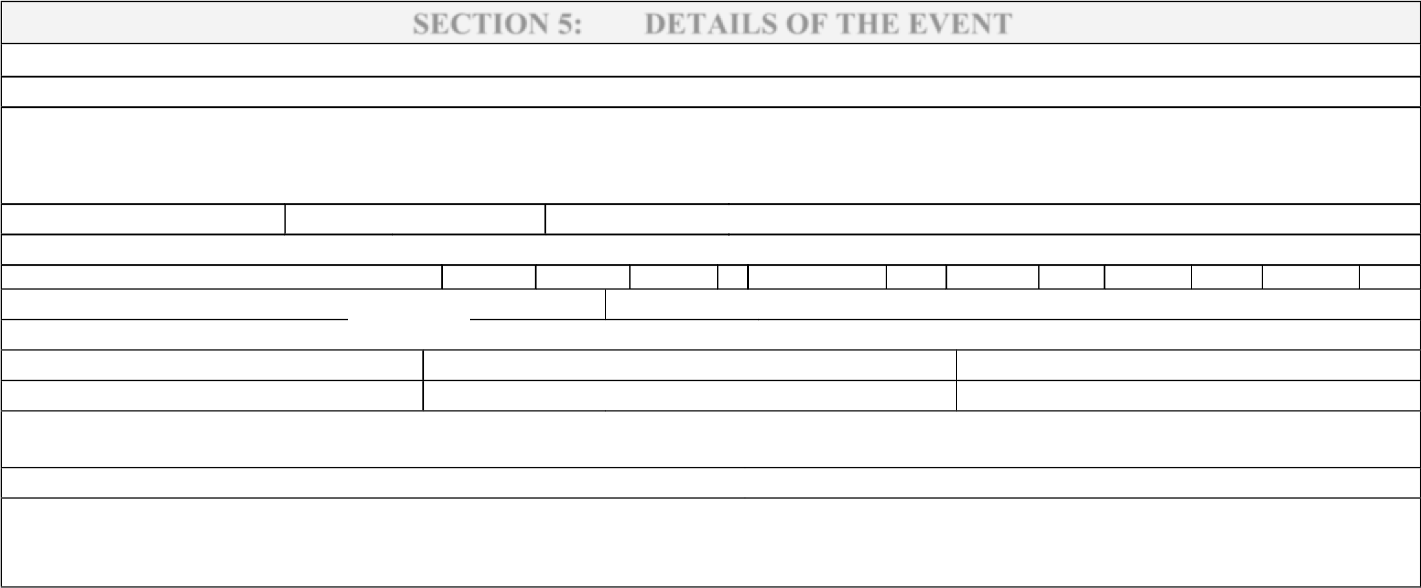
OTHER INFORMATION/DETAIL: The rapid vent change pushed a plug of goaf gas into the TG return exceeding 2.5% for 13 minutes and #1 seal sampling triggered an orderly withdrawal under level 3 TARP36. After levels returned to Normal condition a risk assessment was conducted prior to re-entry.
VERSION 6 – MAY 2009
Created by walkerm

Page 1 of 2
IMPORTANT NOTE:

This is NOT an “Official Form”. There is no statutory obligation to use it. The objectives of the form are to:-
1. Raise awareness of the requirement to provide written confirmation of reported incidents and to facilitate that confirmation process 2. Obtain consistent information as required for input into the Inspectorate Database.
- Guide industry to correctly identify the HPI “Type” that is reported and thereby to understand the statutory obligations that apply
- Provide for the reporting of all Incidents with a “Safety Message” - provides for reporting “Non-Reportable Incidents” (NRI’s)
- Provide a “ready reference” to assist with the understanding of Schedules 1 & 2.

Coal Mining Safety & Health Act 1999:

s.17. A “high potential incident” at a coal mine is an event, or a series of events, that causes or has the potential to cause a significant adverse effect on the safety or health of a person.

Coal Mining Safety & Health Regulation 2000:

 | SCHEDULE 1:  Types Of High Potential Incidents For Section 198 Of The Act | SCHEDULE 2 **
 |  | Part 1 | Part 2
1 | An unplanned ignition of gas, dust, or a combination of gas and dust. |  | 
2 | The spontaneous combustion of coal or other material in an underground mine. |  | 
3 | The entrapment of a person. |  | 
4 | An electric shock to a person. |  | 
5 | An event causing the withdrawal of a person from the mine or part of the mine.
6 | An abnormal circumstances declaration. |  | 
7 | An event that causes only 1 escapeway from the mine to be available for use.
8 | A fire on a vehicle or plant
9 | An incident involving an explosive
10 | A FOLLOWING INCIDENT THAT ENDANGERS THE SAFETY OR HEALTH OF A PERSON—
(a) | a fire;
(b) | a ventilation failure causing a dangerous accumulation of methane or other gas; |  | 
(c) | an inrush; |  | 
(d) | a coal or rock outburst;
(e) | damage to, or failure of, haulage equipment used to transport a person in a shaft or slope; | 
(f) | an unplanned movement of, or failure to stop, a vehicle or plant;
(g) | the failure in service of explosion protection of explosion protected equipment; |  | 
(h) | a failure of electrical equipment or an electrical installation;
(i) | an unplanned ignition or explosion of a blasting agent or explosive; |  | 
(j) | a failure of strata control; |  | 
(k) | the exposure of a person to a hazardous substance;
(l) | an unforeseen hazard requiring a review of the mine’s safety and health management system;
(m) | the unplanned immersion of a person in liquid;
(n) | an unplanned movement of earth or coal;
(o) | a structural failure of equipment; |  | 
(p) | a collision involving a vehicle or plant.

NOTE: ** The ticks indicate those types in Schedule 1 that are also a type in part 1 or part 2 of Schedule 2 and subject to the requirements of that schedule.
 | SCHEDULE 2
 | PART 1 - Types for section 200(1) |  | PART 2 - Types for section 201(1)
 | Must not interfere with site without inspectorate permission |  | Investigation Report to an inspector within 1 month.
1 | An incident causing the death of, or a serious bodily injury to, a person | 1 | An unplanned ignition of gas, dust, or a combination of gas and dust
2 | An unplanned ignition of gas, dust, or a combination of gas and dust. | 2 | The spontaneous combustion of coal or other material in an underground mine.
3 | Damage to, or failure of, haulage equipment used to transport a person in a shaft or slope, if the damage or failure causes a hazard. | 3 | An inrush.
4 | The failure in service of explosion protection of explosion protected equipment. | 4 | The failure in service of explosion protection of explosion protected equipment
5 | A failure of electrical equipment or an electrical installation causing an electric shock to a person. | 5 | An electric shock to a person.
6 | An unplanned ignition or explosion of a blasting agent or explosive. | 6 | An unplanned ignition or explosion of a blasting agent or explosive.
7 | A major structural failure of equipment, if the failure causes a hazard. | 7 | A major failure of strata control.
 |  | 8 | The entrapment of a person.
 |  | 9 | An abnormal circumstances declaration.
 |  | 10 | A major structural failure of equipment.

VERSION 6 – MAY 2009
Created by walkerm

Page 2 of 2

