Mackay Office
P.O. Box 1801, Mackay QLD 4740
Queensland Government Phone: 07 4999 8512, Fax: 07 4999 8519

Mine Name | Mine ID Operator | Activity Type | Activity Date
North Goonyella | MIOI 157 Peabody (Bowen) Pty Ltd | Site Meeting | 19/09/2018

Vision: Our Industries Free of Safety and Health Incidents

Mine Record Entry
This report forms part of the Mine Record under s68 of the Coal Mining Safety and
Health Act 1999. It must be placed in the Mine Record and displayed on Safety Notice Boards.
Note that inspection or audit activities conducted by the Mines Inspectorate are based upon sample techniques. It remains the primary responsibility of Mine Personnel to identify hazards, and risks associated with Operations and ensure those risks are at an acceptable level.
Today 19 September 2018, Deputy Chief Inspector Shaun Dobson, and Inspectors Richard Gouldstone and Geoff Nugent attended NGC Mine at 8:30am to discuss the status of the high CO in 9N TG. Inspectors were met by Marek Romanski, UMM.
Attendees —
Peter Purdie (attended in absence of both SSHRs)
Marek Romanski (UMM)
Peter Baker (Peabody Operations Manager )
Gavin Shields ( SHE Manager),
John Anger (SSE)
John Fitzpatrick (Shift Coordinator)
John Deacon (Development Superintendent),
Steven Stook (Tech Services Manager),
Lee Earnshaw (Development Coordinator)
John Martin (Shift Coordinator)

Snezana Bajic (SIMTARS)
By dial in Darren Brady (Consultant), Michael Brady (Consultant), Martin Watkinson (SIMTARS), Neville Impson (Compliance Manager)

Update on last 24 hours
- Finished drilling GN2696 to target depth of 340m rig being demobilised off hole at start Dayshift 19/9 o Set up over and pre-collar GN2697 (TG Chute rd.)
I
- Wilsons setting up Rocsil hose run for TG Chute remote sealing
- Set up 2nd Narrabri Floxal unit, on line at 10pm into GN2693
Preparing pad for GN2698 and GN2699
- QMRS foam off and on standby
Modified bleeder fan to reduce operating pressure by 200Pa
Boosted Floxal volume to GN2693 and GN2695
- GN 2693 Narrabri unit on line for 36hrs, 80m above seam level 6501/s
Current Status
Gas readings for the previous 24 hours were provided and discussed.
e Tube 24 Stable and inert noted that injection of methane had affected the readings
Tube 29 showed a decrease in CO due to the drop in the bleeder fan pressure and barometric changes believed that the effect of the change has yet to be fully experienced
Tube 28 reflects the results shown in the TG Chute Road. However, there is still a significant difference in CO make when calculated between tube 28 and 29. This indicated there was a significant error in the ventilation quantity being used at one of these points.

Plan for next 24 hours
- Finish relocating Rig 1226 to GN2698 and connect Floxal to GN2696
- Continue with inertisation
- Continue with drilling GN2697 Preparing pad for GN2698 and GN2699
Commence drilling GN2698
2
- Set up pad and pits for re-entry into GN2693 improve depth
- Mobilising Wilsons equipment to inject plug in TG chute TBC RA review on site
Set up Narrabri floxal phase 3 module
- Set up liquid nitrogen tanker
- Wilson compressor for TG chute remote sealing arriving today
Install low point drains on CH4 line from 52.5 ct to GN1991
RA - for the risks of leaving power on without electrical stats since there is no persons underground.
- RA - chute road sealing
- RA - review Wilsons operational RA for remote Rocsil seal installation
RA - review LW Face ventilation with auxiliary fan for changed status, i.e re-entry and in association with TG chute seal in place

All issues are subject to serviceability of Floxal units
Comments from the Group were as follows
The meeting discussed the explosibility risk and potentially unknown explosibility environments from TB 29 to and around the heating event.
The Inspectors referred NGC management team to QMRS explosibility guidelines and re-entry procedures as a reference.
The NGC management team acknowledged the sealing management plan will need to be reviewed and submitted to DNRME also the need to redevelop of sealing TARP
(7) to review triggers and actions, to include explosibility.
The status of incombustibles in and around Longwall should be understood from mine data as part of the re-entry risk assessment process when re-entry becomes an option.
It was recommended that a TARP process for managing risk to surface workers which could be impacted by an explosion underground should be given consideration.
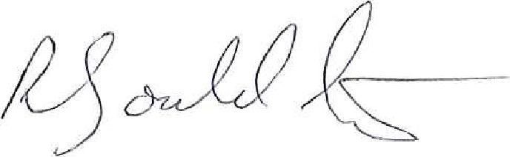
Richard Gouldstone Shaun Dobson
Inspector of Mines Inspector of Mines
3

