Memorandum

Inclusions/Scope:  Attention:  Date:  Opinion Prepared by:  Dallas Reference:  Comments/Queries contact John Rowland  Director, Dallas Mining Services Pty Ltd  NSW Australia 2500  Ph. 0407 283 510  Email: john@dallasmining.com.au www.dallasmining.com.au | Comments pertaining to some of the planned changes to Qld mines regulations  Peter Newman, Mark Stone, Shaun
Dobson
cc. Darren Nicholls
11 January 2020
John Rowland
Qld Leg 20-01

 |  | Page 1
Table of Contents
1. Preamble 4
2. Forward/Summary 7
3. No Documented Evidence of Change Management 8
4. Regulation 344, Specifically 9
4.1 The Impact on Development Panel Face Ventilation Capacity 9
4.2 The Impact of a Second Development Fan to Ventilate the Panel 12
4.3 What the Second Fan Means to the Panel Ventilation Capacity 13
4.4 What this Intended Change Means to Total Mine Ventilation Capacity 16
4.4.1 Base Case Using Existing Regulations 17
4.4.2 Base Case Compliant with New Intended Regulations 19
4.4.3 Base Case at 100% Fan Speed with New Intended Regulations 21
5. A Sense of Déjà Vu 23
6. Conclusions and Recommendations 26

List of Figures
Figure 4.1 Flow distribution. Previous legislation Figure 4.2 Flow distribution new legislation flow requirements ........................................................................................................................................... 11 Figure 4.3 Twin fan arrangement due to altered requirements ....................................................................... 12
Figure 4.4 Modelled panel entry flow for single panel fan............................................................................... 14
Figure 4.5 Modelled coffin pressure single panel fan ..................................................................................... 14
Figure 4.6 Modelled panel entry flow for twin panel fans ................................................................................ 15
Figure 4.7 Modelled coffin pressure twin panel fan ........................................................................................ 16
Figure 4.8 Base case mine wide key flows using former legislative requirements ......................................... 17
Figure 4.9 Base case main fan duty using former legislative requirements .................................................... 18
Figure 4.10 New theoretical flows for the base case design under the new intended regulations .................. 19
Figure 4.11 Base case theoretical main fan duty using new legislative requirements .................................... 20
Figure 4.12 Minewide flows at 100% for the base case design under the new intended regulation ............... 21
Figure 4.13 Base case main fan duty at 100% speed using new intended legislative requirements .............. 22
Figure 5.1 NSW Intended regulatory change ................................................................................................. 23
Figure 5.2 Search result for 0.3m/s in NSW final regulations ......................................................................... 24
Figure 5.3 Final regulatory requirement in NSW 2014 regulations ................................................................. 25

Preamble
The author has been working in the coal industry since 1976, nationally and internationally and predominantly in NSW and Queensland, in a variety of technical and operational roles. He has had considerable experience in not only interpreting and enforcing various regulations in both states but has been involved in reviewing and commenting on proposed regulatory changes on a number of occasions, mostly voluntarily and always on a pro bono basis.
The most recent major regulatory change on which the author made comment was during the draft review process of the change to the regulations in NSW with the introduction of the new regulations there in 2014 when he made around 15 submissions for the consideration of the review committee. NSW regulators at this time demonstrated a mature and disciplined approach and carried out this substantive and systemic review process to make sure they got it mostly right, although it could be still argued had they just adopted the Queensland regulations at that time they would have ended up with a better more comprehensive sets of statutes. That aside they did listen, for the most part, when some of the more controversial draft regulations were subsequently either scrapped completely or altered in line with industry opinion from invited persons and organisations that were involved in this review process.
The Queensland rewrite of the Act and regulations around the start of this millennia were basically written in the blood of the men lost at Moura No.2 mine in 1994 pursuant to a number of other multiple fatality events in that state during the 1970’s and 1980’s. Following exhaustive work over a long period of time involving small workgroups of people responsible for various areas surrounding the primary deficiencies identified during the Warden’s Inquiry the Act and Regulations were finally updated to reflect and manage such issues. This resulted in a set of regulations that were second to none, in the opinion of the author, and far in excess of the protection offered to NSW coal miners with such pivotal inclusions like power tripping adjacent explosion risk zones on methane % contamination, the use of high quality built for purpose and properly engineered ventilation control devices, the management of both sealed and unsealed atmospheres in relation to both explosibility and spontaneous combustion management and the foresight to trip diesel plant according to atmospheric methane contamination, to name just a few.
There have been several updates and amendments to the regulations in Queensland over the last two decades which have basically been forced upon the industry but have been relatively sparse and limited to a small number of mostly minor changes in the main. Sadly, these changes haven’t highlighted the Queensland regulators as avid communicators with little or no consultation generally being sought from interested industry parties and little in the way of formal review or opinion on those planned changes. This hasn’t seen to be too perilous given their limited number and for the most part generally the changes exhibited reasonable sensibility in line with both current knowledge and industry findings such as the Pike River explosion Royal Commission, pursuant to that 2010 disaster.
These latest amendments however have not only suggested change but enacted wholesale changes in the absence of any formal cooperation, consultation and discussion. In the opinion of not only the author but a myriad of industry professionals, including technical experts and mine operators, some of these changes have the real potential to increase risk in other areas. Many of these amendments at first glance appear to be poorly thought out technical solutions that can create alternate problems that don’t yet exist under the former pre 6 January 2020 legislation. A prime example is the apparent requirement to purchase, install, calibrate, maintain, analyse and collect data from methane monitors wherever a vehicle can enter another zone such as between an intake roadway and a main mine return roadway. In some of the larger mines this may number between 40 to 60 extra methane monitors that will be required should the mines decide to keep those machine doors as ongoing access points between these roadways.
In reality it is likely this legislation will simply ensure that the number of access points is substantially reduced because the maintenance of such a system will be so ridiculously complex. The upshot of this legislation, if this likely response becomes evident, will mean machines will be driven far greater distances under full load conditions in both the main mine intakes and returns which will expose Queensland coal mine workers to elevated levels of both diesel particulate matter and airborne and deposited roadways dust with exposure times being much higher than they are currently.
The author would never argue that some mines may require more monitoring but surely it should be dependent on risk on a mine by mine basis as no two mines are even remotely the same. The Queensland industry, under the valued guidance of the regulators over two decades, has done a sterling job training all their coal mine workers to use risk based logic from lowest to highest levels but for the government to mandate these new regulations in the absence of any risk based logic and review process and to expect the Queensland industry to own and buy into such change with arguably zero involvement or participation is just beyond belief.
Another issue of extraordinary note is the changes or clarification to the existing legislation in Section 344 relating to minimum ventilation velocities of air flow in mine roadways. The fact that it is mentioned in the summary notes as a clarification rather than a wholesale alteration suggests the regulator(s) don’t understand the original intent or even the current pre 6th January 2020 wording of this legislation. As such the author has dedicated considerable time and resources to attempt to explain the impact of this poorly understood and thoughtlessly rewritten legislation that will have a huge impact on the ability of our mines to remain safely ventilated and economically viable, if operators are forced to comply with this hipshot change.
The author has carried out mine wide pressure/quantity surveys at every operating underground mine in Queensland over an 18-year period and there are many other ventilation consultants and aficionados with a similar knowledge base who would be more than happy to pass comment on planned changes before they were mandated, if only someone had been bothered to ask us. A similar change plan was attempted in NSW in 2014 when the NSW regulator attempted virtually an identical change with minimum mine wide ventilation velocities of 0.3m/s being suggested because someone had read it in the Queensland regulations but didn’t understand either the wording or the accepted intent of the Queensland rules. This was vehemently howled down during the review process and subsequently scrapped as a very poor idea. The author has included a Section on this, herein, to demonstrate just how a consultation and review process might have worked, if you had bothered to use one.
The author and employees, and arguably even the employers of the Queensland Coal Mining industry, only found out about this legislative change around a week before Xmas with a planned introduction a week after New Year. Thus this communication, forwarded by the author, has been hurriedly formulated during a family holiday period to notify you of what is simply a summary of collective industry dismay in this whole process after a lot of discussion between interested industry personnel that are simply shaking their heads at the way this process has been handled.
The author concedes that nothing written herein is likely to form the basis for immediate concrete change, nor should it without the appropriate analysis of these changes by persons so qualified to discuss and analyse the effect of this change process using accepted risk-based logic, as it should have been in the first instance. This communication is merely a reactionary response to a demonstrably atrocious example of change management by persons who definitely should know better.
All the author would request of the regulator, if he/she were to listen, is to instigate some sort of review period where these changes can be sensibly discussed and agreement reached on just what these changes should look like using a collaborative and risk based exchange of ideas and information using the appropriate industry knowledge and input to ensure we get it as close to right as we can.

Forward/Summary
This memo outlines the authors opinion on some of the planned legislative changes in Queensland scheduled to come into effect on and/or after 6 January 2020. It also highlights some issues which the author believes will negatively impact on the future health and safety of Queensland coal mine workers pursuant to its enactment due to an almost complete disregard to accepted change management strategies by the regulator in getting this legislation authorised by the parliamentary council. Summarily the author has serious concerns with how this regulatory change has been enacted and is of the opinion that all these planned legislative changes should be immediately repealed until an appropriate change management process is agreed upon and then properly instigated and enacted. Specifically, but at first glance, given that there was no review process whatsoever, the author has serious concerns with respect to the amendment of Regulation 344 which, even before amendment, was clearly misunderstood by the Queensland Mines Inspectorate.
The author believes that this legislative change has been poorly thought out and this change to regulation 344 alone may result in an increased level of risk to Queensland coalmine workers with respect to the deposition of explosive coal dust, greatly increased risk of spontaneous combustion and elevated levels of both roadway dust deposition and increased levels of inhalable and respirable coal dust in suspension in the mine atmosphere that hasn’t been properly considered in this amateurishly rushed legislative change. This communication hopes to explain some of the implications of this change and Section 344 is used as a detailed example in Section 4 of this document.
It is simply unacceptable to enact legislative changes, that will in any way elevate the level of risk that coalmine workers in Queensland are exposed to, without giving those very miners the chance to peruse, review and comment on such changes prior to their implementation. The decision for person(s) unknown to make a “Captains Call” to rush through such poorly considered legislation, for assumedly political purposes, without an appropriate review and consultation process shows no due diligence whatsoever in the opinion of the author. The appropriate process would surely have been to seek some professional assistance on the impact of these changes, given the inspectorates obvious lack of any tangible expertise in some of these areas, and then to circulate the planned legislation as a draft for a specified review period so that comments could be sought from industry personnel and similar interested parties. This is the normal change management process, of which the inspectorate is intimately aware and in fact demands from coal mines and coal mine workers, in all aspects of even minor intended changes in their mining activities.
Summarily Queensland coal mine workers deserve to be treated with much more respect and should never have regulatory changes thrust upon them whilst denying them the opportunity to assess whether such changes are in fact beneficial to them from a safety perspective or worse still detrimental to their safety, health and wellbeing which can certainly be argued in this legislation change that has been forcibly and unwittingly thrust upon our industry.
It is of note that this communication is by no means confidential and the list of persons on the cover page are merely the persons involved in a communication meeting in Brisbane on 24th December 2019 in relation to this debacle, along with the addition of the new Chief Inspector of Mines in Queensland, Mr Peter Newman.

No Documented Evidence of Change Management
It simply beggars belief that Coal Mining Safety and Health (Methane Monitoring and Ventilation Systems) Amendment Regulation 2019 has been rushed through the Queensland parliament with no official consultation or review period prior to the implementation of this legislation. This is not a minor change to the legislation. It is a wholesale change to some aspects of the legislation that has major ramifications to both the safety and the ongoing viability of many of our Queensland mines. As such it would be assumed that some form of acceptable change management procedure would be adopted in this process.
Almost every man and woman employed within the Coal Mining industry would know that before any process/procedure is substantially changed the outcomes of such change needs to be considered using riskbased management techniques to ensure that the subsequent level of risk is reduced and not increased due to that intended change. This usually involves extensive communication of the intended change(s) followed by the appropriate risk assessment and review process to ensure no unexpected circumstances might arise from such a change that have not been considered, and that may elevate and not reduce risk. It appears that no such change management was involved in this process with only cursory and almost casual discussion allegedly occurring at a few random meetings attended by a relative handful of persons compared to the total number of persons employed in the Queensland Coal industry.
There was no industry wide pre-release of this intended legislation, as would be expected, so such diagnosis could be carried out and then commented on before enactment, given the substantial impact of some of these amendments.
The author cannot imagine the consequences from the Queensland Mines inspectorate if a mine site was to alter a sealing management plan during a coalmine longwall goaf seal up without using accepted change management techniques to ensure the level of risk was not adversely affected. The author remains to be convinced how the wholesale amendment to Regulation 344, for example, is any different in any way.

Regulation 344, Specifically
When Regulation 344 was drafted it was done so to ensure that working places in operating continuous miner development units were satisfactorily ventilated with a prescribed and designated flow of ventilating air. The current legislation is very specific on this point and it specified that each standing place on the intake side of a working place and the working place itself in an ERZ1 is ventilated with air at a velocity of 0.3m/s measured across the cross-sectional area of the roadway in that place. The legislation was carefully worded that way to help ensure development sequences were planned such that the return roadways were developed first so that long stubs wouldn’t be left poorly ventilated on the intake side of the miner which would create an unacceptable risk to persons working at the operating face. It has always been good mining practice to mine the return side of the panel first, as any practical coal miner would know, and the legislation was written so that adequate ventilation would always be available in a standing place if it was left standing on the intake side of the operating miner place.
It was never the intention of the legislation to provide 0.3m/s everywhere around the mine because the regulators at the time appreciated the impracticality of such an impost and that is exactly why Regulation 344 Section (3) was included. To demand 0.3m/s velocity everywhere around the mine is impractical and arguably impossible without substantially elevating the risk to health and safety of coal mine workers underground. The existing legislation rightly demands controlled ventilation for all places where persons work or travel but it intentionally specifies no minimum velocity in such a place leaving the ultimate control of those environments in the hands of capably qualified mining officials to monitor the environment to ensure there are no unduly elevated levels of any contaminants and people are provided with clean breathable air at all times, in which to work or travel.
To demand around 6.0m³/s of airflow (assuming an average roadway cross-section of say 18m²) in every location throughout the mine generally (with the curious exception of cut-throughs which are no different to other work locations) will reduce the available ventilation capacity of the mine and will result in less ability to direct much needed airflow to places that really need it. The capacity of the main mine fans is limited and finite and elevating airflows in areas that arguably don’t need it at the expense of areas that really need it is a retrograde step and must be reconsidered. To exempt the cut-throughs is to admit that such legislation is ludicrous at best. If the mining officials can be relied upon to ensure every cut-through in the mine is adequately ventilated for people to work safely then why not trust them to do the same at other chosen locations.
Mine operators have done a good job in the past of ensuring sumps and stubs and chute roads and standing places on the return side of the miner are adequately ventilated in a controlled manner without imposing a blanket quantity requirement where it may not be required and cannot be afforded from a total ventilation capacity perspective.

The Impact on Development Panel Face Ventilation Capacity
It’s very simple to highlight an obvious fatal floor in this intended legislation and it involves face ventilation capacity if coal mine sites are forced to deliver an air velocity of 0.3m/s to all places on the return side of a continuous miner. The issue is demonstrated using a ventilation model built for the purpose to highlight comparative miner face flows using existing legislation and the intended legislation.

For the sake of the example the author has specified the following assumptions used in the model assembly process which are not dissimilar to most development units in existing Queensland Coal mines.

- Two heading gate road panel with a lone continuous miner operating with ventilation ducting ventilating both standing and operating places.
- Left side belt return driveage developed as first sequence full distance with 30m overdrive in the belt road for machine placement for the panel advance and with the C/T driven and ventilated ready for holing into.
- Lone fan located outbye boot end in the belt road.
- Right side intake developed second and inbye already driven cut-through holed prior to panel extension.
- Pillar dimensions 100m x 45m and roadway cross section of 18m³/s.
- Ducting 710mm diameter x 2.5m lengths with Velcro joint rubbers.
- Ducting friction factor 0.0055Ns²/m⁴ and ducting joint resistance >3,000,000Ns²/m⁸
- Both headings ventilated using an industry standard 22m³/sec open circuit capacity fan 150kW auxiliary fan as used almost exclusively in the Queensland industry.
- Regulation of all ducts with butterfly valves at most outbye possible location to minimise duct leakage.

You will note the expected ventilation model performance and flows in m³/s in Figs 4.1 to 4.3 below which are labelled accordingly.

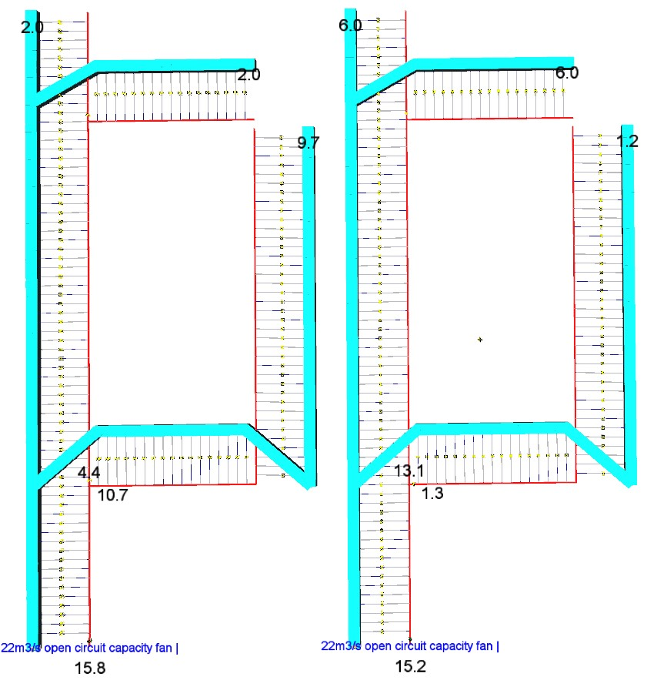

Roadways are in blue

Ducting is in red

Regulator location

Regulator location

Fan

Regulator location

Regulator location

Fan

Ducting rubbers

Figure 4.1 Flow distribution. Previous legislation Figure 4.2 Flow distribution new legislation flow requirements
Figure 4.1 above shows expected flows using the modelling criteria detailed above. As shown, there is 9.7m³/s of air available at the cutting face at the continuous miner just prior to holing when a total of 4m³/s is directed into the A Hdg overdrive and cut-through stub combined.
In Fig 4.2, where 6.0m³/s will be required at the two standing stubs according to the poorly planned legislative change it is impossible to ventilate the miner face and a second fan in the panel will definitely be required to comply with this legislation. The impact of a second fan is the sequential but most problematic issue surrounding this legislation and is discussed in Section 4.2 below.
Regardless of the actual driveage scenario or pillar length or the number of standing stubs that will be required to be ventilated the act of elevating these stub flows above the existing practical flows currently utilised in our industry will, in every circumstance, reduce available flows at the cutting head of the continuous miner. Reduced flows at the operating continuous miner means increased workplace dust, heat and gas contamination that Queensland coal mine workers will be exposed to during their whole working shifts on every day they are at work.

The Impact of a Second Development Fan to Ventilate the Panel
The above panel arrangement can be ventilated using a second development fan which is the usual arrangement in a super panel where twin continuous miners are operating. The author has modelled such a scenario which is shown in Fig 4.3 where the fan is shown located in the outbye cut-through in place of the usual location for the Deputies station/crib room which needs to be located a further one pillar length outbye of the last completed line of cut-throughs.
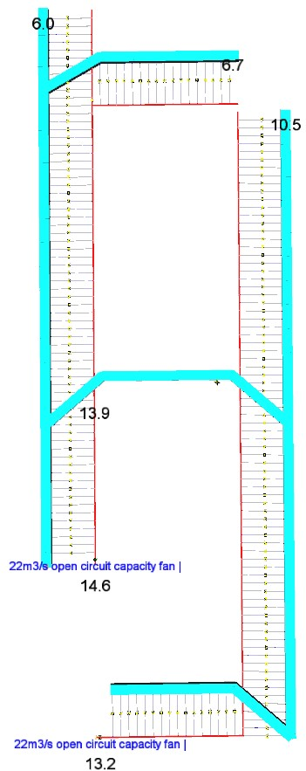
Figure 4.3 Twin fan arrangement due to altered requirements
Above, as you see, it is easily possible to ventilate the lone continuous miner and the standing stubs with two industry standard auxiliary fans. The problem this creates is that the requirement to satisfy Regulation 355, in relation to air in excess of fan open circuit capacity, means that the total panel ventilation requirement for a 22m³/s capacity auxiliary fan goes from 29m³/s at the last line of cut-throughs to 51m³/s at the same location, if the new legislation forces the use of the second 22m³/s fan in the panel.

What the Second Fan Means to the Panel Ventilation Capacity
The increased airflow requirement in the panel face area to legally run the second auxiliary fan greatly increases the pressure and ventilation flow required at the panel entry area out near the mains roadways. Such a demand will, without doubt, increase the risk of spontaneous combustion and will greatly increase the deposition rate and increase the size of the deposition zone of fine raw coal dust particles blown off the conveyor belt at the panel entry coffin stopping due to highly elevated pressures required there.
Further it will cause such coal dust to be blown into suspension over much longer distances meaning persons working or inspecting the return airways outbye this location will be subjected to greatly elevated levels of both inhalable and respirable dust and the deposition of explosive concentrations of coaldust will be spread over a much longer distance and be more difficult to adequately inertise with stonedust.

The author has modelled the effects of a last line flow of 29m³/s which can legally operate a 22m³/s auxiliary fan in the face area and then assembled a model with identical attributes but whereby 51m³/s will be required at the last line of cut-throughs to run a second equivalent auxiliary fan in the panel to satisfy the new legislative requirements.
You will note some panel performance data for both scenarios in Figures 4.4 and 4.5 which details panel entry flows and resultant pressures required to generate those flows.
For the sake of the panel performance example the author has specified the following assumptions which are again not dissimilar to most gateroad development units in existing Queensland Coal mines.
- Two heading gate road panel 3.5km in length with 17.2m² roadway dimensions.
- Combined stopping and double door resistance throughout the panel of 600Ns²/m⁸, which is around measured industry average.
- Belt road and travel road friction factors of 0.0135 and 0.0085Ns²/m⁴ respectively which is around measured industry average.

In Figure 4.4 you will note the panel entry flow inbye of the chute road intersection in the panel travel road of 40m³/s is required to deliver 29m³/s to the face area using the aforementioned model attributes.
In Figure 4.5, which is a close up of the panel entry area, you will note that a modelled pressure of 335Pa is required across the coal stream at the belt road coffin seal to generate these resultant flows which is normal, practicable and manageable.
The equivalent orifice area of the coffin stopping opening that will flow 10m³/s is 0.71m² which results in a flow velocity of air travelling across the coal stream of 14.1m/s. Whilst this is an excessive velocity due to the very nature of a coffin stopping, coal fines spillages are routinely well managed at such differential pressures and resultant velocities.
Figure 4.4 Modelled panel entry flow for single panel fan
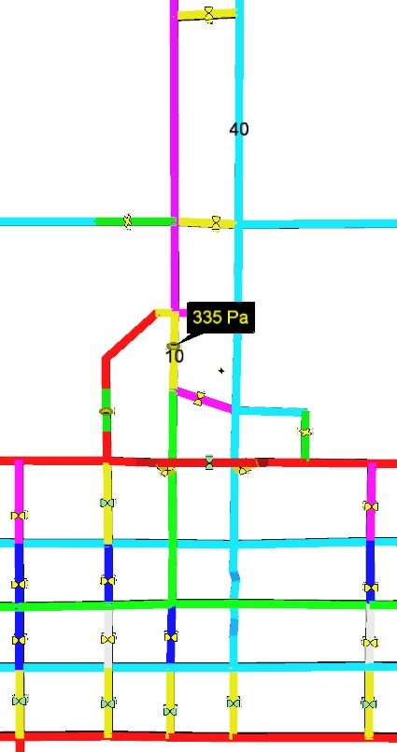
Figure 4.5 Modelled coffin pressure single panel fan
In Figure 4.6 you will note the greatly elevated panel entry flow inbye of the chute road intersection is now 70m³/s which is required to deliver the 51m³/s to the face area to run both auxiliary fans using the same aforementioned attributes.
In Figure 4.7, which is a close up of the panel entry area, you will note that a modelled pressure in excess of 1kPa is required across the coal stream at the belt road coffin seal to generate these much higher required flows bought about by this legislative change.
The equivalent orifice area of the coffin stopping opening that will flow 10m³/s under this greatly elevated pressure is 0.41m² which results in a flow velocity of air travelling across the coal stream of 24.4m/s. Such a velocity generated by a differential pressure of 1000Pa on a coffin stopping creates a major issue blowing huge quantities of coal fines off the belt and inundating the return roadways in both the panel dogleg and the main mine returns outbye this point and any this is no news to any experienced Mineworker, Deputy, Undermanager of Ventilation Officer.
It is ludicrous to insist that 1000Pa of ventilation pressure has to be applied across a coffin stopping to essentially ventilate a standing face stub within the production Deputies district given the increased risks such a law would place onto the operation with respect to spontaneous combustion and the deposition of roadway and airborne coal dust particles along with the substantial reduction in primary ventilation capacity and longevity that this inevitable situation would bring about.

Figure 4.6 Modelled panel entry flow for twin panel fans

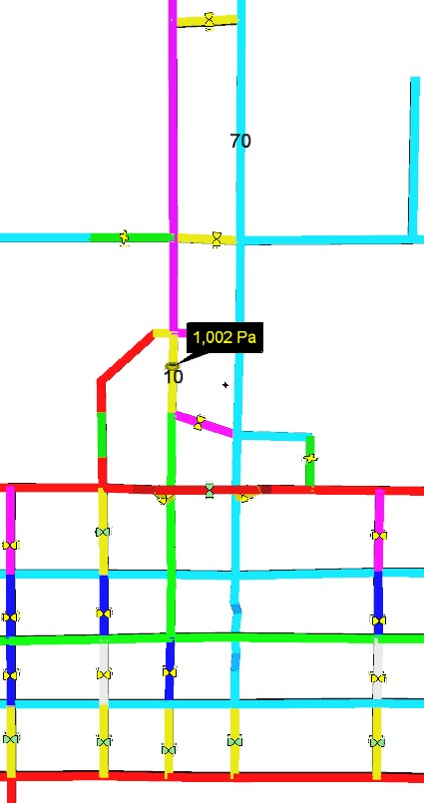
Figure 4.7 Modelled coffin pressure twin panel fan

What this Intended Change Means to Total Mine Ventilation Capacity
The above issue in 4.3 relating to excessive panel ventilation demands pales into insignificance when the impact on the total mine ventilation circuit is considered.

To highlight this the author has utilised a former real and validated whole of mine ventilation model from real mine “A” and set up the circuit for this example with an operating homotropal L/W and two long single continuous miner gateroad panels of 3.5km and 2.5km in length and the third continuous miner unit located in the 5 heading mains face area. The main fan data utilised is real as used at Mine “A” and all model attributes are as validated at that mine and in line with normal industry standards. Aside from the production areas the ventilation demand also includes mandatory ventilation of a pump/sump location and three crossdrives with 80m long brattice ventilated stubs as well as three belt chambers and three Z heading dog legs all of which will require a minimum flow velocity of 0.3m/s throughout their lengths under the intended legislative change. The combined effect of these new minimum demands in conjunction with the huge increase in ventilation flow within the panel area makes a wholesale difference to the whole of mine ventilation circuit performance and robs excess ventilation capacity from every operating continuous miner/longwall unit.

All existing Queensland mines have had their ventilation designs including shaft locations and main fan capacities specified according to the previous existing legislation and it is impractical and illogical to legislate such a significant step change in ventilation demand in the complete absence of any warning, consultation, discussion and with no evidence at all of any significant analysis on the part of the legislator on how this change will affect our ability to safely continue to ventilate our mines.

Base Case Using Existing Regulations
You will note the generic circuit is labelled and explained in Figure 4.8 and the key flows are as shown on the Figure. You will note Figure 4.9 identifies the main fan performance identified in this modelled scenario.

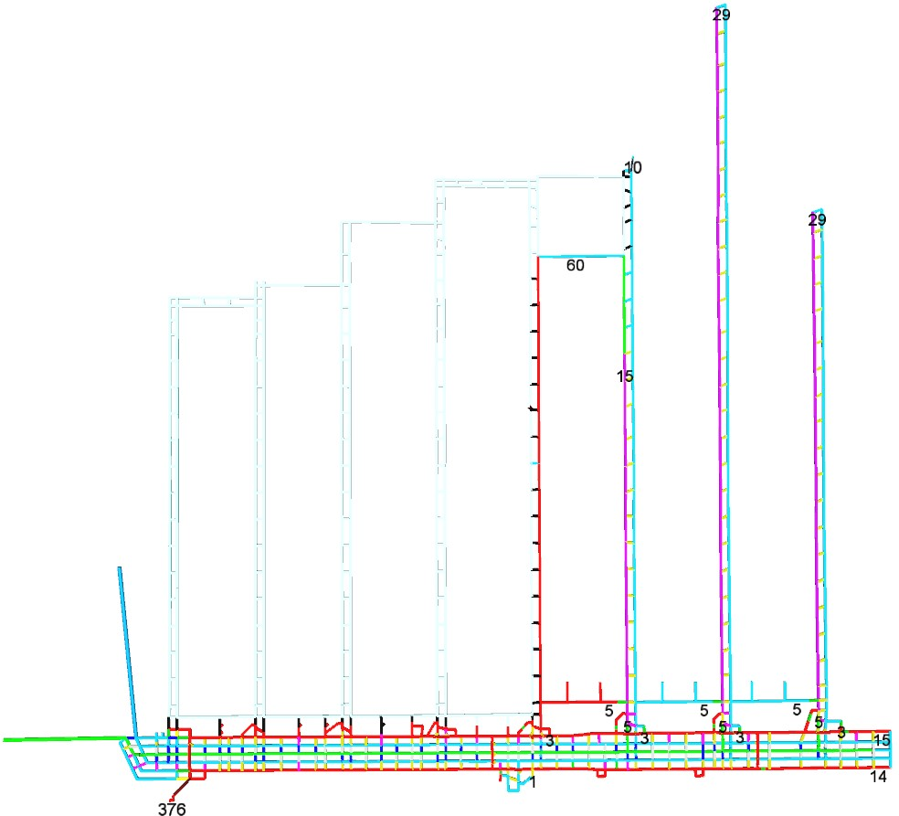

Pump/sump

Z Hdg doglegs

Belt chamber and
chute roads at
each panel

Single 22m
3
/s fan

Single 22m
3
/s fan

Single 22m
3
/s fan

Longwall operating

Back block intake

Inbye end of
homo belt road

Longwall is the unregulated split

Figure 4.8 Base case mine wide key flows using former legislative requirements
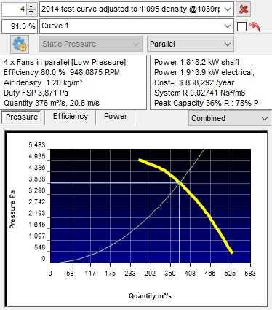
Figure 4.9 Base case main fan duty using former legislative requirements

You will note the parallel fan set is operating at 91.3% of full speed at nearly 3.9kPa pressure and flowing 376m³/s for an approximate electrical input power requirement of nearly 1.9MW to satisfy the mine wide flow requirements under the previous legislative requirements in this modelled example.

This is a practical, achievable and a realistic prediction of the mine ventilation load under the mine design depicted in Figure 4.8.

Base Case Compliant with New Intended Regulations
You will note the same circuit below but with flows compliant with the new legislation, including twin auxiliary fans in use in the 3 operating continuous miner units along with 6.0m³/s (0.3m/s velocity) minimum in all other locations which could normally be maintained compliant with respect to intolerant contaminations by assigning them reasonable but reduced flows. You will note the huge impact of ventilating the three chute roads given that the new legislation literally requires 0.3m/s velocity at the end of an 80m long brattice run at the end of the chute stub. It is doubtful such imposts were given any consideration when this regulatory change was considered. Figure 4.10 identifies the key flows around the mine under the assumption that the main fans could be wound up sufficiently to satisfy demand.
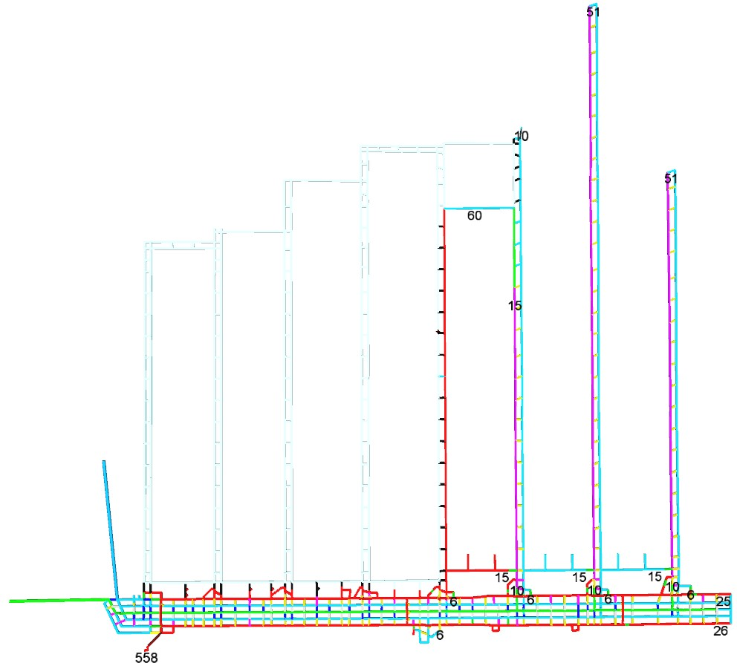
Increased flow to pumps/sump

Increased flow to Z Hdg doglegs

Twin 22m
3
/s fans

Twin 22m
3
/s fans

Longwall operating

Back block intake

Inbye end of
homo belt road

Long gate panel
is now the unregulated split

Increased mandatory flows to belt Twin 22m3/s fan
chamber and chute roads at each panel

Figure 4.10 New theoretical flows for the base case design under the new intended regulations
Figure 4.11 identifies the main fan performance that would be technically required to satisfy the required minewide flows using the increased flow requirements at the various locations.
The fan performance however to satisfy the mineplan with those flows is completely unassailable because the author has simply wound up the speed of the fan set in the model until all flows were satisfied. You will note below that to achieve these flow requirements the parallel fan set would have to operate at 136.5% of full speed and develop a ridiculous 8.76kPa for nearly 560m³/s flow and around 6.5MW of fan input power.

This represents an increase in mine ventilation performance criteria as shown below.
91.3% speed to 136.5% speed = increase of 50%
3.87kPa to 8.76kPa fan pressure = increase of 126%
376m3/s to 558m³/s shaft flow = increase of 48%
1914kW to 6430kW fan electrical input power = increase of 236%

The above numbers clearly demonstrate the inability of this mine design used in this example to be ventilated adequately under the altered requirements of the new legislation give the increased carbon footprint and the power bill that would result not to mention the excessive pressures generated everywhere around the mine in this example.

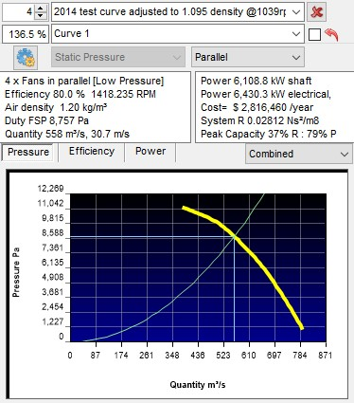
Figure 4.11 Base case theoretical main fan duty using new legislative requirements

Base Case at 100% Fan Speed with New Intended Regulations
The 50% increase in main fan speed as detailed above is totally unachievable and included to purely demonstrate demand that will never be possible to actually achieve in practice.
What would happen in reality is that the main fans would be wound up to 100% speed and the ventilation circuit adjusted to ventilate the panels in order of priority. Given that the altered regulations mandate the flow of 0.3m/s at otherwise exempted locations under the previous legislation the operation would have no choice but to turn off production units resulting in a loss of continuity and ongoing operational viability. Figure 4.12 identifies the key flows around the mine that would be possible with the fans running at 100% speed to highlight the magnitude of the difference that adherence to this new regulation 344 will create.
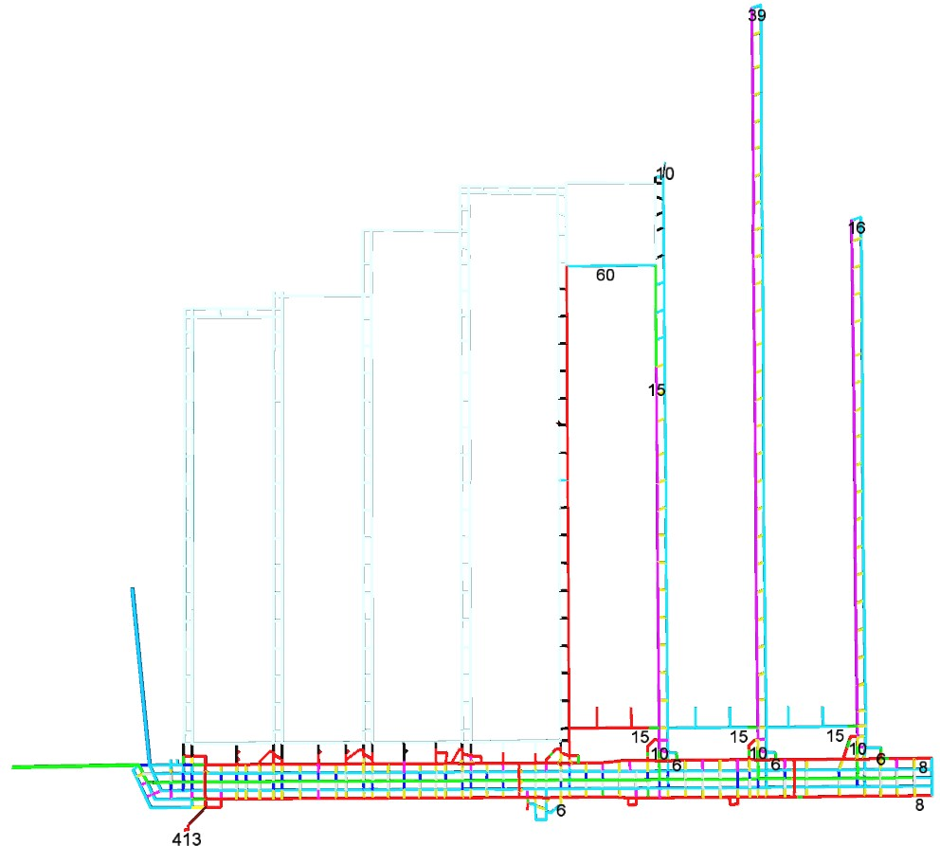
produce

Increased flow to pumps/sump

Increased flow to Z Hdg
doglegs

Increased mandatory flows to belt
chamber and chute roads at each panel

Longwall operating

Back block intake

Inbye end of
homo belt road

Insufficient airflow to
produce

Insufficient airflow to
Insufficient airflow to
produce

Figure 4.12 Minewide flows at 100% for the base case design under the new intended regulation

Figure 4.13 identifies the main fan performance that would be required to ventilate the mine according to the design in Figure 4.12 where the mine fans are running at full speed.
Obviously, the mine layout under the new intended regulations would be vastly different however at that time as there would not have been sufficient air to develop the gate roads to the locations shown on the Figure. The flows shown in the Figure merely represent the modelled capacity of the main fans running at full speed so flow capacity comparisons can be made by the reader, according to the modelled results.
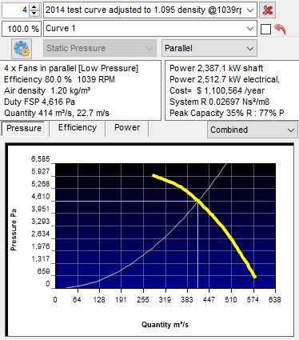
Figure 4.13 Base case main fan duty at 100% speed using new intended legislative requirements

Summarily if these regulations stay enacted, and enforced according to the new legislation as written, our mines will lose the ability to deliver excess air capacity to places of choice because of the necessity to deliver higher flow quantities than they may currently choose to adopt to not only standing places in the panel areas but around the mine generally.

It would be a travesty of justice if that resulted in faceworkers in gassy, hot and dusty regimes having to settle for lower dilution capacities that they currently have available to them because changes to the legislation didn’t utilise industry accepted methods to properly assess and manage the consequences of such change.

A Sense of Déjà Vu
If you, the reader, thinks the author is overstating the possible consequences of such a change then it should be noted that a similar adjustment has been attempted previously but was fortunately circumvented before it could become law.
This involved the intended change to minimum flow requirements in NSW in 2014 which is worthy of reiteration here given the similarity of the intended change here in Queensland.
Below the author has included the Section pertaining to the intended change that was published in the draft document entitled “Draft-WHS-Mines-Reg-2014 public copy” as shown in Figure 5.1 which was released for public comment and review in early to mid-2014.
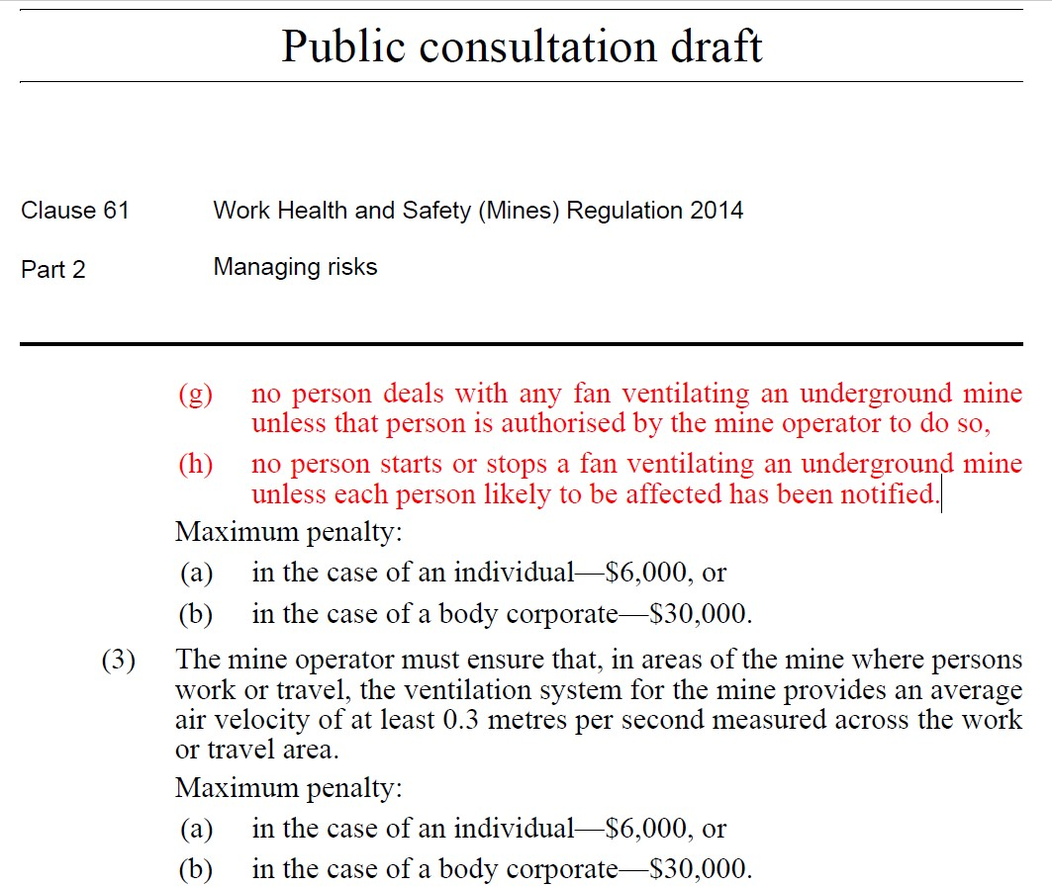

Figure
5
.
1

NSW Intended regulatory change

It is a matter of history now that the NSW regulators were convinced to remove this ridiculous requirement after the feedback was completed during the public consultation process. There was considerable argument against the inclusion which likely included:
- The inability for any site to ever comply with a mine wide velocity minimum of 0.3m/s.
- The inability to carry out a ventilation change underground without breaking this regulation given that airflows stagnate or reverse during most ventilation changes.
- The inability to test surface access doors that might result in a flow velocity non-compliance and so on.

In Figure 5.2 below you will note the results of a word search within the whole final document “2014-WH&S Regulation” whereby any reference to 0.3 anywhere in the final regulations was removed due to the number of objective criticisms received in regard to this planned inclusion.

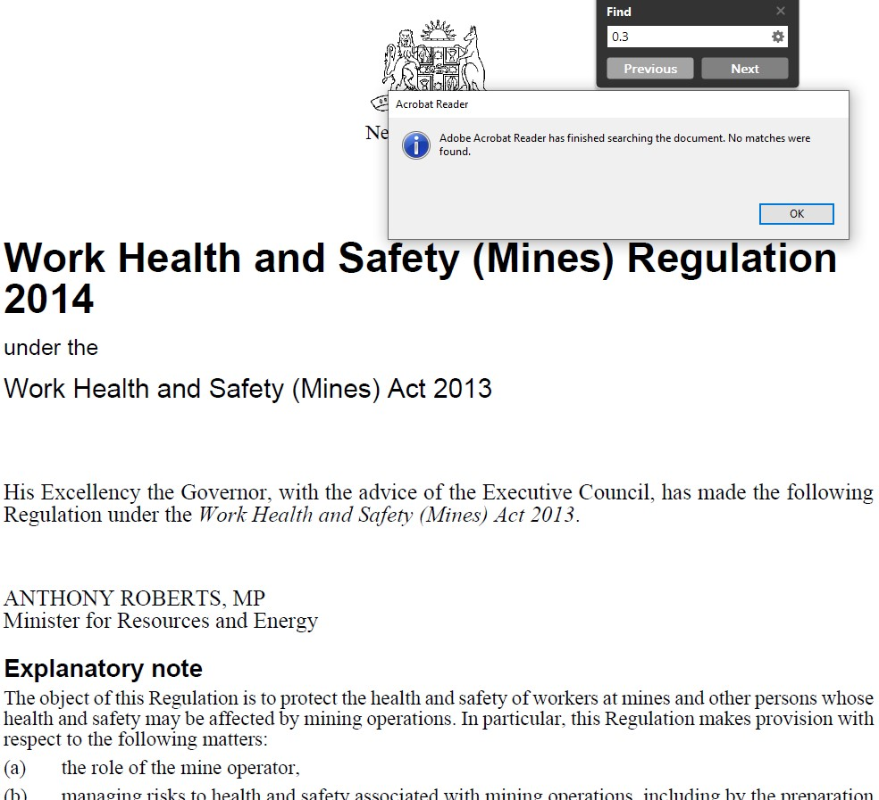
Figure 5.2 Search result for 0.3m/s in NSW final regulations

In place of the 0.3m/s initial requirement for minimum velocity the NSW regulators replaced this with Section 59(3) which is a requirement to supply a minimum of 1m³/s to all places where men work or travel into the final approved regulations which you will note highlighted below in Figure 5.3.

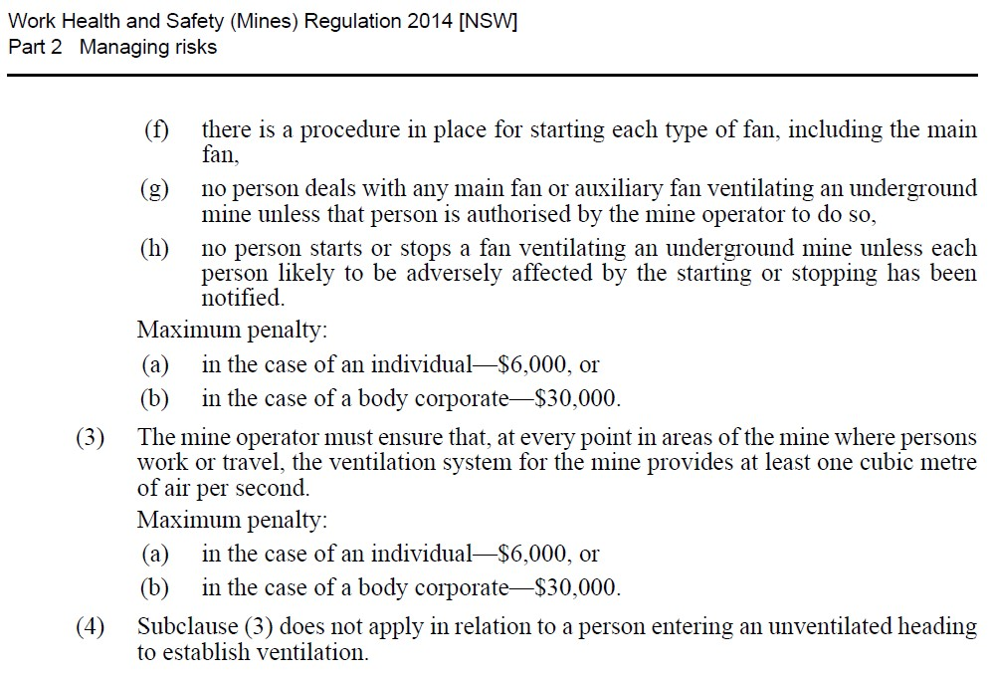

Figure 5.3 Final regulatory requirement in NSW 2014 regulations

The author has been a licensed auditor to audit ventilation systems in NSW coal mines since 2007. It must be noted that in the six years that the author has been performing annual audits of ventilation systems, pursuant to the 2014 inclusion of the 1m³/s minimum into the NSW regulations, that not one solitary mine site has complied with this requirement and it is likely no mine ever will. We don’t even have a suitable accepted method to actually and accurately measure 1m³/s of airflow or even 0.3m/s of air velocity anyway which substantiates the absolute impracticality of either of these blanket requirements.

If NSW can’t comply with 1m³/s it is hardly likely Queensland operations will be able to comply with around 5 to 6 times this flow even with the last-minute curious exclusion of mine cut-throughs in these legislated Queensland amendments.

In the authors opinion the fact that cut-throughs can be excluded is an admission that somehow a mine cutthrough (magically) has less chance of becoming gassed out or hot or dusty or otherwise contaminated in the absence of this minimum ventilation requirement than all other mine roadways that don’t fit the definition of being a cut-through. This admission is bizarre at best!! It really has been poorly thought out and much embarrassment and consternation may have been saved if formal feedback processes had been adopted in the first instance here in Queensland as they rightly were in NSW around 6 years ago. A quick word to the regulators in NSW might have been a prudent first step before Regulation 344 was rewritten as it has been in Queensland, even if you didn’t think industry personnel in general were worth talking to.

Conclusions and Recommendations.
The author is just lost for words to properly summarise this whole debacle.

In his opinion the whole change process should be completely overhauled from scratch with a suitable consultation and review period so as to improve the chances of actually getting these amendments close to right. We, as an industry, have extensive collective knowledge in Queensland and we have learnt to utilise proven and accepted risk management principles arguably better than the rest of the coal industry worldwide. We demand the right to be involved in properly assessing planned changes, using our combined resource base, to ensure we don’t elevate risks in what should be an extensive and properly executed management of change process.
This changed legislation has quite simply been a rushed and poorly executed decree and the coalminers of Queensland deserve a much more robust process that will enhance their safety, as is their right.

If you have any questions or wish to discuss the contents of this document, please do not hesitate to contact the author at any time.
11 January 2020.
John Rowland
Director, Dallas Mining Services Pty Ltd.
Phone: +61407283510
Email: jr@dallasmining.com.au

