NORTH GOONYELLA COAL MINE
8 North Sealing Management Plan

July 2016

Owner | Signed | Position | Date
David Craft |  | Ventilation Officer
Countersigned by | Signed | Position | Date
Marek Romanski |  | Underground Mine Manager

TABLE OF CONTENTS
TABLE OF CONTENTS .......................................................................................................................... 2 LIST OF FIGURES ....................................................................................................................................... 4
- Purpose .......................................................................................................................................... 5
- Scope ............................................................................................................................................. 5
- Compliance ..................................................................................................................................... 6
- Definitions ....................................................................................................................................... 6
- Area of Mine to be Sealed (ref CMSHR s326, 2c) ...................................................................... 8
- Proposed Location of Seals (ref CMSHR s326, 2b) ....................................................................... 9
  - Ventilation arrangments ........................................................................................................ 13
- Evidence of Ignition Sources Present (ref CMSHR s326, 2d) ..................................................... 15
- Prediction of Gas Accumulation Rates (ref CMSHR s326, 2e) .................................................... 17
- Gas Monitoring Procedure (ref CMSHR s326, 2f) ........................................................................ 22
  - Objective ..................................................................................................................................... 22
  - Location and Frequency of Monitoring ....................................................................................... 22
  - Alarm Review and Communication ............................................................................................ 24
- Sealing Procedure (ref CMSHR s326, 2a) ................................................................................... 25
  - Final sealing stage - procedure to close the MG 2c/t ‘hatch’ and complete the seal ............ 26
- Sealing Crew ................................................................................................................................ 26
- Roles & Responsibilities ............................................................................................................... 28
  - Critical Actions....................................................................................................................... 28
  - Site Senior Executive (SSE) ..................................................................................................... 28
  - Underground Mine Manager (UMM) ......................................................................................... 28
  - Shift Coordinator (SC) .............................................................................................................. 29
  - Ventilation Officer (VO) ............................................................................................................. 29
  - Control Room Operator (CRO) ................................................................................................. 29
  - ERZ Controller (ERZ) ............................................................................................................... 29
  - Coal Mine Workers (CMW) ....................................................................................................... 29
- Conformance/Audit Criteria .......................................................................................................... 30
- Review Criteria ............................................................................................................................. 30
- References ................................................................................................................................... 31
- Appendices ................................................................................................................................... 31

LIST OF FIGURES
Figure 1 - Area of the mine to be sealed ................................................................................................. 8
Figure 2 – 8N LW recovery surface topographic contour plan ............................................................... 9
Figure 3 - Location and installation sequence of final seals ................................................................. 10
Figure 4 - Seal installation sequence vs support recovery ................................................................... 12
Figure 5 - Example of a final seal hatch ................................................................................................ 12
Figure 6 - Bulkhead seal design ........................................................................................................... 13
Figure 7 - Ventilation arrangements during bolt-up & initial support recovery ...................................... 14
Figure 8 - Ventilation arrangements during support recovery (mid face) ............................................. 14
Figure 9 - Ventilation arrangements for 9N LW production .................................................................. 15
Figure 10 - Lightning Strike Density (AS/NZS 1768:2007 Lightning Protection) .................................. 16
Figure 11 - Metconnect live lightning data tracking system .................................................................. 17
Figure 12 - Tube bundle monitoring from the adjacent 7N goaf ........................................................... 18
Figure 13 - Predicted accumulation of gases within the sealed area ................................................... 21
Figure 14 – Ellicott’s diagram (trend) during the sealing process ......................................................... 21
Figure 15 - TG ‘purging’ seal................................................................................................................. 22
Figure 16 – Inertisation system & tube bundle sample locations.......................................................... 23
Figure 17 - TARP activation flow chart ................................................................................................. 24

1. PURPOSE
The purpose of this Standard Operating Procedure is to provide clear guidelines for the safe and effective sealing of the 8 North longwall block, whilst achieving an acceptable level of risk that is as low as reasonably achievable

2. SCOPE
This Management Plan applies to all underground activities at North Goonyella Coal Mine with reference to Coal Mining Safety and Health Regulation 2001 section 326. It applies equally to all coal mine workers, permanent, temporary and contract employees. Activities associated with carrying out the requirements of this Management Plan are in accordance with the CMSHR 2001 s 326 and the approved standard for the monitoring of sealed areas (Recognised Standard 09). These activities have been subject to risk assessment (NG-TSE-RSK-VO007 8N LW Sealing Operations Risk
Assessment) and include the following matters;
- The risk management process that was used to develop this Management Plan
- The area of the mine to be sealed and the proposed seal locations
- The proposed sequence of seal construction for the final seals
- Any evidence of ignition sources being present in the area to be sealed
- The predicted rate at which gases will accumulate in the sealed area
- The gas monitoring procedures to be carried out before, during and after the sealing
- The method of inertisation of the sealed area
- The final sealing process, which includes purging and closing of the final hatch • The roles and responsibilities

The area of the mine to be sealed involves a total of six (6) final seals that will have a type “D” rating as per schedule 4 of CMSHR. All other installed seals around the perimeter of the 8 North longwall block are a type “C” rated seal.
Normal mine operations are planned to continue during the sealing operation with environmental monitoring, procedures and trigger action response plans (TARP) in place.

3. COMPLIANCE
This document forms part of NGC Operations' Safety and Health Management System. In accordance with section 39 of the CMSHA, coal mine workers and other persons have a statutory obligation to comply with this document.
This procedure complies with Seal Management Plan submission requirements under CMSHR section 326 and Recognised Standard 9 for Monitoring of Seal Areas.
A Workplace Risk Assessment and Control (WRAC) for the 8N Sealing Operations (NG-TSE-RSKVO007) was conducted on 31/3/16 in accordance with Recognised Standard – 02 Control of risk management practices and Peabody Energy standards. In summary;
- A representative cross-section of the affected coal mine workers were involved in the hazard identification and control process, including personnel involved in carrying out the proposed tasks
- The proposed controls have been deemed appropriate to provide an acceptable level of risk
- No hazards identified were deemed unquantifiable
- No non-consensus issues were raised during the risk assessment
The scope of the risk assessment encompassed all aspects of the sealing operations of the 8N LW block including VCD construction for sealing, purging the goaf area to reduce the oxygen content and develop a fuel rich atmosphere and the closing of the final seal ‘hatches’.

 | 4. DEFINITIONS
NGC: |  | North Goonyella Coal Mine
CMSHA: |  | Coal Mining Safety and Health Act 1999
CMSHR: |  | Coal Mining Safety and Health Regulation 2001
SHMS: |  | Safety & Health Management System (a documented system that incorporates risk management elements and practices that ensure safety and health of persons who may be affected by coal mining operations)

DAS: | The North Goonyella Document Access System
Coal Mine Worker: | An individual who carries out work at a coal mine and includes the following individuals who carry out work at a coal mine:  An employee of the coal mine operator;  A contractor or employee of a contractor.
Shall: | Indicates that a statement is mandatory
Should: | Indicates a recommendation
SOP: | Standard Operating Procedure
SWP: | Standard Work Procedure
JSEA: | Job Safety Environmental Analysis
SSE: | Senior Site Executive
UMM: | Underground Mine Manager
VO: | Ventilation Officer
Competent Person: | A person who has the necessary training, skills and capability to carry out the task.
Authorised Person: | A competent person who has been authorised by a person with an obligation to appoint a competent person under the CMSHA or SHMS.
Type C Seal | A ventilation control device capable of withstanding an overpressure of 140kPa
Type D Seal | A ventilation control device capable of withstanding an overpressure of 345kPa
Ventilated Roadway (TARP025) | Underground workings that are accessible to coal mine workers and positively ventilated with an acceptable and safe atmosphere.
Longwall Production (TARP019) | Spontaneous Combustion based trigger action response plan used during the production phase of the longwall
Transition to Final Sealing (TARP036) | When a ‘barrier to prevent oxygen flow into the sealed area’ occurs. This is to be enacted once the MG 2c/t seal hatch has been closed. At this point, the TG A hdg 1-2c/t purging hatch will remain open to ensure oxygen is purged from the sealing area.
Sealed Area (TARP007) | The sealing area has been below 8% Oxygen for 5 consecutive days and the final sealing of the purging hatch has occurred.

5. AREA OF MINE TO BE SEALED (REF CMSHR S326, 2C)
The area of the mine to be sealed is the 8 North LW block as shown in Figure 1 below. This area does not include the 8N bleeder roadway, 8N MG B hdg (future 9N LW TG airway) or the Mains B hdg return roadway. There are six (6) final seals to be installed to seal this area following the extraction of the longwall to 8N MG 2c/t (0m chainage).
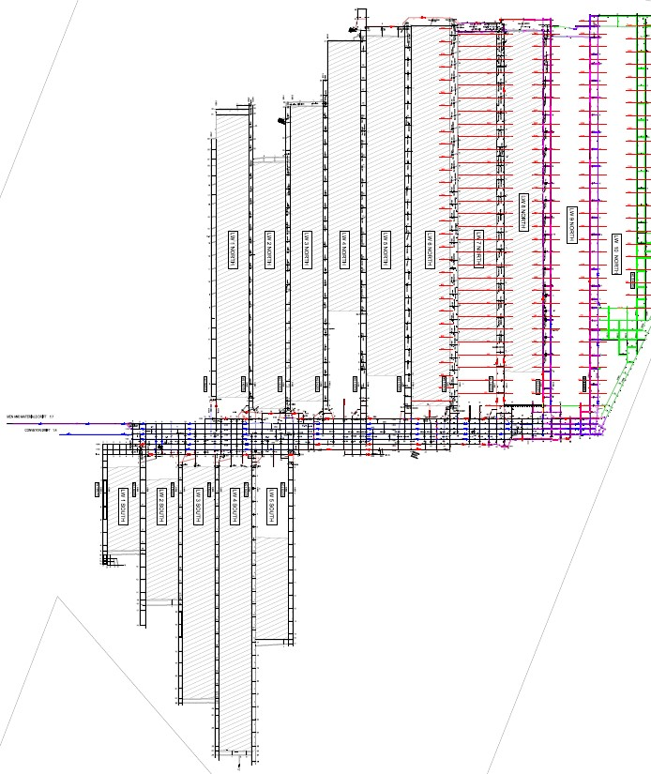

Area to
be sealed

Figure 1 - Area of the mine to be sealed

All boreholes within the area to be sealed with be cemented and capped in accordance with North Goonyella site standards (NG-TSE-PRO-SG-007-Plug and grout of historical holes) at the completion of the final sealing stage and when the sealed area reverts from the proposed sealing transition TARP to the ‘sealed goaf’ TARP status. Prior to this, it is proposed that one (1) borehole, strategically placed to maximise effectiveness, will be left available (capped) for surface to seam inertisation injection during the purging process.
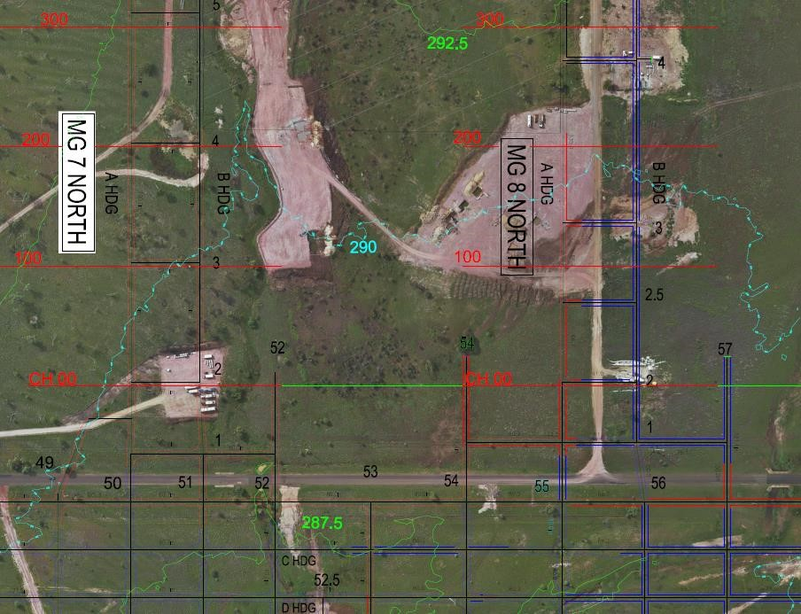
Figure 2 – 8N LW recovery surface topographic contour plan

6. PROPOSED LOCATION OF SEALS (REF CMSHR S326, 2B)
There will be six (6) final seals to be located at the following locations, as illustrated by Figure 3 - Location and installation sequence of final seals;
- TG A hdg 1-2c/t (with purging hatch)
- TG B hdg 1-2c/t
- TG chute road
- MG A hdg 1-2c/t
- MG chute road
- MG 2c/t (with hatch)

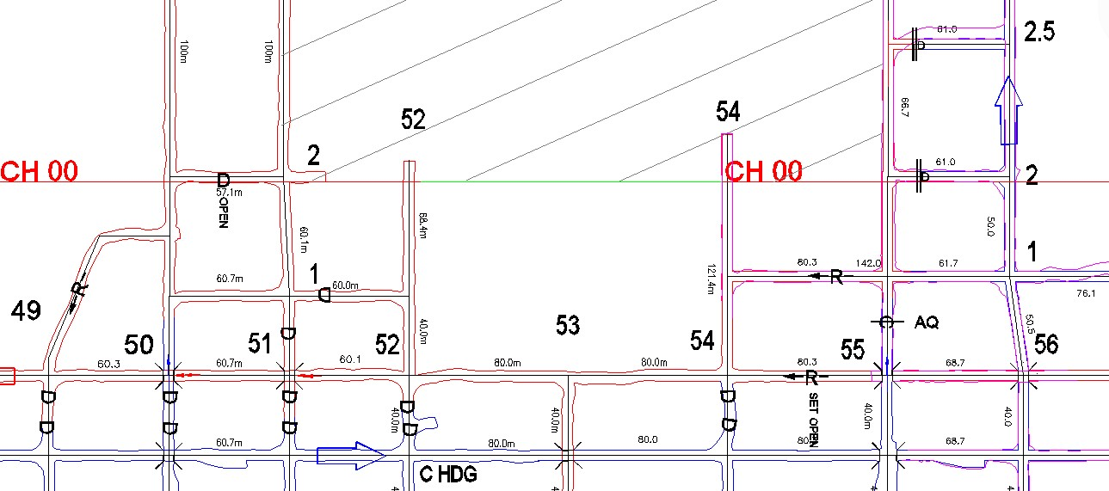

1

2

3

4

5

6

A (TG)

B

)
TG
(

A (M
G)

B

(
M
G)

Figure 3 - Location and installation sequence of final seals
All final seals will have a certified design rating of 345kPa (type “D” seals) with a factor of safety of 3. The seal design has an incorporated dam wall on both sides of the seal to assist with water management and seals 2 to 5 (see Figure 3 - Location and installation sequence of final seals) will have a (flexible VCD) pressure balancing chamber on the goaf side of the seal. Seals 1 and 6 will have a 1.0 x 1.0 square hatch to facilitate purging (seal 1) and air ingress regulation (seal 6).
Each of the final seals will have inertisation capability and tube bundle monitoring. The inertisation process will be administered by the site floxal (nitrogen) generator with a capacity of 2000m³/hr. A standby smaller unit (400m³/hr) will also be available to supplement the flow capacity of the larger unit. This smaller unit will be directed to the chute and tailgate seals, leaving the larger capacity inert gas floxal unit to inject a majority of the flow into the goaf from the maingate side seals.

1. TG A hdg 1-2c/t (with purging hatch)
During the bolt-up phase of the longwall recovery, the first of the final seals will commence in the TG A hdg 1-2c/t. This seal will have a 1.0m x 1.0m square hatch installed on the left hand side (looking inbye towards the goaf) which will enable some airflow to be maintained through 2c/t during the initial stage of the TG drive and support recovery.
A brattice wing will be installed to enable safe access to the purging hatch to conduct inspections and to complete the final sealing, including the closing of the hatch in accordance with the final sealing procedure.
The hatch will have two (2) doors, including an internal door that can be closed from outside the hatch on the intake side of the discharge. The outer door will have a mesh fence in place that can be locked across the opening of the hatch to prevent any inadvertent access during purging operations.

2. TG B hdg 1-2c/t
The second seal to be constructed will be the TG B hdg 1-2c/t seal. This seal will have a preinstalled flexi stopping to form the pressure balancing chamber at this location. Once the TG drive and other planned equipment is recovered via the TG roadway, the standing support and flexi stopping will be pre-installed to enable rapid initial goaf separation to protect the ventilation crew from the goaf gas while constructing the 50psi seal. This flexi stopping and the remainder of the seal will be completed once the support recovery is at the TG chute road, where the recovery face return airway will be via the TG chute.

3. TG chute road
The next seal to be constructed will be the TG chute road seal. The construction of this seal will be the same as the TG B hdg 1-2c/t seal with a pressure balancing chamber installed. The preparatory work for this seal will be the standing support and pre-installed flexi stopping. These will be in place prior to the longwall support recovery passing the TG chute road.
At this stage the main recovery return airway will be via the TG chute road and the purging seal (TG A hdg 1-2c/t).
The blocking of this (TG chute road) airway will be affected as soon as the support recovery passes the MG chute road.

4. MG A hdg 1-2c/t
The fourth of the final seals to be installed will be the MG A hdg 1-2c/t seal following the recovery of the BSL and monorail infrastructure. The trigger for the commencement of this seal will be after the MG belt rd equipment is removed and is planned to occur sequentially following seal 3 at the TG chute road. This seal site will be ventilated from the panel intake air (anti-tropal arrangement) via the belt road across the face and returning via the MG chute.

5. MG chute road
The MG chute road will be used for return ventilation from the recovery face for the final sequence of the support removal from the MG chute to the MG. As such, the trigger for both seals 5 and 6 will be the recovery of all remaining equipment.
The MG chute road seal will also have a pressure balancing chamber with pre-installed flexi stopping. All seal sites will have a wide side brattice wing installed to the seal site to enable the initial flexi stopping to be installed safely before continuing with the rest of the seal.

6. MG 2c/t (with hatch)
Similar to seal no. 5, the MG 2c/t seal will only be installed after the last of the longwall equipment has been recovered. It is planned to have two (2) ventilation crews working simultaneously on seals 5 and 6 at this point.
The MG 2c/t seal will not have a pressure balancing chamber, rather a chamber to control the flow of intake air through the area to be sealed during the transition period to final sealing when this hatch will be closed and purging via the TG A hdg 1-2c/t seal (seal no. 1) will continue until a stable monitoring trend below 8% oxygen in the sealed area has been established.
The floxal inertisation delivery will be available to each of the final seals, however due to the differential pressure profile across the goaf (towards the TG purging seal) the majority of the floxal injection will be via this seal (no. 6).

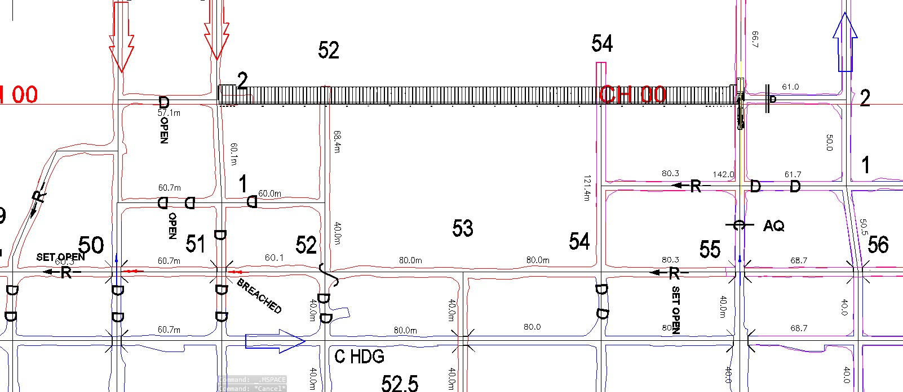

T
G
-
#120
(8
days
)

#120
-
#40

(
14

days)

#40
-
MG

(8
days
)

1

2

3

5

4

6

Figure 4 - Seal installation sequence vs support recovery
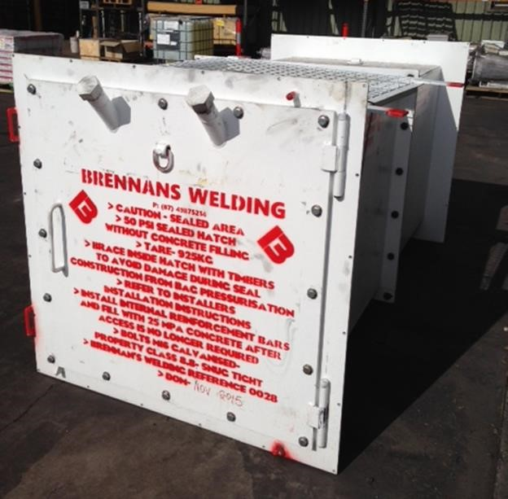

Figure 5 - Example of a final seal hatch

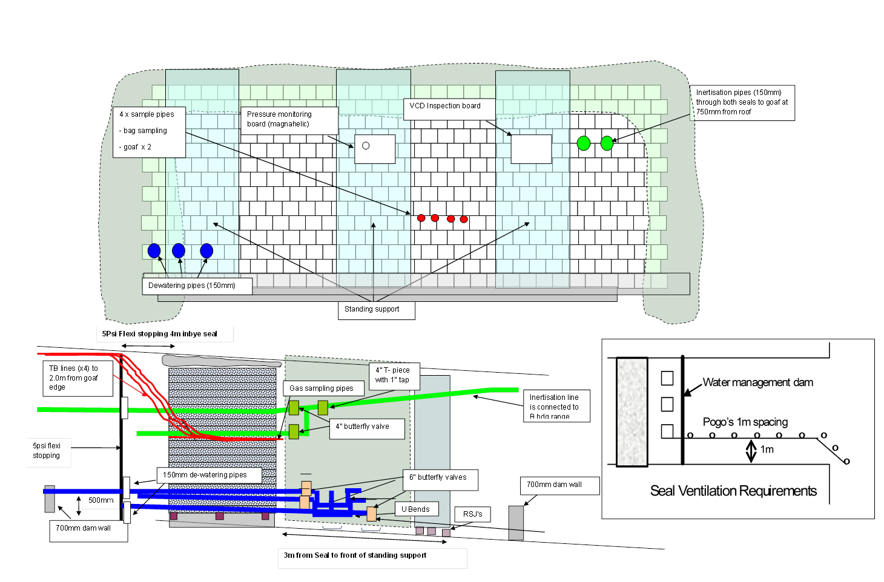
Figure 6 - Bulkhead seal design

6.1 VENTILATION ARRANGMENTS
The ventilation arrangements during the sealing operations have been illustrated in three key stages as follows;
- Bolt-up & initial support recovery
- Support recovery from mid face
- Ready for 9N longwall production
Should the ventilation path through the longwall face (return side of the recovery E-frame) become restricted during the support recovery process, an auxillary fan will be utilised to ventilate the recovery face. This will be determined by the Ventilation Officer (VO) and Underground Mine Manager (UMM) based upon the air quantity available and will be either a forcing ventilation system or extracting system with the auxillary fan set-up in the 8N MG travelling road (B hdg) inbye of the last open cutthrough.
During the bolt-up and support recovery (from TG to MG) phases, the mains B hdg will be placed on a regulated intake to provide easier access to remove the supports and positively ventilate the seal sites.

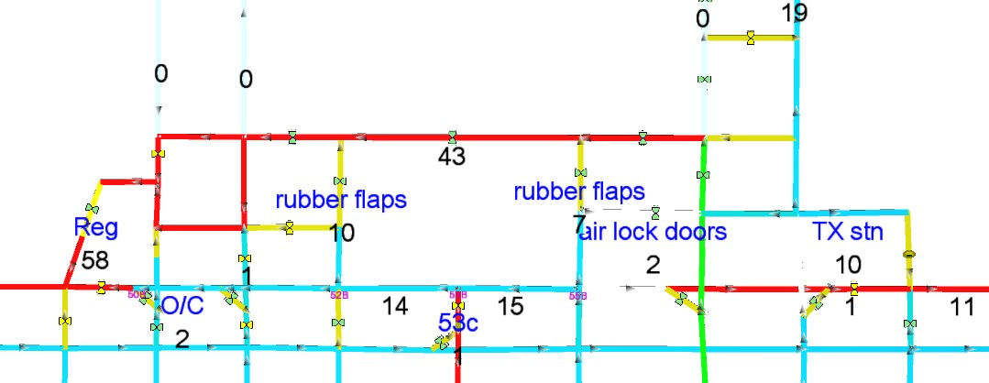

Figure 7 - Ventilation arrangements during bolt-up & initial support recovery

During the mid-face support recovery phase, the TG chute road will be used as the face return airway. The flexi stopping will be pre-installed to the roof and a brattice wing installed to the seal site from the 52c/t (1c/t) intersection.
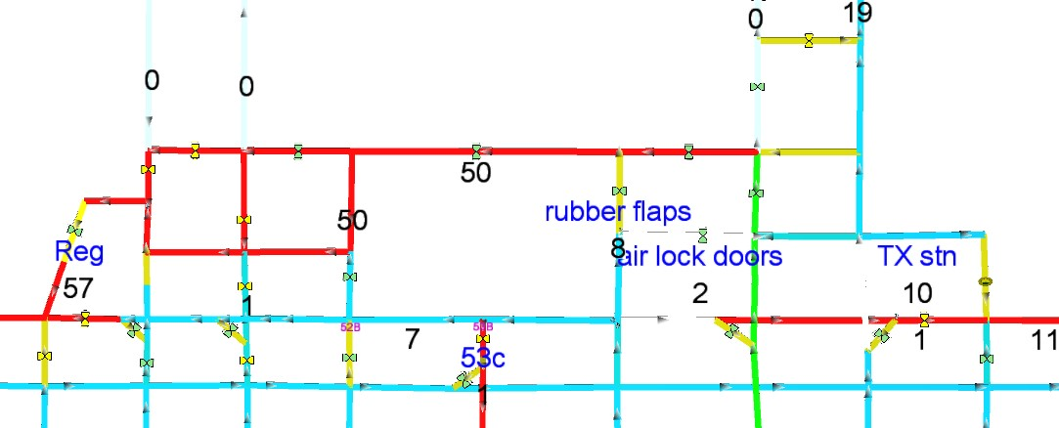

Figure 8 - Ventilation arrangements during support recovery (mid face)

Towards the completion of the support recovery, the mains B hdg will revert to a main return and a set of 9N TG entry machine doors will be installed in preparation for establishing a ventilation circuit for 9N LW production. This ventilation change will be made after the final sealing stage has been enacted.
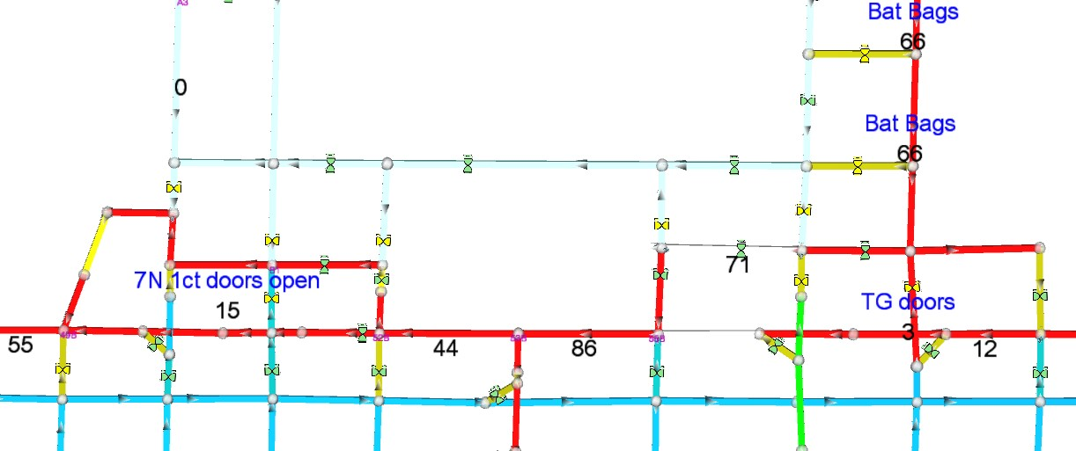
Figure 9 - Ventilation arrangements for 9N LW production

7. EVIDENCE OF IGNITION SOURCES PRESENT (REF CMSHR S326, 2D)
There are no anticipated ignition sources within the proposed sealing area:
- NGCM has no documented instances of frictional ignition occurring in over 22 years of mining operations. Additionally, a study of roof strata by James Cook University (2003) indicated strata with included incendive materials were not common. Furthermore, the quartz content of the immediate strata is typically less than 30% and does not contain pyrites.
- The area to be sealed will be stonedusted during the final stages of production in accordance with MIN-SOP-300 Stonedust Application and Sampling and prior to sealing will have additional stonedust applied (>85% incombustible content) and be signed-off in the Sealing Checklist.
- The seal sites are cleared of any cables that could act as a conductor.
- The ERZ Controller will complete a final seal VCD checklist immediately prior to seal-up and will ensure all electrical services, plant and equipment are withdrawn from the area to be sealed.
- All surface boreholes have been cemented with the conductive casing cut below ground level and backfilled in accordance with site procedures.
- Spontaneous combustion was also considered as an ignition source, however with the seal closure sequence, inertisation, low adiabatic self-heat index value and with the 8N TG gas analysis and trending, the risk was considered to be low. The atmosphere monitoring regime
in the sealing area has been installed to detect abnormal levels of oxidisation that could lead to a spontaneous combustion event. These seals will become part of the monthly bag sample regime once they are completed and stable monitoring has been achieved.
- North Goonyella mine lease area is considered at low potential for lightning strike with 2-3 strikes per km² per year as shown in Figure 11.
- The Control Room Operator monitors the Bureau of Meteorology alerts identifying weather events in localised areas. In addition to the forecast, live lightning activity can also be tracked with live data and nominated proximities being referenced to site by the Metconnect interface that was installed in January, 2016 and aligned to the TARP. The surface goaf stack operator reports any lightning or thunder to the CRO so TARP028 Lightning Event can be followed. This TARP makes provision for the ceasing of all sealing activities in the event of any trigger being activated (level 1 or above).
- The final sealing and inertisation procedure will only proceed with no expected storm activity within 48 hrs prior (as per checklist).
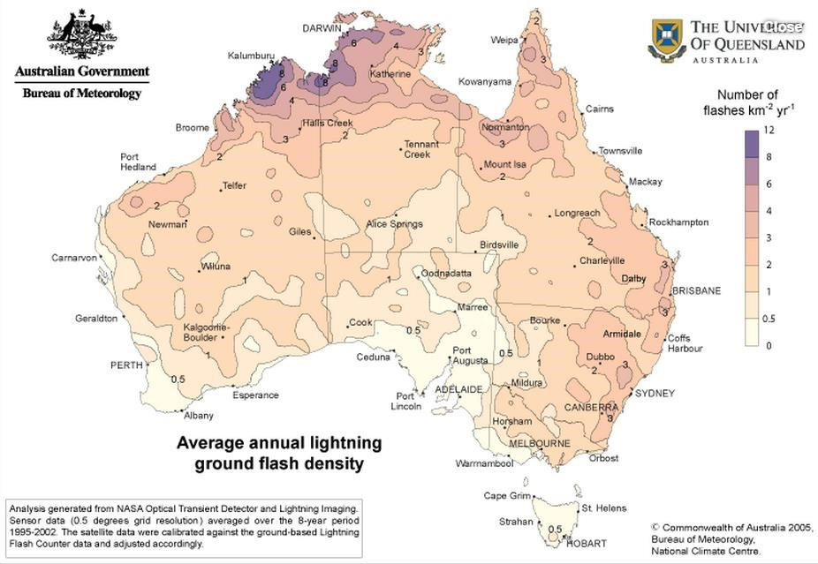

Figure 10 - Lightning Strike Density (AS/NZS 1768:2007 Lightning Protection)

Figure 11 - Metconnect live lightning data tracking system

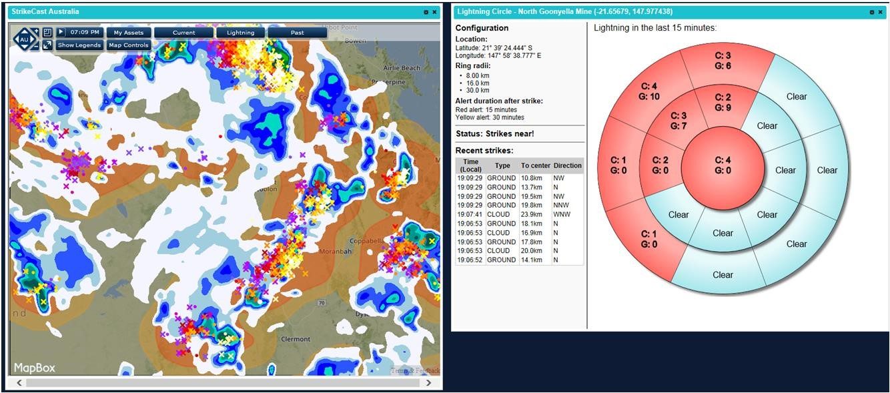
8. PREDICTION OF GAS ACCUMULATION RATES (REF CMSHR
S326, 2E)
The adjacent 7 North goaf environment, as evidenced by tube bundle monitoring is clearly fuel rich with greater than 40% methane and less than 1% oxygen being present. A recent tube bundle monitoring graph can be seen below.
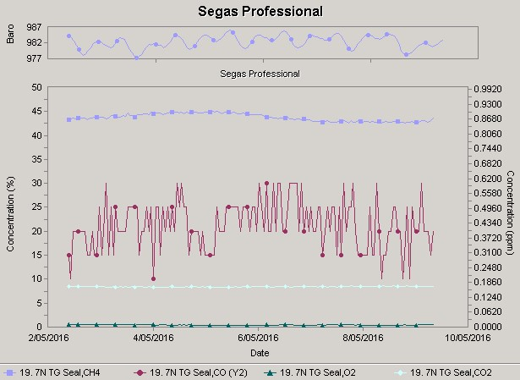

Figure 12 - Tube bundle monitoring from the adjacent 7N goaf

The current 8N longwall tailgate environmental analysis is shown in the following graphs of various trends during production in the lead-up to the sealing of the longwall. These sample points have been recorded from bag samples taken in the tailgate between 28.2.16 and 10.5.16.

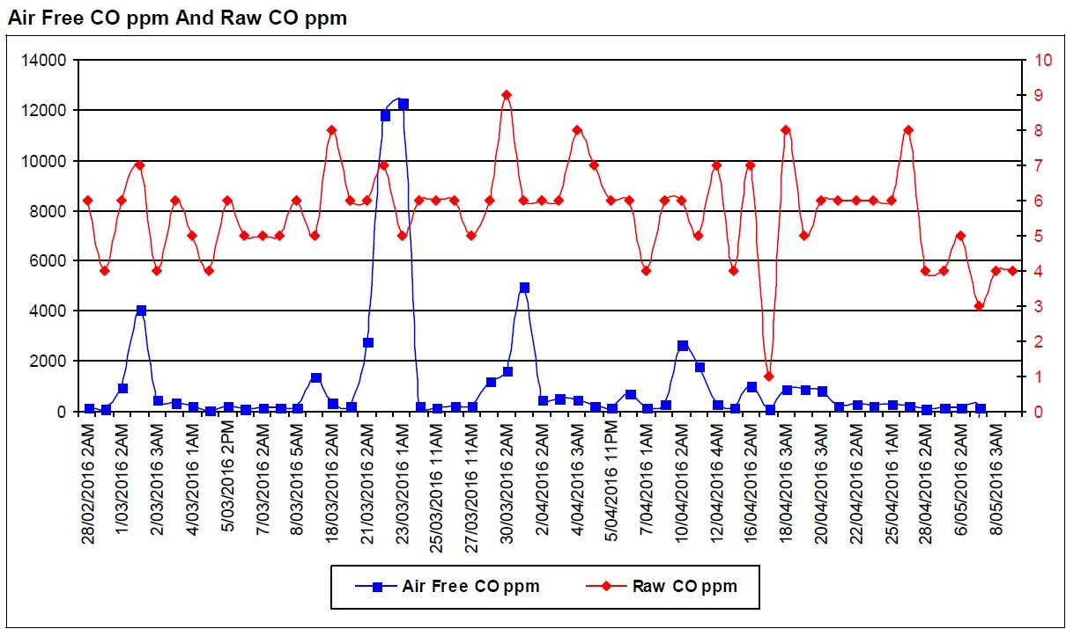

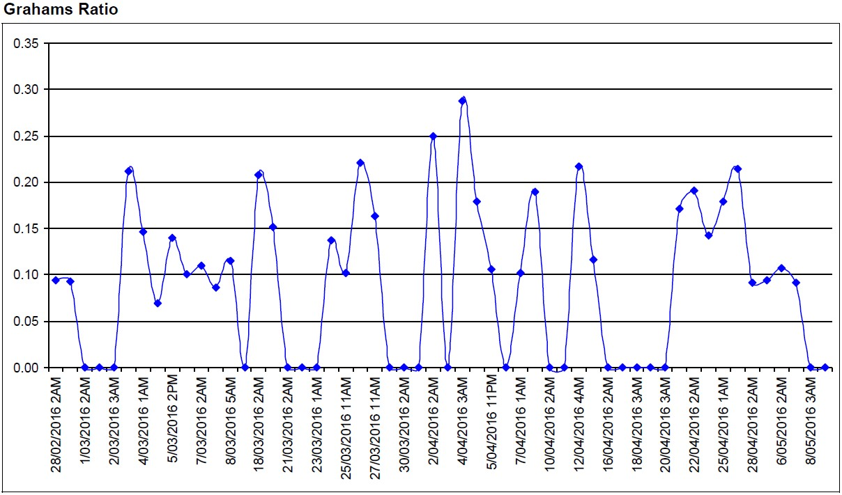

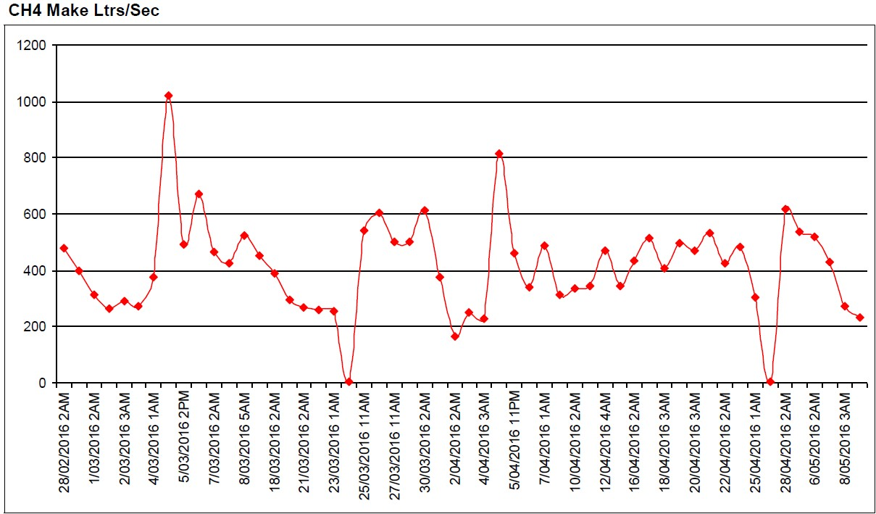

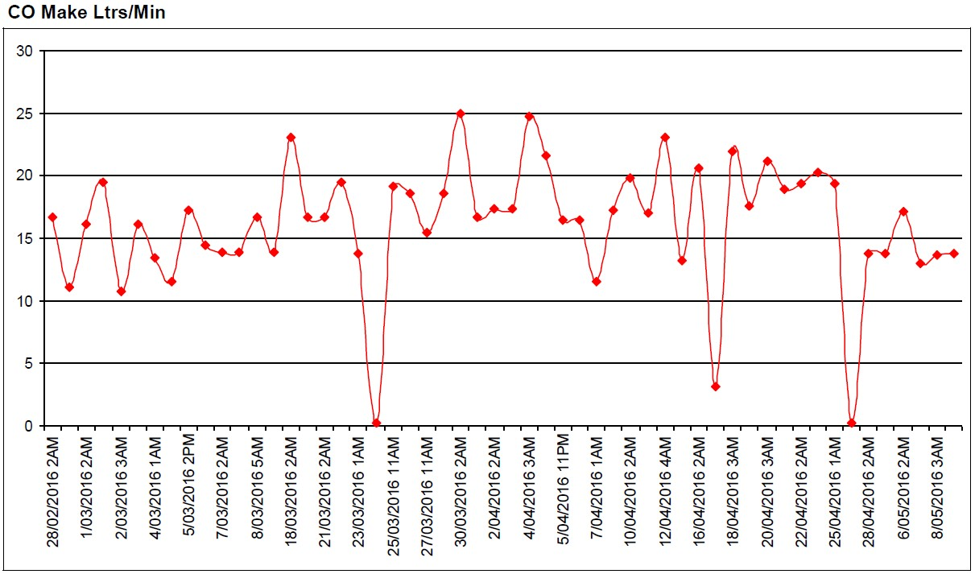

During the latter stages of the support recovery process at the MG area, floxal inertisation will be introduced to the goaf via the surface to seam borehole (GN1746) at 8N MG 4c/t to the final seals and then subsequently to the MG side seals to assist with the purging process to reduce the overall oxygen content of the area to be sealed. An additional mobile floxal unit (400m³/hr) will also be available on standby to deliver inert gas to the final seals. Borehole GN1946 located at 8N MG 2c/t will be prepared for this back-up unit. The inertisation reticulation system and delivery boreholes are shown in Figure 16 – Inertisation system & tube bundle sample locations.
To further aid the self inertisation process during purging of the area to be sealed, the goaf drainage infrastructure will be turned off at an appropriate stage during the support recovery. This procedure is detailed in the final sealing procedure (section 10).
The predicted accumulation of gases within the sealed area is shown in Figure 13 - Predicted accumulation of gases within the sealed area. This illustrates the period prior to and throughout the closing of the MG seal hatch as part of the final sealing process. It is estimated to take 13 hours to become inert then a further 18 hours for the oxygen to go below a concentration of 8%.
Figure 14 – Ellicott’s diagram (trend) indicates the trend throughout the purging process based on the predicted gas accumulation plotted on an Ellicott’s diagram (from time of purging to enacting the final sealing process).

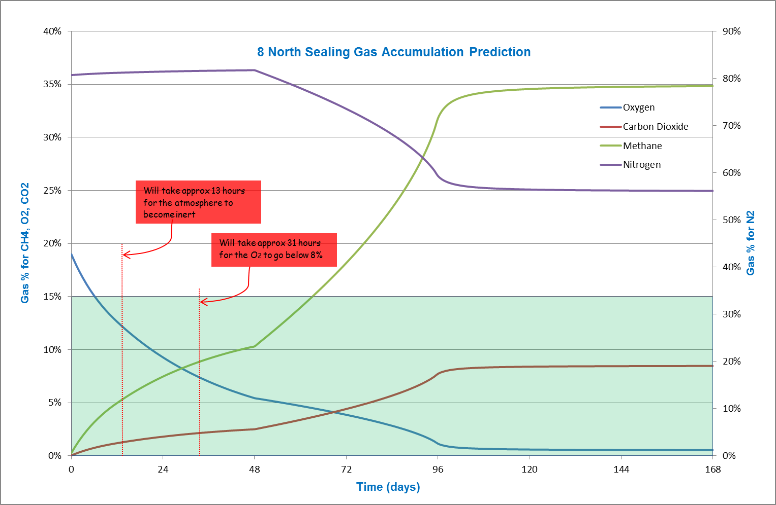

Figure 13 - Predicted accumulation of gases within the sealed area
`
-20.00
-15.00
-10.00
-5.00
0.00
5.00
10.00
15.00
20.00
-20.00
-15.00
-10.00
-5.00
0.00
5.00
10.00
15.00
20.00
Ellicott Y

Ellicott X

Explosive

Lean

Inert

Rich

Figure 14 – Ellicott’s diagram (trend) during the sealing process
The sealed area atmosphere will be purged from the sealing area via the TG A hdg 1-2c/t seal hatch and into B Heading via the 49c/t return. This ‘mixing point’ with other return air (predominantly from 9N MG) will be diluted to an acceptable level. There will be approximately 40m³/s of low methane (<0.5%) ventilation to assist with this mixing. This area will have appropriate barricading around these hazardous areas to prevent personnel access.
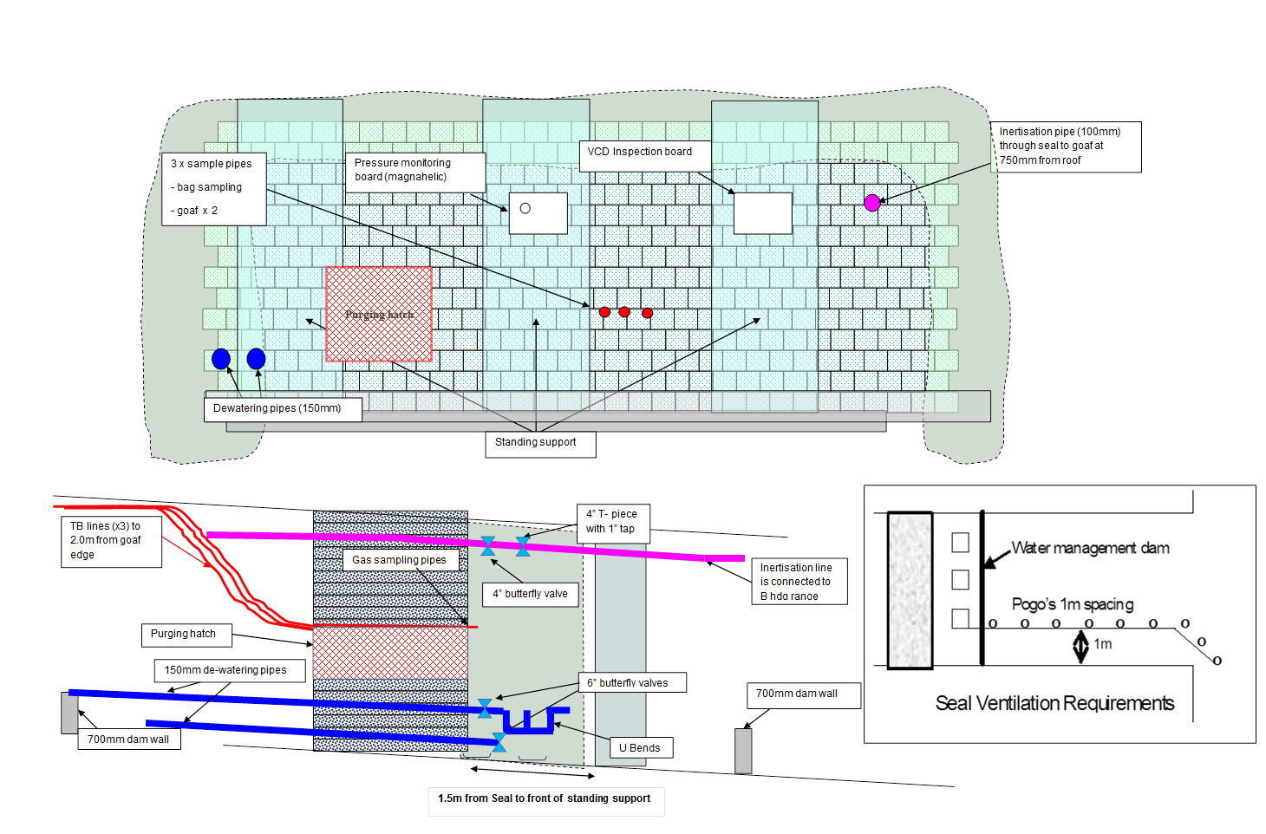
Figure 15 - TG ‘purging’ seal

9. GAS MONITORING PROCEDURE (REF CMSHR S326, 2F)

9.1 OBJECTIVE
Monitoring of sealed areas will be carried out in order to adequately predict and define the potential for an explosive atmosphere to occur within the sealed area. Sufficient samples will be taken to delineate both the size of any explosive zone and the time that the zone will be within the explosive range. In addition, monitoring will be carried out to identify any occurrence of spontaneous combustion within the sealed area as a potential ignition source (Recognised Standard 09 – The Monitoring of Sealed Areas).

9.2 LOCATION AND FREQUENCY OF MONITORING
The North Goonyella standard for seal site monitoring points is to have four sampling points installed (at each seal location) to facilitate lines for pressure differential measuring, tube bundle, bag sample and a redundancy line. The seals with hatches (seal #1 & seal #6) will only have three (3) sampling tubes due to no pressure balancing chamber.
Each of the final seals will have the ability to be monitored by the tube bundle system and will be used to assess the goaf behaviour during purging and after the final sealing process has been enacted.
All tube bundle lines utilised will be pressure tested and/or calibration gas tested prior to commissioning to test for any leaks. This will occur during the initial installation and whenever a tube bundle point is relocated.
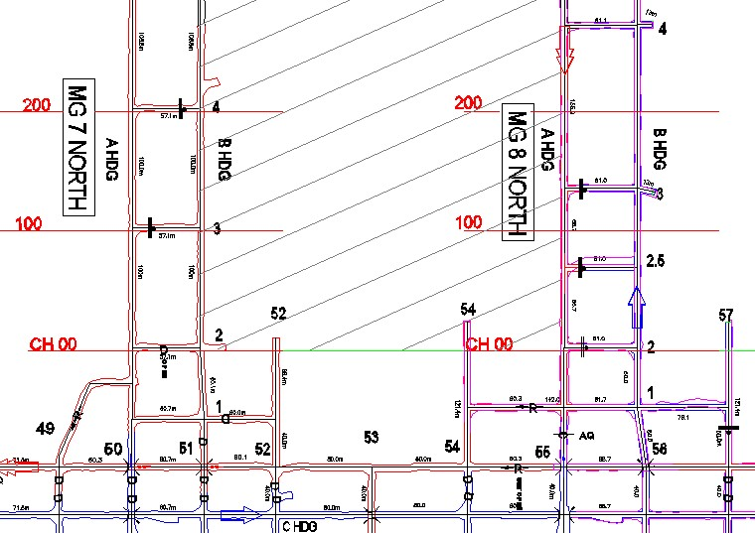

Tube bundle sample
l
ocation (final sealing stage)

Inertisation range

Inertisation borehole

GN1746

GN1946

Figure 16 – Inertisation system & tube bundle sample locations
Tube bundle points will be monitored at all times in the mine’s Control Room using the existing 40 point tube bundle SAFEGAS gas system. The tube bundle location installed will monitor the gas composition with a sample taken approximately every 75 minutes, as part of the regular tube sample regime.
On request, a hold can be placed on one point or changes made to the sample sequence if required. Tube bundle analysis shows that the draw time for a sample from this site is approximately 20 minutes.
Bag samples will be taken from each of the final seals once completed every 4 hours and coincide with the diurnal high and low throughout the final sealing process, commencing when the final sealing process is initiated (section 10) with the closing of the MG 2c/t seal hatch. Bag samples will be analysed using the North Goonyella gas chromatograph by competent persons and stored within the SEGASPro database (SIMTARS).
The remainder of the active goaf (8N) seals will continue to be monitored in accordance with the mine gas bag sampling regime, sampled on a weekly basis. Additional tube bundle monitoring points are available for any areas of the goaf requiring increased monitoring frequency.
Hand held MX4 gas detectors will also be used as part of normal ERZ Controller inspections and with the ventilation crew during seal construction. The supervisor of the ventilation crew will carry an MX4 gas detector at all times during the sealing process when in close proximity to the sealing area. Another gas detector will also be placed at a point as close as practicable to the seal being constructed throughout the seal erection to detect the presence of flammable or noxious gases and will alarm to alert personnel in the area. Where an alarm is activated, the expectation of the ventilation crew is to withdraw to a place of safety (intake) and inform the ERZ Controller for the area.
ERZ Controller inspections will be in accordance with NGC-MIN-SOP-309 Inspections of Mine
Workings and be conducted at minimum 4 hourly intervals and the continuous presence of an ERZ Controller within the longwall district throughout the seal construction process. The final sealing procedure (as detailed in section 10) will be carried out with the continuous presence of an ERZ Controller.
Sampling locations and frequency may be increased as directed by the Ventilation Officer to enable complete understanding of the behaviour of gases. Sampling will continue at the frequency nominated until the Ventilation Officer and Underground Mine Manager are satisfied that the goaf atmosphere has stabilised, in accordance with ‘Normal’ conditions detailed in TARP-007 Goaf Seals.

9.3 ALARM REVIEW AND COMMUNICATION
Alarm levels and triggered actions for all gas monitoring data will be determined by the following TARPs and what stage of the sealing is in effect:
- TARP 019 8N LW Production & TARP 025 General Body Gas Levels
- TARP 036 8 North Transition to Final Sealing
- TARP 007 Goaf
•
Pre
-
sealing

•
TARP
-
019

•
TARP
-
025

1

•
Final
sealing
process

•
TARP
-
036

2

•
After
sealing

•
TARP
-
007

3

Figure 17 - TARP activation flow chart
Control Room Operators are authorised to acknowledge alarms and TARP condition for atmosphere monitoring results.
Findings and updated diagrams of the daily seal-up gas analysis will be posted on surface notice boards for review by all mineworkers on a daily basis. The mine Ventilation Officer and Underground Mine Manager, in addition to the Control Room Operator and Shift Co-ordinator, will be reviewing analysis of trends of atmosphere on a daily basis during and after the sealing process. Any alarms or TARP triggers from this area will also be reviewed and countersigned in the gas alarm log by the Control Room Operator, Shift Co-ordinator, Ventilation Officer and Underground Mine Manager. TARP communication requirements will also be enacted for triggers that are activated.
External independent gas analysis will consist of Joncris Sentinel Services reviewing bag sample results and, as required Simtars reviewing the operation of the Gas Chromatograph.
After the seal-up is completed and the atmosphere trend is stable, the tube bundle monitoring requirement will be determined by the ventilation officer. All final seals will become part of the North Goonyella monthly bag sample regime after the sealing is completed.

10. | SEALING PROCEDURE (REF CMSHR S326, 2A)
The key control identified within the sealing risk assessment (NG-TSE-RSK-VO001 8N LW Sealing Operations Risk Assessment) was a comprehensive Seal Management Checklist to be submitted to the Inspectorate (ref TSV PF77 8 North LW Sealing Checklist) prior seal-up for approval per CMSHR s327 & s330. The mine’s Ventilation Officer will coordinate the sealing. Direct supervision will be provided by ERZ Controllers. The Underground Mine Manager shall assume the responsibility for the sealing in the absence of the Ventilation Officer.
In summary, the checklist details the seal plan sequence and ensures:-
- Adequate provision of this Seal Management Plan, Sealing Checklist and Sealing Risk Assessment to the Inspectorate
- Presentation of Seal Management Plan to affected mine workforce
- Instruction in Seal Management Plan to contractor and ERZ Controller completing seal-up
- Barricades erected at sealing ‘controlled zone’ entry points (as per zone of ‘sealing operations’ plan); barricades installed in accordance with NGC-MIN-WP-209 Restricted Mine Access
- Establish mine communications (DAC) to seal site
- Heavy stone-dusting of entire seal-up zone
- Adequate ventilation of seal-up sites
- Function test of tube bundle gas monitoring to seal-up site
- Adequate monitoring and communication of gas trends during seal-up
- Delivery of Floxal gas inertisation to seal sites to be enacted following the construction of each final seal with an open hatch return via seal #1 (TG A hdg 1-2c/t) to effectively reduce the oxygen levels in the area to be sealed
- Final seal-up checklist with :- o VCD permits issued for each final seal o Area (at seal sites) positively ventilated with >0.3m/s air velocity o Continuous presence of ERZ controller o Removal of electricity, other services, plant & equipment prior seal-up
  - Removal / restriction of non-essential personnel from seal site in accordance with zone of sealing operations plan
  - Ceasing of goaf drainage activity
- Seal construction completed in sequential order as indicated in Figure 4 - Seal installation sequence vs support recovery

10.1 FINAL SEALING STAGE - PROCEDURE TO CLOSE THE MG 2C/T
‘HATCH’ AND COMPLETE THE SEAL

- Consent received from the Inspector to conduct the final sealing stage
- Final approval for seal-up from UMM following approval from Inspectorate
- Activate final sealing stage tube bundle monitoring and initiate bag sampling regime (s. 9.3).
- ERZ Controller/UMM to activate final inertisation status, including inertisation to pressure balancing chambers as directed by V.O.
- ERZ Controller/UMM to close ‘hatch’ door at seal #6 (MG 2c/t). Note: TARP036 transition to final sealing now in place
- Open floxal inertisation range into area to be sealed at seal #6 (MG 2c/t) and other seals on the maingate side as directed by V.O.
a. Monitor atmosphere behind seals during purging process. If atmosphere becomes >80% explosive, action as per TARP036 8 North Transition to Final Sealing TARP level 3 trigger and withdraw all personnel from underground to surface, otherwise as per step #7
- Monitor atmosphere until oxygen reduces to below 8%, then close ‘hatch’ door (seal #6) and fill chamber and spray seal to appropriate rating
- Close purging hatch at seal #1 (TG A hdg 1-2c/t) to complete sealing operation
- ERZ Controller to sign-off VCD permit and Ventilation Officer to complete sealing checklist.

11. | SEALING CREW
The sealing crew will be authorised by the Ventilation Officer to construct the final seals. Persons involved in the construction/installation of the seals are to have the appropriate competencies for the tasks, including the crew supervisors having RIIMCU2121A Construct and maintain basic ventilation devices. Seals are to be constructed in accordance with safe working practices and any relevant procedures associated with the issued construction permit.
Personnel involved in the sealing process will be familiarised with the sealing operations area (see Appendix: zone of sealing operations plan). This will include a familiarisation in the location of the area inspection boards, boundaries of the zone, location of the bulkhead seals and egress routes from the area. An ERZ Controller will facilitate an inspection of the area with the work crews prior to commencing construction.
All familiarised personnel entering the ‘zone of sealing operations’ will, for the record, sign onto the permit for the zone (located in the shift co-ordinators office on the surface). This permit recognises acknowledgement of being familiarised with the Sealing Management Plan and associated documentation (including the risk assessment, checklist and zone of sealing operations plan). These documents are also kept underground at the site of the sealing area entry tag board.
An ERZ Controller will be present during closing of the seal hatches in the final seals (seals #1 and seal #6). All applicable permits will be completed prior to each job being started and communicated to the persons involved with the construction of the seals. Seals are to be built to the standard required by the North Goonyella Coal Mine permit system. Each seal site is to be stone dusted prior to the commencement of seal construction.
The sealing crew is to carry a gas detection unit whilst constructing the seals. If any of the concentrations of gases present at the seal site are at the following levels during the construction phase, the sealing crew is to retreat to an area of known fresh air and inform the ERZ Controller:
• | Oxygen | < 19%
• | Carbon Monoxide | > 30ppm
• | Carbon Dioxide | > 1.25%
• | Methane | > 2.3%
• | Hydrogen Sulphide | >10ppm
The sealing crew is to inform an ERZ Controller of any unusual changes in conditions, such as gas emission, sweating, haze, heat or smoke, strata changes etc.

 | 12. | ROLES & RESPONSIBILITIES
12.1 CRITICAL ACTIONS
Action required |  |  | Position responsible | Timing
Completion of Seal  Management Plan Checklist |  |  | Underground Mine Manger and  Ventilation Officer | Prior seal-up request to Inspectorate
Communication of Seal Management Plan per CMSHR s328 |  |  | Underground Mine Manger | Prior and post seal-up
Construction of seals to engineering design |  |  | Vent Contractor | At seal-up
Sign-off of seal completion in accordance with VCD permits |  |  | ERZ Controller and Ventilation Officer | Post VCD construction
Monitoring, review & communication of seal-up gas analysis to mine workers |  |  | Underground Mine Manger and  Ventilation Officer | Prior and post seal-up
Notification of successful sealup to Inspectorate |  |  | Underground Mine Manger | Post seal-up

12.2 SITE SENIOR EXECUTIVE (SSE)
Shall:
• Ensure that the necessary resources are available to provide that the NGCM documents are managed in accordance with the provisions of this procedure.

12.3 UNDERGROUND MINE MANAGER (UMM)
Shall
- Complete the Seal Management Checklist in accordance with the Seal Management Plan
- Seek notification in writing from Inspectorate of approval to seal per CMSHR 2001 – S326 (1), S326 (2), S327 (1), S327 (2) and S330
- Authorise sealing operations
- Notify Inspectorate of any departures from Seal Management Plan per CMSHR S328
- Monitor, review and communicate analysis of gas trends to workforce in conjunction with VO
- Notify Inspectorate of successful sealing when complete

12.4 SHIFT COORDINATOR (SC)
Shall
- Provide adequate resources to personnel involved in sealing operations
- Supervise activities of mineworkers and contractors involved in sealing operations
- Ensure communication of Seal Management Plan activities to all affected mineworkers

12.5 VENTILATION OFFICER (VO)
Shall
- Complete the Seal Management Checklist in accordance with the Seal Management Plan
- Monitor, review and communicate gas trends to mineworkers in conjunction with UMM
- Communicate Seal Management Plan activities to all affected mineworkers

12.6 CONTROL ROOM OPERATOR (CRO)
Shall:
• Monitor gas monitoring data in accordance with relevant TARPs associated with this sealing management plan during and after seal-up

12.7 ERZ CONTROLLER (ERZ)
Shall:
• Carry out sealing area inspections in accordance with inspection regime (section 9.2) • Certify seals per engineering design and VCD Permit

12.8 COAL MINE WORKERS (CMW)
Shall:
- To work or carry out the worker’s or person’s activities in a way that does not expose the worker or person or someone else to an unacceptable level of risk
- Conform to the risk management practices of the mine and the sealing operations in accordance with this sealing management plan

13. | CONFORMANCE/AUDIT CRITERIA
A sign-off process by the ERZ Controller in control of the zone of sealing operations will be conducted for each stage of the seal construction.
The sealing checklist for each section will be completed prior to commencing the subsequent part of the sealing sequence. This will be verified by the ventilation officer to ensure compliance with the sealing management plan.

14. | REVIEW CRITERIA
This document shall be reviewed as follows:
- When there is a change of method and/or technology that may affect the accuracy of this document
- Whenever there is a significant change to the coal mining operations of NGC Operations that impacts upon this document

15. | REFERENCES
- CMSHR 2001 – S326 (1) & S326 (2) Notice of intention to seal mine
- CMSHR 2001 – S327 (1) & S327 (2) Sealing underground mine
- CMSHR 2001 – S330 Evacuating mine after sealing
- Sealing a part of Coal Mine – QMI Standard and Process V1 Nov2009
- NG-TSE-RSK-VO007 8N LW Sealing Operations Risk Assessment
- SOP 352 Ventilation Control Devices
- TSV PF77 8N LW Sealing Checklist
- TARP005 Air quality & quantity
- TARP007 Goaf Seals
- TARP 019 8N LW Production
- TARP025 Withdrawal conditions for general body gas events
- TARP036 8N LW Transition to final sealing
- Incendive Spark Potential - CGRI May2003
- AS/NZS 1768:2007 Lightning Protection
- TARP028 Lightning event TARP
- NGC-MIN-WP-209 Restricted Mine Access
- NGC-MIN-SOP-300 Stonedust Application and Sampling
- NGC-MIN-SOP-309 Inspections of Mine Workings
- NG-TSE-PRO-SG-007-Plug and grout of historical holes

16. | APPENDICES
- TSV PF77 8N LW Sealing Checklist
- Final seal certification – Rating for 345kPa 8 North final seals
- Zone of sealing operations location and detailed plan

