Compliance Policy
Coal Mining Safety and Health Act 1999
Coal Mining Safety and Health Regulation 2001
Mining and Quarrying Safety and Health Act 1999
Mining and Quarrying Safety and Health Regulation 2001
Principles and Procedures for Assessing Compliance and
Determining Response to Non-Compliance
Natural Resources
and
Mines
November 2001
Compliance Policy
containing
Compliance principles
Guidelines for controlling risk associated with non-compliance and
determining the appropriate action to take in cases of non-compliance
Procedures for reviewing recommended actions regarding non-compliance
FOREWORD
For almost a decade the Queensland mining and quarrying industries have focused attention and devoted considerable effort towards improving safety and health standards. With many companies adopting a target of zero fatalities and zero serious injuries, considerable progress has been made. To achieve and maintain acceptable safety and health standards requires considerable effort; to then lift these standards even further requires that this effort is relentless.
Mining is one of Queensland’s most important industries providing significant export revenue to the state and the nation. Mining is the life-blood of many important regional centres and without it many regional centres could not survive in their present form.
We all recognise and accept that there is a strong moral obligation to ensure the health and safety of those who work to produce the wealth that is so important to our state and nation. In addition to meeting these obligations, we must also acknowledge and ensure that we are seen to be meeting these obligations.
In August 1994 an explosion at Moura No 2 Mine in Central Queensland led to the loss of eleven lives. This was the fourth major mining accident in Queensland in 25 years, three of which directly affected the township of Moura. This situation was completely unacceptable and the resulting major inquiry recommended a number of reforms, including the completion of the development of new mining legislation.
In March this year the Coal Mining Safety and Health
Act and the Mining and Quarrying Safety and Health Act came into force. These Acts are acknowledged as modern, progressive and effective hazardous industry safety and health legislation. The efforts and input of many parties, including mining companies, unions and the Mines Inspectorate in the development of this legislation are acknowledged.
This Compliance Policy, which I have the pleasure of introducing, has the purpose of ensuring that this legislation is administered in a consistent, transparent and effective manner. It ensures the safety and health obligations we all owe to the people in the mining industry who produce the wealth are met, and are demonstrated to be met.
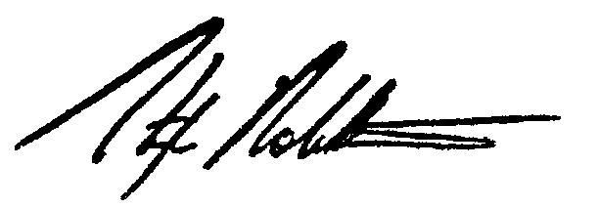
STEPHEN ROBERTSON MP
Minister for Natural Resources and Mines
CONTENTS

1 OVERVIEW 1 2 COMPLIANCE POLICY
2.1 Introduction 2
2.2 Dictionary 2
2.3 Objectives 2

3 COMPLIANCE PRINCIPLES
3.1 Principles 3
3.2 Application 3

4 ASSESSMENT - RESPONSE GUIDELINES
4.1 Acceptable risk and appropriate actions 4
4.2 Achieving an acceptable level of risk 4
4.3 Determining an appropriate action to take against people responsible for non-compliance 4

5 PROCEDURES FOR ASSESSING RECOMMENDATIONS
5.1 Procedures 5
5.2 Procedure 1: Investigation Team’s recommendation and the recommendation from an
inspector investigating a fatal accident 5
5.3 Procedure 2: Inspector’s recommendation - where the recommendation is not associated with an investigation by an Investigation Team or an investigation into a fatal accident 6
5.4 Procedure 3: Recommendation for prosecution by a person (other than an inspector)
authorised by legislation as being able to recommend prosecutions 6
5.5 Investigation Teams and Review Committees 7
5.6 Initiation of prosecutions 7

6 DIAGRAMS AND ASSESSMENT PROCEDURES
6.1 Response Guideline 1: Guide to ensure an acceptable level of risk 8
6.2 Response Guideline 2: Guide for determining appropriate administrative action 9
6.3 Procedure 1: Assessing an Investigation Team’s recommended response to non-compliance 10
6.4 Procedure 2: Assessing an inspector’s recommendation to prosecute 11
6.5 Procedure 3: Assessing a recommendation for prosecution made by a person (other than an
inspector) authorised by legislation to recommend prosecutions 12 APPENDICES
Appendix 1: Investigation Team 13 Appendix 2: Review Committee 14
Appendix 3: Factors influencing decisions to prosecute 15
REFERENCE DOCUMENTS 16

1. OVERVIEW
This policy is part of the Department of Natural Resources and Mines’ compliance strategy and complements the Department’s auditing and inspection role.
The policy is intended to ensure an unbiased, consistent treatment of non-compliance with the requirements of mining safety and health legislation.
The objective of the mining safety and health legislation is to protect the safety and health of mine and quarry workers and those who are affected by the activities of these industries. The Department’s safety and health mission is to ensure that the objective of legislation is achieved. Associated with this mission is the need to preserve public confidence in the administration of the legislation. This requires the Department to enforce the legislation in a consistent and impartial manner and, where appropriate, hold people accountable for their failure to meet the requirements of legislation.
The Department’s initial emphasis is on co-operation with stakeholders, including giving advice and encouragement to achieve required health and safety standards. This approach also includes the concept of staged escalation to deal appropriately with people or companies who fail or neglect to fulfil their safety or health obligations. The approach does not preclude prosecution as an initial response where, for example, situations involve gross negligence.
A Review Committee is proposed as part of the process for ensuring that an appropriate response is made to any major non-compliance. This Review Committee is designed to provide the Statutory Chief Inspectors with a second opinion on the appropriateness of recommended responses to breaches of legislation that may involve the potential for prosecution. Where people empowered by legislation recommend a prosecution to the Statutory Chief Inspector this compliance policy requires, where serious breaches of compliance are involved, the Statutory Chief Inspector to obtain an opinion from a Review Committee on the appropriateness of a recommendation. The Review Committee cannot and does not remove the power granted to the Statutory Chief Inspectors by the legislation to initiate a prosecution where he/she considers this appropriate or, alternatively, decides not to proceed with a prosecution where he/she considers prosecution is not appropriate.

2. COMPLIANCE POLICY

2.1 Introduction
People involved with the mining industry have legal obligations to comply with the requirements of safety and health legislation. For those involved with the coal mining industry this is the Coal Mining Safety and Health Act 1999; and for those involved with the metalliferous mining and quarrying industries it is the Mining and Quarrying Safety and Health Act 1999. The Department has the function, through the inspectorates established by each piece of legislation, to enforce the legislation and, if unsafe practices or conditions are detected, to ensure timely corrective or remedial action is being taken.
This policy is designed to assist in establishing methods for the treatment of non-compliance which are logical, consistent, transparent and appropriate.
In addition to assisting the Department to carry out its function effectively and efficiently, the policy, by establishing clear guidelines for treating noncompliance, is designed to preserve public confidence in the administration of safety and health legislation in the mining and quarrying industries.
The policy contains:
- A statement of the objectives of the policy and the principles to be applied in the event of the discovery of non-compliance with safety and health obligations.
- A guideline to assist in determining:
  - actions to be taken to ensure risk associated with non-compliance is contained
  - the appropriate action to be taken against people or companies who fail to comply with legislation requirements.
- Procedures to be followed when a recommendation is made regarding the prosecution of a person or company as a result of a non-compliance with safety and health legislation.

2.2 Dictionary
Appropriate action is the action taken or recommended against a person or company not fulfilling legislative safety and health obligations. The appropriate action varies in accordance with the circumstance and significance of the non-compliance.
Chief Inspector of Mines is the person appointed to manage the mining inspectorate.
Complaint is a representation by a mine worker to an inspector of a breach of the safety and health legislation; to be distinguished from the complaint laid by a Statutory Chief Inspector in the Industrial Magistrates Court to commence a prosecution.
Directive is a communication made to a mine operator or site senior executive by an inspector or inspection officer requiring a safety or health-related action to be taken.
High Potential Incident of Especial Significance is a high potential incident that is so serious that it warrants a major investigation.
Non-compliance is a failure to meet the legal requirements of the Coal Mining Safety and Health Act and Regulation or the Mining and Quarrying Safety and Health Act and Regulation.
Officer includes inspectors, inspection officers, industry safety and health representatives and district workers representatives.
People involved with the mining industry includes all people with obligations under the mining Acts for safety and health and includes holders of mining tenements, mine operators, workers, contractors, visitors to mines, etc.
Review Committee is a committee appointed by the Chief Inspector of Mines to provide an opinion on the appropriateness of a proposed action in response to a serious breach of safety and health legislation.
Serious Accident and High Potential Incidents are categories of accidents and incidents and are defined in the mining safety and health legislation.
Serious Accident of Especial Significance is a serious accident that results in grievous bodily injury.
Statutory Chief Inspector is a person appointed under either the Coal Mining Safety and Health Act 1999 or the Mining and Quarrying Safety and Health Act 1999 as Chief Inspector.

2.3 Objectives
The objectives of this compliance policy are to:
- Assist officers and others to ensure that where non-compliance is detected that associated risk is effectively and appropriately managed
- Assist officers and others to take consistent and appropriate actions against people or companies who fail to meet their obligations under the mining safety and health legislation
- Ensure that recommendations relating to prosecutions (including recommendations not to prosecute) are assessed in a fair and equitable way that will protect people and companies who meet their safety and health obligations while holding accountable those people and companies that do not
- Provide a document that will reassure the general public that the Department is administering the Coal Mining Safety and Health Act and the Mining and Quarrying Safety and Health Act in a manner that meets the objectives of the legislation and is in the public interest.

3. COMPLIANCE PRINCIPLES

3.1 Principles
The following principles form the basis of the compliance policy and should be applied by officers carrying out their legislative functions:
- The principal means of meeting safety and health obligations is through compliance with legislation, or with directives issued under provisions of the legislation
- Safety and health obligations may also be met by following standards arising from the legislation; for example recognised standards or guidelines issued pursuant to the legislation
- Responsibility for compliance with legislation is with industry
- The Department, through the mines inspectorate, is to monitor compliance and enforce the legislation. Monitoring compliance will include issuing directives to manage risk when risk is found to be at an unacceptable level; enforcing legislation may include initiating prosecutions against people or companies for failing to meet safety and health obligations
- The Department has the role, as regulator, in the improvement, review and promulgation of standards issued pursuant to the legislation
- Investigations into non-compliance and determination of corrective measures will be carried out in an unbiased manner that promotes and preserves confidence in the integrity and professional competence of the Department’s officers
- Corrective measures are to be used consistently, be commensurate with the seriousness of a situation and escalate where previous measures have been ineffective
- In the first instance, subject to the seriousness of a situation, a co-operative response is preferred.

3.2 Application
The Department will:
- Administer the legislation in accordance with the principles and procedures of the compliance policy
- Develop, improve and promulgate recognised standards and guidelines
- Respond to detected non-compliance in a timely andeffective manner. Corrective action measures and directives will be followed up where possible to a pre-planned timetable and as expeditiously as the circumstances of the situation warrant
- Grade responses to the seriousness of the non-compliance
- Maintain records of serious non-compliance detectedtogether with the resulting measures undertaken.
ASSESSMENT - RESPONSE GUIDELINES

4.1 Acceptable risk and appropriate actions
Responsibility for compliance with legislation is with industry; however, where non-compliance is detected an officer may have to use the powers provided by legislation to ensure that the necessary action is taken to achieve an acceptable level of risk. In addition the officer may have to decide what action, if any, he/she should recommend be taken against the person or company who is in non-compliance.
Corrective measures are to be used consistently, be commensurate with the seriousness of a situation and escalate where previous measures have been ineffective. In directing what should be done to control the risk and deciding what action should be taken against those responsible for the non-compliance, the officer should follow this principle.
To help officers follow the above principle the Response Guidelines 1 and 2, shown in Part 6, are provided. Section 6.1 shows the actions available to ensure the risk resulting from non-compliance is contained. Section 6.2 gives guidance as to what aspects should be considered in determining the appropriate action against those responsible where a non-compliance is detected.

4.2 Achieving an acceptable level of risk
When non-compliance is detected, and before being able to decide the appropriate action to ensure that an acceptable level of risk is achieved, it is necessary to assess the level of risk.
The seriousness of the situation and the immediacy of the problems to be resolved will determine how the risk assessment process is carried out. Some situations may be so serious that immediate action is appropriate and an inspector may simply use the guideline to confirm an already implemented response. Section 6.1 of Part 6 Diagrams and assessment procedures suggests action that may be taken.
For complex situations it may be advisable to go through a team-based risk assessment process. Risk assessment is not a substitute for competent judgement based on experience and knowledge; it is a tool to guide those with the necessary experience and knowledge to a sound decision.

4.3 Determining an appropriate action to take against people responsible for non-compliance
Having determined the level of risk created as a result of non-compliance and taken the necessary actions to achieve an acceptable level of risk, the next task is to determine the appropriate action to be taken against the people responsible for the non-compliance.
Factors to be considered in determining what this action should be are shown in Section 6.2 of the Response Guideline and include consequences of the noncompliance as well as the circumstances surrounding the non-compliance.
The response depends on the factors involved and may be any one of a number or, as suggested in Step 2 of the guideline, a combination of responses.
Options include:
- verbal expression of concern
- entry in the mine record
- senior company accountability meeting at NR&M head office
- recommendation for prosecution.
PROCEDURES FOR ASSESSING RECOMMENDATIONS

5.1 Procedures
Provisions for recommending and initiating a prosecution are laid down in the Coal Mining Safety and Health Act 1999 and the Mining and Quarrying Safety and Health Act 1999. Under the legislation only the Chief Inspectors defined in each piece of legislation (referred to as Statutory Chief Inspectors in this policy) or a person authorised by the Minister (or Attorney-General) can initiate a prosecution. However, a number of people can recommend to the Statutory Chief Inspectors that prosecutions be initiated.
This part outlines procedures that are to be followed for assessing recommendations to prosecute.
Recommendations fall into one of three groups:
- Procedure 1 addresses recommendations by Investigation Teams, or from inspectors investigating a single fatality. The legislation requires the inspectorate to investigate and report on all fatal accidents. To meet this requirement the Department will allocate inspectors to determine the nature and cause of the accident and detect any associated non-compliance. The level of resources used will be appropriate for the significance and complexity of the accident and could vary from a single inspector to an investigation team; the investigation will determine measures to prevent reoccurrence and suggest what administrative response should be made to any non-compliance found. Investigation Teams may also be established to investigate serious accidents or high potential incidents where it is considered they are of especial significance
- Procedure 2 addresses recommendations made by inspectors, other than recommendations associated with investigating a fatality. Not all recommendations to prosecute will be associated with fatal or serious injuries or high potential incidents. Some may be the result of continually and deliberately neglecting to meet requirements of the legislation and these will generally come from inspectors
- Procedure 3 addresses recommendations by people authorised by the legislation to make recommendations. The legislation specifically authorises a number of people in addition to inspectors to recommend that prosecutions be initiated. These people are site senior executives, industry safety and health representatives (coal mining legislation) and district workers’ representatives (mining and quarrying legislation).

5.2 Procedure 1: Investigation Team’s recommendation and the recommendation from an inspector

investigating a fatal accident
The procedure to be followed is shown in Section 6.3: Procedure 1. The procedure commences with a fatal accident or another type of serious accident or high potential incident of especial significance (trigger events). Whether a fatal accident is investigated by an investigation team or by an inspector(s) from the local area would depend on the complexity of the accident.
The investigation of the occurrence includes taking statements, collecting evidence, analysing events and preparing a report to be forwarded to the Statutory Chief Inspector. On receiving the report the Statutory
Chief Inspector will make the report available to the Executive Director Safety and Health Division through the Chief Inspector of Mines and to the Review Committee. Where the incident involves a fatal injury the Statutory Chief Inspector will forward a copy of the report to the Coroner. Refer to flow chart.
Legal advice should be obtained if further legal action is a possibility; the flow chart shows this being obtained by the Statutory Chief Inspector prior to consideration by the Review Committee. This advice should be provided to the Review Committee, together with the report of the investigation.
On receiving the report, the Review Committee is to consider all the issues and provide a written opinion on the actions recommended in response to any non-compliance. On receiving the opinion of the Review Committee, the Statutory Chief Inspector must decide whether further action is justified. On arriving at a decision, the Statutory Chief Inspector must inform the Chief Inspector of Mines, the inspectors involved in the investigation and the Minister through the DirectorGeneral and the Executive Director Safety and Health.
If the decision is to proceed to prosecution, the Statutory Chief Inspector is to prepare a budget estimate for the cost of the proceedings. He/she must inform the Director-General of this possible expenditure so that funds may be made available to undertake the prosecution.
The Statutory Chief Inspector charged with initiating the prosecution completes the procedure and obtains any necessary legal assistance. He/she liaises with the Coroner, where a fatal accident is involved, and initiates the prosecution in the Industrial Magistrates Court. It is necessary to communicate with the Coroner to ensure proceedings under the safety and health legislation do not conflict with proceedings in the Coroner’s Court.

5.3 Procedure 2: Inspector’s recommendation - where the recommendation is not associated with an investigation by an Investigation Team or an investigation into a fatal accident
The procedure to be followed is shown in Section 6.4: Procedure 2. The procedure commences with an inspector reaching the conclusion that a person or organisation has failed in a significant way to meet the requirements of the legislation (trigger) and recommending a prosecution. After due process the procedure ends either with rejection of the inspector’s recommendation or, where endorsed, with the initiation of legal proceedings.
A recommendation for prosecution should be based on a perceived failure to meet safety and health obligations or some other significant legislative requirement and the evidence of such a breach.
Initially, the inspector should obtain sufficient information to apply the Response Guideline 2. The inspector must forward a report to the Statutory Chief Inspector providing the justification for the recommendation and establishing that all other avenues had been exhausted
On receiving an inspector’s recommendation the
Statutory Chief Inspector is to inform the Executive Director Safety and Health Division through the Chief Inspector of Mines of the recommendation.
On receiving the report the Statutory Chief Inspector must decide whether further action is justified. On arriving at a decision the Statutory Chief Inspector must inform the inspector making the recommendation and the Chief Inspector of Mines who will inform the Executive Director Safety and Health. If the decision is to prosecute, the Statutory Chief Inspector is to inform the Minister through the Director-General and the Executive Director Safety and Health of this intention.
In the event of a decision to prosecute the Statutory Chief Inspector is to prepare a budget estimate for the cost of the proceedings. He/she must inform the Director-General of this possible expenditure so that funds may be made available to undertake the prosecution.
The procedure is completed by the Statutory Chief Inspector obtaining any necessary legal assistance and initiating the prosecution in the Industrial Magistrates Court.

5.4 Procedure 3: Recommendation for prosecution by a person (other than an inspector) authorised by legislation as being able to recommend prosecutions
The procedure to be followed is shown in Section 6.5: Procedure 3. The procedure commences with a recommendation to the Statutory Chief Inspector from an authorised person based on an incident or series of incidents (trigger events). It ends after due process, either with the recommendation being rejected or, where endorsed, with the initiation of legal proceedings.
The provision in the legislation that authorises certain people to recommend prosecutions is intended to allow the re-examination of significant non-compliance or ongoing breaches of legislative requirements. It is not intended to bypass inspectors and facilitate people making submissions directly to a Statutory Chief Inspector. Allegations should be first directed to the inspectors in the regions. Authorised people should follow due process of allowing an inspector to investigate a complaint and only recommend prosecutions following the completion of an inspector’s investigation and in situations where they do not agree with the decision made by an inspector not to recommend prosecution.
A person who is authorised to do so and is considering recommending a prosecution should, prior to making the recommendation, obtain sufficient information to apply the Response Guideline 2 (Section 6.2) and then decide whether there is sufficient justification for recommending a prosecution. The person making the recommendation must forward the recommendation in writing to the Statutory Chief Inspector outlining the grounds for making the recommendation and include any information that supports the recommendation.
The recommendation should address the subject of non-compliance, be specific on the nature of the non-compliance and include evidence of the noncompliance. The Statutory Chief Inspector, on receiving the recommendation, should inform the inspector in the relevant region and, through the Chief Inspector of Mines, the Executive Director Safety and Health, the Director-General and the Minister.
Where the recommendation is not associated with a fatal accident, serious injury or high potential incident of especial significance, the Statutory Chief Inspector may decide, based on the information provided with the recommendation, whether further action is warranted. When this decision is that further action is not warranted, the Statutory Chief Inspector must inform the person making the recommendation, the inspector in the relevant region and the Executive Director Safety and Health through the Chief Inspector of Mines of his/her decision and the reasons for the decision.
Where the recommendation is associated with a fatal accident, serious injury or high potential incident of especial significance, the Statutory Chief Inspector will forward the recommendation to a Review Committee for an opinion.
The Statutory Chief Inspector should obtain legal advice prior to consideration of the issue by the Review Committee, and this advice, together with the report of any further investigation, should be provided to the Review Committee. After appraising the recommendation and associated information, the Review Committee will provide a written opinion to the Statutory Chief Inspector on whether they consider that sufficient grounds exist for a prosecution
On receiving the Review Committee’s opinion the Statutory Chief Inspector is to decide whether further action is justified. The Statutory Chief Inspector’s decision and opinion of the Review Committee should be forwarded to departmental officers as above, and the Minister through the Director-General. Where the Statutory Chief Inspector decides not to proceed further the person recommending the prosecution is to be advised of the decision and the reasons for the decision.
If the decision is that a prosecution is to proceed, the Statutory Chief Inspector is to prepare a budget estimate for the cost of the proceedings and inform the Chief Executive (Director-General) and Minister of this possible expenditure so that funds may be made available to undertake the prosecution.
Where a decision is made to proceed, the Statutory Chief Inspector charged with initiating the prosecution completes the procedure by obtaining any necessary legal assistance, and initiating the prosecution in the Industrial Magistrates Court.

5.5 Investigation Teams and Review Committees
The function and organisation of the Investigation
Team and nature of the investigation report is shown in Appendix 1: Investigation Team. The function and organisation of the Review Committee is shown in Appendix 2: Review Committee.
Where the recommendations are associated with investigations into fatal accidents or serious injuries or high potential incidents of especial significance, part of the assessment process will involve a review of recommendations by a Review Committee. This will be applicable in Procedure 1 and where the recommendations are associated with a fatal accident or a high potential incident or serious injury of especial significance in Procedure 3. The Review Committee will provide a written opinion on the suitability of the response recommended by an Investigation Team and on recommendations to prosecute made by people (other than inspectors) authorised to make such recommendations. Further descriptions of the procedures involving Investigation Teams and Review Committees are given in Sections 6.3 and 6.5.

5.6 Initiation of prosecutions
The Coal Mining Safety and Health Act 1999 and the Mining and Quarrying Safety and Health Act 1999 limit the power to initiate prosecution to the respective Chief Inspector defined in the Act (Statutory Chief Inspector) and people authorised by the Minister or AttorneyGeneral to initiate prosecutions. The Statutory Chief Inspector’s power can be delegated to an inspector in accordance with the provisions in the legislation; however, the delegation should be made in writing, be made on a case-by-case basis and be subject to the agreement of the Chief Inspector of Mines.
A prosecution starts when a complaint is lodged in the Industrial Magistrates Court. Particular attention needs to be paid with prosecutions involving fatalities; close liaison should be maintained with the Coroner. Consideration should also be given to the possibility of a Board of Inquiry and legal advice taken if the Minister is considering using powers under the mining safety and health legislation to establish such a body.
The Industrial Magistrates Court is under the control of an Industrial Magistrate who is a judicial officer, usually a magistrate acting in the capacity of an Industrial Magistrate. Appeal from this court is to the Industrial Court under the control of a judge. This is not to be confused with Industrial Commission that deals with industrial issues. The issues brought before an Industrial Magistrate are quasi-criminal not industrial.

6. DIAGRAMS AND ASSESSMENT PROCEDURES

6.1 Response Guideline 1
Guide to ensure an acceptable level of risk*
No immediate safety and health risk
Immediate safety and health risk
Issue instructions or directive as appropriate
Record non-compliance
Initiate immediate remedial action
For example, issue directive to:
Stop equipment
Stop activity
Clear operating area
Withdraw persons
Stop operations
Record non-compliance
Audit
Step 1
Inspection
Investigation
Complaint
Non-compliance detected (see Section 6.2 for appropriate administrative response)
Step 2
Assess risk resulting from non-compliance detected
Minor
Major
Step 3
Step 4
Record completion of remedial actions | Record completion of remedial actions
*Refer to Section 4.2 page 4 for application

6.2 Response Guideline 2
Guide for determining appropriate administrative action*
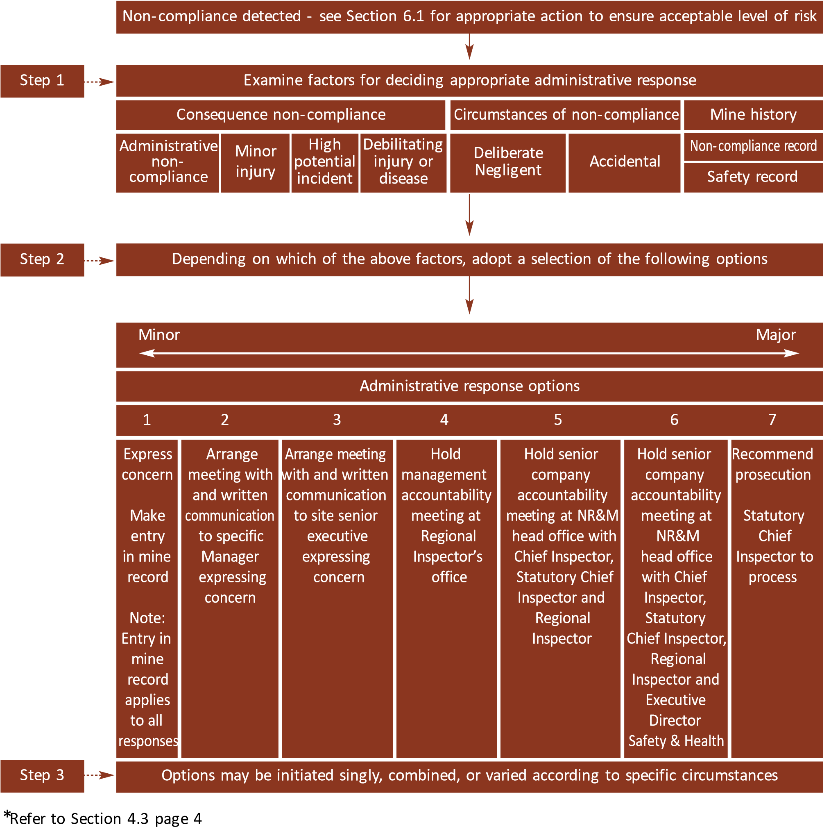

6.3 Procedure 1. Assessing an Investigation Team’s recommended response to non-compliance*
These actions and associated communications will only occur if there is a decision to proceed Communicate in the event of a fatal accident |  | Persons to be informed  This communication will depend on need
Minister
Director-General
Executive-Director
Chief Inspector -
Mining
Statutory Chief
Inspector
Inspector
Legal Advice/
Assistance
Police
Coroner
Fatal accident Serious
accident or high
potential incident of
especial significance
Trigger
Investigation
Team
Review
Statutory
Chief
Inspector
Review
Provide
opinion
Review
Committee
Decide on
further
action
Statutory
Chief
Inspector
Prepare
budget
estimate
Statutory
Chief
Inspector
Initiate
prosecution
Statutory
Chief
Inspector
Investigate
Recomme
nd
Report
Note: only required
for recommendations
associated with fatal
accident, or serious
accident or high
potential incidents of
especial significance
*Refer to Section 5.2 page 5. This procedure would also be followed where an inspector investigated a fatal accident

6.4 Procedure 2. Assessing an inspector’s recommendation to prosecute*
These actions and associated communications will only occur if there is a decision to proceed  These communications are required only if the decision is made to proceed |  | Persons to be informed  This communication will depend on need
Minister
Director-General
Executive-Director
Chief Inspector
-
Mining
Inspector
Legal advice/
assistance
Perceived significant
failure to meet
requirements of
legislation
Trigger
Inspector
Review
Statutory
Chief
Inspector
If
considered
appropriate
Further
Investigation
Decide on
further
action
Statutory
Chief
Inspector
Prepare
budget
estimate
Statutory
Chief
Inspector
Initiate
prosecution
Statutory
Chief
Inspector
Investigate
nd
Recomme
Report
*Refer to Section 5.4 page 6. This process is not associated with an investigation into an accident by an investigation team or by a single inspector investigating a fatal accident

6.5 Procedure 3. Assessing a recommendation for prosecution made by a person (other than an inspector) authorised by legislation to recommend prosecutions*
These actions and associated communications will only occur if there is a decision made to proceed  This communication is only made if the decision is NOT to proceed | Persons to be informed  This communication will depend on need
accident or serious
Trigger
Statutory
Chief
Inspector
Authorised
person
Minister
Director-General
Chief Inspector
-
Mining
Statutory
Chief Inspector
Inspector
Legal advice/
assistance
Executive Director
Further
investigation
Review
Committee
Accident
Incident
Event
If
considered
necessary
Review
Provide
opinion
Review
Recom-
mend with
justif-
ication
Note: only required for
recommendations
associated with fatal
Statutory
Chief
Inspector
Statutory
Chief
Inspector
Decide on
further
action
Prepare
budget
estimate
Initiate
prosecution
Authorised person accident or high potential incidents of especial significance
*Refer Section 5.4 page 6

APPENDIX 1 Investigation Team

Objectives
Where an Investigation Team is investigating a fatal accident, serious accident or high potential incident of especial significance the objectives of the Investigation Team are to:
- Ensure that effective and timely actions have been taken by the people or companies involved in the occurrence to restore an acceptable level of risk
- Take statements from witnesses and other involved people and collect material evidence that may assist in determining nature and cause of the occurrence and establishing any non-compliance that may be associated with the event
- Determine the nature of the accident or high potential incident and both the immediate causes and underlying causes of the event
- Recommend remedial measures that will prevent similar events from re-occurring
- Determine any failures of people or companies to meet the requirements of the Coal Mining Safety and Health Act 1999 and the Mining and Quarrying Safety and Health Act 1999
- Provide a written report to the Statutory Chief Inspector of the investigation including recommendations of what administrative response is appropriate to any non-compliance detected during the course of the investigation.

Structure of the Investigation Team
The Investigation Team will consist of:
- An inspector from outside the area in which the mine is located
- An inspector who normally inspects the mine.
Depending on the complexity of the matter under investigation the Investigation Team may be supplemented by other inspectors, inspection officers or appropriate experts.
The inspector from outside the area may lead the Investigation Team.

Report
The report should be in the format contained in the investigation process manual and contain:
- Description and explanation of the investigation
- Recommended remedial action to prevent recurrence
- Where non-compliance has been found, recommend an appropriate administrative response
- Appendices (see investigation manual for suggested contents).
Where statements have been obtained under compulsion these statements are to be clearly marked to that effect.

APPENDIX 2 Review Committee

Purpose
The purpose of the Review Committee is to provide the Statutory Chief Inspector of Mines with an opinion on the suitability of a recommended administrative response to serious non-compliance associated with fatal accidents or serious accidents or high potential incidents of especial significance.

Functions
- Review the recommendations made as part of an investigation into a fatal accident or serious accidents or high potential incident of especial significance.
- Provide the Statutory Chief Inspector with an opinionon whether the administrative responses recommended by an investigation into such an event are appropriate.
- Review the recommendation to prosecute made to the Statutory Chief Inspector by a person authorised by legislation to make such a recommendation where the recommendation is associated with a fatal accident or serious accident or high potential incident of especial significance.
- Provide the Statutory Chief Inspector with an opinionon whether sufficient grounds have been established to warrant a prosecution.

Structure and working of the Review Committee
The committee will not be a standing committee. The Chief Inspector of Mines will select and re-establish the committee each time an opinion is required on a recommendation for prosecution or for assistance in determining an appropriate response to non-compliance with legislative requirements.
The committee will consist of:
- Chair - Chief Inspector of Mines
- Participating Secretary - Inspector or Senior Inspector
(person not involved in the investigation)
- Members:
- Person with legal qualifications
- Professional person with experience in the area under review
- Government officer involved in health and safety from another jurisdiction; possibly interstate jurisdiction.

Structure of Report
The report is to be divided into two parts:
- First part: the reasoning that led to the opinion
- Second part: a clear statement of opinion of the suitability of the administrative response being reviewed.

General
The opinion of the majority of the Review Committee will be considered to be the opinion of the committee. The committee will have access to all investigation reports and written material available to the Statutory Chief Inspector with the exception of statements obtained under compulsion which are available at the discretion of the Chief Inspector. Deliberations of the committee are to be confidential.

APPENDIX 3 Factors influencing decisions to prosecute
A decision to prosecute must consider three factors:
- The case to answer
- The likelihood of conviction
- The public interest.
Situations that could result in a prosecution include:
- Where perceived non-compliance has resulted in a fatal injury or grievous bodily harm
- Where perceived non-compliance has resulted in a situation that may have resulted in a fatal injury or grievous bodily harm
- Where an inspector alleges that a person has repeated the same offence
- Where an inspector alleges a person has been advisedof the legislation but fails to comply
- Where a person has failed to meet the requirements of a directive issued under the provisions of the legislation.
Factors that have to be considered in determining if there is a case to answer include:
- Whether evidence indicates that elements of the offence are proved beyond reasonable doubt
- Whether the conclusions drawn from the investigation are logical and supported by the facts.

Likelihood of conviction
• Where there is no or very little chance of conviction it is not in the interest of any party to pursue a prosecution under the safety and health legislation.

Public interest
Public interest is satisfied when the public is satisfied with the decision or outcome. Factors to be considered would include:
- Maintenance of public confidence in the legislation
- Punishment and deterrence
- Circumstances of the alleged non-compliance
- Trivial or technical nature of the alleged breach
- Age, physical or mental health of the alleged offender
- Alleged offenders previous history regarding safety and health obligations
- Time elapsed since the alleged breach
- Public concern
- Co-operation of the alleged offender in the prosecution of others
- Impact on safety and health strategies
- Relationship of victim to the alleged offender
- Penalty already imposed or loss suffered by the alleged offender.
These factors are sometime at odds with each other and a balanced view has to be taken; to arrive at a balanced decision on whether a prosecution should be initiated the Department would seek appropriate advice.

Reference documents
Coal Mining Safety and Health Act 1999
Coal Mining Safety and Health Regulation 2001
Mining and Quarrying Safety and Health Act 1999
Mining and Quarrying Safety and Health Regulation 2001
Investigation Process Manual: Complaints, Incidents,
Accidents and Fatalities

